Beyond the Pattern
LAGI 2019 - Abu Dhabi

- Back to Traditions -

Beyond the Pattern is a textile installation to provide energy and leisure inside Masdar City. The project wants to merge the local culture and modern technologies through three different prototypes. Those prototypes are composed by several modular tents designed by a unique element the pattern. Studying arabesque patterns we reinterpreted its methodology in order to design our personal pattern. The final result is made of different layers where each layer has a specific function, and for this reason has been assigned to a specific material. The connection with the local tradition isn’t based only on the pattern perhaps it focuses also on the appearance of the final composition, to aware people of the use of textile in the 21st century highlighting the progress of the science on renewable energy production. To achieve that, textiles are used to play, to light, to produce energy while providing shadows, and to change the environment to create different spaces. The surrounding landscape take the final role during the design process, perhaps the site can be seen as one of the main gates of the city linking the city to nature, and at the same time the city to the energy. We decide to let enter the surrounding landscape inside the city shaping the landscape with a desert look made up by palm trees and desert plants.

- S M L -

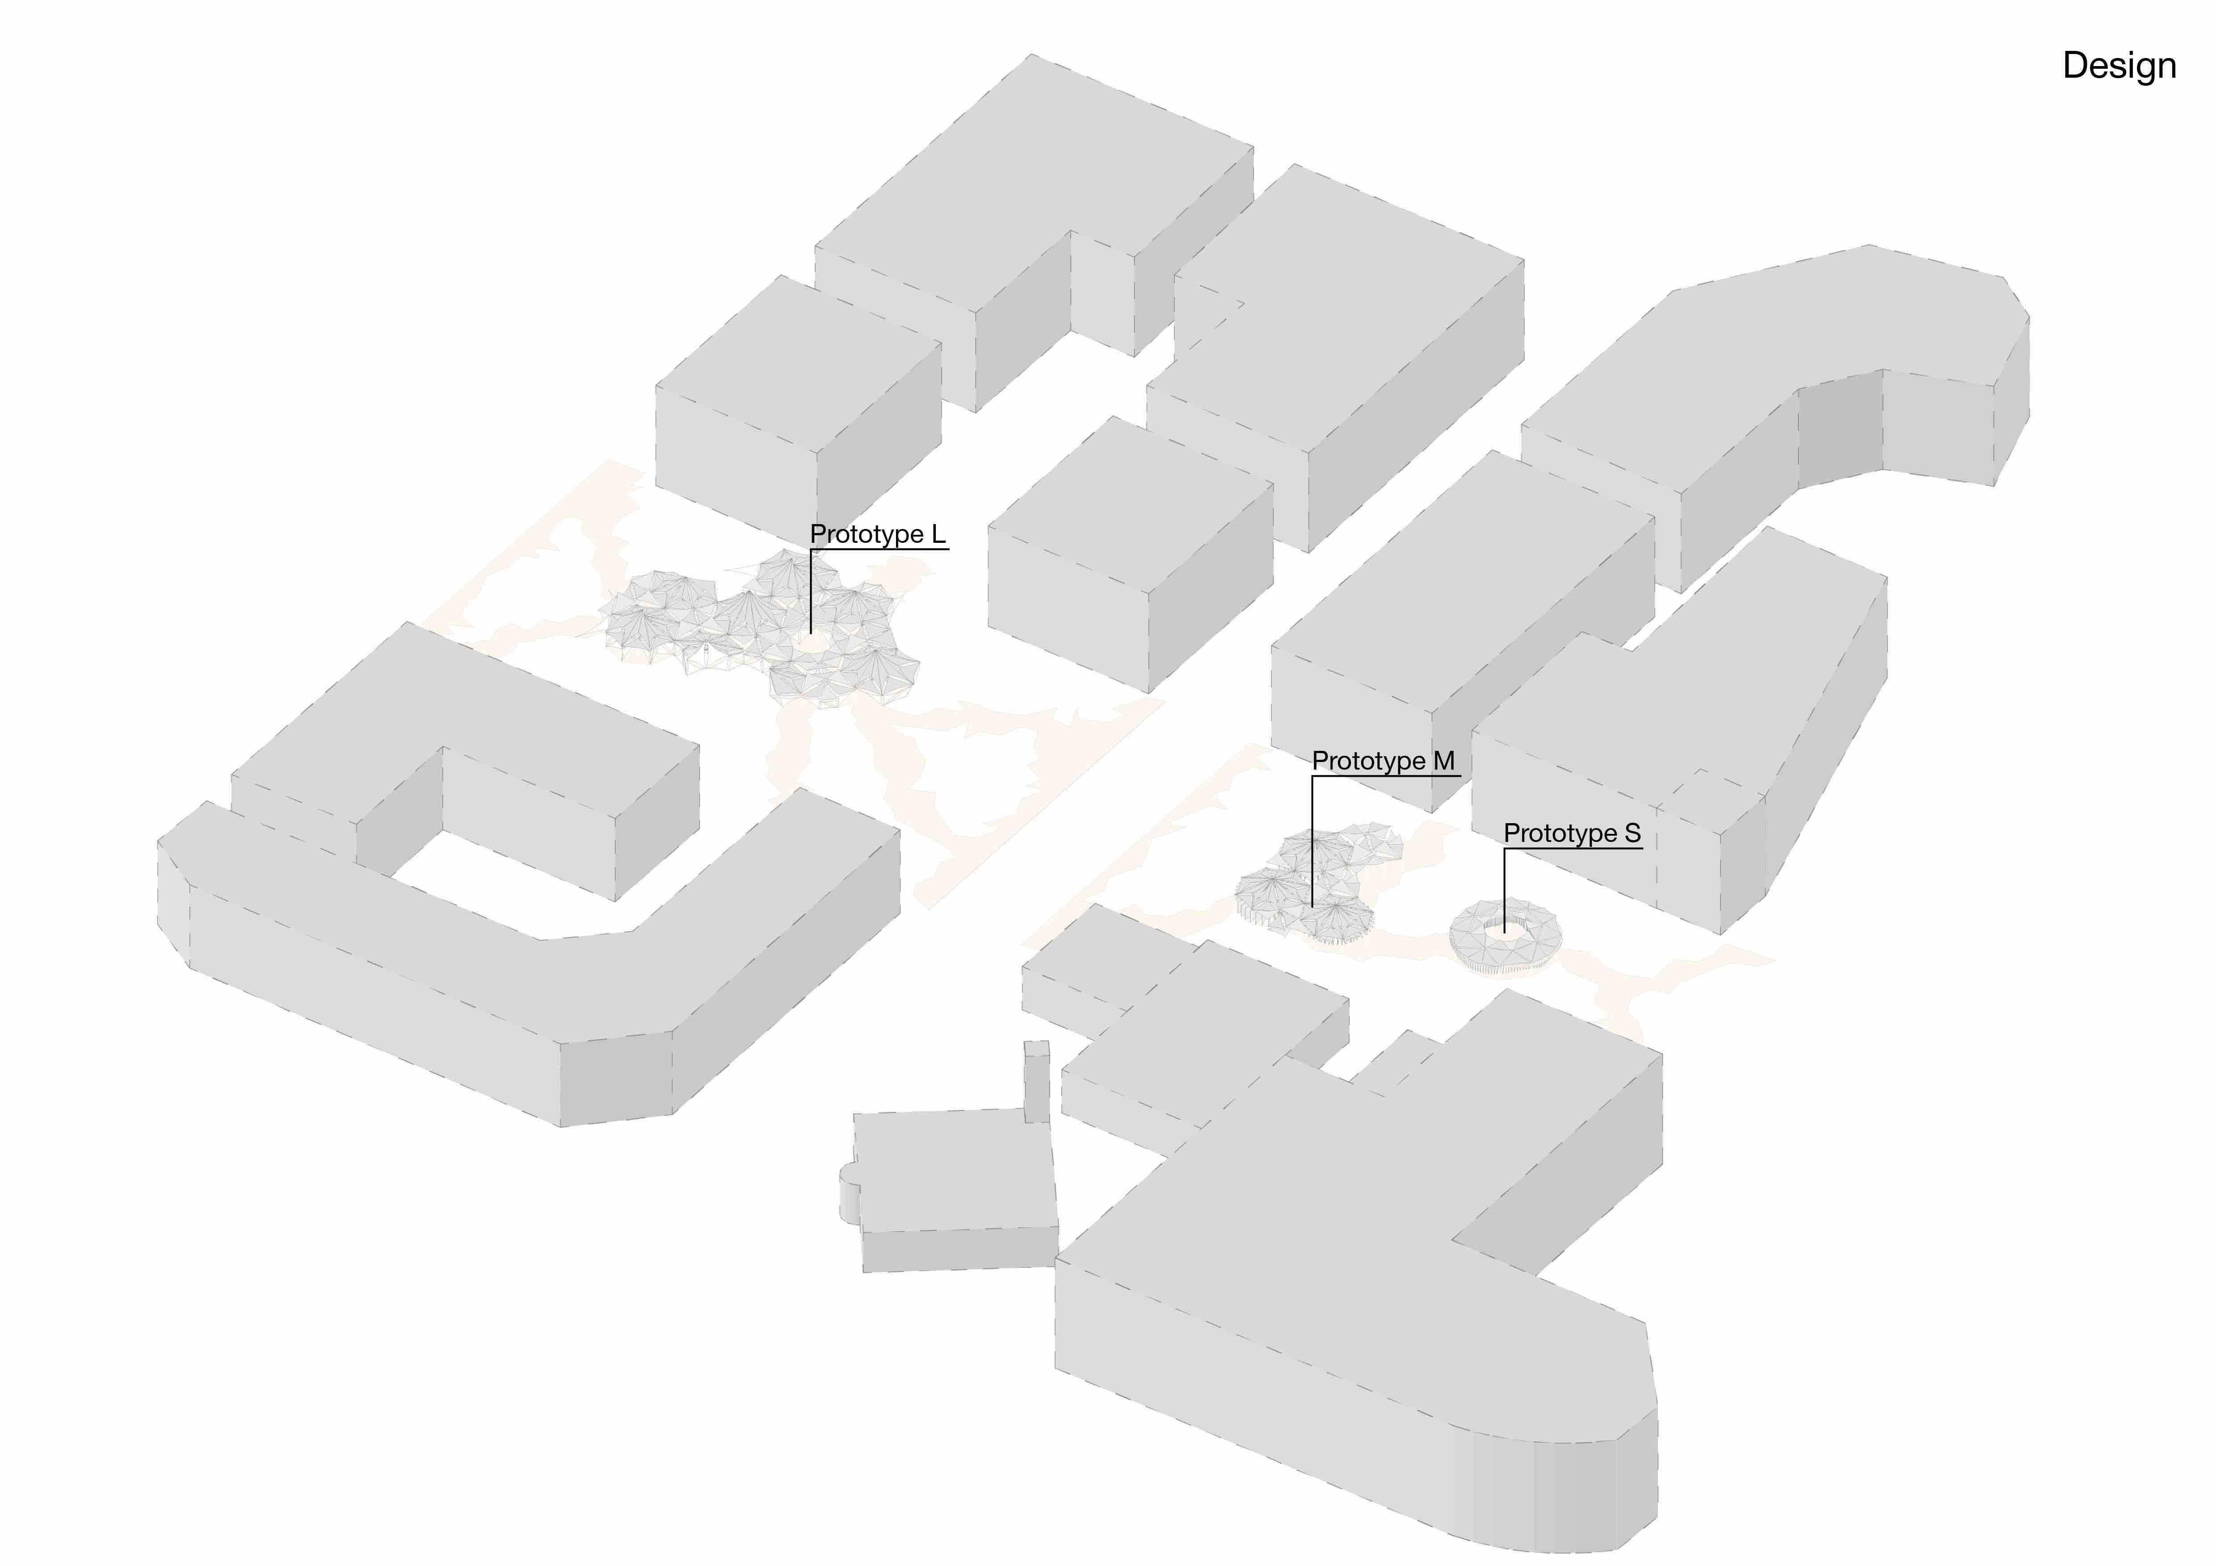
We believe that a modular design could help the economic and the construction phase, that’s why we choose to arrange our project into 3 different prototypes: S, M and L.
The site will be one of the main open-air areas of the city, therefore, it must be controlled and designed with proper storytelling. In order to generate a unique experience, the three prototypes are spread along the project area and linked with a series of paths that link every part of the proposal with the possible urban junctions. The bigger prototype (L) has been thought to host events like little concerts and open-air conferences, apart from being a shaded urban square, while the other two prototypes (M and S) as leisure pavilions where the relationship between the visitors and the textiles is more intimate. In every prototype, the visitor is in touch with a particular ray of light related to a particular space, designed to perform a wide range of activities. Textiles domes are creating the space inside Prototype L, textiles walls and corridors are redefining the idea of privacy inside Prototype M, while the cloud of 120 different textiles inside the prototype S is shaping the light to create a dense and quiet atmosphere to relax and enjoy the free time.

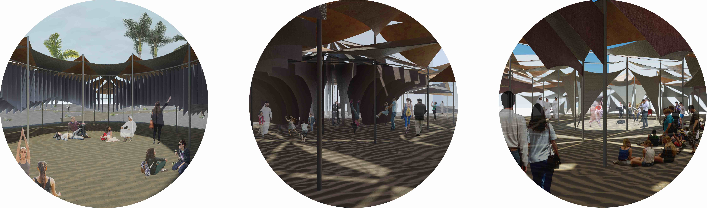
Prototype S Prototype M Prototype L

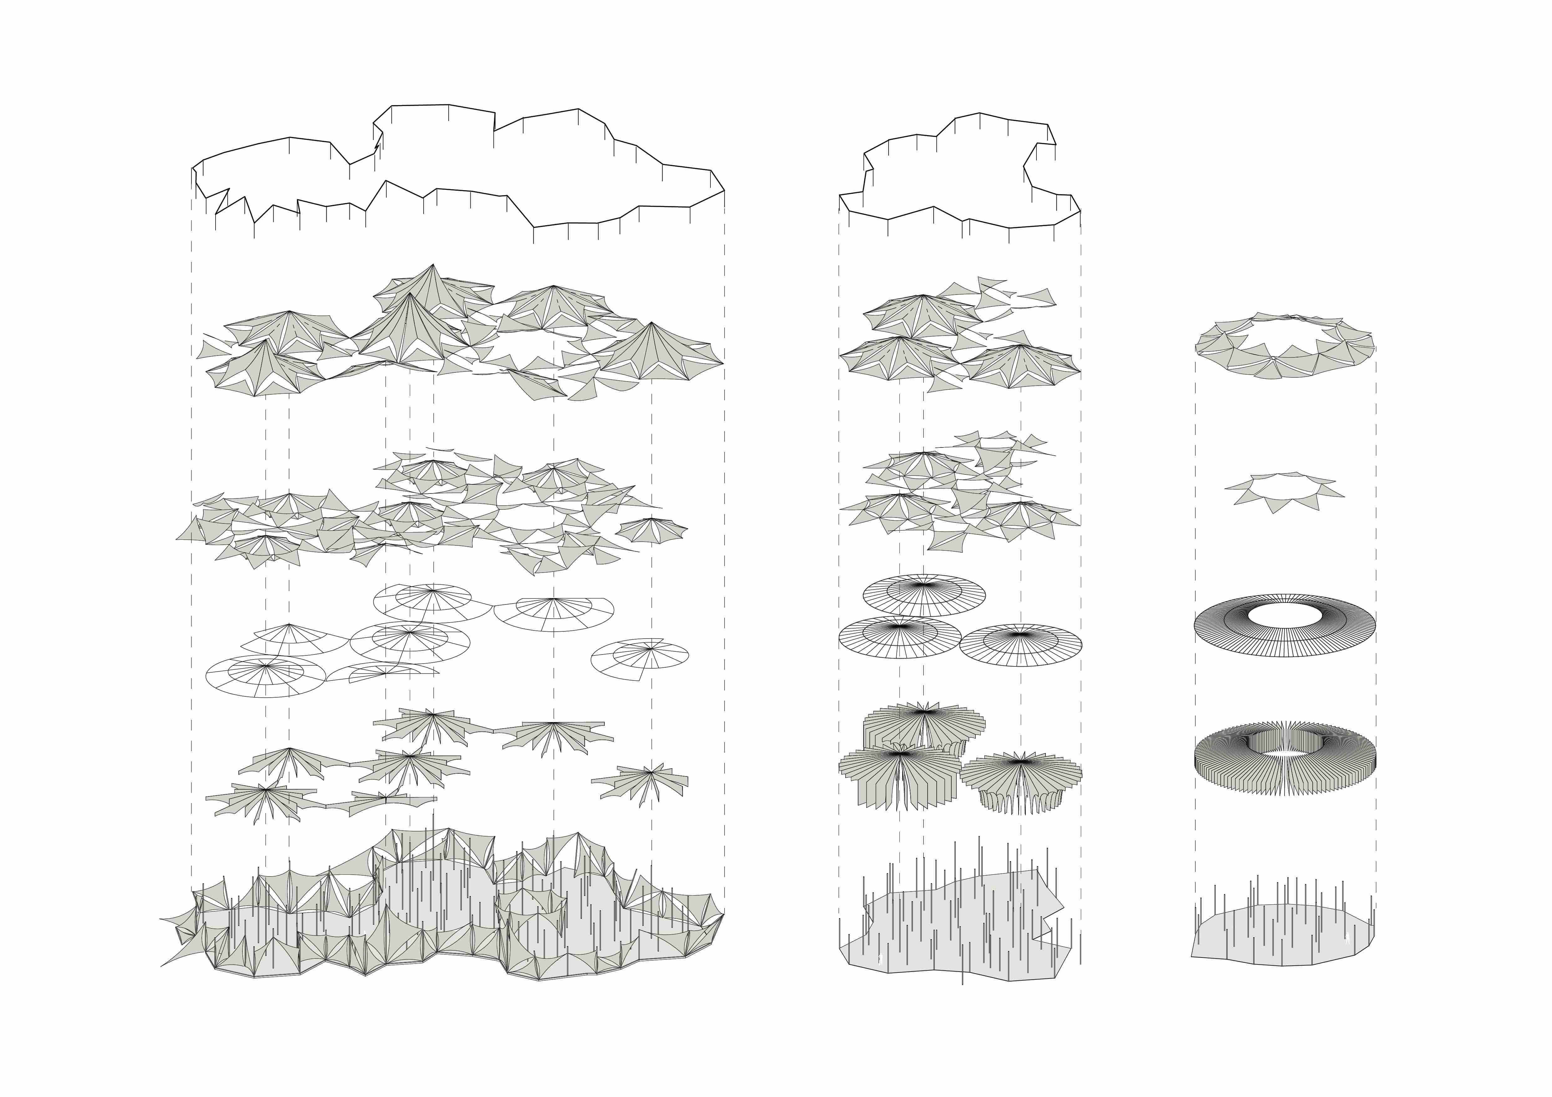
- Layered Structure -

6th layer
Wind belt textiles

5th layer
Solar cells Textiles

4th layer
OLED textiles

3rd layer
beam structure

2nd layer
Textiles

1st layer
pillar structure Textiles (Prototype L)

Prototype L Prototype M Prototype S

The project deals with modular textiles, moving forward from the common use of textiles in everyday life, and a thin metal structure.

1st Layer, pillar structure and Textiles (Prototype L)
The Thin steel pillar structures are used to sustain and move the tents by two winches, the first one moves the solar cells tents improving the daily energy production, the second winch, present only inside Prototype M’s pillar, is manual and allow the visitor to move the 1st layer of textiles in order to create different spaces according to the user’s activity, in this way even the energy produced by the visitor is stored. The bottom part of every central pillar is devoted to storing the battery, to guarantee easy maintenance of the system.
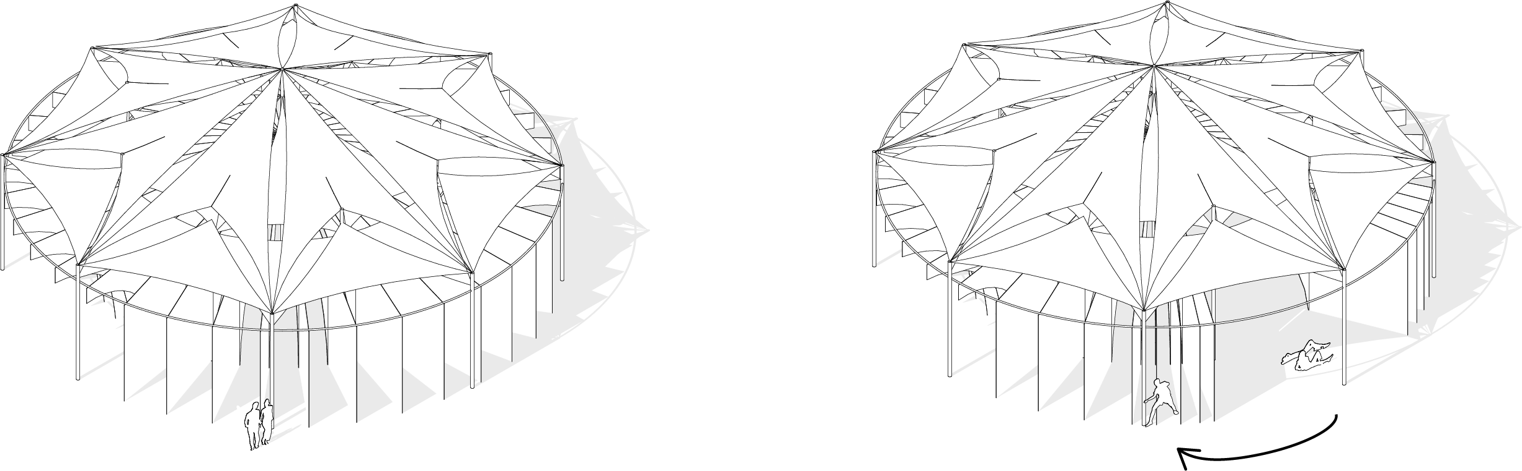

2nd Layer, textiles
The second layer is characterized by different modular textiles, 2 for the Prototype L, 2 for the Prototype M and 120 different textiles for the Prototype S. The diversity of modules allowed us to generate different spaces and different experiences. This layer of textiles can be moved by the visitor inside the Prototype M by a series of winches, where a group of 5 to 6 tents are rotating around the central pillar.

3rd Layer, beam structure
To guarantee stability to the structure and support for the lower textiles a circular and a radial beam structure connects the pillars to each other and to the textiles.

4th Layer, OLED textiles
During the night 1400 m² of OLED textiles light up the three prototypes allowing the visitors to use the artworks 24 hours. Those textiles are composed of friction nano-generators to produce energy while waved by the wind force. The amount of energy produced by this technology is 10 MW per year.

5th Layer, Solar cell textiles
The main technology devoted to the energy production is composed of solar cells textiles, where 1940 m² of textiles allow us to produce 1248 MW per year. The solar cells can move up and down the pillars to follow the sun during the day, changing the exterior look of the building and maximizing the energy collection. A sensor and an automatic winch are applied to the pillars enabling the movements of the solar cells.

6th Layer, Wind belt
The last layer is used to intercept the wind force to generate electricity. The Wind belt technology is the one that suits better for our artwork. It is based on a thin steel stick (100-200cm tall) partially insert into the pillar and connected to a pressure sensor. This sensor perceives the movements of the metal stick and transforms the movements into electricity. The sticks are connected to each other by thin textiles to capture more wind force and maximize the related energy production. The belt is located at the boundary of the Prototype M and L producing an average of 200 MW per year.

- Energy production -

Elements | Quantity | Power | Energy Production (day) | Working hours
Solar cells Textiles | 1940 m² | 0.13 KW/m² | 2 522 KWh | 10h
Wind Belt | 206 pillars | 0.11 KW/pillar | 550 KWh | 10h
Manual winch | 42 pillars | 73-150W  380-480W/5~6pieces | 24.5-50.4 KWh  109.4-138.2 KWh | 8h
Friction nano-generator | 1450 m² | 867 μW/m² | 30 KWh | 10h
TOT |  |  | 1005 - 1015 MWh per year

Costs

- Costs -

Technologies

Elements | Quantity | Operating life  (years) | Cost
Solar cells Textiles | 1940 m² | 20 | 2 865 000$
Wind Belt | 206 | 10 | 86 520$
Battery | 8 240 | 1 | 1 417 280$
Friction nano-generator | 950 m² | 3 | 2 400 000$
Wind Belt textile | 20 m² | 5 | 400$
Winch | 84 | 15 | 2 730$
TOT |  |  | 6 771 930$

Construction site and materials

Elements | Quantity | Price | Cost
Steal beam +  jobs | 40 ton | 2 838 $/ton | 113 520$
Copper cables | 7 km | 3 $/m | 21 000$
Construction site |  |  | 2 000 000$
Textiles | 3260 m² | 20 $/m² | 65 200$
TOT |  |  | 2 199 720$

Total Cost: 8 971 650$

Ratio: 8,8 $/W

- Environmental Impact –

The proposal wants to combine the local tradition of the desert elements with the most advanced technologies related to solar energy and wind energy. The proposal can be seen as an example for a new lifestyle that reinterpret the tradition. The main technological cluster is composed by solar cell panels and a wind belt line. The materials used are mainly made from renewable and recyclable materials, an example is the thin metal structure made of recycled aluminium, abundant in Masdar City which guarantee strength and flexibility against the wind force, making our projects a low-carbon. For the first layer of fabrics, we decided to use traditional materials like wool, usually used for the desert tents. Those type of fabric aim to decrease the loads, carried by the structure, to improve the utilization efficiency.

- Conclusion –

Beyond the Pattern wants to reinterpret the methodology the local traditional features leads by Masdar City, achieving new healthy lifestyle. The Intervention propose a new space where the modern technologies and the natural environment are merged in a unique harmony.

