Wave Generator

Concept
Water is regarded as an object that gives life in the Islamic world, it sustains life and purifies life. The Koran says, "I use water to make every living thing." Masdar is located at the junction of desert and ocean, and its base is located at the portal of Masdar ecological corridor connecting ocean.

The plan form generated based on the concept of water mark, which takes wave as prototype to optimize its shape. Wave, as a form of water, shows its infinite power and makes people feel awed.Using the undulating form of waves, it provides a public space to imitate the underwater world. To create a quiet and kind is full of light on the ground, this scheme using white giant steel frame structure and deep and remote blue photoelectric glass .

The wave generation of blue power glass and all-steel grid structure set off against the desert, bringing a cool and refreshing for hot pedestrians at the junction of desert and ocean. Blue glass components that can rotate in the wind fold onto the ground to project light and shadow, as if to let pedestrians in the underwater world. With the change of sunshine trajectory and the blowing of wind, the mark of water on the ground is in infinite change also.

Technology&Nameplate capacity
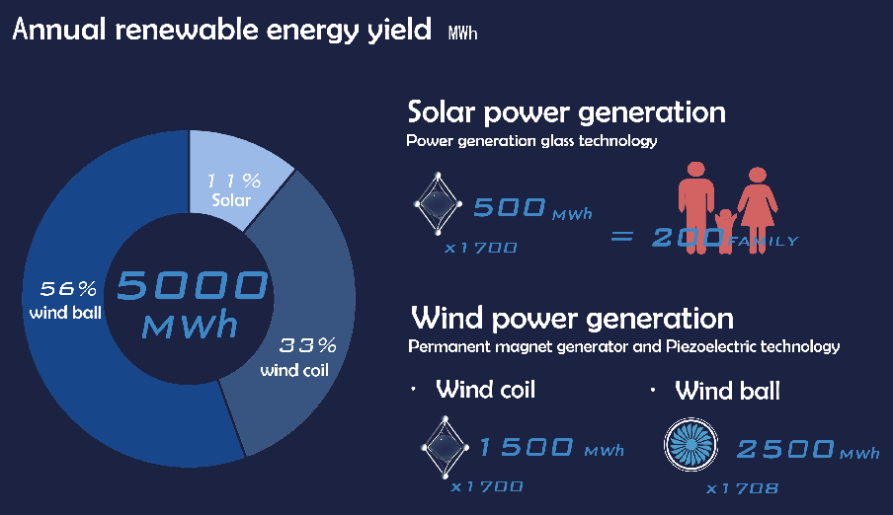1. Power generation glass technology
The design adopts the mode of combining wind energy with solar energy. Solar energy utilizes power glass, which is known as "oil field hanging on the wall". The electricity generated by three or four thousand pieces of this glass is equivalent to the electricity transformed by the oil produced by an ordinary oil well in a whole year.
2. Permanent magnet generator technology
Wind coil & wind boll.
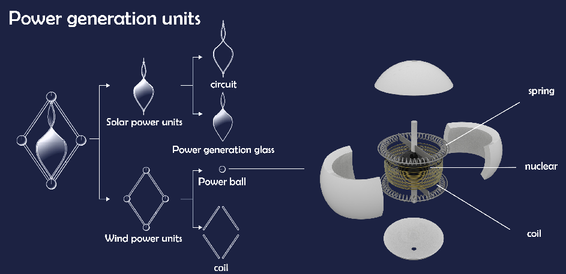
3. Piezoelectric technology
Wind energy uses permanent magnet generator technology, which to adopt two-stage mode. The first stage land and sea wind direct put the coil generates power. The second stage uses the role of the first stage wind to further promote the movement of the internal wind bulb, relying on the transmission structure, to achieve a higher scale of operation speed, thereby obtaining higher power generation.
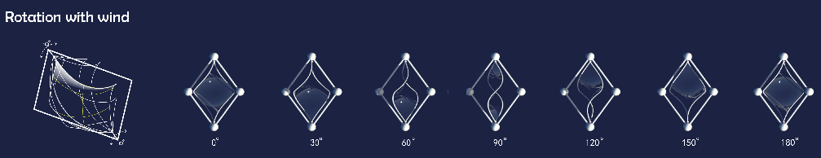
Size
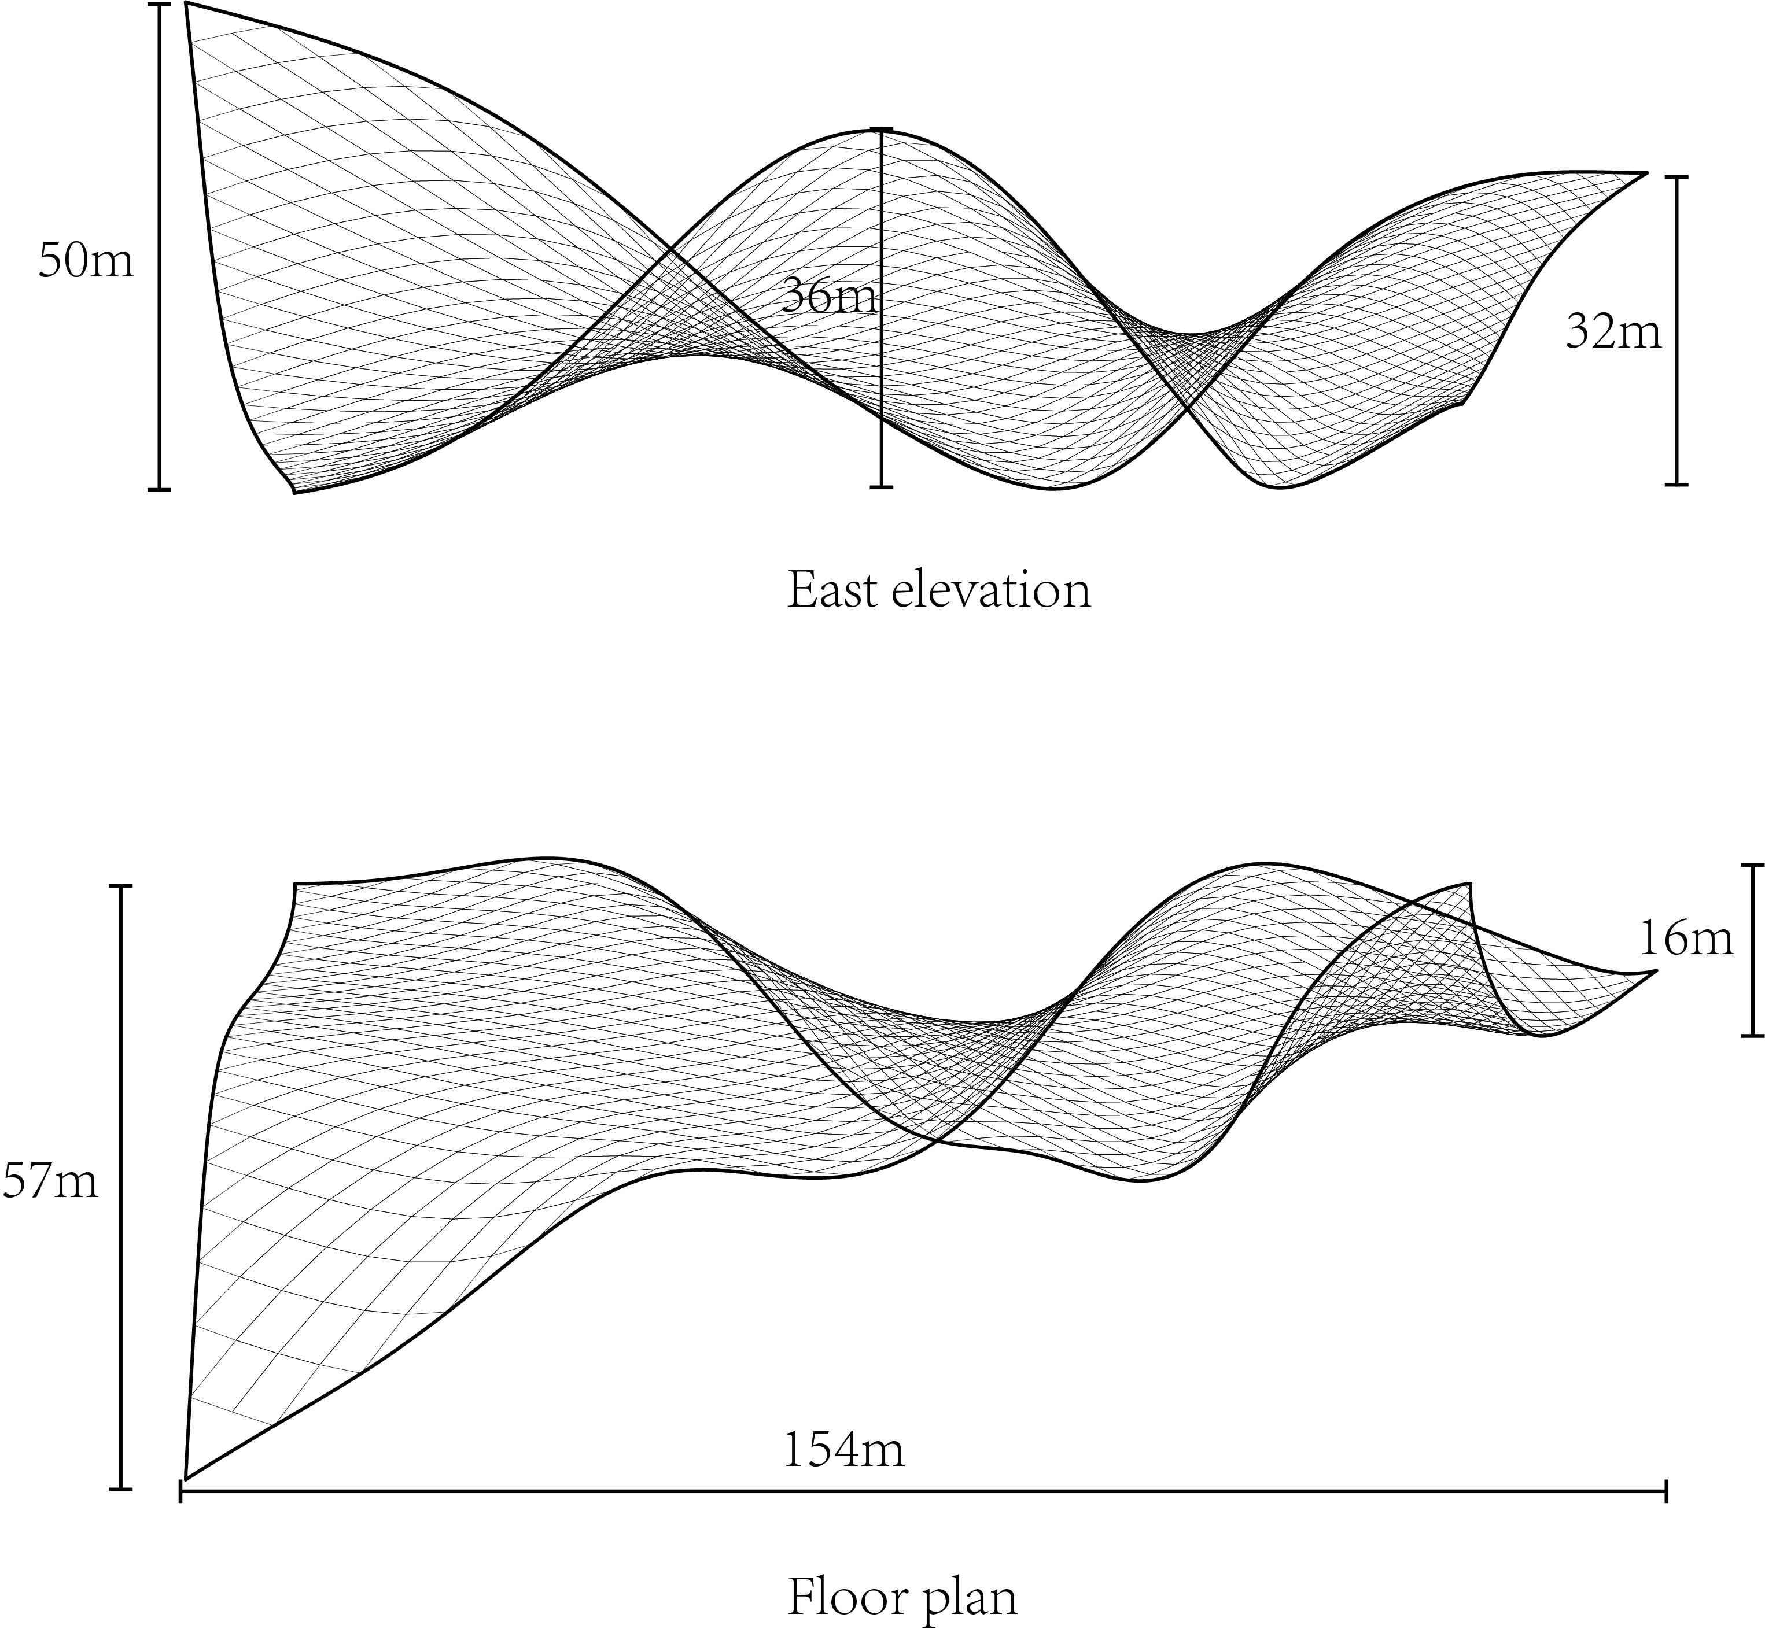
Material
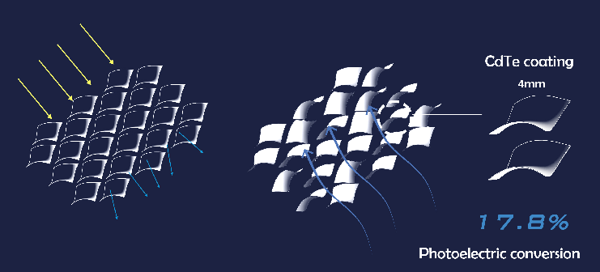Power generation glass、The carbon fiber、steel.

Maximum environmental impact statement
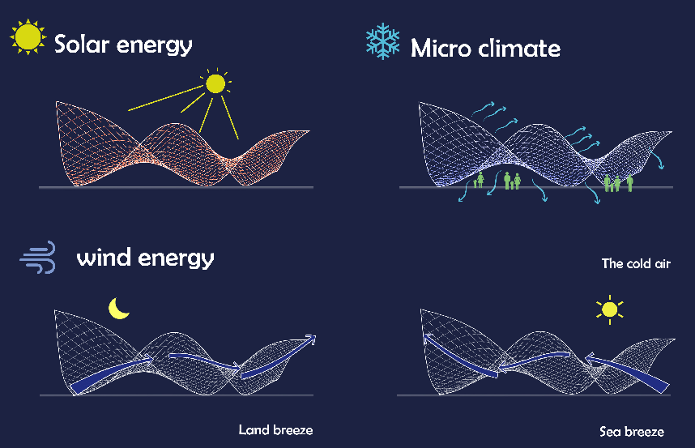· Land conservation Masdar, where land resources are relatively scarce, undulating patterns can provide public space for activities.
· Microclimate blue power glass, which can provide sunshade for the site
· Component organization of environmental protection and sustainable development, easy replacement of parts and components

