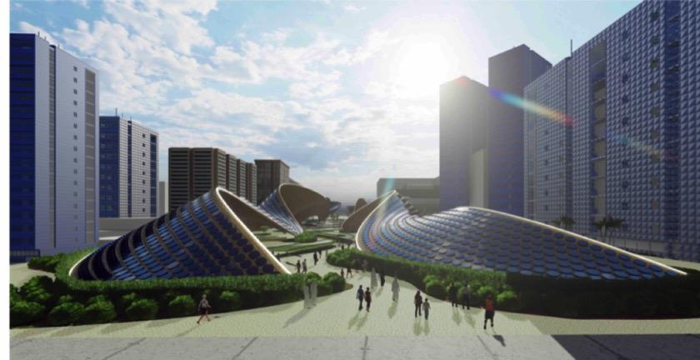



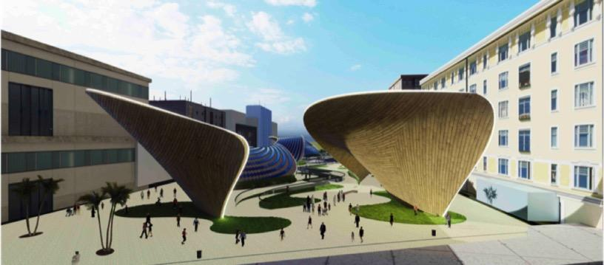

***SUMMARY***

The Binary Canopy proposes a radical approach to public art; one that reimagines the traditional role of the designer/artist as more of an orchestrator designing a computationally processed algorithm. The design strategy is to optimize the functionality of the sculpture, and therefore relies on the capabilities of parametricism to define a canopy custom to its home. Inspired by the local dune topographies of the U.A.E., the Binary Canopy aims to set the precedent of an ideal marriage between form and function. The vision is to promote innovation towards renewable energy by creating a thought provoking and energy generating piece of artwork.

The design ethos behind the sculptural solar canopy is that it must perfectly respond to this specific site through a continuous dialogue with its climate constraints and surrounding environments. In order to create a comfortable exterior climate sheltered from glaring hot days, a canopy of such magnitude is necessary. Shading an oasis and botanical gardens designed to cool exterior temperatures during the regionally notorious summers, the canopy does not only catch the eye, but also showcases the potential of beautifully capturing renewable energy and balancing ecosystems.

The idea behind this project sparks a new approach to multifunctional solar canopy design since undulating forms theoretically receive more direct sunlight and radiation, as explored in the form finding research behind this sculpture. This can be seen in figures IV and V. The project strays away from the typical solar carpet, and proposes an undulating morphology with round panels instead, while spatially forming botanical gardens and an aquaponic oasis to expose the balance and harmony of different ecological systems.

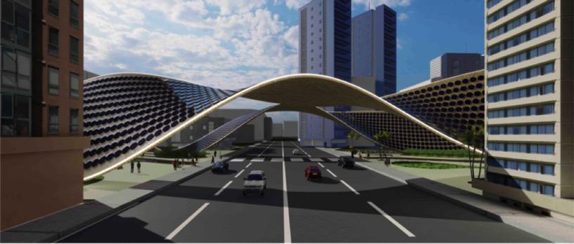

***DESIGN***

*EXPERIENCE*

The design of the sculpture is thoroughly informed by the site, both experientially and morphologically. Experientially, the dune like structure creates pockets of shade that allow the users to enjoy cooler exterior climates at all times of day, similar to how the local nomads (Bedouins), use the undulating topologies of the desert to remain protected from the blazing sun. Regardless of the sun’s position, the canopy guarantees that at least one pocket of full shade can be found. The pockets also serve to divide areas of the park for various garden typologies and different area programs for potential recreation, events and interaction.

The experience also features a pedestrian tunnel that takes the wavy form of the sculpture, which is a continuation of the adjacent park, and serves as a walkway to cross the street dividing the two plots. While walking through the tunnel, the audience is immersed in an educational experience to enjoy along the way. The works on the walls are meant to challenge visitors’ views on climate change. The experience also allows the users to view the mechanical equipment rooms through glass panels, which showcase the complexity behind the structure and the equipment that transforms the solar power to usable electricity.

*MORPHOLOGY*

Morphologically, the undulating design is entirely informed by the site; as it consisted of roughly 2 million iterations of possible forms that were tested for solar radiation, sunlight hours, and surface area while optimizing structural distribution. The designs were tested using an evolutionary algorithm that eventually generated the optimized combination of parameters against the predefined goals. In other words, thanks to the power of artificial intelligence, out of the millions of different undulating canopy designs that could have possibly stood up on that specific site, the sculpture that is proposed is the ideal conceivable form that can generate the maximum amount of potential energy.

Evolutionary algorithms (EA) are a subset of computation, within the realm of artificial intelligence, that are based on biological evolution and operate using logic that is similar to that of Darwin’s theory of natural selection. The algorithm creates different combinations (mutations) and allows the fittest permutation to evolve based on the degree to which it corresponds to the predefined goals (fitness functions). This guides the evolution of mutations towards the fittest. In other words, it operates like an automated trial and error solver. First, it tries a combination of parameters (mutations) and runs the goal analyses, which entail of the radiation, sunlight hours, and structural analyses (fitness functions), records the values obtained from these studies, and their corresponding parameters, and then repeats until the results begin to converge.

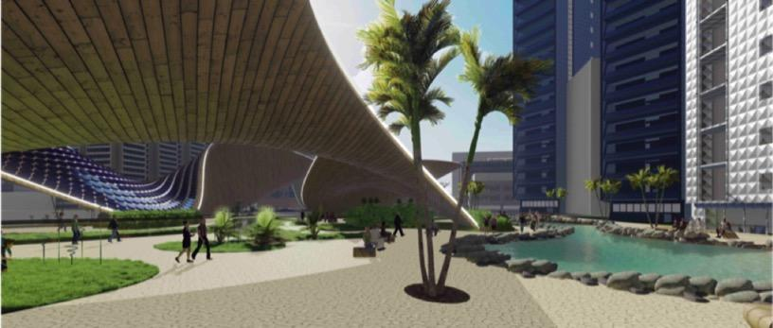

***SYSTEMS***

*PV SYSTEM*

The energy capturing system has a nameplate capacity of 587 kW and thus consists of 7,332 80W monocrystalline silicon round solar cells, that can generate around 475 MWh per year. The system is designed to store the expected captured energy per day (1300 kWh) in underground mechanical equipment rooms, using 50 solar batteries (10 kWh per unit) to power the aquaponic system, lights around the botanical gardens, and surrounding infrastructure. The residue energy is transferred back to grid. The estimated values of energy output were calculated using an algorithm that takes into account the shading of surrounding buildings, and is based on the NREL PVWatts calculator.

Round solar panels were chosen over typical rectangular cells and flexible PV sheets, because the former would not be able to accommodate the sculpture’s curvature, and the latter are still limited on the market and can be extremely costly with low efficiency output. Although the chosen PV cells have a relatively low power output per unit compared to rectangular units, the idea is to compensate with the optimized orientation of the PV cells to produce the maximum possible output.

*AQUAPONIC SYSTEM*

Although not an energy generating system, the aquaponic system is designed in response to the hot climate of the site’s location. Considering that most summer days are unbearably hot in the region, the idea is to naturally cool shaded areas by having a 1110 m2 body of water to induce the lake breeze effect, along with misters that are envisioned to make the experience more enjoyable to the audience.

The presence of water could also allow for greenery and wildlife to be accommodated in this hot environment, and merging both aspects within an integrated aquaponic system means that both ecosystems can thrive off each other. The beauty behind aquaponics is that the hydro system allows for water recycling, so instead of irrigating directly from recycled greywater influent, the water goes into the basin that supports the fish environments and enriches it with phosphates and nitrates from fish droppings. This results in nutrient rich water to irrigate the botanical gardens, as seen in figure I.

*\*An important factor to consider is that the maintenance of the aquaponic system is costly over time, and so we acknowledge that this might deter the feasibility of the project. In response to this, we propose that Masdar City creates an initiative that encourages locals to learn how to maintain these systems, and allow them to use the space to grow their own fruits and vegetables in exchange for maintenance services when required. Otherwise, the basin can be a typical water body and the aquaponic system can be avoided for cost efficiency.*

***FIGURE 1 –*** *detailed section portraying the loops of the PV and aquaponic systems.*

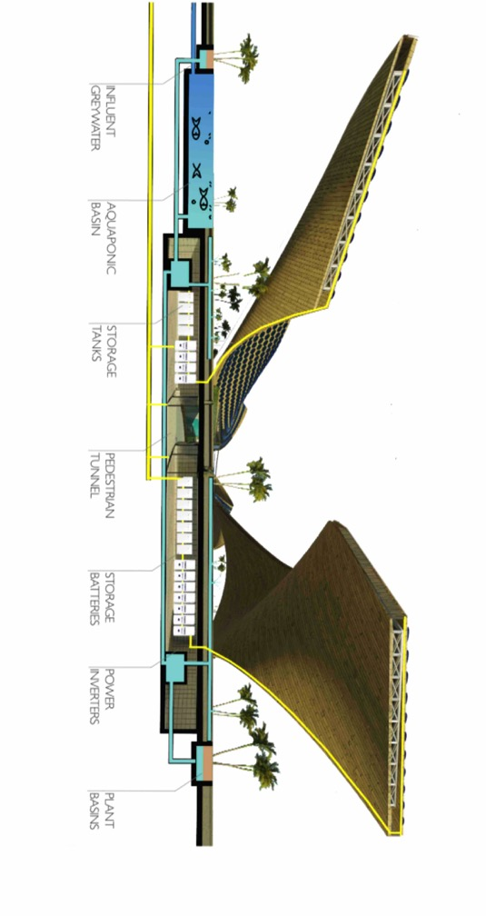

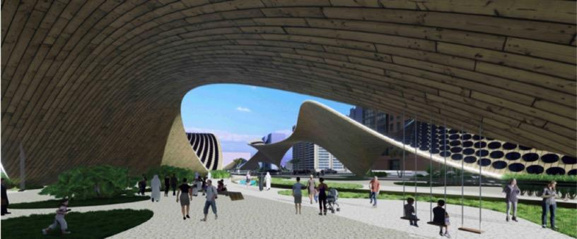

***FEASIBILITY***

*DIMENSIONS*

The Binary Canopy proposes a sculpture that stands across the extents of both plots of the site, spanning a length of 280 meters, a width of about 16 meters at most, and a maximum height of 18 meters. Preliminary iterations of the design involved splitting the sculpture in half where the street cuts through the site, but the difference in how much potential energy was lost was enough to support the decision of having a single extended canopy. While setting up the design algorithm, the points that determined the form of the canopy on top of the street were limited to a range between 8 and 18 meters to ensure clearance for safe traffic flow.

*MATERIALITY*

In order to reduce the embodied energy behind the project, the ideal situation would be to use locally sourced recycled wood from carpenters and other suppliers, as well as salvaged steel for the structural diagrid. This of course depends on the local availability. Nevertheless, the use of wood and steel as primary materials with minimal glass boasts a relatively low embodied energy compared to dealing with plastic cladding or synthetic textiles for example. The park floor is envisioned to be made out of local stone.

*COST*

The order of magnitude conceptual cost estimate foresees a total cost of $11,718,928 which falls in line with the budget of $11,731,200. That is basically a reflection of the nameplate capacity of 586,560 watts at a cost limitation of $20/watt. A more detailed estimate can be found in figure III. Since the design was entirely conceived with parametric tools, no quantity takeoffs were done for this estimate as the quantities used were all automatically generated.

***FIGURE I1 –*** *exploded axonometric illustration to depict the layers of the Binary Canopy.*

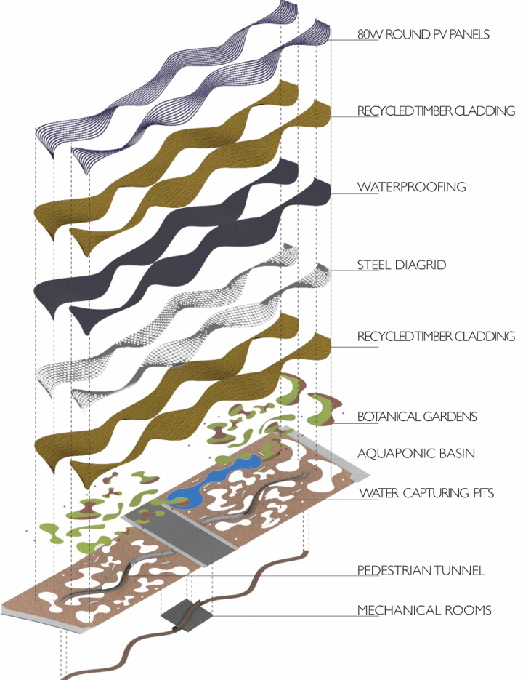

***FIGURE III -*** *detailed cost estimate for the main components of the Binary Canopy.*

|  |  |  |  |  |  |  |
| --- | --- | --- | --- | --- | --- | --- |
| ITEM | QUANTITY | UNIT | UNIT COST | SUBTOTAL | LABOR (25%) | TOTAL |
| Steel | 2,265.00 | tons | $1,890.00 | $4,280,850 | $1,070,213 | $5,351,063 |
| Recycled Wood | 21,130.00 | m2 | $15.00 | $316,950 | $79,238 | $396,188 |
| PV System | 586,560.00 | watt | $3.20 | $1,876,992 | $469,248 | $2,346,240 |
| Aquaponics | 1,110.00 | m2 | $1,150.00 | $1,276,500 | $319,125 | $1,595,625 |
| Gardens | 10,956.00 | m2 | $100.00 | $1,095,600 | $273,900 | $1,369,500 |
| Waterproofing | 10,565.00 | m2 | $50.00 | $528,250 | $132,063 | $660,313 |
| BUDGET | 586,560.00 | watt | $20.00 | $11,731,200 | > | $11,718,928 |

|  |  |  |  |
| --- | --- | --- | --- |
|  |  |  |  |
|  | THE BINARY CANOPY | PLANAR CANOPY AT 10º INCLINATION | DELTA (%) |
| Area (m2) | 10,565 | 10,565 | 0% |
| Total Annual Radiation (MWh/m2) | 750 | 495 | 51% |
| Total Sunlight Hours (hours) | 3,128 | 2,333 | 34% |
| Average Daily AC Energy Per Day (kWh/day) | 1,300 | 798 | 63% |
| Total Annual Power Output (MWh) | 475 | 291 | 63% |

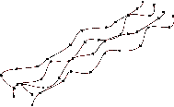***FIGURE IV –*** *an estimated analysis comparing performance of the Binary Canopy in contrast to a typical canopy.*



***FIGURE V –*** *visual representation of the data above from fig. IV.*

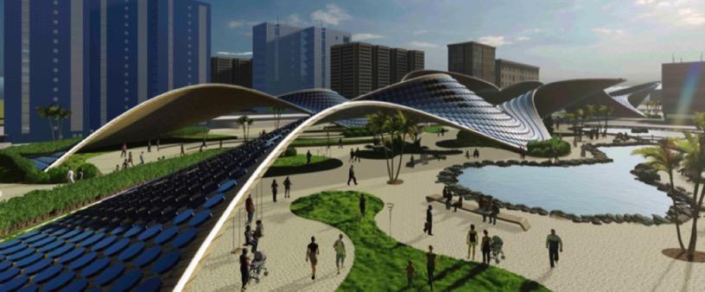

***ENVIRONMENTAL IMPACT***

The environmental impact of the Binary Canopy is taken into consideration from the conception of the design to realization. The main theme revolving around the project is to maximize the potential output. Having a perfectly form found structure that can generate as much renewable energy as possible already compensates for the potential damage against the environment during construction. Yet, the goal is to fully avoid any harm to surrounding habitats. The canopy should have minimal impact during construction, as the approach would be to build a modular truss structure in shop using recycled steel beams, which will eventually be erected on site. By doing so, we would reduce the noise impact behind the project.

As for all the unearthed soil that will be removed to build the underground tunnel, mechanical rooms, and aquaponic basin, the idea is to capitalize on its reuse in order to form discrete hills under the patches of grass across the gardens. The study on the embodied energy seen in figure VI estimates a payback time of 7 years to compensate for the energy required to process the raw materials envisioned for the project.

***FIGURE VI –*** *embodied energy payback time analysis for the primary materials of the Binary Canopy. Values used for embodied energy (MJ/kg) were averaged out from a range of different sources of construction material embodied energy tables.*

|  |  |  |  |  |  |
| --- | --- | --- | --- | --- | --- |
| Primary Raw Materials | Embodied Energy (MJ/kg) | Estimated Quantity (kg) | Total Energy to Fabricate (MJ) | Total Energy to Fabricate (MWh) | Payback Time (Years) (Energy to Fabricate/475 MWh) |
| Recycled Timber Cladding | 5.00 | 287,368 | 1,436,840 | 399 | 0.84 |
| Recycled Steel (100%) | 17.00 | 226,500 | 3,850,500 | 1,070 | 2.25 |
| Glass | 19.00 | 73,294 | 1,392,590 | 387 | 0.81 |
| Stone Flooring | 3.58 | 1,482,800 | 5,308,424 | 1,475 | 3.10 |
| TOTAL | 44.58 | 2,069,962 | 11,988,354 | 3,330 | 7.01 |

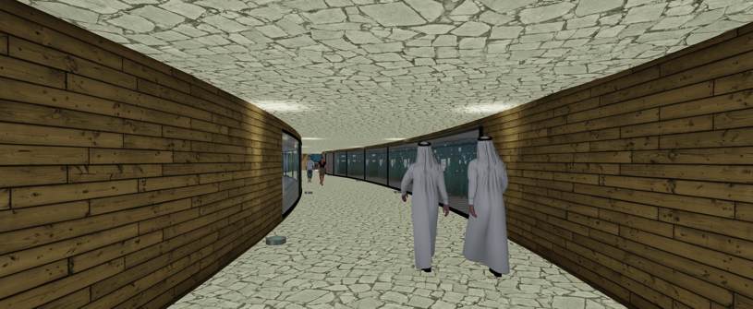

***CONCLUSION***

Considering the forward driven mentality that the U.A.E has adopted over the last two decades, we believe that the Binary Canopy is the perfect art generator to complement Masdar City. The cutting edge development that is seen across the existing buildings of Masdar City beautifully portrays a future of post modernist architecture. A parametrically designed sculpture that harnesses computational power to optimize renewable energy generation, defined by bold curvature and an experience specifically designed to showcase the tectonics behind the structure, creates a contemporary and relevant attraction that bolsters local characteristics. We believe that the proposal is pragmatic and can be constructed as an attempt to further drive innovation towards renewable energy generation.

THANK YOU

