THE MASDAR FRACTALS

“Beautiful, damn hard, increasingly useful.
That's fractals.”
- Benoit Mandelbrot,Mathematician who first used the term "fractal" in 1975

Description

The Masdar Fractals comprises of two large scale structures that function as photo voltaic electricity collectors. These unique looking forms one triangular the other cubic are based on Sierpiński-Menger fractal models. The project entails a unique pairing of visual mathematical complexity and physical functionality, pushing the envelope of Artwork that is able to collect electricity with a realistic approach and striking aesthetics.
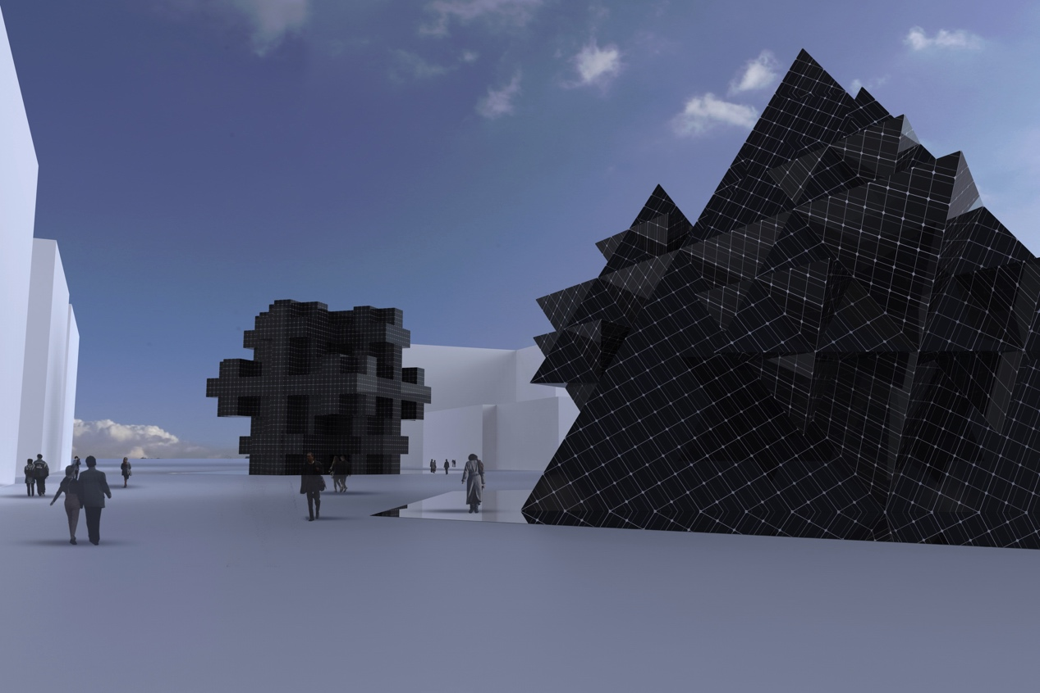

The two structures stand 18 meters high and spatially operate as would be a social meeting point or small public building, energizing the social environment and providing shade from the sun. At night the structures have the potential to come to life with built in lighting using its own gathered energy supply, these lights will be minimal, highlighting the facets and edges, and could be a stunning addition. Besides ceaseless energy collection each of The Masdar Fractals double as open public space- a temporal refugee from the midday sun.
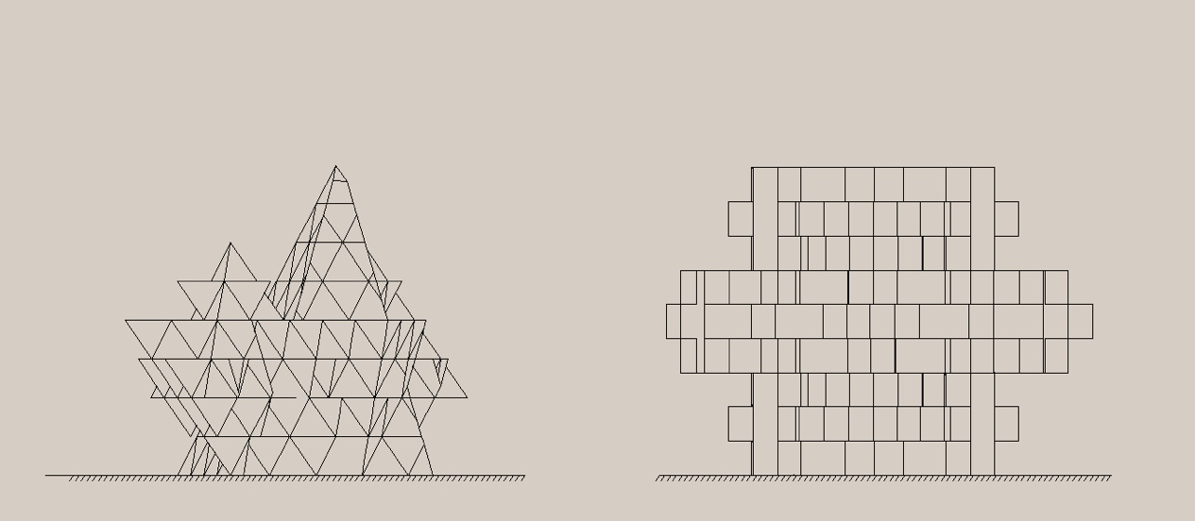

Walking around the base perimeter of each structure a visitor will discover openings allowing access to the large interior space. Passers by are free to wander in, a break in the solar surface creates a doorway activating the spacious interior. As you enter inside the interior space it is quite vast, darker and much cooler than the outside. This allows the eyes to reset from the intense tropical sun. The lofty interiors are perhaps reminiscent of a place of worship or interior of some super enlarged metallic crystal. Pix-elated quadrants reflect and repeat into darkness extending in all directions.
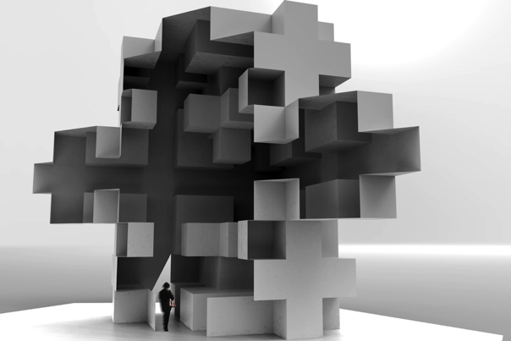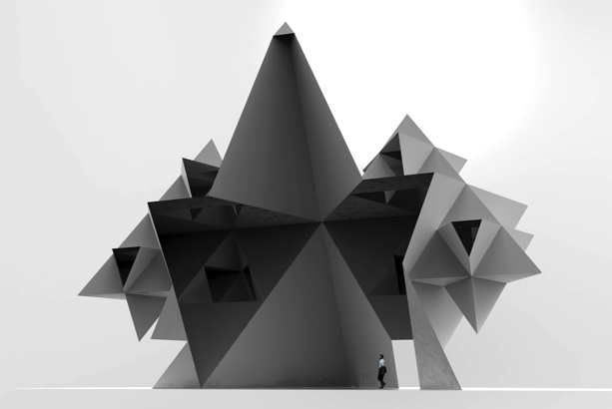
Higher up shafts soft volume metric light can be seen and softly illuminate the space via reflections. The space is noticeably cooler because as warm air rises excess heat is vented into the outside at the top. To make this happen here and there a selected few solar panels are removed. The light is reflected down to the base of the inside illuminating a pathway for visitors. Providing the locality with a meeting point, place of solitude and contemplation. At night the outline of each structure could be illuminated by self powered efficient LEDs softly lighting it and the immediate surrounds. There is also the possibility to illuminate the interior space.
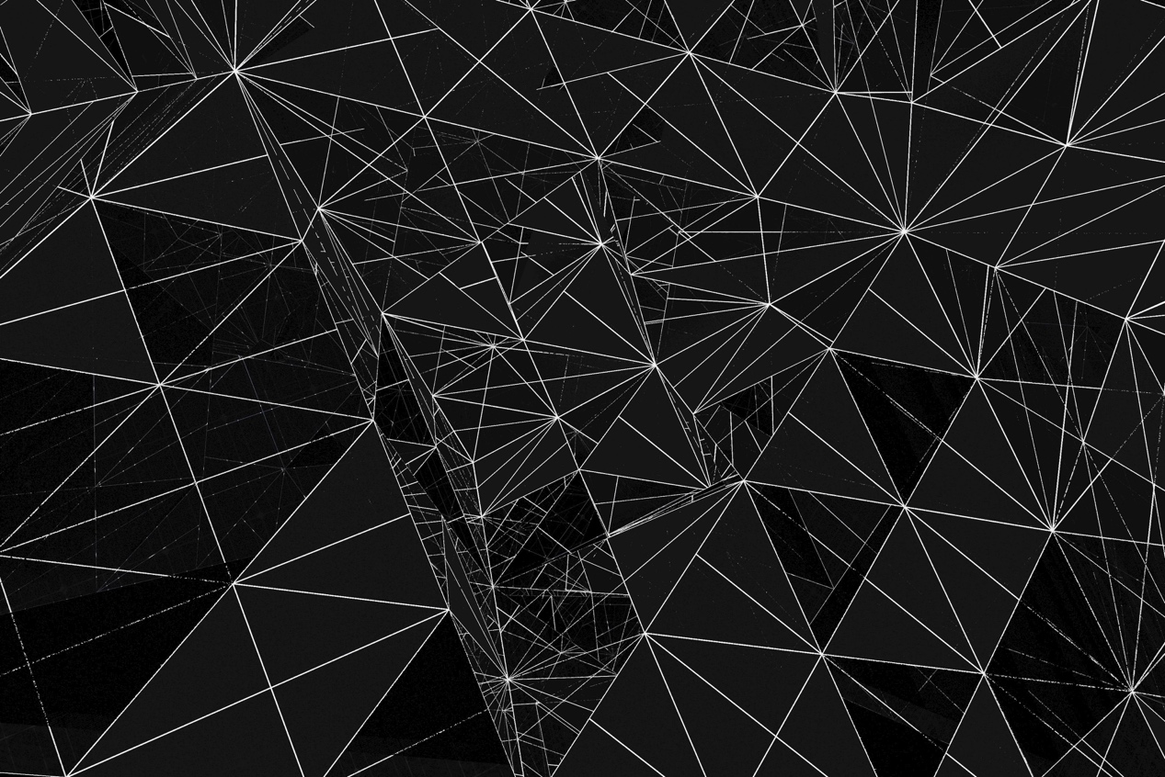

Technology/design

The choice of a fractal geometry as solar collector owes as much to their unique visual signature as to a under utilized physical property. It is the realization that these geometries possess extremely large surface areas compared to their volume and ground footprint. This feature makes them ideal for solar collection as surface area equates to potential energy capture.

Further to large surface area for solar catchment the geometry offers differing angles able to collect light without the need for moving parts. As the suns position changes energy can still be efficiently collected, thus omitting the use of expensive mechanics and motors found in tracking devices. Over long time scales these moving parts can fail and require replacement.
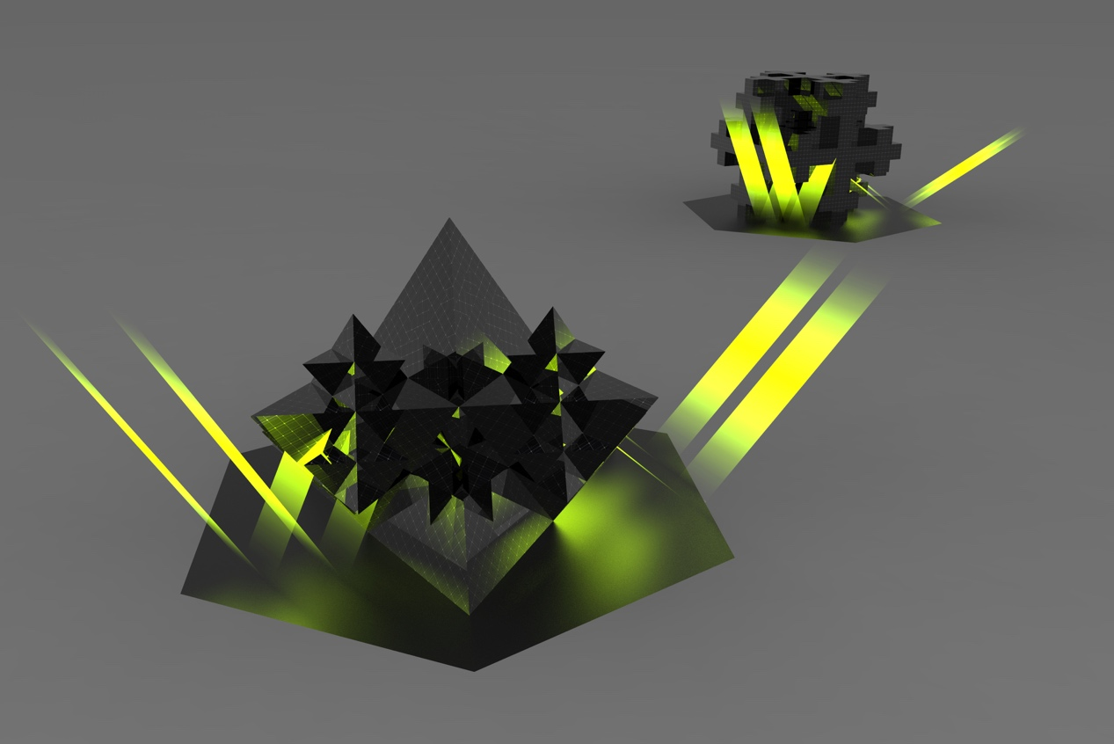
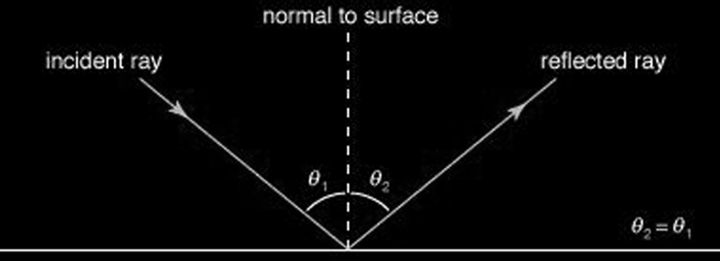

To further extend the solar collecting potential of each structure large metal mirrors (polished stainless steel sheet) will be situated and fixed around the base of each. The purpose of this is not to create some optical effect but to use the reflected incident light waves as an energy source (please see rendering). Following the 'angle of incidence' principle solar panels can even be orientated vertically and facing downward and are able to collect some light during the course of each day.
Ultimately The Masdar Fractals will provide the opportunity to efficiently collect light almost maintenance free. This builds on the prospect of the project having a low long term cost and energy foot print.

The conservative low annual energy output for combined 2 collectors is 437,000 KWh/yr
Total combined collecting surface area 1,538 m²
1m square able to produce 280 watts per annum

Environmental Impact

With the exception of periodic cleaning our proposal is largely maintenance free and should last at least 3 decades. Although the project may have a relatively high initial embodied energy and cost its low maintenance simple operation will limit running costs to a minimum once constructed. The entire project uses solid state components free from trouble some moving parts like pumps, bearings and actuators that can easily fail in the hot dry dusty desert sun.

The Masdar city has a particularly high surface salinity deposition rate due to the proximity to the gulf of Oman and its low rainfall, corrosion of metallic components and structures possessing stray voltages from solar collection will corrode very quickly. The stainless steel sheeting used for the floor mirrors does have a high initial carbon footprint, however the longevity of the material- several hundred years and its ease to recycle make it ideal in the long term.

A lightweight prefabricated space frame would be used to build the armature structure to which the panels are attached. Several commercial systems already exist that could fit the design requirements, these comprise of many small parts that fit together. This will alleviate large costly transport of pieces and their associated emissions during the construction of the project.

The use of standard square and triangular Solar panels will limit the need for timely and expense development of custom shaped parts are well understood and on this scale implemented with the use of base reflecting mirrors will provide reliable stable electrical power.

