INFINITY
Integrated , Free , Immortal & Natural Infrastructures Technology

Where do we come from ? Where will we go finally ? Where is the end of the Universe ? How long will the Universe live ? How much time do we have for being together ?
The answer to all these questions maybe one word : “ to Infinity “
Let’s return to the source . But where is the source ?
Nearly 14 billion years ago , happened a great event in an unknown and mysterious point . Scientists believe The great explosion ( called Big Bang ) is the major source of all amounts of energy and matter in the world . All of the billions galaxies and their stars and planets were integrated in that point but not as types of matter and energy we know . Then happened that big explosion and all the contents threw into an absolute dark and frozen space and everything started . Yes , everything started with that unique and wondrous event.
The frozen space became warm and clear by that pure energy and light . At first there was only energy , and matter was absent for a long time . Billions of years were needed to become colder and slowly convert to dense molten masses to create elementary galaxies . Billion years again passed and many pieces of those molten galaxies separated and become colder to form stars and then planets separated from stars . some of them slowly become suitable places for life as our planet Earth .Of course those incidents didn’t happen to us only . We have to wait to visit our strange relatives and this meeting may happens erelong or in a far future .
Anyway , all of us are common in one thing : the source is a unique point and we’ll return to the source in the future .
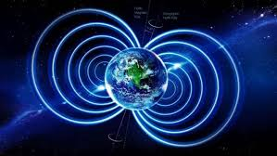

Why INFINITY ?

Designing and constructing new energy harvesting systems must have some extra specifications :
- Integrated : Renewable energy harvesting systems must be as a unique and integrated structure not a number of modules and panels only.
- Free : Energy is free in nature , we must respect to nature and use its gifts
- Immortal : Renewable energy must design and construct for our children and their children
- Natural : Energy and matter are in convert cycles
- Infrastructures : It’s better to construct more efficient systems by designing complete constructions
- Technology : Technologies are constantly evolving and we must prepare to accept new and efficient equipment
EXERGY and benefits
INFINITY includes hybrid systems to help the environment to be cleaner . SODIS system is an integrated purification system to disinfect 1500 m^3 / day . (total area of the main building of INFINITY is 20200 m^2 and the thickness is 10 cm ) . 25% of this volume must be empty to best efficiency . Regarding to researches accepted by WHO , solar UV disinfection is an useful and free system for water treatment . Hybrid PV modules (CIGS) are attached the inner side of tempered glass by patterns to cover only 70% of the glass. In this way every 6 hour we can disinfect about 1500 m^3 of gray water . The output is fresh water and can be used for water fountains , pools , laundry, aquariums , and any other uses (except drinking) .
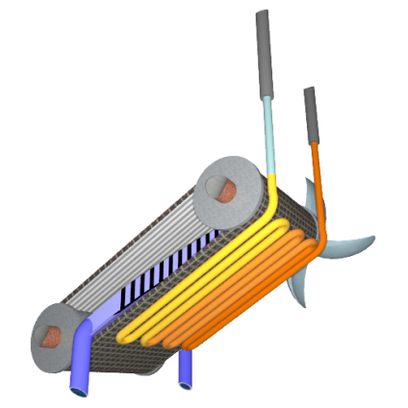
Wind Water is an efficient system to capture drink water from air. The building is as a dome with linear gates all around it. The wind moves around the spheral domes as an aerodynamic body. Average wind speed in Abu Dhabi is about 12 km/h and average humidity is 61% . INFINITY has about 500 m^2 of air gates in each side. If the system works by only 25% efficiency and 10 hours a day wind flows and we only can capture 5 grams of air water, then this is the result :
12000 m * 500 m^2 * 10 = 60 million m^3 of humid air for wind water generators .
60.000.000 * 25% ( Efficiency ) = 15.000.000 m^3 * 5 g = 75000 liters / day .
Hydrogel saltwater desalination can produce 25 liter / m^2 per day . we have nearly 2700 m^2 the surface . So we have about 65000 liter pure water .
Hybraulic system is a creative and simple system that makes energy from people steps and cars and bikes passes with the minimum effect to their comfort. This system makes hydraulic pressure and the extra pressure can supply the pressure of reverse osmosis pump . Each pump contains 25 cm^3 ( for pedestrians ) and 200 cm^3 ( for cars ) . We have 500.000 units of pedestrian pumps and 45.000 of car’s . So we have the potential of moving amounts of water by stepping and passing .
500.000 * 25 cm^3 = 12.5 m^3 ( pedestrians )
45.000 * 200 cm^3 = 9 m^3 ( cars )
12.5 + 9 = 21.5 m^3 ( for one press )
If only 50% of units be in cycle and receive only 200 presses / day , we can calculate the total pressure and water moved .
12.5 * 50% * 200 = 1250 m^3
9 * 50% * 200 = 900 m^3
1250 + 900 = 2150 m^3 / day .
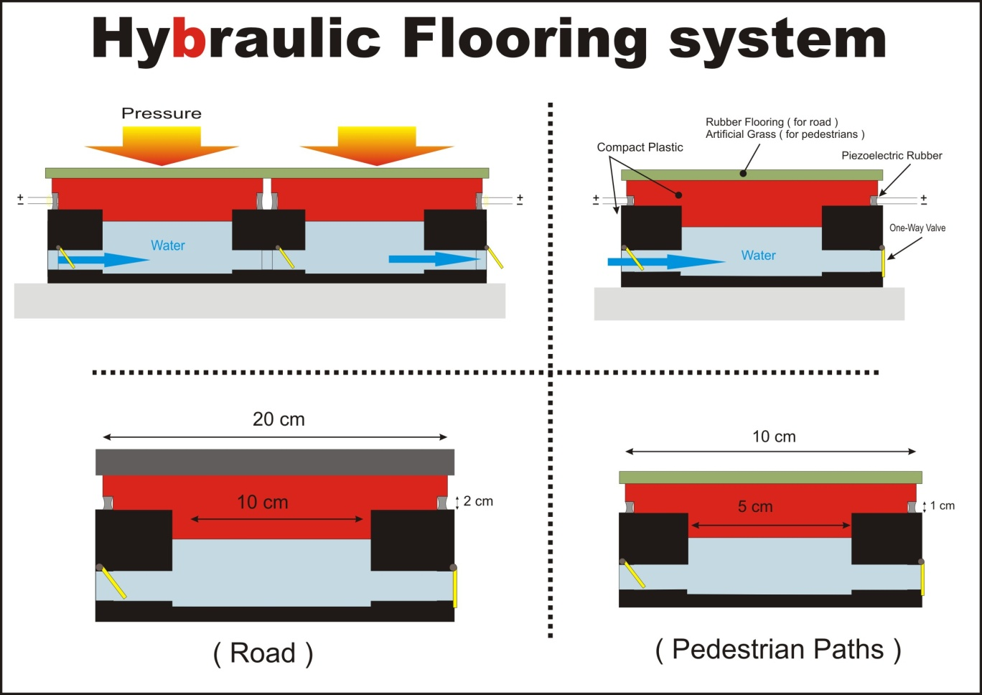
If average weights for pedestrians be 60 kg and for cars be 1000 kg , the pressure received by pumps are :
60 kg : 25 cm^2 = 2.4 kg / cm^2 = 0.235 Mpa
(1000 kg :4 wheel = 250 kg each wheel ) 250kg : 100 cm^2 = 2.5 kg/cm^2 = 0.245 Mpa
For seawater RO we need around 6-8 Mpa of pressure and we consider the maximums .
8 Mpa : 0.235 = 34 . So 34 persons at the same time can make the pressure enough for RO pumps and about cars about 33 cars can do that . So we change the potential energy of gravity to the useful kinetic energy ( Exergy ) to provide the people drinkable water almost as free ! The piezorubbers can make enough electricity for lighting and other instant electricity needs.
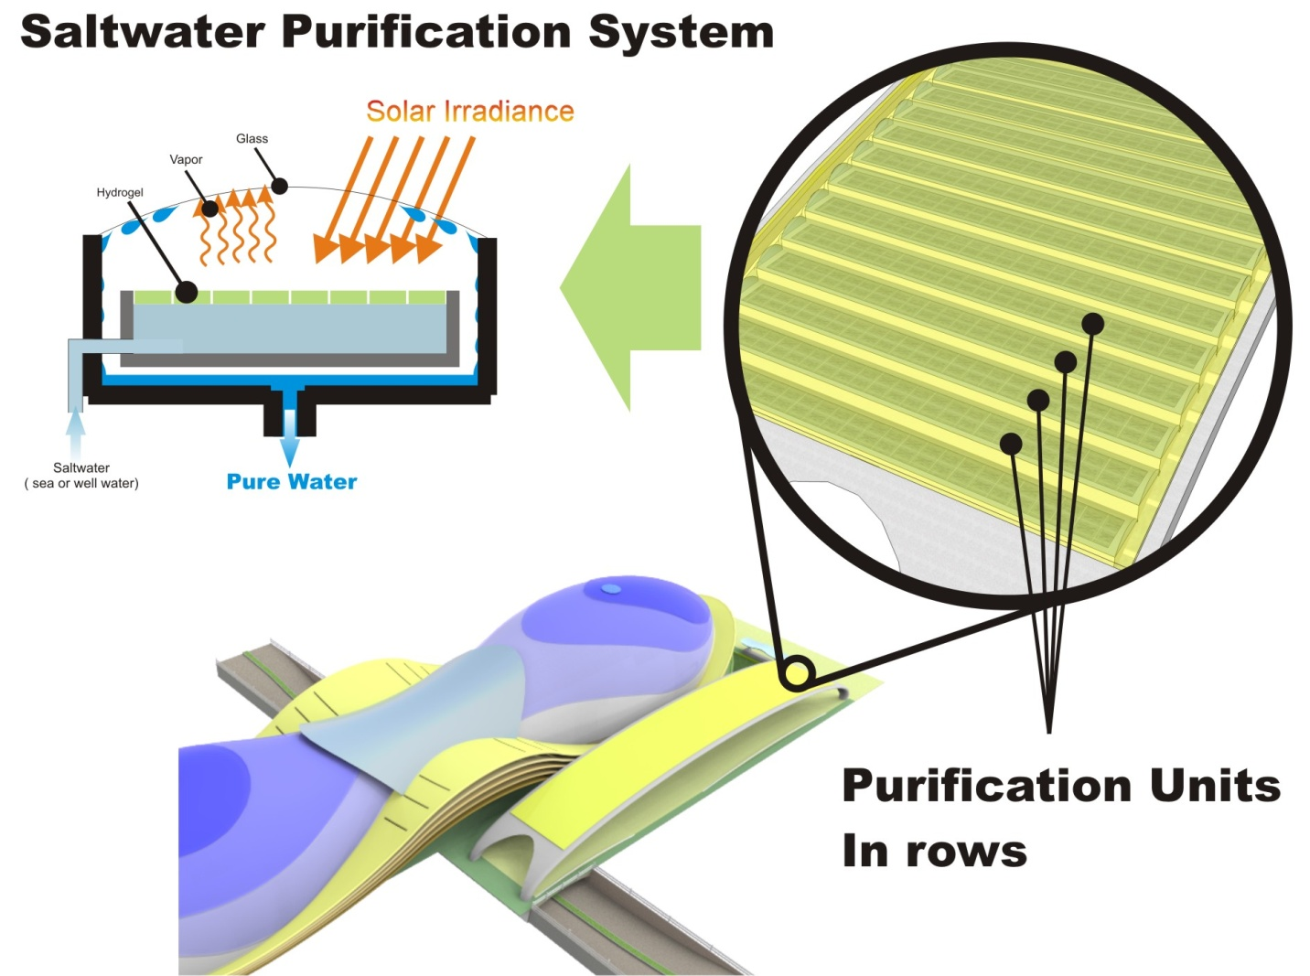
Overall we have an efficient and useful infrastructure to use free energies and water around us without any environment damages.

INFINITY Energy & Exergy technologies :
- Hybrid pv panels CIGS
- PVT solar thermal pv panels
- Wind Water (capturing water from air )
- Hybraulic ( hybrid hydraulic and piezoelectric flooring pumps )
- SODIS ( Solar Disinfection - for gray water only )
- Solar purification with HydroGel ( for saltwater only )
- Constructed Wetlands

INFINITY energy storage systems :
- Storage batteries
- Pressure storage ( supplement of Hybraulic system )

INFINITY outputs :
- Fresh water ( SODIS + Wetlands ) + 1500 m^3 / Day
- Drink water ( Solar purification + Wind Water ) 120,000 liters / day
- Drink water ( Reverse Osmosis system ) 5000 – 10000 Liters / day

Energy capacities :
- Hybrid Pv panels ( CIGS ) Integrated to Water Disinfection System ( SODID )
Total area : 13400 m^2
Efficiency : 22.6 %
13400 m * 226 W = 3 MW
- PVT panels
Total area : 2280 m^2
Efficiency : pv = 13 % , thermal = 32 %
2280 m * 130 W = 296 kW
2280 m * 320 W = 729 kW
729 + 296 = 1 MW
Total PV and PVT capacity : 4 MW
Total budget :4,000,000 * 20 = 80,000,000 $

Annual Energy Harvesting :
Total energy harvesting capacity : 4MW
Average annual Solar radiation in Abu Dhabi : 3500 H
( 25 % for shadings , cloudy , early morning and evenings )
3500 * 75% = 2625
4 MW * 2625 = 10500 MW

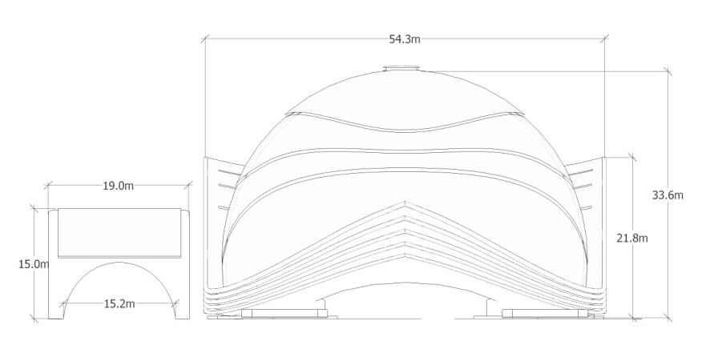
Dimensions
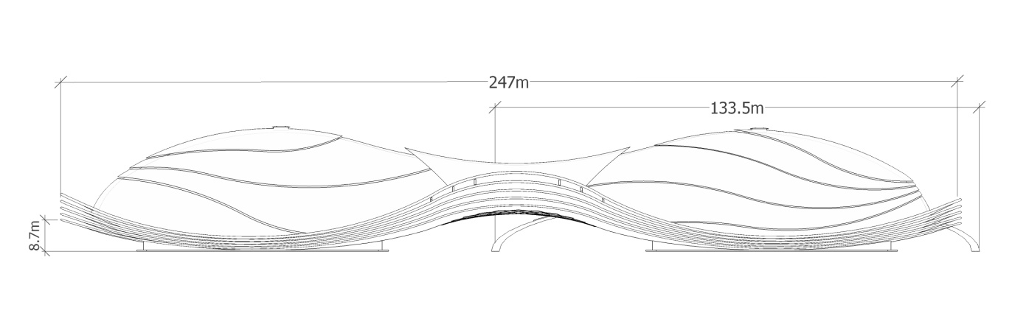

Costs table
Material / system | amount | unit | Price per unit USD | Total price USD
concrete | 25000 | M^3 | 108.00 | 2.700.000.00
Steel (for reinforced concrete) | 5400 | ton | 936.00 | 5.055.000.00
Steel (for installations) | 500 | ton | 936.00 | 468.000.00
Tempered glass | 22000 | M^2 | 300.00 | 6.600.000.00
Insulation | 25000 | M^2 | 15 | 375.000.00
Formwork | 25000 | M^2 | 36.00 | 900.000.00
PV & PVT modules | 4.000.000 | Watt | 5.00 | 20.000.000.00
Hybraulic pumps | 550.000 | unit | 20.00 | 11.000.000.00
Wind Water system | 12 | unit | 10.000.00 | 120.000.00
Installations  ( mechanical ) | 25000 ( max ) | M^2 | 200.00 | 5.000.000.00
Installations  ( Electrical ) | 25000 ( max ) | M^2 | 100.00 | 2.500.000.00
Aquarium | 2 | unit | 100.000.00 | 200.000.00
Water fountain | 350 | M^2 | 200 | 70.000.00
Landscaping and site preparing | 22000 | M^2 | 12.00 | 265.000.00
Other costs | - | - | - | 1.000.000.00
Total cost |  |  |  | 56.253.000.00
Our budget is : 4M * 20 = 80 million$
80.000.000 – 56.253.000 = 23.747.000.00$ for Labor and engineering

References
www.Wikipedia.org
www.solar-flow.co.uk
www.export.gov
www.ead.ae
www.researchgate.net
www.landartgenerator.org
