Dancing leaves
- Application of technology
1.1 "Flexible Intelligent Blade" low Wind Speed Generation Technology
According to the meteorological data of Masdar City, it is known that the annual average wind speed in the area is 10~15km/h (2.8~4.2m/s), and the maximum annual wind speed is 20~30km/h (5.6~8.3m/s) .According to the comparison table of wind rating, the annual wind level in this area is level 2 ~ 4, belonging to the low wind speed area.
Table 1 Wind rating comparison Table
Wind level | Wind level | wind speed (m/s) | (km/h) | Land surface objects | Sea surface waves | Wave height(m) | highest(m)
2 | Light breeze | 1.6-3.3 | 6-11 | Little wind | Wavelet peak unbroken | 0.2 | 0.3
3 | breeze | 3.4-5.4 | 12-19 | Flag spread | Wavelet peak rupture | 0.6 | 1.0
4 | soft breeze | 5.5-7.9 | 20-28 | Blow up dust | Small wave foam peak | 1.0 | 1.5

According to the simulation results of the Fluent flow field, the blade end is taken as part of the total length of 1/6 like Fig.1, and the "flexible intelligent blade" low wind speed wind power generation technology is adopted. The principle of flexible Intelligent Blade is shown in Fig 2. The technology can be operated in level 1 wind, and level 3~4 wind energy is very good at generating electricity. With the increase of wind speed, wind load will gradually decrease, which can completely avoid high wind load on blades, ensure stable operation, greatly increase power generation by 2 times and reduce the cost by more than 60%, with the increase of wind speed above level 6, the wind load will be reduced gradually, and the power generation can be greatly increased by 2 times and the cost reduced by more than 60%. Moreover, the flexible intelligent blade can change surfaces according to the change of wind speed, and improve the stress state of the blade while increasing the amount of wind energy acquisition and transformation.
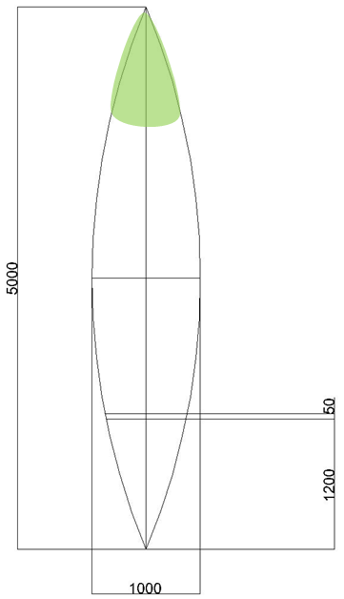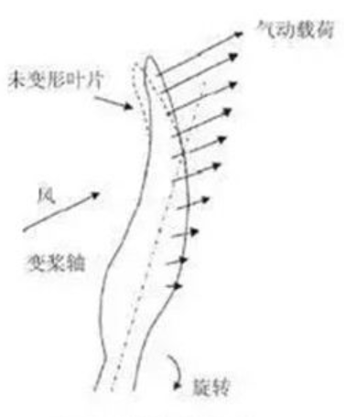
Fig. 1 Flexible Smart Blade location Fig. 2 Principle of flexible Intelligent Blade
  - Flexible CIGS thin Film Photovoltaic Power Generation Technology
CIGS thin Film power generation is a crystalline thin film solar cell composed of copper (Cu), indium (In), gallium (Ga), selenium (Se) four elements in the optimum proportion.
Advantages:
1. Light weight, easy to install;
2. Good performance of weak light generation;
3. Low power attenuation;
4. Rich color, but also to achieve architectural beauty and other ideas, light angle requirements are low;
5. Photoelectric conversion efficiency is high, currently the highest conversion efficiency record in the laboratory has reached 22.9%.
According to simulation results, 5/6 length of the leaf is used the technology for solar power generation.
  - Structure of the blade
Fig. 3 Principle of the joint at the bottom of the blade Fig. 4 Principle of the joint at the medium of the blade

A blade has 3 joints. The 1st joint like Fig 3 called slewing drive is at the bottom of the blade. It can safely hold radial and axial loads, as well as transmit a torque for rotation. The whole blade can rotate around the x-axis. The 2nd joint like Fig 4 is the same as the 1st joint. The upper blade can rotate around the x-axis. The 3rd joint like Fig 4 called hydraulic cylinder is at the medium of the blade. The top blade can rotate around the y-axis.
- Energy estimate
2.1 Wind energy converted electricity
According to the actual size of the blade, the wind energy and converted electricity are calculated.
Wind energy calculation formula:
$P_{a}=\frac{1}{2}ρv_{0}^{3}A$ (1)
Meanwhile, P is the available power, W; $ρ$ is the air density, kg/m³, 1.2 ; A is the above area of the blade, m² ,6.4; v₀ is the wind speed.
The wind energy utilization factor represents the conversion efficiency of wind power from wind to electricity:
$c_{p}=\frac{dF_{d}rω}{\frac{1}{2}ρv_{0}^{3}dA}$ (2)
Meanwhile, w is the angular velocity of blade rotation; $dF_{d}$is the local tangential force; r is the radius of leaf element extension; $dA=2πrdr$ is the local blade area.
The total blade of the bridge is 1777.17kWha a year of wind energy, which can be converted into 924.13 kWh/a of electricity.
  - Solar energy converted electricity
Formula for calculating solar energy:
Theoretical annual output = annual average solar radiation total photovoltaic cell total area photoelectric conversion efficiency
According to the optimum angle of 20 °of the blade, the theoretical annual power generation is calculated as follows 2168.4254×107.53×22.9%=50.22MWh/a.
So the total annual output of wind and solar energy for all the blades of a bridge is 51.14MWh/a.
The total expansion area of a bridge blade is 107.53 m², and the usable area is 27000 m². Therefore, a bridge covers 0.4% of the usable site area. That is, the annual power generation per unit area of the bridge, which covers 0.4% of the area, is 0.4779MWh/ m²·a.
- Materials and cost estimate
The material of flexible intelligent blade is carbon fiber prepreg (CFRP) as shown in Fig 5, which is the epoxy resin composite on carbon fiber by high pressure and high temperature technology. The composite material made of carbon fiber yarn, epoxy resin, release paper and so on is called carbon fiber prepreg cloth by coating, hot pressing, cooling, film coating, coiling and so on. It not only has the inherent intrinsic characteristics of carbon material, but also has the soft machinability of textile fiber. It is a new generation of reinforced fiber. The market price of this material is 400 yuan/m². It is calculated that the blade cost of the material is 6.4×400 = 2560 yuan for all the requirements of a bridge.
The "flexible CIGS thin film photovoltaic" material is shown in Fig.6. According to the market price, the CIGS film price of 50MWh is 2.5 yuan/W, and the blade cost of all the materials required for a bridge is 2.5×50.22/(24×365) = 14384 yuan.

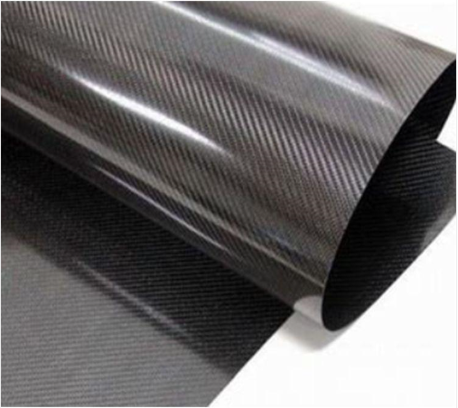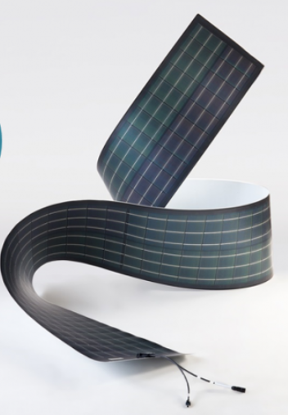
Fig 5 Carbon fiber prepreg cloth Fig 6 CIGS thin Film Photovoltaic
The total materials and cost are shown on the table 2. The total cost is 19229 yuan, about $2828, converted to an average of 0.48yuan / W, US $3.30 / W < US $ 20/W.
Table 2 Cost calculation
Materials | Number/area/volume | Single prize | Total prize
carbon fibre composite | 6.4m² | 400yuan/m² | 2560yuan
CIGS thin Film Photovoltaic | 107.53m² | 2.5yuan/W | 14384yuan
concrete | 11m³ | 35yuan/m³ | 385yuan
plank | 37m² | 10yuan/m² | 370yuan
hinge | 102个 | 15yuan/个 | 1530yuan
Total |  |  | 19229yuan（2828US$)

