LAGI 2019 ABUDHABI
Project name: MASDAR LAND ART FOR RENEWAL ENERGY
DESIGN BRIEF
1.0 - Introduction
The project consists of two main subjects:
a- Renewable energy generation
b- Architecture and sustainability
They are both connected to each other and integrated with each other in the attached design proposal.
2.0 - proposal concept description
The site consists of two sectors (G21) & (G06).
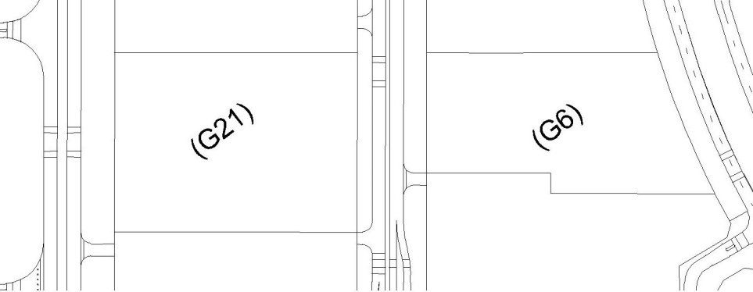
Figure (1)
- The public art work will consists of two buildings, one of them will be in sector (G06) and the other one will be in sector (G21).
- Both of buildings will generate the electricity.
- Each building will accommodate a cultural way for air-conditioning the public spaces which is the wind tower.
Page (1)
- The energy will be generated in sector (G06) using two ways:
a- Wind power: installing a multi horizontal axis cylinder wind turbines (HACWT) inside the wind tower, it is a new technology, the wind tower will work as an air shaft, increase the air velocity and will generate much more power.
b- Solar power: installing photovoltaic panels on the building, facing south direction.
- The energy will be generated in sector (G21) using the hydropower, sector (G21) building will accommodate an underground water tank and upper water tank, they both will be used for the hydropower generation, and for the gardening too.
- Above each building there is installed electric tower cladded with a copper sculpture in a palm tree form.
- Both electric towers are connected together with upper electric cables, will work as upper electric network.
2.1 The concept vision:

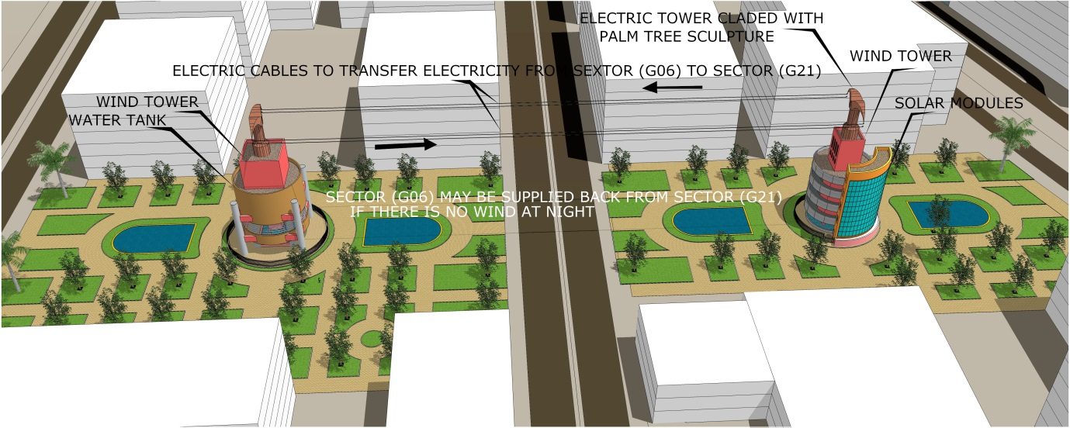
Figure (2)
Page (2)
The concept vision will be as following:
- The energy will be generated in sector (G06) using the wind power and the solar power.
- The energy will be used for sector (G06), and will be transferred to sector (G21) through the upper electric tower end upper electric network.
NOTE:
The sculpture with a palm tree form which covering the electric tower, will make the visitor understand that this electricity is a green energy.
- The transferred energy can be used in sector (G21), and will be saved as a hydropower, by pumping the water and filling the upper water tank.
NOTE:
The hydropower was chosen as a way to save the power, because the current available technologies such as the batteries will be old technology after sometime, and will not be suitable to work as a permanent installation on the site, but the hydropower will never be old technology.
- At night if the wind stopped blowing the hydropower generation will start in sector (G21), and sector (G06) can be supplied back from sector (G21).

Page (3)
3.0 - The architectural components in the project:
3.1- The site:
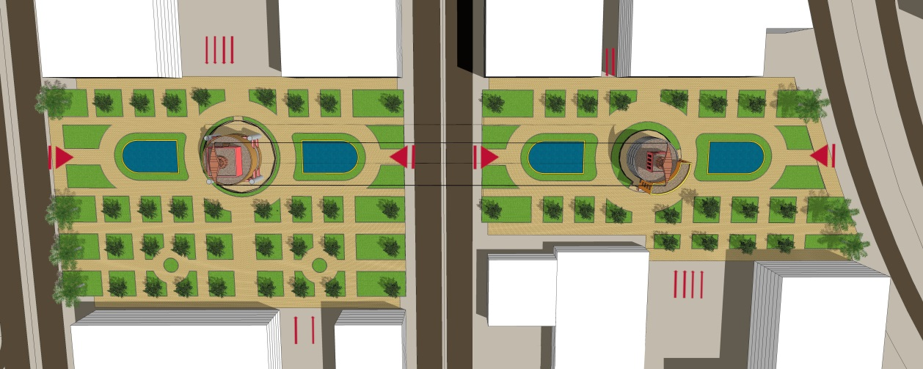
Figure (3)
Considered in the site design to be flexible, the site has a main longitudinal axis of motion, and it is accessible for all sides.
3.2- Sector (G06) building:
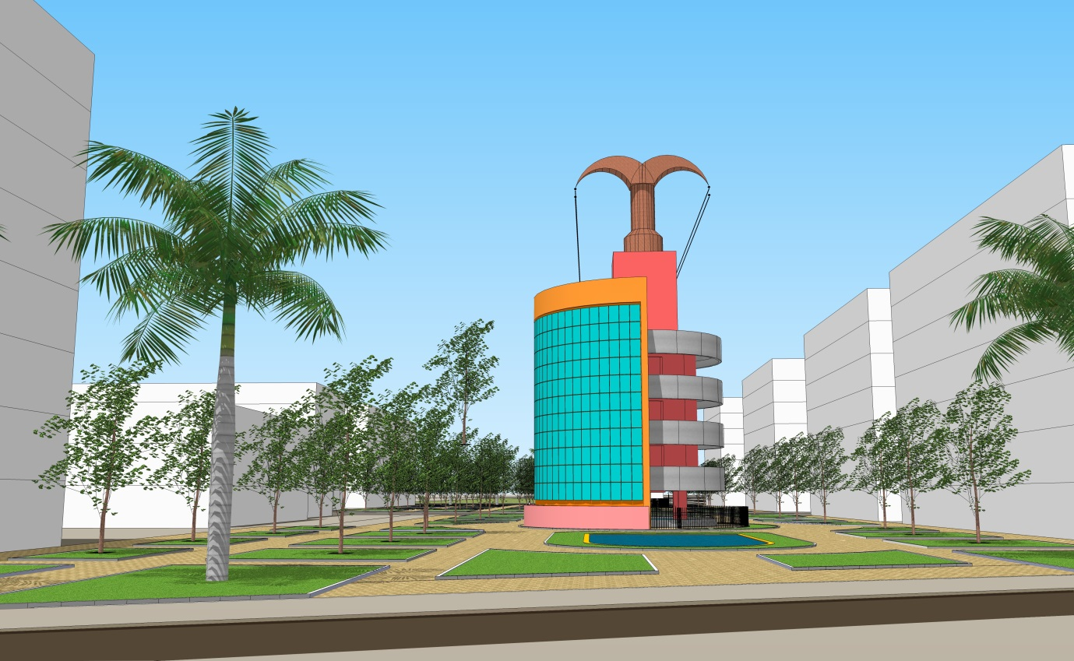
Figure (4)
Page (4)
- In the ground level there is a steel fence to be safe to the people who would view it, and there is a water pool under the wind tower for air-cooling.
- The next upper three levels, a horizontal axis cylinder wind turbine (HACWT) installed in each floor with 2 generator rooms, 2 generators per each turbine.
- 4th & 5th levels, the wind tower openings with sand trap.
- Above the building there is the electric tower cladded with a palm tree cooper sculpture, the sculpture height is 12.35 meters.
3.3 - Sector (G21) building:
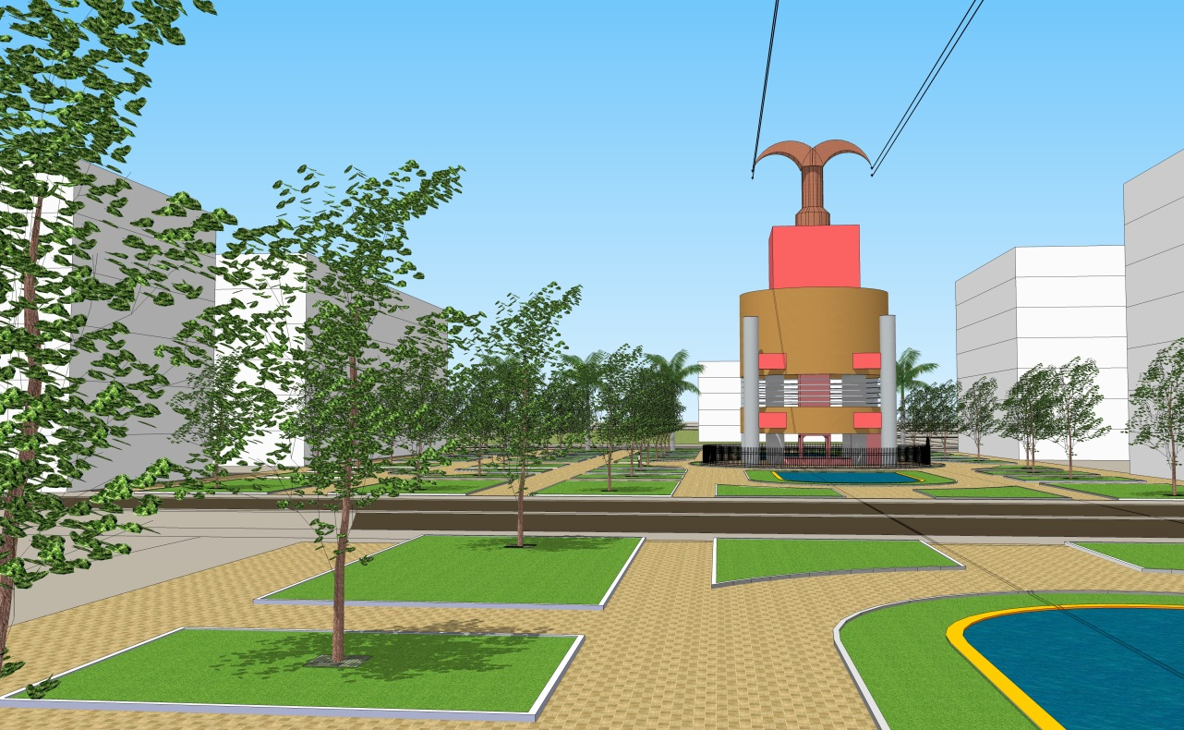
Figure (5)
- There is an under-ground water tank.
- In the ground level there is a steel fence to be safe to the people who would view it, and there is a water pool under the wind tower for air-cooling, a hydro-turbine, generator, and control rooms.
Page (5)
- 2nd level is a void, 3rd level is a water tank.
NOTE:
The underground water tank and the upper water tank will be used for the hydro power generation and for the gardening too.
- 4th level, the wind tower openings with sand trap.
- Above the building there is the electric tower cladded with a palm tree cooper sculpture, the sculpture height is 12.35 meters.
4.0 – The sustainability elements in the project:
A- The site designed to present the natural environment with its components, and to be integrated with the surrounded environment.
B- The buildings locations in the site were chosen to distribute the cold air to the whole site to achieve the thermal comfort for the site visitors.
C- The wind towers are a traditional way to do the air cooling, and this will reduce the electricity consumption.
D- The buildings surrounded by the trees and water to reduce the hot temperature, and the trees will reduce the air pollution too.
E- The trees will help to keep the cold air in the site.
F- Generating the electricity using wind and solar powers, then saving some of the energy as a hydropower is sustainable.
NOTE:
Saving the energy is a must to achieve the net zero carbon future. Page (6)

G- The proposed new technology to generate the electricity, the multi horizontal axis cylinder wind turbines (HACWT) installed inside the wind tower, will generate a big amount of renewable power; this can cover the site consumption, can save energy, and can supply the local electric network.
H- The water tanks will be used for the hydropower generation, and for the gardening.
I- The project designed to live for a long time, as a permanent installation, the long building life cycle this will avoid demolishing after sometime and wasting of materials.
J- Reuse of materials can be done in some of the installed items, such as the aluminum windows.
K- Local materials can be used during the installation period.
L- During installation will use a clean power will not generate greenhouse gas emissions or other forms of environmental pollution.

M- The project foot print is zero, and will give a very good impact on the quality of life of the people.

N- The project will make the people learn more about the sustainability, and know how to be sustainable.

Page (7)
5.0 – The amount of generated electricity:
A- The wind power:
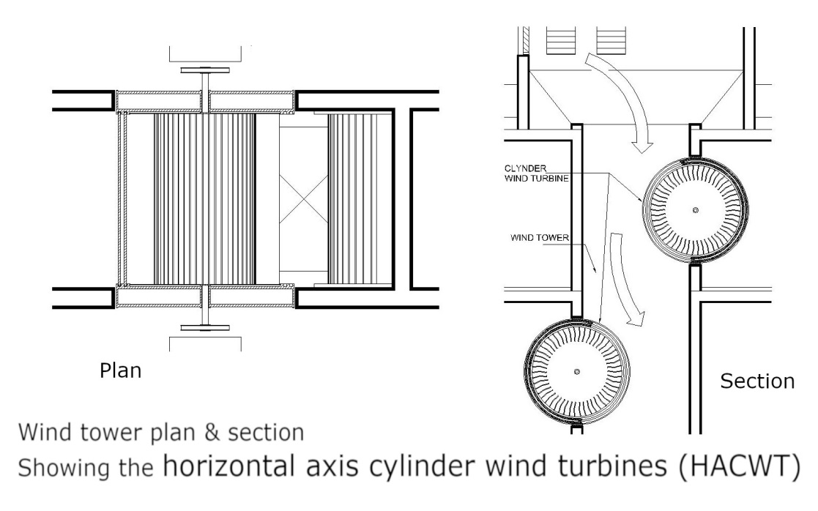
Figure (6)
- Installing a multi horizontal axis cylinder wind turbines (HACWT) inside the wind tower, is a new technology, the wind tower will work as an air shaft, increase the air velocity and will generate much more power.
- If we compare the relationship between the (HACWT), and the horizontal axis wind turbine, in case they both have same diameter.
- The following relationship will be the base to calculate the power.
mass of the HACWT cylinder / mass of HAWT rotor = generated power by (HACWT) / generated power by (HAWT)
- From this relation the formula of the generated power by one turbine (HACWT) will be:
Power= { 2 + ( 2.6 × h/r) } × ( ½ PAV³ × 0.4 )
Page (8)
Where: h= cylinder height, r= cylinder radius, P= air density, A= swept area of cylinder, V= velocity of the wind
Power = { 2 + ( 2.6 × 2.85/1.25) } × { ½ × 1.23 × (125.39)³ × 0.4 }
Power = 7.928 × 484979.98 = 3844921.28 w = 3.84 Mw per one turbine.
Total installed wind power= 3.84 Mw × 3 turbines = 11.52 Mw.
NOTE:
The maximum wind speed during the year is 66.7 m/s , the area air openings in the north west side = 16.96 m², and the cross section area of wind tower = 9 m², this will increase the air velocity up to 125.39 m/s.
Wind power annual capacity= 11.52 Mw × 8760 hours per year × 30% Wind power annual capacity= 30274.56 Mwh.
B- The solar power:
The no. of solar modules = 209
Each module has installed power = 250 w.
Installed solar power = 209 × 250 w = 52.25 Kw.
Solar power annual capacity = 52.25 Kw × 8760 hours per year × 18%
Solar power annual capacity = 82.38 Mwh.
C- The hydropower:
In this proposal the hydropower generation is a saved energy, so to avoid duplication of calculation will not be added to the name plate, and will mention the following properties of the system.
Page (9)
- The upper water tank capacity = 1370 m³
- Hydropower system covers the site consumption for 1:30 hours.
- Water flow rate: Q = A × V
Q = 3.14 ( 0.075) ² × 18.0047 = 0.56534 m³/s
-Installed hydropower:
P= m × g × H net × η = 565.34 × 9.81 × 11.25 × .9 × .75 = 18.84 Kw.
D- The total amount of installed power and annual capacity, only for the wind power and solar power:
Total installed power= 11.52 Mw+0.05225 Mw= 11.57 Mw.
Total annual capacity= 30274.56 Mw+82.38 Mw= 30356.94 Mwh.
6.0 – List of materials & installation cast:
6.1 - MATERIAL SCHEDULE
ITEM | R.CONCRETE | MASON WORK | PLASTER | SCREED FLOORING | PAINT | CERAMIC TILES | STEEL DOORS | ALUMINUME WINDOWS | INTERLLOCK TILES | STEEL FENCE | STEEL TUBES CLADDING | GRAVIL FLOOR | STEEL STRUCTURE | COOPER CLADING
GO6 BLDG. GR. LEVEL
GO6 BLDG. 1ST LEVEL
GO6 BLDG.2nd LEVEL
GO6 BLDG.3rd LEVEL
GO6 BLDG.4th LEVEL
GO6 BLDG.5th LEVEL
ELEC. TOWER
G21 bldg. under ground water
G21 BLDG. gr level
G21 BLDG. 1st level
G21 BLDG. 2nd level
G21 BLDG. 3rd level
ELEC. TOWER
Page (10)
6.2 – ART WORK INSTALLATION COAST IN US DOLLARS
ITEM | BUILT UP AREA IN m² units | HEIGHT | NO. OF PIECES | INSTALLATION COAST / m² | INSTALLATION COAST/ PIECE | TOTAL ITEM COAST
GO6 BLDG. GR. LEVEL | 295.20 | 4.90 | --- | 1000 | --- | 295,200
GO6 BLDG. 1ST LEVEL | 269.58 | 4.5 | --- | 1000 | --- | 269,580
GO6 BLDG.2nd LEVEL | 269.58 | 4.5 | --- | 1000 | --- | 269,580
GO6 BLDG.3rd LEVEL | 269.58 | 4.5 | --- | 1000 | --- | 269,580
GO6 BLDG.4th LEVEL | 111.27 | 4.5 | --- | 1000 | --- | 111,270
GO6 BLDG.5th LEVEL | 43.56 | 4.5 | --- | 1000 | --- | 43,560
ELEC. TOWER & SCLPTURE | --- | 12.35 | 1 | --- | 26000 | 26,000
G21 bldg. under ground water | 115.43 | 5.3 | --- | 1000 | --- | 115,430
G21 BLDG. gr level | 288.28 | 4.85 | --- | 1000 | --- | 288,280
G21 BLDG. 1st level | 288.28 | 8.35 | --- | 1000 | --- | 288,280
G21 BLDG. 2nd level | 288.28 | 6.25 | --- | 1000 | --- | 288,280
G21 BLDG. 3rd level | 104.04 | 7.85 | --- | 1000 | --- | 104,040
ELEC. TOWER & SCULPTURE | --- | 12.35 | 1 | --- | 26000 | 26,000
TOTAL COAST | --- | --- | --- | --- | --- | 2,395,080 $

6.3- Renewable energy installation coast:
A- Wind power:
-Estimated price per 1 turbine with generators= 9,000,000 $
Total wind power installation price = 9,000,000 × 3 = 27,000,000 $
B- Solar power:
Total estimated solar modules installation= 52250 × 3$= 156,750 $
C- Hydropower:
Total estimated hydro system installation= 20,000 $
Page (11)
7.0 – The architectural philosophy of the design:
- The site in the design represents the natural environment with its land, water and air.
- Capturing the energy from the nature, the two buildings are doing this job, and it is visible to the visitors that these two buildings are generating the electricity.
- The two buildings they look different in the form, this will make the people understand that the two buildings are generating the electricity in a different way; this will make a visitors challenging.
- The wind towers is a cultural way for the air cooling, this will make the people feel that this project belongs to them, and using the cultural ways can reduce the electricity consumption too.
- The palm tree sculpture above each of both buildings, they act as electric towers to transfer the electricity to other places, this will challenge the visitors about understanding that the generated electricity is a clean energy, and the renewable energy can be saved, can be transferred to other places to be designed by others.
- The proposed new technology for generating the renewable energy which is the horizontal axis cylinder wind turbine (HACWT), does not need a big space and produce a big amount of power, the aim of this and what's mentioned above is to inspire the world about the beauty of renewable energy infrastructures and bring a positive message about life in a post-carbon future.

Page (12)

