The Capsule

Abstract

As we increasingly make use of our environment to create the world we inhabit, we should be reminded of our responsibility and to this environment we exploit.
Our proposal questions how we dialogue with nature, and the potential to reverse the narrative and use technology to benefit the environment and thus return to the source.

Our responsibilities as stewards of our environment was a cause championed by Sheikh Zayed bin Sultan al Nahyan. Conscious of how much we owed to our environment for our survival and success, he championed an initiative to restore the emirates flora and fauna.

The Capsule aims to communicate the vulnerability of our environment to climate change by visually communicating the narrative of how we can return to nature. By visually communicating how we can harness solar energy, store it and use it the artwork is readable.

20 plants were chosen which can thrive in this environment, each chosen as a symbol for the uniqueness, versatility, and resilience of our planet. Capsules of varying scales and features are distributed on the site in response to the local climate and its content- a single species of plant which it hosts, protects and nourishes.

The Capsule Logic and Impact

Each capsule creates a comfortable environment for its host plant to flourish. Visually distinct from one another yet based on the same set of rules from which their forms emerge, informed by the specific site conditions and microclimates of its location.

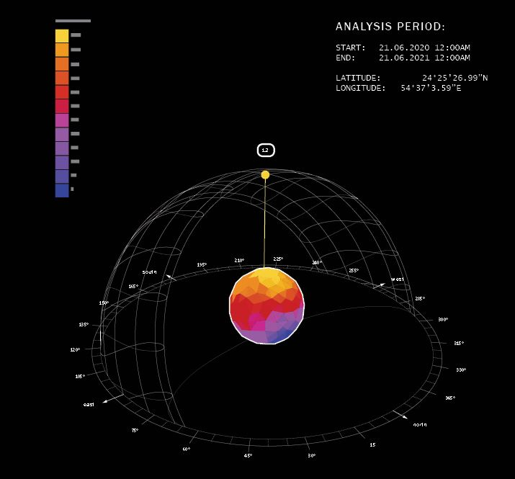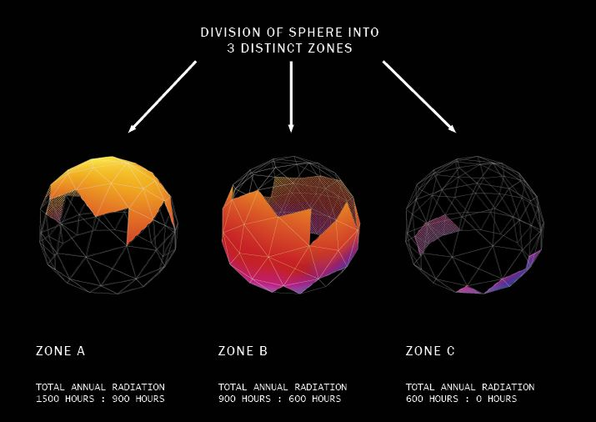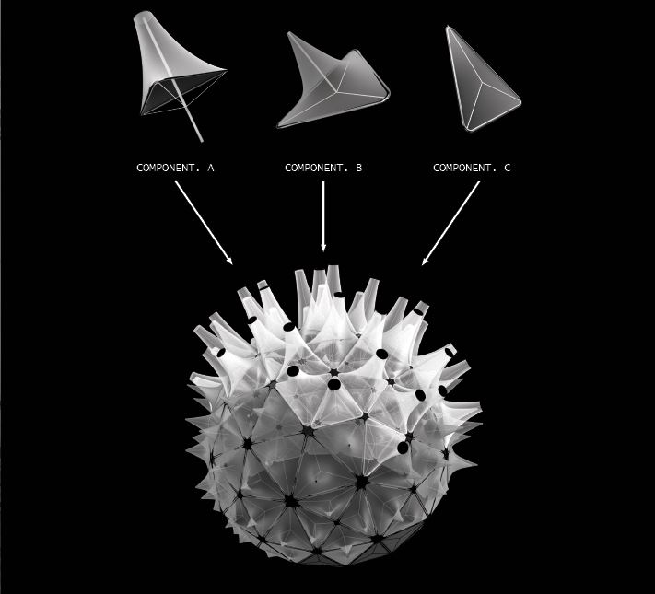

The capsules are composed of three distinct zones:

- The lowest portion, zone C receives between 0 to 600 hours of sunlight per annum. For this reason, its components are flat to visually communicate the absence of energy received.
- The middle portion, zone B receives 900 to 600 hours of sunlight per annum. It is a transition area which lays between the zone with little light and those with immense sunlight hours. Here the components begin to bud as they are elongated perpendicular to their surface
- The upper portion, zone A receives the greatest hours of sunlight per annum, that is over 900 hours. The components have fully bloomed and now house the PV panels. They absorb and store the energy they collect during the day to dissipate it in the evening.

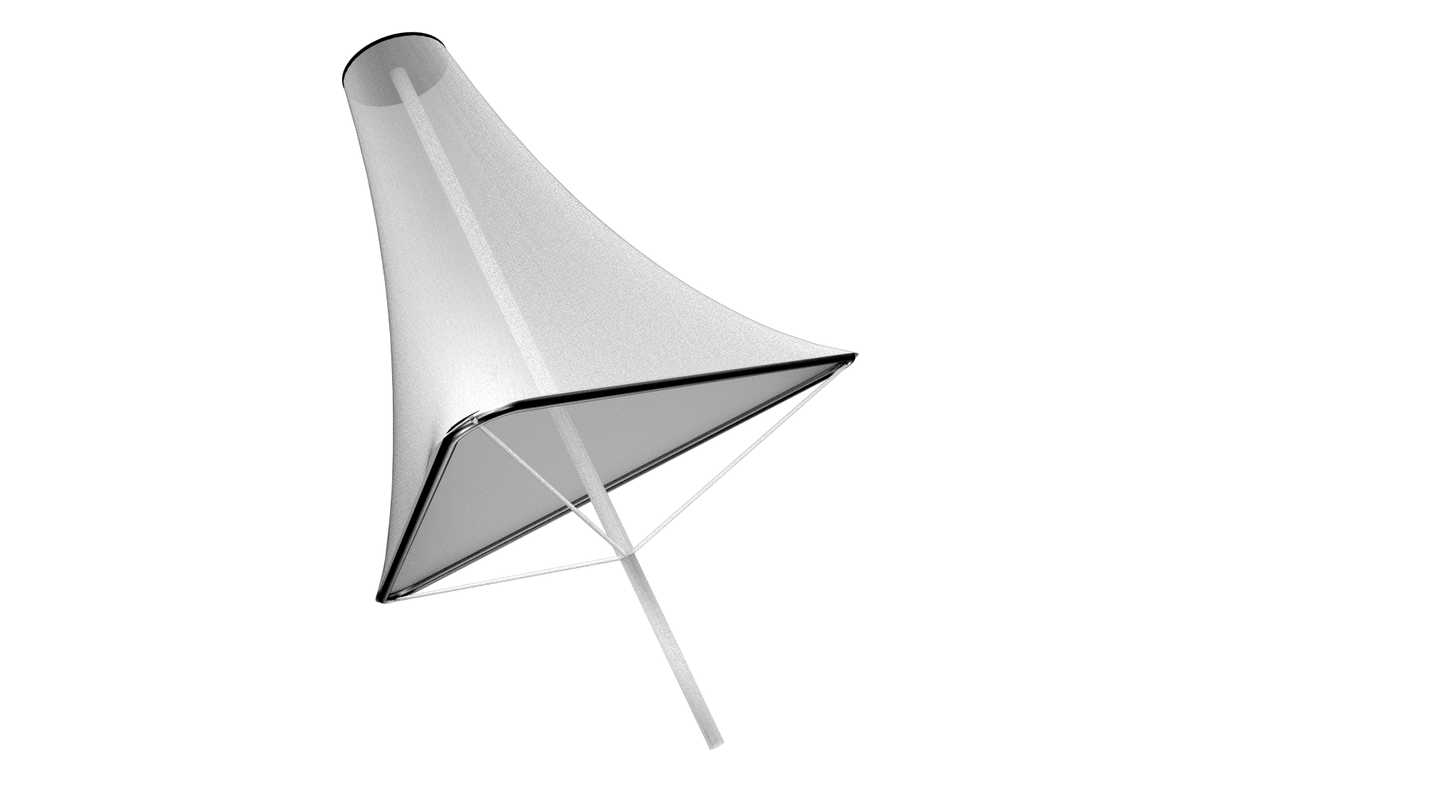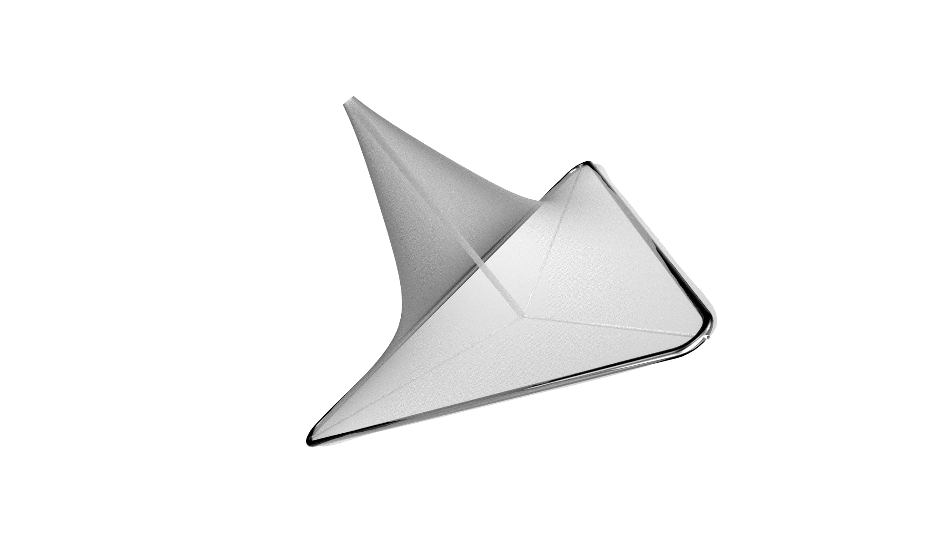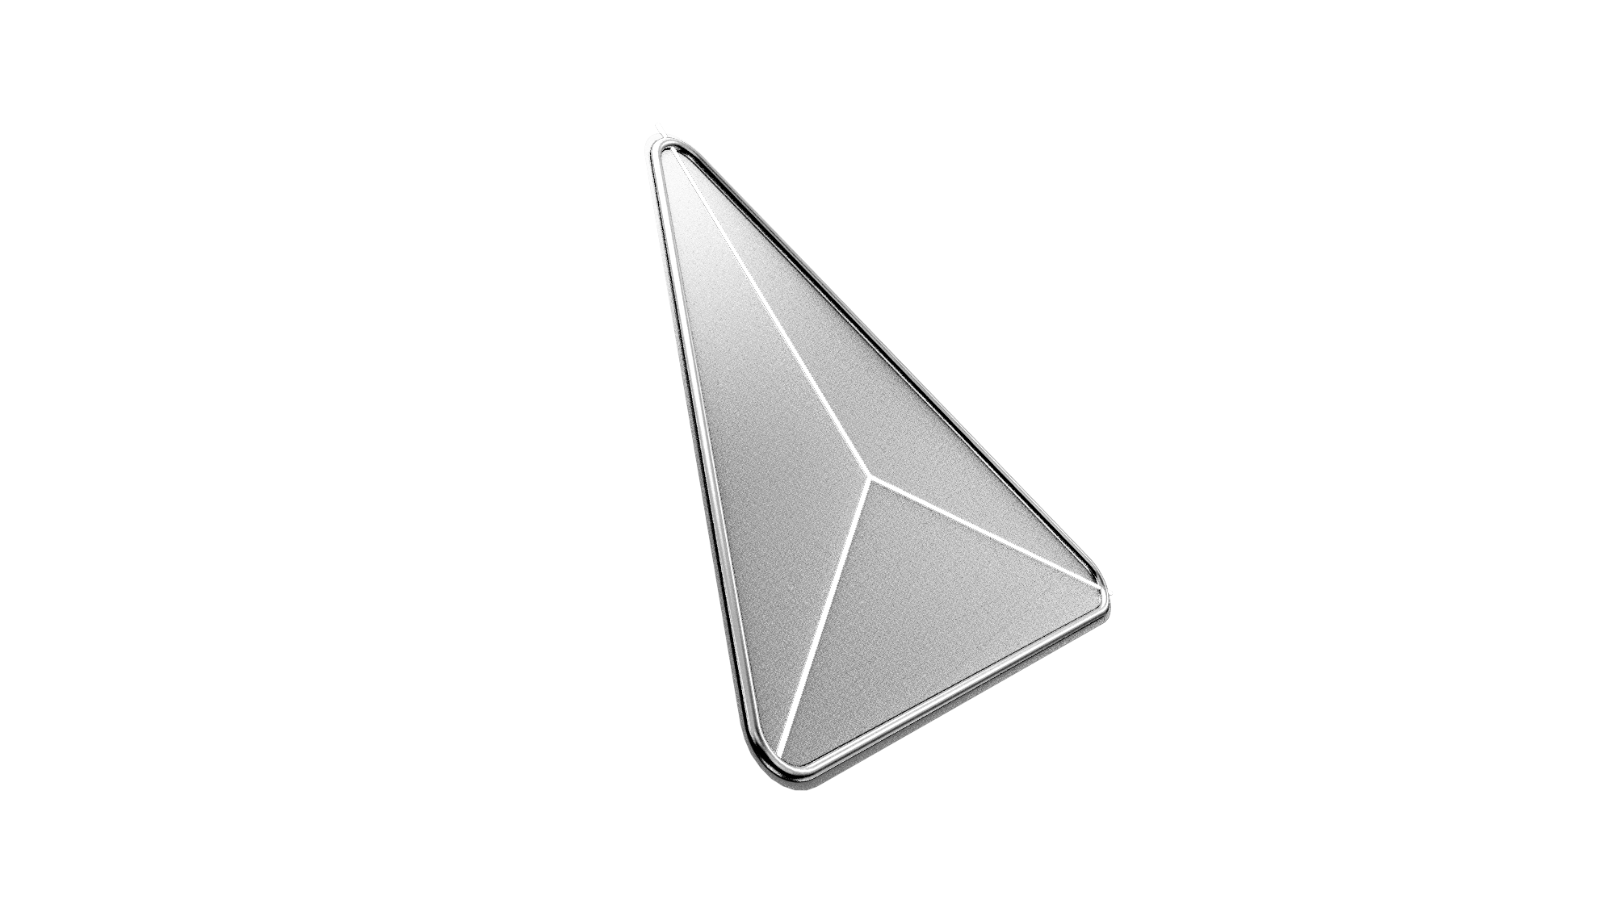

These three distinct component types of the artwork visually show and highlights the capture, storage and transfer of energy. A light translucent membrane then serves to protect the Fauna from a harsh environment. Creating shading during the hot desert days and gently illuminating the plants during nights. Focusing our attention to the precious entities it hosts.

This organically transforms the surrounding area into spaces for social gathering, contemplation, and interaction.

Structure
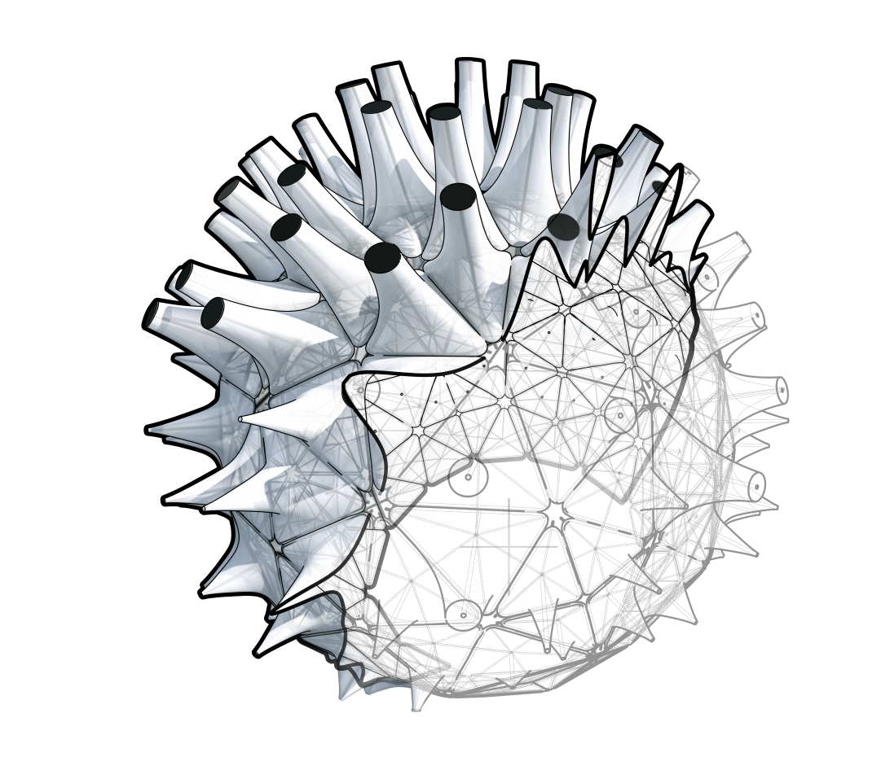

- The structure of each capsule is both Visually and Structurally light
- By using light translucent, transparent and reflective materials the capsule melts into its environment further highlighting its host, the plants.
- The physical structure is a lightweight structure composed of self-sufficient components, assembled to a whole.
- As the structure is assembled using non-adhesive joints, it can be assembled and dismantled with ease and furthermore each element thus becomes completely recyclable.
- Every capsule is irrigated through an underground irrigation system remotely.

The use of light translucent, transparent and reflective materials makes the capsule melt into its environment further highlighting its host, the plants.

This lightness, however, extends beyond aesthetics. The underlying structure of the capsules is that of a 3D truss. Furthermore, each component is self-sufficient and can be assembled independently of the whole structure. A reason for this design decision is to facilitate maintenance and assembly of the structure. As the structure is assembled using non adhesive joints, it can be assembled and dismantled with ease and furthermore each element thus becomes completely recyclable.

As part of the greater irrigation of the site, the capsule will benefit from being irrigated through an underground system that is operated remotely.

Materials

  - Membrane - Light translucent knitted membrane. Knitting is used to differentiate the curvature of each component membrane with a homogenous material which is facilitates recycling of the fabric.
  - PV panel - HCPV panels have achieved 44.7% efficiency in research, for our Energy and environmental impact we assumed using commercially available panels of 22.2% conversion efficiency.
  - Aluminum - Aluminium is used for the compression shell of the structure. It is durable, lightweight, low maintenance, non-toxic and 100% recyclable.
  - Polycarbonate rod - As a sustainable thermoplastic, Polycarbonate ease of molding/fabrication and high impact resistance. This makes it well suited to transmit light from OLED to the plants and to serve as a compression rod in the components.
  - OLED - Organic Light Emitting Diodes
  - Lithium ION Cells - These batteries are adequate to store the energy collected during the day additionally their compact nature are ideal to house in the components.

Environmental impact summary

- By using lightweight construction typologies, materials required to realise the artwork is significantly reduced.
- As a lightweight structure, the impact on the ground is further minimized as the physical footprint of the sculptures are minimal.
- By using non-chemical joints in the assembly off-gassing is eliminated. As the Artwork is made up of light compact and modular elements, embedded energy from transportation to the site will be reduced.
- Low maintenance of the structure would further minimize embedded energy.
- The above-stated fabrication strategies and material choices acknowledge the life cycle of the artwork and the potential introduction of future technologies that would further enhance its performance and increase the artworks positive environmental impact by enabling parts to be easily disassembled, fixed or replaced and re-assembled.

Annual kWh energy expected to be generated by design
3220.094 MWh

Conceptual cost estimate
- Engineering:
  - Development
  - Structural analysis
  - Detail design

Estimated cost: 50,000 €

- Fabrication:
  - Planning - 15,000 €
  - Fabrication - 250,000 €

- Raw materials:
  - Membrane - 30 € per sq.meter
(Total Area: 7.5*10⁹ sq.mm)
Estimate price: 225,000 €

  - Aluminum rods - 12 € per meter.
(Total length: 13828 m. Diameter: 0.02 m)
Estimate price: 166,000 €

  - Polycarbonate rod - 20 € per meter.
(Total length: 7.770 m. Diameter: 0.02 m)
Estimate price: 155,400 €

  - OLED - 10 € per unit
(Total amount: 1063)
Estimate price: 10,630 €

  - Solar Panels - 12 € per unit
(Total amount: 1063)
Estimate price: 12,756 €

Summary: 884.786 €

- Artists fee: 265,435 €

Total Sum: 1,150,221 €

