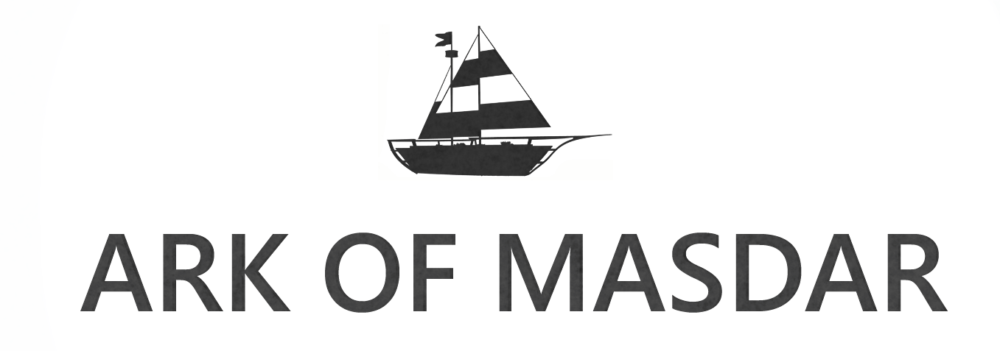

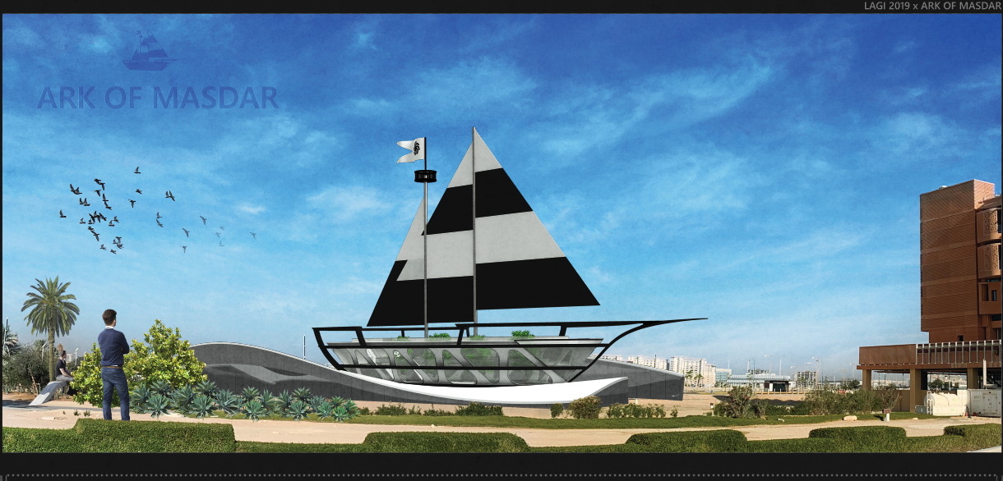
LAGI 2019

Ark of Masdar
Design Proposal

Ark of Masdar proposes to incorporate sport and art into electricity generation. It will provide sheltered parking space for 500 cars, offer drinking water for 2500 residents and keep 5000 healthy.

The proposed design is capable of providing 153.3 MWh of electricity annually. The installation cost comes close to the limit at $19 per watt, however, this can be easily justified as the Ark of Masdar will provide significant health and social benefits in return.

Site
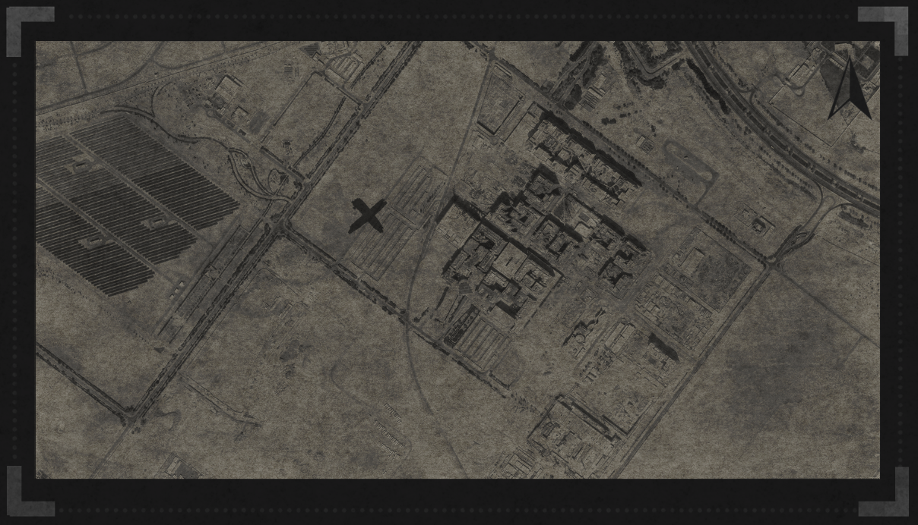

Composition
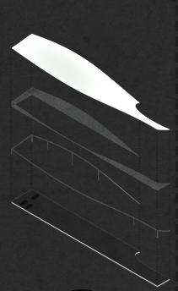
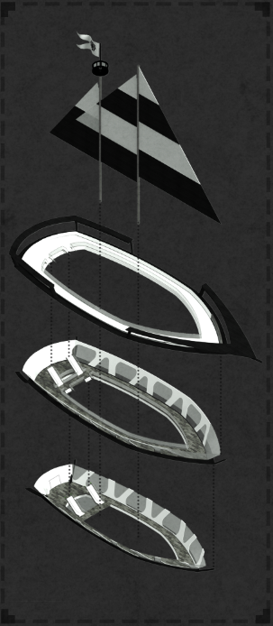
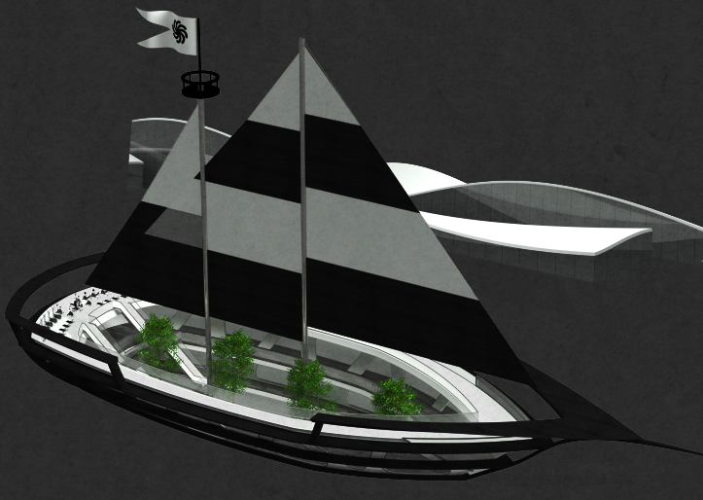
Side View
Three Pillar of Sustainability
Environment, Economy & Society

Enivroment, economy, and society form the thirr pillars of sustainability development, and the prosed design can thus break down into three sections accordingly. More details will be covered in the calculation section.
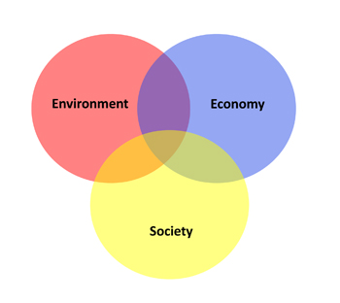

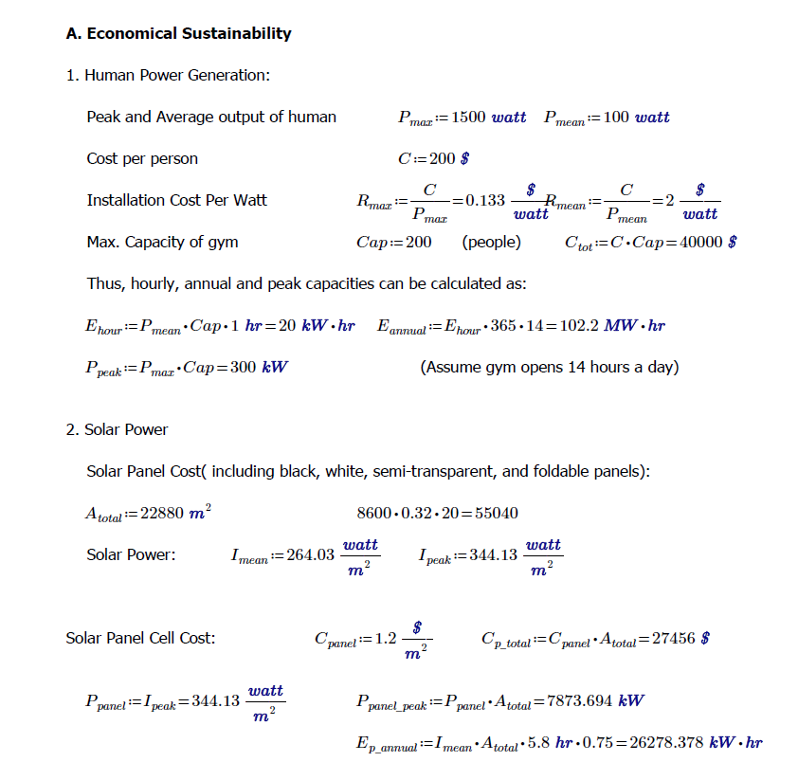
Calculations
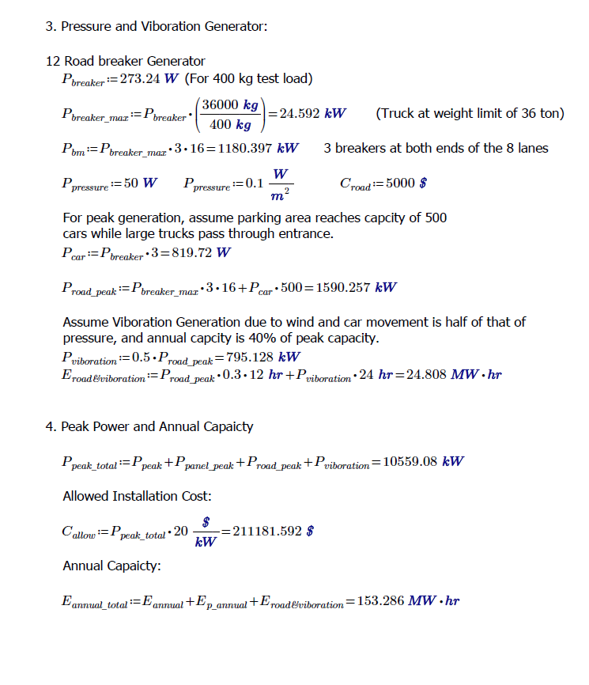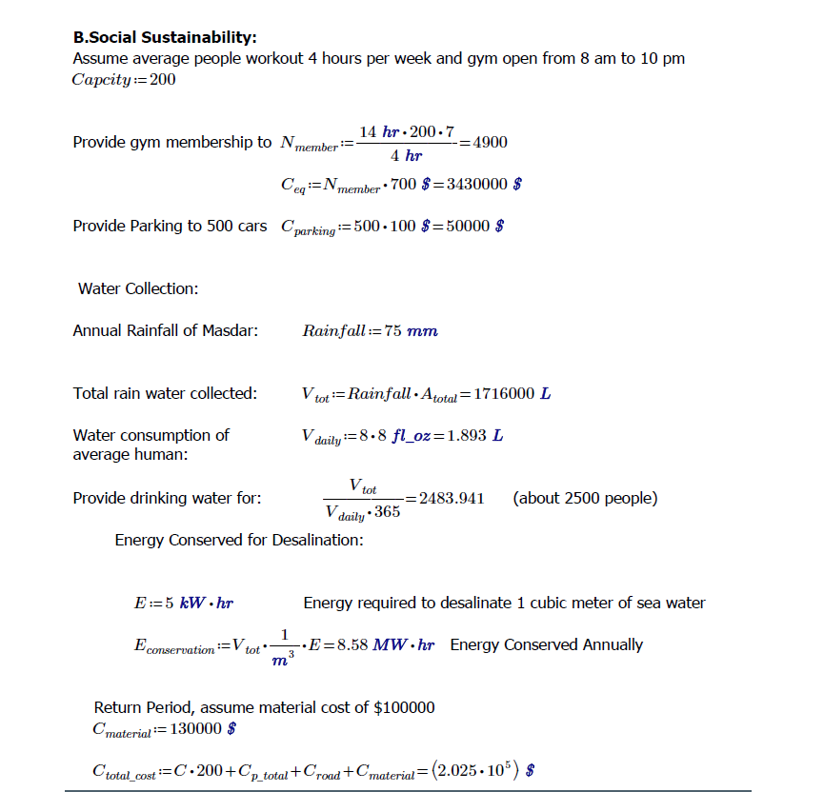

C. Environment Assessment Statement

The Ark of Masdar is environmentally friendly due to the following reasons:

- Reducing noise level by replacing wind turbine with vibration generator
- Reduce concrete by 30% using composite floor slab.
- Use recycled aluminium for frames.
- Passive cooling lower carbon footprint
References in Addition to Competition Package

https://www.researchgate.net/publication/264848061_Wind_Data_Collection_and_Analyses_at_Masdar_City_for_Wind_Turbine_Assessment
https://www.scad.ae/Release%20Documents/Energy%20and%20Water%20-%20Cover%20-%20EN-v2.pdf
https://www.mesia.com/wp-content/uploads/2017/09/Solar-for-Students.pdf
https://scholar.colorado.edu/cven_gradetds/396/
https://www.researchgate.net/publication/314213735_Speed_Breaker_Power_Generator

