LAGUI 2019 SOLAR WAVES

PROPOSAL
Solar Waves proposes to supply the equivalent of energy consumption for 2340 households along with all Waves Park energy consumption using solar photovoltaic cells generators and Eolic turbines generators.
Those energy cells are fixed in metallic structure of curved surfaces extend all over the Waves Park, and were inspired by the ripples of the desert dunes, provide shade to the pedestrians, and are oriented north-south, capturing the best orientation to generate energy.
Much of the energy used comes from the structure itself, characterizing the energy transition that the contemporary architectural structures go through the 21st century. Solar Wave project shows the possibility of building a post-carbon environment based on existing technologies. The presence of abundant green areas, as well as its access, in addition to contact with water, provides spaces of quality and service of urban ecology for the citizens of Abu Dhabi.

Designed from a metal frame structure of recycled aluminum and surrounded by a membrane, Solar Wave provides lightness and slenderness. Photovoltaic cells close the upper part of the waves, using the high solar incidence of the region as a primary source for the production of clean and renewable energy. Also in the field are wind turbines, which are positioned in some specific points, mimicking with landscaping.

The geography of the coast of Abu Dhabi is quite fragmented, composed of a series of islands that characterize in a unique way the relief of that region. Proposal take these forms as a match, the waves park is composed of a series of elements that refer to the archipelago around Abu Dhabi, providing green areas from a drawing that refers directly to the spatial memory of the place. The islands function as separate landscape elements and their designs emerge from the design adopted.

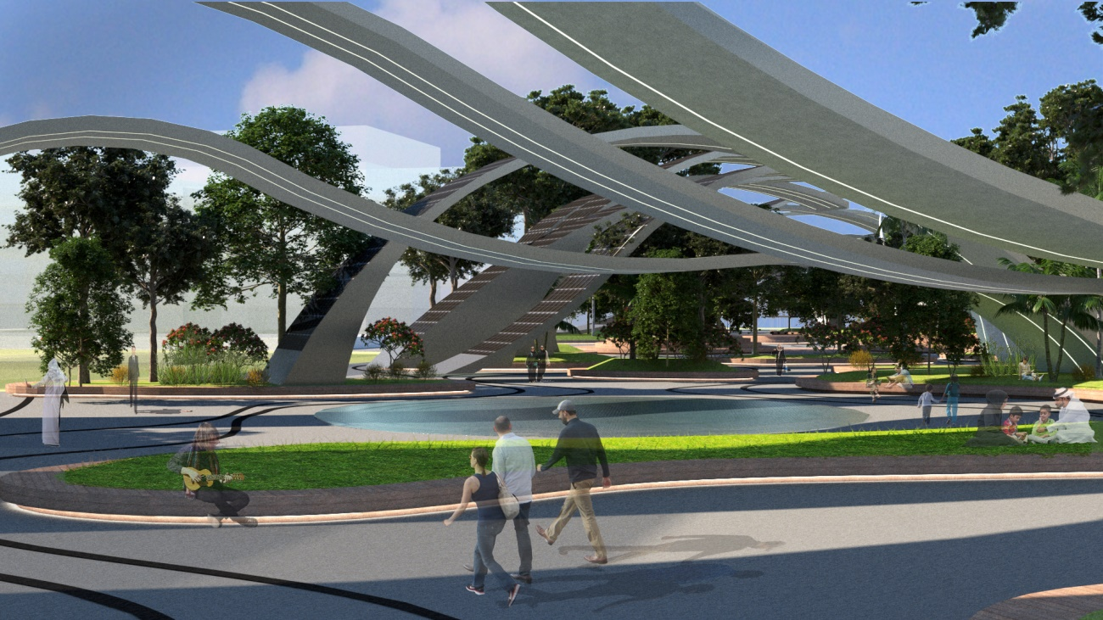

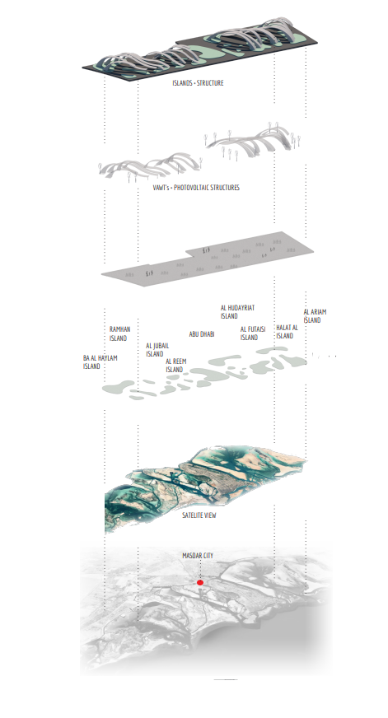

MASTER PLAN
Waves park proposes integration between spaces around it planned in city plan of Masdar, connecting people to public spaces, residential, institutional and open spaces. Roads between buildings were respected, also it was lowered the street that passes in the center of the ground to give continuity to the park, giving preference to pedestrians, who can circulate freely. The recessed street will give access to the shaded parking lot in the basement of the park, and access to the park with lifts.
The park will serve as an infrastructure that allows events to happen, bringing nature into the park, connecting people with green spaces and shaded water, fulfilling the special function of generating a public space for the inhabitants of Masdar City with leisure equipment, considering the local climate and its sunshine.
Our proposal for Masdar City in its conception of intelligent city and quality of life deserves a comfortable public space, well designed to be activated by people and their experiences.

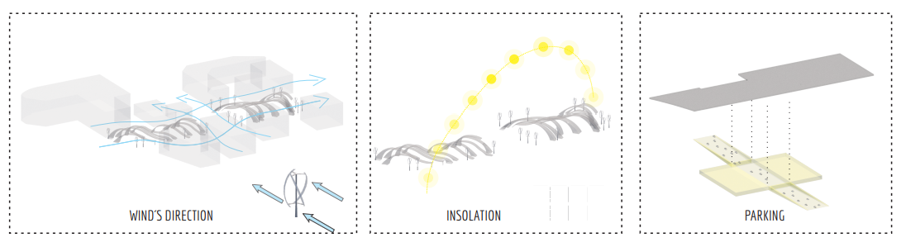

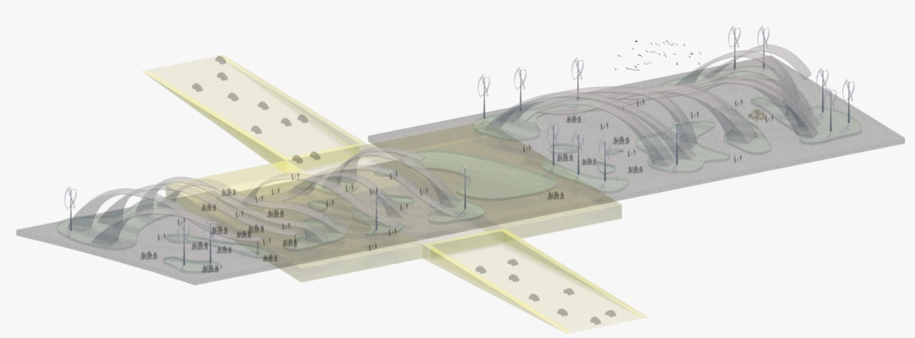

ENERGY TECHNOLOGY

Solar photovoltaic assignment:
Choosing photovoltaic cells instead of the solar panels guarantees a greater energy utilization of the curved spaces of the solar waves surfaces, allowing the angles of curvature necessary to obtain the desired designs. By using the curvilinear form from the dismembered cells, it is possible to obtain a greater efficiency if we compare, for example, the thin film, also used as an energetic alternative in curved surfaces, but with less capacity of generation of energy.
The monocrystalline photovoltaic cells used in the design of the project have dimensions of 156mm x156mm, but for calculation purposes, it was considered 170mm x 170mm, predicting the spacing between them, necessary for material expansion.
- Just Solar P6RF-4, 4,8W Poly (15,6 X 15,6cm) each.
Wind turbine assignment
For greater energy efficiency, 18 vertical Axis Wind Turbine (VAWT) in Darrieus model, with blades revolving around a vertical shaft. Each blade gets hit by the Wind at a different angle. The VAWT´S are omnidirectional. they do not need yaw mechanisms to be pointed in the Wind. Also compared to horizontal turbines, VAWT´s can be grouped closer together, because they can operate in turbulent and not unidirectionals winds.
Operating at lower speeds and without the need for a specific indicated wind, we obtain higher expectations of work, ensuring optimal energy efficiency in urban space.
- FLTXNY FH-50000
Return of investment analysis

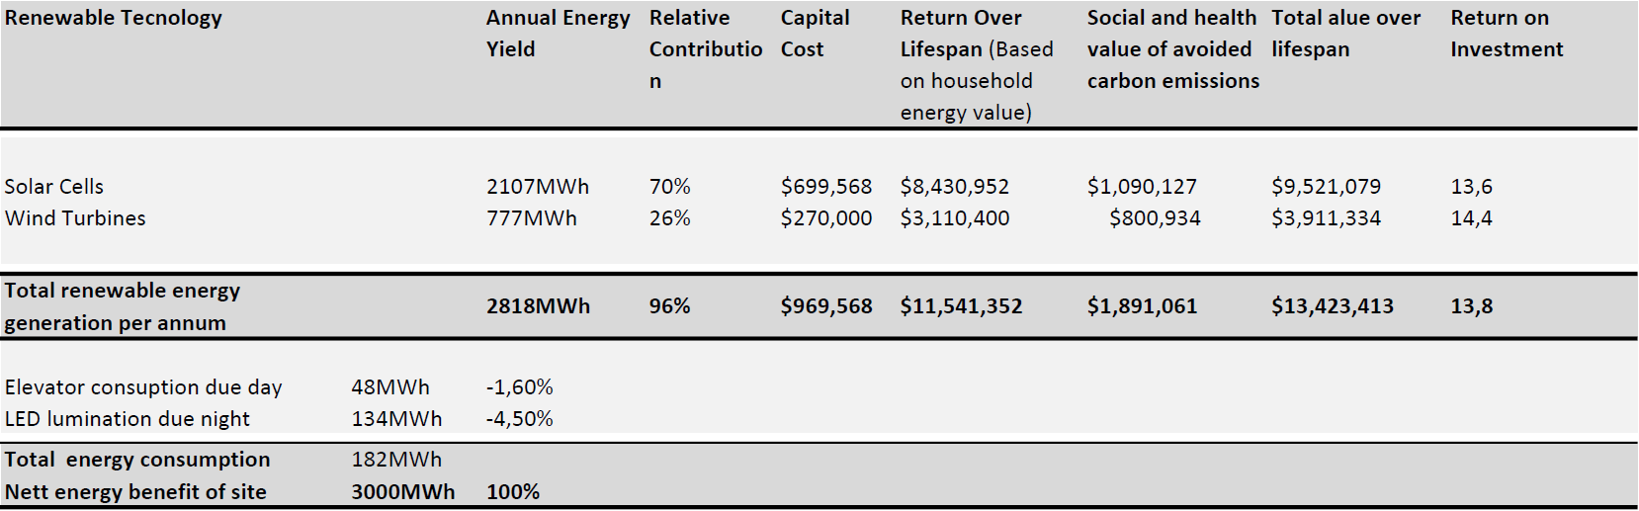
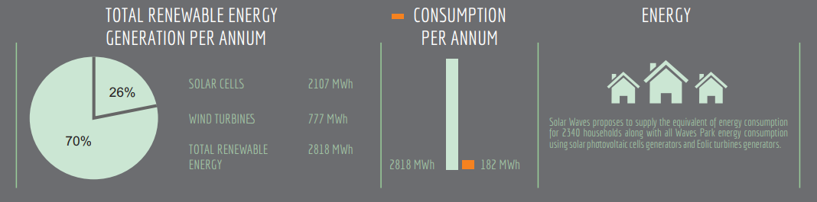

MATERIALS
Structure:
The solar waves rise from metallic lattice structures, capable of maintaining an extremely light membrane as a form of sealing. This type of space structure reduces the consumption of material, allowing the construction of large pieces, increasing visual scale of architectural proposal. Recycled aluminum was the material chosen, a product that has one-eighth the carbon footprint of conventional virgin aluminum sheeting. All timber is certified as sustainably sourced, while steel reinforcing bars are made with recycled scrap.

At the top of solar waves, exposed to intense solar incidence of Abu Dhabi throughout the year, are located individual photovoltaic cells, which provided curvatures without losing their energetic performances, as well as being substitutable. These cells are supported by a perforated aluminum plate and covered by a membrane with fiberglass fabric. ETFE and PTFE membranes ensure greater stability and protection.

Dust that can accumulate on photovoltaic cells decreasing its efficiency of 20 to 30%, in Arab Emirates this problem is further aggravated by having a desert climate with possibilities of sandstorms. To solve this problem, the structures of Solar Waves have a self-cleaning system, where in some specific points water comes out at its top, flowing down to the islands' gardens or to the promenade, which has a drainage system storing this water to be used in irrigation park.
In addicion the park floor pagination, with corrugated channels, is also the drainage, ventilation and natural lighting system of the parking lot below.

Ground:
Thinking of reducing the amount of waste generated and using alternative means of reusing discarded materials, it was decided to use flooring made up of recycled tires. The dyed recycled tire rubber granulate is used in the top layer of the floor with. The lower layer has the function of generating greater damping and facilitating the molding of the floor in different types of surfaces, mainly in the ground.
Islands:
The banks of the islands are composed of wooden benches, arranged along the shaded areas provided by the trees of the beds. All the wood used is in bamboo, which is characterized by being an ecologically correct alternative to conventional wooden furniture. The bamboo regenerates automatically and its harvest produces minimal waste and pollution, besides being stable and strong. Their installation can be done with the same techniques used in conventional wood.

