DUNE
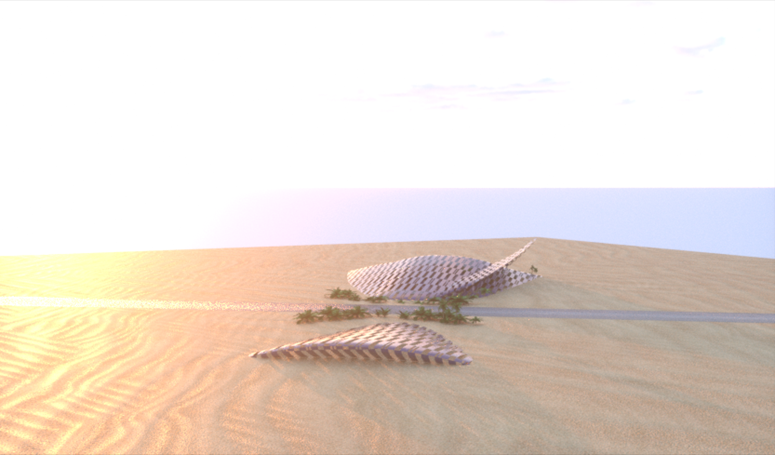
LAGI 2019
DUNE reflects the parabola shape of a dune paralleled with the shape of the nearby institute’s undulating walls. The project integrates a solar tracker system and energy storage to offset electricity for over 700 homes in Masdar City. During the day the panels darken to absorb the sunlight. At night when the temperature drops the panels will change to a warm hue that represents energy saved.
DUNE serves as a forum space where innovators can exchange ideas in a natural space, connecting the sun, sky, and the ground. During the day participants can take shelter within the dune’s undulating eaves. At night, the parabola space in the slip face of DUNE serves as an outdoor space where events, presentations, and cleantech art can be highlighted. Reflecting the design of Masdar City, pedestrian streets connect DUNE to the rest of the city and to public transport, a central component of the city’s masterplan. The angle of DUNE’s slip face reflects the arc the sun makes in the sky above Masdar City each day throughout the year. The face points towards the horizon where the sun sets each night, representing a new page turned for the city of Masdar and climate change.
The technology incorporates sun tracker technology at the two wings of DUNE’s parabola that follow the sun’s rays throughout the day, the west wing lifting in the morning to take in the sun’s morning rays from the east, and the east wing side lifting in the evening to take in the evening rays as the sun sets to the west. This undulating pattern reflects the project’s focus on “the source” being the sun and the moving nature of DUNE a testament to the organic shifts of nature. DUNE aims to inspire change with movement and focus on solar energy.

The Technology
The technology chosen has been shown to be realistic and is currently available for large scale deployment.

Solar modules
Type: Thin Film Copper Indium Gallium DiSelenide (CIGS) modules by Global Solar - Hanergy
Features:
- The solar modules are arrayed in the shape of DUNE’s windward slope
- Electricity generated from this type of PV have lower greenhouse gas emissions due to lower material consumption and efficient manufacturing compared to crystalline silicon.
- At night the panels change color to show that it is conserving electricity
- The company has the production capacity to meet the needs of large scale thin film projects

Energy Storage:

Type: Sodium-sulfur batteries by NGK (Japan)

Features:

This type of battery has precedent in the UAE on large scale energy storage projects. Sodium-sulfur is preferable to Lithium-ion batteries for the following reasons:
- More effective storage: Sodium-sulfur can store electric energy for 6 hours at rated output
- More efficient in a desert setting: Sodium-sulfur operates at 300°C, is heavily insulated, and requires almost no air conditioning to maintain the optimal operating temperature.
- Flexibility: takes up less space than other battery technologies
- Remote Monitoring: minimal maintenance to the batteries is required
- Value: longer duration storage and capacity makes the system cheaper compared to lithium-ion batteries.
Single axis solar tracker system
By following the direction of the sun, the use of these can boost production up to 35% with minimal energy used. We estimate a conservative boost of 20% compared to the production of the system without the tracking system.

Analysis of System Production

This section uses insights provided by the Helioscope platform, a Web-based solar system design software.

Note that the Annual Production calculation includes the additional 20% production that dual axis trackers provide the system.
Module DC Nameplate | 3MW
Inverter AC Nameplate | 2.4MW  Load Ratio: 1.24
Annual Production | 5.3 GWh * 1.2 = 6.36 GWh
Performance Ratio | 78.7%
kWh/kWp | 1,776.7
Weather Dataset | TMY, ABU DHABI, IWEC Data (epw)

Sources of System Loss
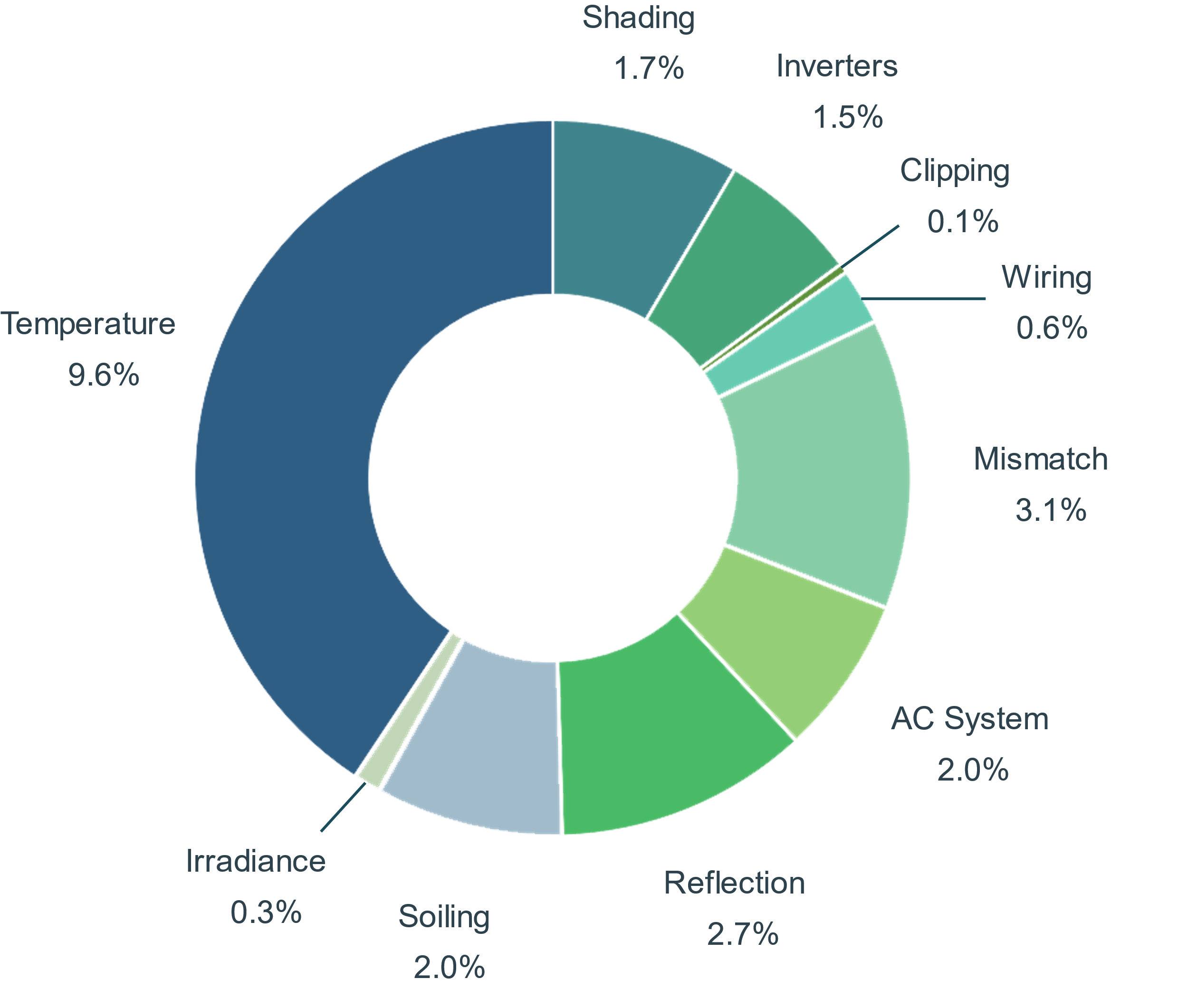

Pricing
Note that pricing is based off current estimations for each component. These prices are anticipated to reduce over time as the efficiency for panels increases. The following has been determined for the material cost.
Materials | Price Estimate | Price
Solar System: Modules: Global Solar/Hanergy | $1.100 | $3,300,000
Solar System: String Inverters | $0.150 | $450,000
Solar System: Transformer | $0.030 | $90,000
Solar System: Monitoring: Also Energy | $0.025 | $75,000
Energy Storage: NGK | $0.500 | $1,500,000
Single-axis tracker racking | $1.800 | $5,400,000
Structure Framing | $1.800 | $5,400,000
Contingency (5%) | $0.300 | $900,000
Total | $5.705 | $17,115,000

Return on Investment:
Materials | Capital Spent | Annual Yield (kWh) | Lifetime return  based on Abu Dhabi household energy value | Economic/ Social value of avoided C0² | Total lifetime value | Return on Investment
Solar System | $3,915,000 | $6,360,000 | $9,540,000 | $13,883,880 | $23,423,880 | 5.98
Energy Storage System | $1,500,000 | $2,100,000 | $3,150,000 | $4,584,300 | $7,734,300 | 5.16
Total | $5,415,000 | $8,460,000 | $12,690,000 | $18,468,180 | $31,158,180 | 5.75

environmental IMPACT statement
The current site in Masdar City is seventeen miles south of Abu Dhabi and sits between the coastal desert and desert climate. While characterized by extreme physical condition including minimal rainfall, high temperatures, and dry wind, the region has a dearth of species including over 400 species of plants and 50 species of mammals. Construction of renewable energy will encroach on this habitat, but there are many ways that this man-made renewable energy project minimizes and negates its impact on the environment.
Landscape:
The form of DUNE takes the natural shape of the native landscape of sand dunes alongside the man-made architectural shapes of the nearby Masdar Institute. In the masterplan the project site is surrounded by buildings; DUNE seeks to provide a park space where innovators can converse amongst natural forms and local species.
Local Species:
DUNE takes into account the local environment not only in form but also in function. The base of the project will serve as a cultivation ground for native species of plants to grow and serve as a lush gate to the city of Masdar.
Proximity:
The proximity of the project to the city of Masdar makes it ideal for offsetting energy consumed by the surrounding buildings. Pedestrian walkways and connectivity to the city via public transport is key to the integration of the project into the local surroundings.
Materials:
By choosing materials that have low impact and high durability, especially during in extreme temperature climate, the project is primed to integrate with its surroundings and become a part of the landscape within the city of Masdar.

