PROPOSAL

Jawahrat Alnaas (Jewel of the people), is a sculptural Pavilion, proposed in the heart of Masdar City, Abu Dhabi. The structure stands as a manifestation portraying the cultural essence of the Emiratis. The ornate composition of the structure extends beyond the opulence and aesthetics, by serving as a performative and sustainable framework. It harnesses the micro and macro climatic energy resources, and engages in the storage, utilization, production and distribution of the excess to the Grid.

The structure is essentially an inclusive complex catering to the essential requisites of Masdar City. The spatial configuration of the site informs the accessibility through multiple channels, unfolding an Architectural canvas – with an array of features and
facilities. The structures are composed of multiple levels of garden plate racks, that allows the visitors to the site and the structures accommodate an Aquaponic farm and garden, relaxation and recreational spaces such as an Amphitheater for events, production of resources through food farming and aquaculture. This ecological framework mobilizes the wind, solar, oceanic and geothermal energies and serves the City in return. The following resources are produced through the structure.

 | Electricity |  | Urban garden and farm
 | Food production |  | Oceanic Ocean Thermal Energy Conversion
 | Fish production |  | Geothermal energy

SOLAR ENERGY

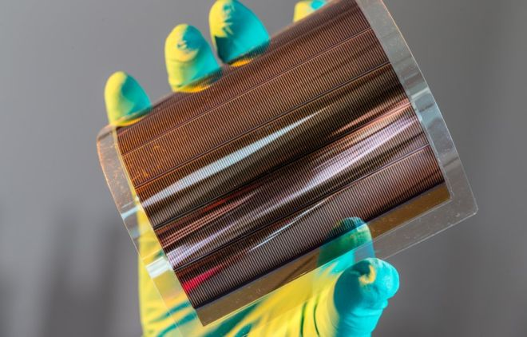
An organic solar cell (plastic solar cell) is a photovoltaic that uses organic electronics, a branch of electronics that deals with conductive organic polymers or small organic molecules, for light absorption and charge transport to produce electricity from sunlight by the photovoltaic effect. Organic photo voltaic cells are polymer solar cells. The molecules used in organic solar cells are solution-process able at high throughput and are cheap, resulting in low production costs to fabricate a large volume. Combined with the flexibility of organic molecules, organic solar cells are potentially cost-effective for photovoltaic applications. Molecular engineering (e.g. changing the length and functional group of polymers) can change the band gap, allowing for electronic tenability. The optical absorption coefficient of organic molecules is high, so a large amount of light can be absorbed with a small amount of materials, usually on the order of hundreds of nanometers.
Organic solar cell module with six interconnected solar cells
Pic Courtesy: https://www.bbc.com/news/science-environment-45132427

C
Compared to silicon-based devices, polymer solar cells are lightweight (which is important for small autonomous sensors), potentially disposable and inexpensive to fabricate (sometimes using printed electronics), flexible, customizable on the molecular level and potentially have less adverse environmental impact.
Calculation of Output In order to calculate the energy output from a solar panel, this simple formula can be used:
Area x Efficiency x Peak Sun Hours x Effective Output % After Deducting Losses = Output (kwh/day)
36,696.45 x 17.3 x 6 x 0.75 (75%) = 285,681.86W
OCEAN THERMAL ENERGY CONVERSION
OTEC
Ocean Thermal Energy Conversion (OTEC) is the marine renewable energy technology that harnesses the solar energy absorbed by the oceans to generate electric power. The sun’s heat warms the surface water a lot more than the deep ocean water, which creates the ocean’s naturally available temperature gradient, or thermal energy. The efficiency of the cycle is strongly determined by the temperature differential. The greater the temperature difference, the higher the efficiency. The technology is therefore viable primarily in areas where the year-round temperature differential is at least 20 degrees Celsius or 36 degrees Fahrenheit.
The energy source of OTEC is free, available abundantly and is continually being replenished as long as the sun shines and the natural ocean currents exist. Various renowned parties estimate the amount of energy that can be practically harvested to be in the order of 3 to 5 terawatts (1 terawatt is 1012 watts) of base load power generation, without affecting the temperature of the ocean or the world’s environment. That’s about twice the global electricity demand. The oceans are thus a vast renewable resource, with the potential to contribute to the future energy mix offering a sustainable electricity production method.

SYNERGETIC PRODUCTS OF OTEC
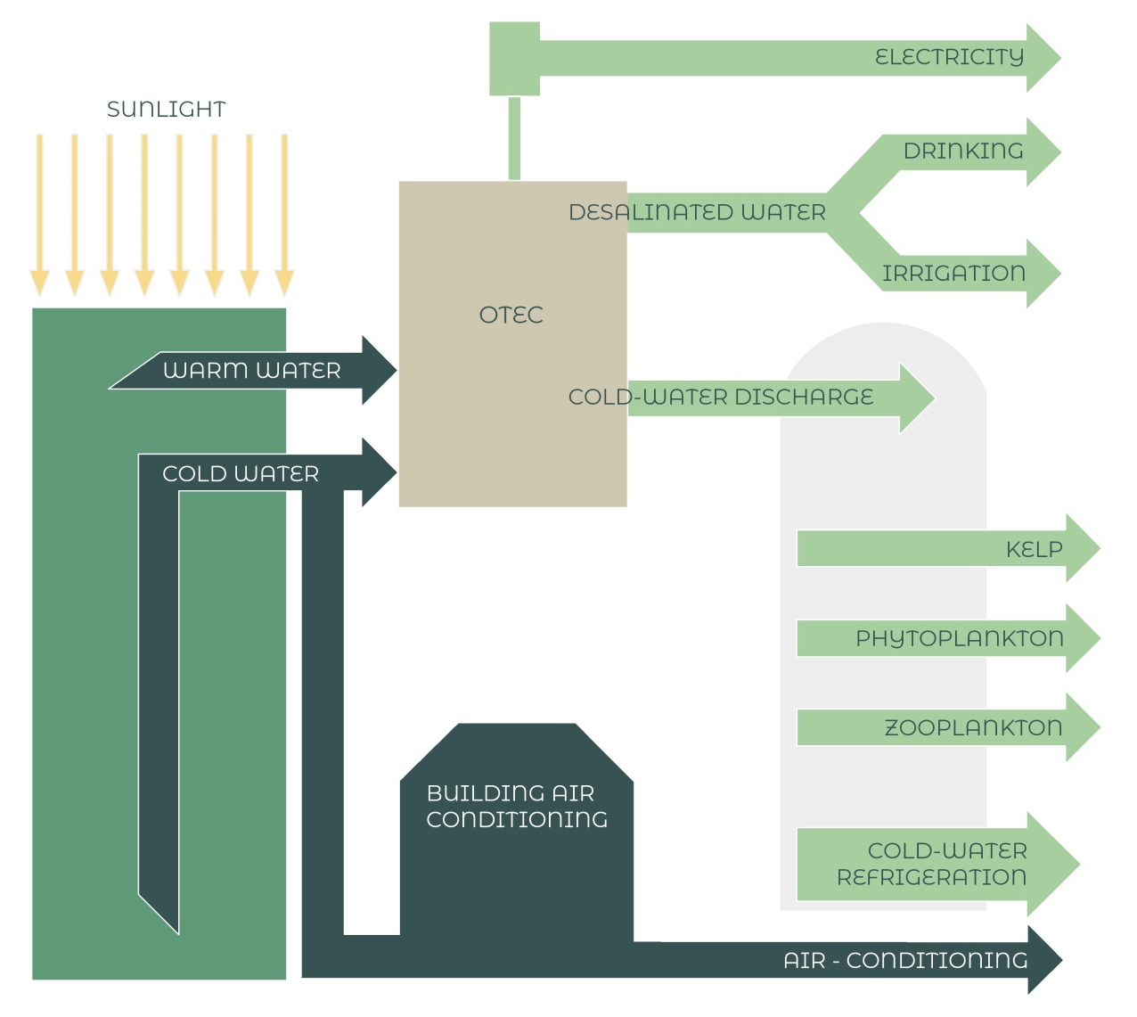
The greatest advantages of OTEC are the synergetic by products in the process. The primary product is electricity and first and the most important by-product is fresh water A small hybrid 1 MW OTEC is capable of producing some 4,500 cubic meters of fresh water per day. This water could be a prime source for many related actions such as aquaponic, Coldwater refrigeration etc.,

AQUAPONIC

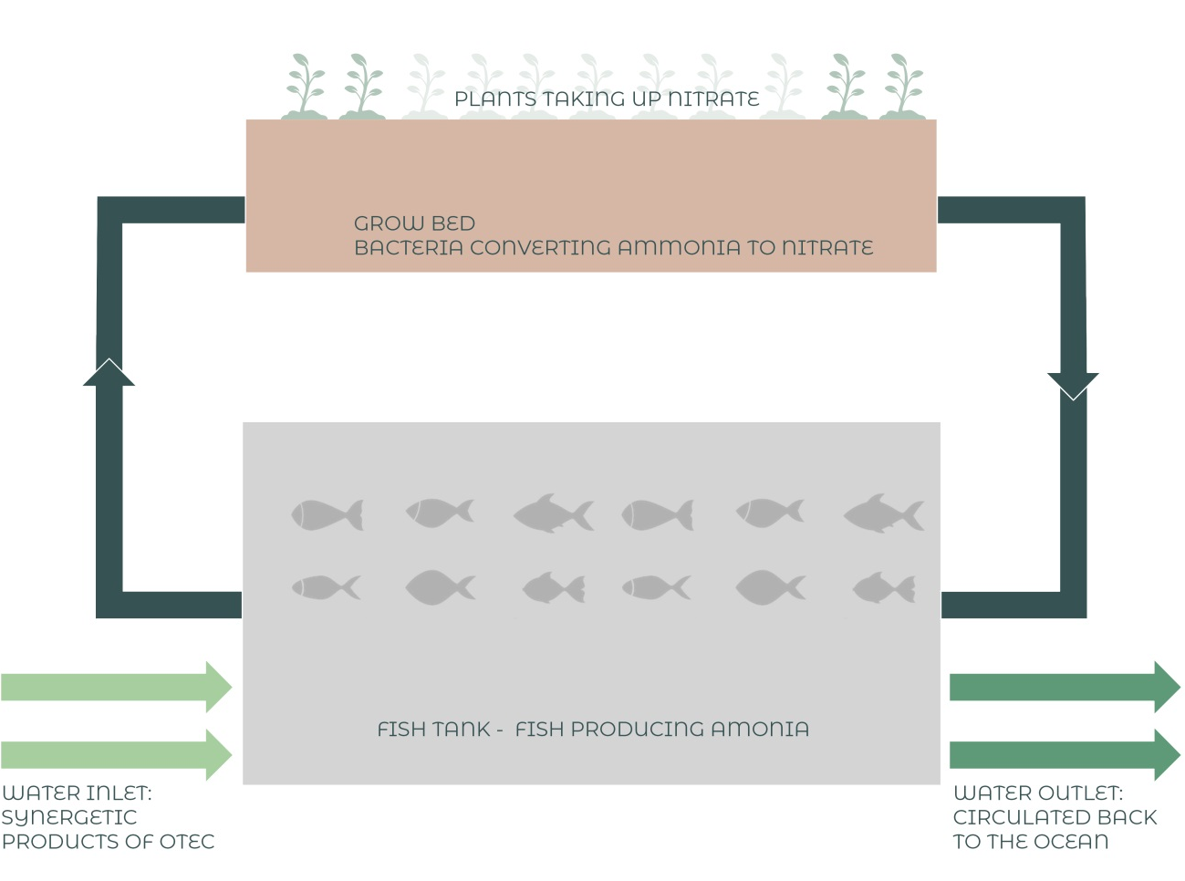
All the above OTEC synergies could be utilized to have a Marine Aquaponic - Urban Garden at the Jawahrat Alnaas . Aquaponics saves water, as it only uses 1/10th of the amount required for regular soil based gardening/farming and even less water than hydroponics or recirculating agriculture. The aquaponic system cuts down maintenance, chores like weeding are not required.

SOLAR DESALINATION

Solar energy and sunlight may provide heat for evaporative desalination process; the aquaponic structure could act as the source for this effort. There would a phase change from water to steam in the first phase with the help of thermal energy inside the shell which is covered with a condensate film. These condensate film traps the steam and coverts it back to water in phase of the process.

GEOTHERMAL

The inter-link between energy and food is key when discussing major global trends such as growing population, poverty and climate change. The energy-food nexus mostly concerns the use of energy in the food supply chain, including food production, harvesting, processing, storage, transportation, retail, preparation and cooking. Indeed, the FAO estimates that the food sector accounts for some 30% of global primary energy consumption.
RETURN OF INVESTMENT ANALYSIS
RENEWABLE ENERGY TECHNOLOGY | ANNUAL ENERGY YIELD | RELATIVE CONTRIBUTION | CAPITAL COST | RETURN OVER LIFE SPAN | SOCIAL AND HEALTH VALUE OF AVOIDED CARBON EMISSION
Solar Energy | 285.68 MWh | 15.0% | $214,260.00 | $22,854.40 | $5,007.60
Ocean thermal | 600 MWh | 31.5% | $535,000.00 | $48,000.00 | $10,516.80
Geothermal | 1020 MWh | 53.5% | $212,500.00 | $81,600.00 | $17,878.40
TOTAL RENWABLE ENERGY GENERATION PER ANNUM = 1905.68 MWh
WATER SAVINGS | ANNUAL WATER PRODUCED | RELATIVE CONTRIBUTION | CAPITAL COST | RETURN OVER LIFE SPAN | SOCIAL AND HEALTH VALUE OF AVOIDED CARBON EMMISSION
Ocean thermal | 4590000 |  | $0.00 | $1,377,000.00 | $402,267.60
Condensate | 17858.939 |  | $0.00 | $5,357.68 | $1,878.40
TOTAL CAPITAL COST | $961,760.00 |  | RETURN OF INVESTMENT |  | 2.1 YEARS

Carbon savings -Metric tons of CO2e
Annual Renewable Energy Yield (MWh)
MATERIAL

Ornate shell structures are devised with a Steel dia-grid formwork, cladded with terracotta-based panels as surface articulation. The terracotta panels on the exterior. They are affordable and a very effective solar shade solutions. They are a Lightweight systems starting at 7 pounds per square foot. Terracotta- Natural, earth tone colors to harmonize with the surrounding and other structures. They are shielded with Organic solar photovoltaic and the interior of the shell is articulated with a condensation film on the interior to capture all the condensate water from the aquaponic structure.

ARCHITECTURAL FLOOR PLAN

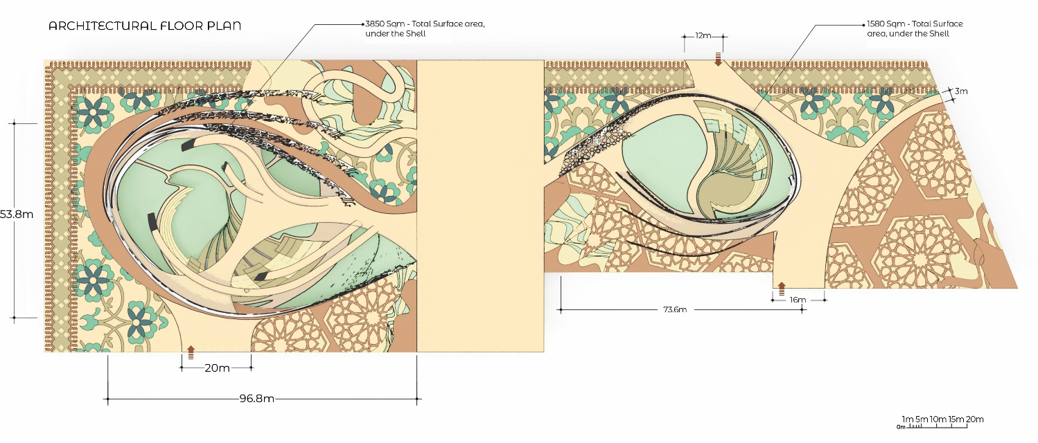

CONCLUSION

Jawahrat Alnaas (Jewel of the people), stands calm and poise, in harmony with the Masdar context. The sculptural complex replenishes the food resource and electricity, by giving back to the City. The sustainable and renewable material management is powered by the utilization of state-of-the-art energy harnessing strategies. The structure renders itself as an ecologically viable entity, thus fostering a natural and communal wellbeing in the heart of Abu Dhabi.
The essence of Jawahart Alnaas can be inferred from the economical, social and financial outcomes.

