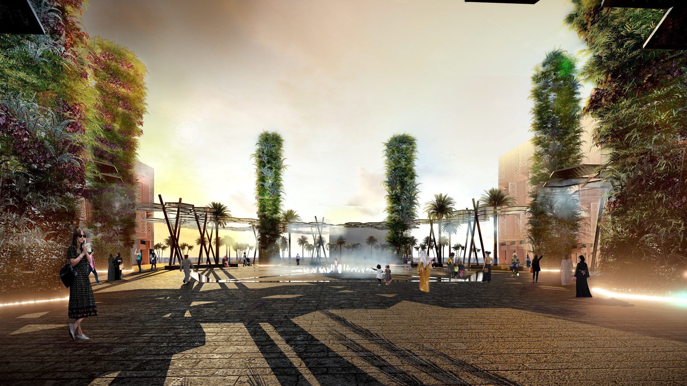
The Solar Mirage, Masdar City
Lagi 2019

PROPOSAL

We enter upon the Mirage. From a distance, the blue panels will look like an fantastical hoax, just a sun spot in the desert, but they are not, they are real, and a beacon of sustainability in uncertain times. We are more than ever in need of establishing a connection with nature as our planet is under threat from climate change. The masterplan of the Solar Mirage brings together energy production, beauty, engagement with nature, and hypernatural design. The Solar Mirage sits at the threshold of Masdar city, the new net zero energy development led by Foster and Partners. The Solar Mirage will become a hub of activity, biophilic experience, and energy harvesting.
MASTERPLAN
The grid of steel photovoltaic panel ‘trees’ will provide shelter from the sun, as well as energy. The form of the trees is derived from traditional Islamic girih patterns often found around windows and in tiling. The masterplan aims to create a walkable, engaging, environment allowing multipurpose usage. Space is available for performances, markets, and for people to sit and rest. Our photovoltaic panels will have a second function, capturing the full potential of the site by harvesting condensation at night as the temperature cools. This water will then be recycled into the microbial fuel cell towers, perpetuating this function and creating a closed system. The towers will provide a cooling effect across the site both by the inclusion of planting, and by the function of releasing mist into the plaza fed by attenuation, while also producing energy through the use of microbial fuel cells. The structures will all provide shelter from a harsh environment and create an engaging environment.

ENERGY

Photovoltaic Panels:

The photovoltaic panels will be constructed with ultra high efficiency cells, and will under optimal conditions harvest 1200 watts. Each photovoltaic tree is constructed of 6 panels, and there are 60 trees spread throughout the Hive.
At an average of 10 hours of sunlight a day, the photovoltaic panels would produce 4320KWH daily*, and 1576 MWH annually.* The solar panels will produce 87.5% of the total energy produced on site.
* (432,000x10x365= 1,576,800,000watts per year or 1576.8MWH per annum. ) (1200x6x60= 432,000 watts, 432,000)

Microbial Fuel Cells:

The Microbial fuel cell towers will produce 25 watts per cubic meter of ‘food’, and will be capable of generating 615.6KWH daily and 224.7MWH annually or 12.5% of the total energy produced.

Total Energy Produced:

The Mirage will be able to generate energy to power approximately 135 homes, as well as its own lights and infrastructure.

In total, the Hive will generate 1800.7MWH of energy annually.

ENERGY STORAGE

Energy will be stored underneath the plaza structure in solar batteries. The energy can then be fed back into the grid.

MATERIALS

Photocatalytic concrete pavers will absorb pollution and release nitrogen to fertilize planted areas produced by Italcementi and made of 80% recycled materials. $1,500,000.00
Recycled Steel Beams will be used to construct the solar trees and green towers, procured from Al Nawras Metal Scrap Trading, $4000.00 per unit.
Photovoltaic panels and energy storage battery, produced by GulfSolar technologies. $890,000.00
Microbial Fuel Cells, produced by Plant-E. $100.00 per unit.

ENVIRONMENTAL IMPACT STATEMENT

The materials used for construction will aim to be mostly recycled and or offset their own environmental impact. Through the use of photocatalytic concrete paving we will aim to sequester pollution and by using recycled steel eliminate the need for raw materials being harvested.

