DYADIC SPHERE

LANDSCAPE + POWER + WATER GENERATION CYCLE

The future of Masdar City and the Earth relies on finding solutions for sustainable energy, one of the greatest and vast source of clean energy is solar.

By using the HCPV technology which is one with higher conversion efficiency values, we take advantage of the available radiation at this latitude.

In addition to solar radiation, the site has the relative humidity qualities to use an innovative technology that literally sucks water from the environment called (SMAG 1)

With this resource obtained from the environment, it will be possible to produce even more clean energy through the implementation of a solar pond, this causes a cycle that makes possible the sustainable development of the landscape of the site in the medium term.

¹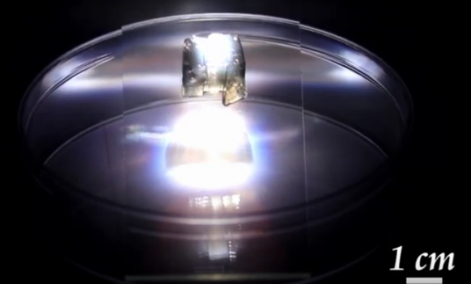 New solar-powered technology collects clean water from the air, (gel-polymer hybrid acts like a “super sponge”) placed outside to collect moisture. When exposed to sunlight, the hydrogel releases the water it absorbed. 35 grams prototype (1cm aprox.) tests showed daily water production up to 37 grams.

This technology is developed by scientists of the Austin´s Cockrell School of Engineering in the University of Texas.

<https://discovery.kaust.edu.sa/en/article/723/drinking-water-sucked-from-the-dusty-desert-air>

<https://pubs.acs.org/doi/10.1021/acs.est.8b02852>

<https://onlinelibrary.wiley.com/action/downloadSupplement?doi=10.1002%2Fadma.201806446&file=adma201806446-sup-0001-S1.pdf&>

This integrated duality gets positioned in the site, which is a fragment of a Green Axis in the Master Plan of Masdar City, this duality is perceived and explorable in multiple directions, it is proposed as repeatable, scalable and a phenomenon for interaction, a place that makes people to be involved and aware that the habitat, the technology, the resource, and the morphology are linked.

THE EXPERIENCE

Two big scale landscape elements are planted in opposite sides of the site, both defined by the same geometry in opposite gestures, the pedestrians modify their paths to be able to approach and interact with them.

One spherical structure stands on the site ethereal like a bubble, permeable to the passing of people who enter in it and discover a thrilling everyday event, clean fresh water rains from the heated SMAG that has been receiving daylight for a couple of hours. The arid ground now gets the conditions for supporting vegetal life.

In the southwest, the geometry of the sphere gets subtracted from the ground morphing a SOLAR POND, sustainable power generation becomes the topic, this side gets more populated with the HCPV panels, the environment gets modification and dialogue with shades and running water through irrigation ditch, which provide the humidity for the growing vegetation

In the near future (1 to 2 years) Masdar City population will walk their everyday paths and outside activities under the refreshing and intermittent shades of HCPV panels and climbing plants attached to slim structures that lay in the site, in company off xerophile species, running water through the irrigation ditch in any direction, all integrated within a strict geometry of a mashrabiya composed by different layers.

FIRST PHASE

The rise of supporting structures for the High Concentrated Photovoltaics panels will generate clean electric power which will be supplied to the buildings next to the site.

The edification of the sphere, a 30m diameter structure, and a supporting substructure attached to it, designed inside the mashrabiya template, that holds an upper membrane of SMAG, this element collects water during the night time and releases it in the form of clean fresh water during the day inside the sphere, trough being heated with a couple of hours of daylight .

The water that falls gently like rain is led through the irrigation ditches to be used by the people in the surrounding buildings of the site, then it returns to our facility as gray water into phytodepuration water system ponds and finally to the solar pond which is fed at its lower level by the brackish water extracted from the site, electrical energy is generated by its difference in salinity.

Finish your course in the upper layer of the solar pond of 35 m. In diameter, which is fed in its lower level by brackish water extracted from the groundwater level of the site, electrical energy is generated by its difference in salinity for its use in the buildings surrounding the site.

SECOND PHASE

The water obtained through the proposed cycles will modify the desert conditions of the site, the intervention behaves like an evolving organism and the hostile environment now becomes friendly and sustainable ecosystem.

**Estimate of the nameplate capacity**

**High Concentrated Photovoltaic**



**186** modules (10m2) = **1860** BSQ-D280 HCPV panels (1m2)

Wp per panel = **280 Wp**

Wp per module = **2800 Wp**

186 x 2800W = **520800 Wp = 520.8 kWp**

520.8 kW X 8760 hours per year X 28% capacity factor = **127740 MWh per year**

**Enough for 3252 Masdar´s city Eco-villas per year.**

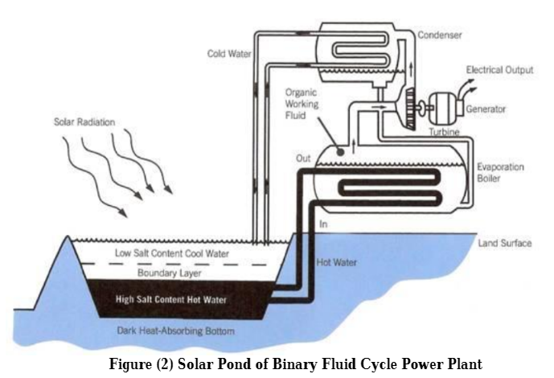**Solar Pond (Sodium Chloride Salt added)**

**Surface:** 960 m2

**Flow rate**: 6.9x106  cm3/min

**Thermal Power: 200 MWt**

**Electricity Production: 5 MWe**

5000 kW X 8760 hours per year X 10% capacity factor = **4380 MWh per year**

**Enough for Illumination and mechanical systems.**

**Parameters from: https://www.researchgate.net/publication/330935120_Design_of_Solar_Pond_for_Electricity_Production

**Estimate of H2O uptake**

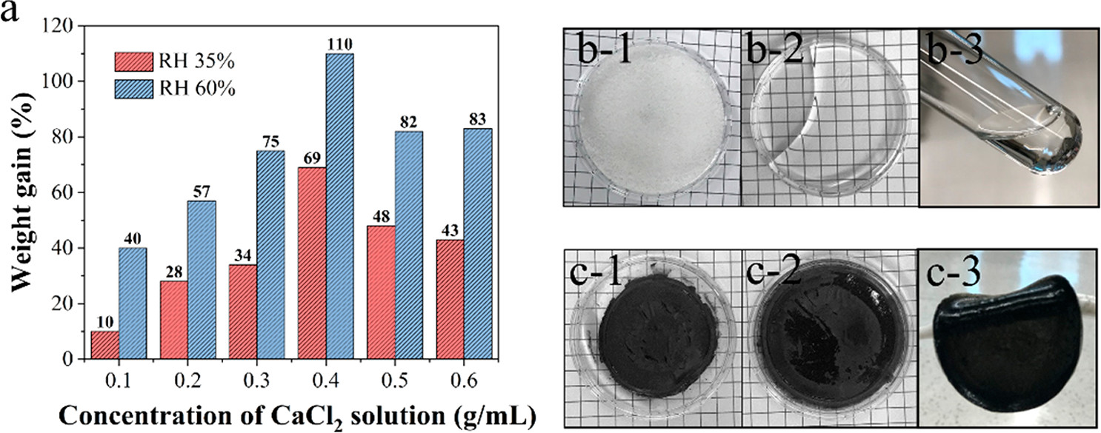

**SMAG surface =** 600 m2 = 6000000 cm2

**SMAG weight =** 35gr/cm2

600 m2 = 210000 kg of SMAG

SMAG fresh water uptake = 119700 lts per day.

**Enough for 748 persons per day.**

**Magnitude conceptual cost estimate**

|  |  |  |  |
| --- | --- | --- | --- |
|  | **kWpeak** | **USD/W** | **COST** |
| **HCPV** | 520800 Wp | 20 USD | **10416 USD** |

|  |  |  |  |
| --- | --- | --- | --- |
|  | **Liter uptaken** | **USD/l** | **COST** |
| **SMAG** | 119700 l/day | 1 USD | **119700 USD** |