Apple garden

The main idea was to create an image of an Apple garden as an oasis in the desert.
The project proposes two types of alternative sources.

The principle of operation of the unit (Type 1)
For the normal operation of a turbine-type wind turbine, a wind blowing at a speed of 2 m/s to 60 m/s. the Principle of operation of the installation is as follows. The flow of air enters the blades, rotates them. Air masses report the kinetic energy of the blades, where it is converted into mechanical energy, rotating the rotor. The rotation of the rotor produces a three-phase current flowing to the generator. From there, the current goes to the controller, where it is rectified, then it flows through the batteries, charges them, then enters the inverter. The inverter produces a single-phase alternating current, the frequency of its oscillations is 50 Hz for networks with a voltage of 220 V, or a three-phase current with a voltage of 380 V, necessary for industrial enterprises, as well as for supplying the load.
One microturbine produces 20 Wp/h. There are 32 microturbines on one tree. Total objects 29 pieces. 162585 KWp/h of energy is produced per year.
Advantages of turbine wind turbine
Wind turbine design has significant advantages over wind turbines of other designs.
1.High sensitivity to wind. The minimum wind speed to bring the blades in motion from 2 m/s; wind turbines of a different type need a wind speed of 4 m/s.
2.The generator is able to operate at hurricane wind speeds (up to 60 m/s). Most other wind turbines run up to 25-30 m/s.
3.The efficiency of the wind turbine generator is almost twice the efficiency of the windmill, which has unprotected blades. The turbine is safe for birds and bats. Windmills with open blades often cause the death of flying animals that are not able to determine the boundaries of the danger zone. Wind turbine design bats and birds identify as a single obstacle and successfully envelope it.
4.Wind turbines of most designs produce a lot of noise, at certain wind speeds generate infrasound, so they can not be placed near houses, farms, forests. Turbine units do not produce infrasound, harmful to humans and animals. They can be installed next to the house. Turbine wind turbines do not provoke artificial migration of animals.
5.Lower, compared with the blade, the cost of production. Production of free blades is a complex, expensive process. Their absence significantly reduces the cost and simplifies the production of the installation.
6.Ease and speed of installation. Components of the turbogenerator are produced at the plant; there is also the Assembly of the main blocks. The installation includes only the layout, the connection of blocks, fixing it to the support. Installation is carried out using standard lifts.
7.Ease of maintenance. Maintenance of turbine wind turbines is much easier and cheaper than the blade. With proper maintenance, installation, periodic proper maintenance, the lifespan is 50 years.
8.The wind power plant of turbine type, unlike classical windmills, does not interfere with pilots and dispatchers of flight services, is not detected by air defense radars, does not pose a threat to national security.
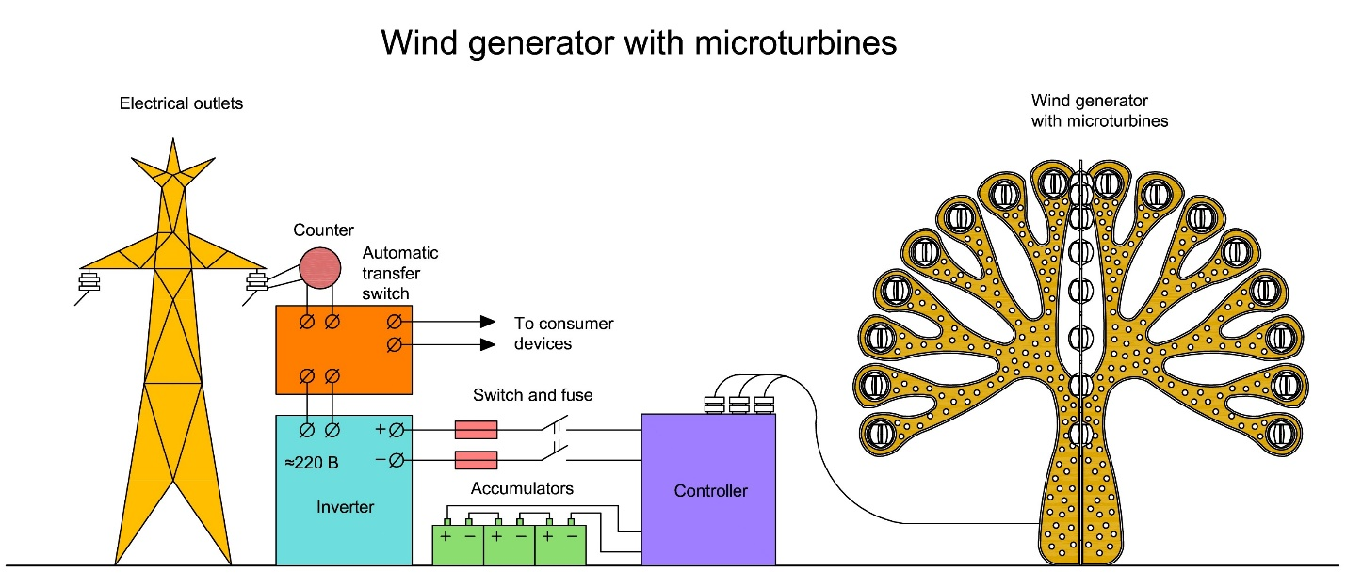

The principle of operation of the unit (Type 2)

The solar salt pond is a shallow (2 – 4 m) pool with a steep brine at the bottom. As a brine, for example, a saturated solution consisting of 95% magnesium chloride and 5% calcium chloride is used. In order to avoid liquid spreading, waterproofing of the pool is provided. To reduce heat losses through the soil it is recommended to provide thermal insulation of the bottom and walls of the pool. At its core, the salt pond is a solar collector – a heat trap.
In the pond, part of the solar radiation — the infrared spectrum is completely absorbed by the upper layer of fresh water, short-wave absorbed by the lower layers of water, and not the absorbed part of the radiation that passed through the water — the dark bottom. The energy reflected from the bottom will be partially absorbed by the water on the way back. In a normal pool, warm and cold water are mixed due to natural convection. Warm water has a lower density and it rises to the surface. The saturated salt solution has a high density (about 1.5) and therefore can not rise up when heated. The physical properties of the intermediate "gradient" layer with a sharp change in the density akin to is approximately 1.7 m2∙ ° C∙W-1, which corresponds to the values of the thermal resistance of the walls of most of the exploited buildings. The thermal resistance of the surface water layer is 1000 times lower than the thermal resistance of the gradient layer. Thus, the energy of solar radiation passing through the thickness of the solution is almost completely retained in the lower layer of the pond and has no outlet outside. This property is akin to the greenhouse effect and leads to a sharp increase in the temperature of the salt solution, which can reach 100 degrees. Unlike conventional solar collectors, in which the role of the heat trap is played by having a small volume of the bulb, the volume and heat capacity of the salt pond are very large. This makes it possible to use the salt pond not only as a solar collector, but also as a heat storage battery.
So the principle of operation is as follows: water (60-90 °C) from the lower layers is fed into the heat exchanger and is used to evaporate the liquid with a low boiling point (freon, ammonia). The vapors of this liquid rotate the turbine.

The electrical power that can be "off" with the salt pond is about 8-10 Wp/m2
The total area of the water surface is 3500 m2. The solar pond produces 306600 KWp/h of energy per year.
