ANTHROPOCENE

LAGI 2019

MASDAR

Abu Dhabi

UAE

# ANTHROPOCENE

An energy installation inspired by Sir David Attenborough’s statement at the 2018 World Economic Forum (WEF) in Davos, where the 92-year-old naturalist and broadcaster warned that human activity has taken the world into a new era, threatening to undermine civilisation.

*“The Holocene has ended. The Garden of Eden is no more. We have changed the world so much that we are in a new geological age: the Anthropocene, the age of humans.”[1]*

The intent is that the artwork functions on multiple levels and at different scales. At the masterplan scale the artwork is designed to announce the ANTHROPOCENE to all those flying over, through the setting out of the PV array. It is designed to be a none-too-subtle warning to the world, to bring attention to the new geological age we have created.

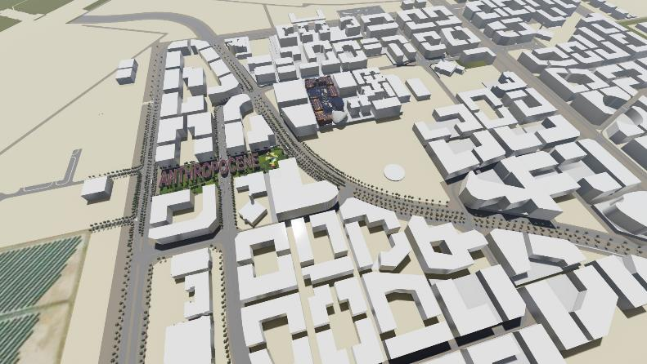

Figure 1 - ANTHROPOCENE Masterplan Aerial View

As we drop down closer, we see that watching over the ANTHROPOCENE is the SENTINEL, a 20-metre-high canary.

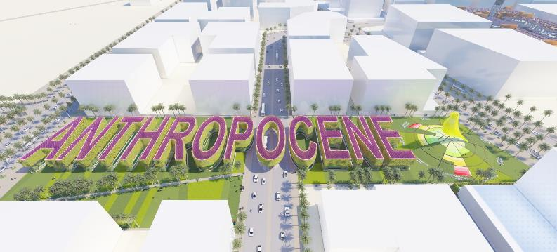

Figure 2 - The SENTINEL watches over the ANTHROPOCENE

At ground level, the structures supporting the ANTHROPOCENE PV array appear as topiary above a series of constructed wetlands within a park, the SENTINEL becomes the focal point.

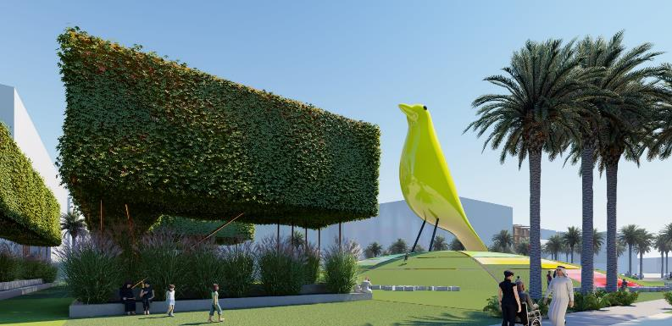

Figure 3 - The SENTINEL becomes the focal point at ground level

The project comprises of three key parts: a large photovoltaic (PV) array; a biological wastewater treatment system; and a biogas production facility. The following diagram is a systems overview of the project breaking down system inflows and outflows.

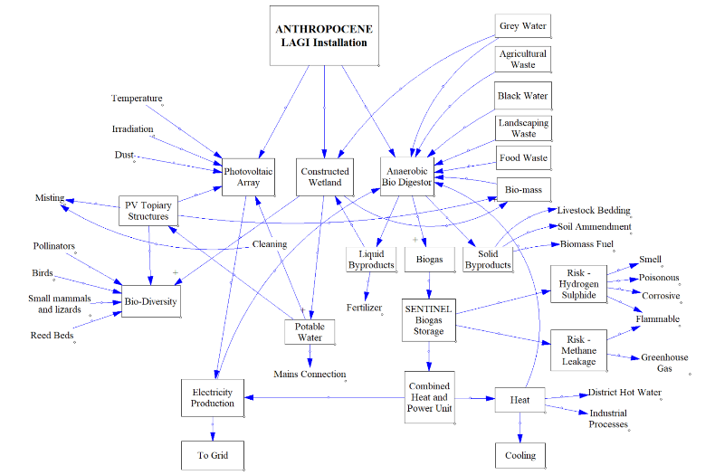

Figure 4 - ANTHROPOCENE System Diagram

# ANTHROPOCENE

The ANTHROPOCENE geoglyph is made of 40m x 15m letters, 215m in total length, which spans over the road bisecting the site. The letters are extruded 5m and are lifted 5m above ground level by randomly distributed Corten pilotis.

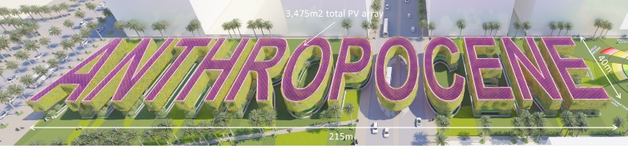

Figure 5 - ANTHROPOCENE PV Array Dimensions

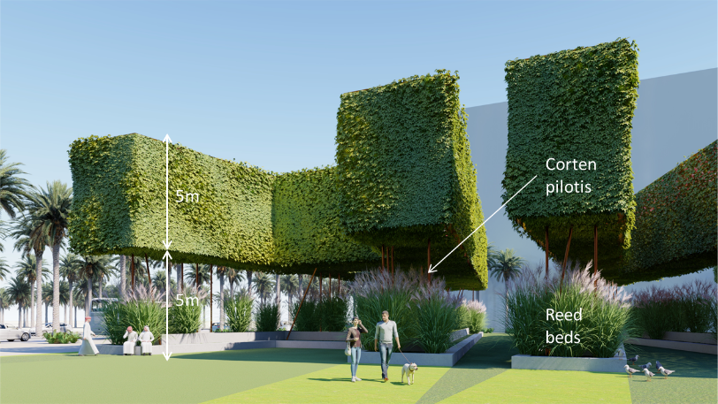

Figure 6 - Topiary with Wetland Beds Below

The pilotis are intended to appear delicate and fragile in order to create a tension between the “man-made” block forms floating over the wetland habitat below.

## PHOTOVOLTAIC ARRAY

The top plane of the extruded text forms the 574kWp nameplate capacity photovoltaic array. A crystalline silicon (c-Si) PV laminated glass system[2] has been selected in order to maximise the power output per m2. A 160Wp/m2 nominal power can be achieved by such a system, the cells will be spaced to allow natural light to penetrate into the boxes to promote plant growth below. A red cell colour has been selected to bring an urgency to the message.

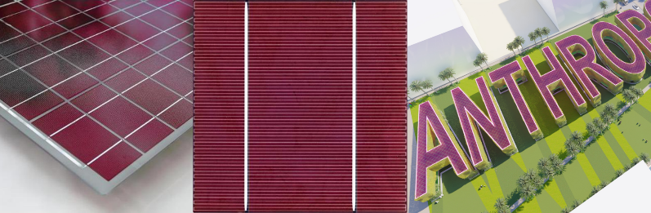

Figure 7 - Red Crystalline Silicon PV Array

The 5m high extruded text supporting the array are formed from basic Corten mesh. Balance of system items will be concealed within. These structures will be colonised by vines growing from the planter beds below and over time will evolve into the ANTHROPOCENE topiary. Irrigation and misting will be incorporated and will also serve to periodically clean the PV array above.

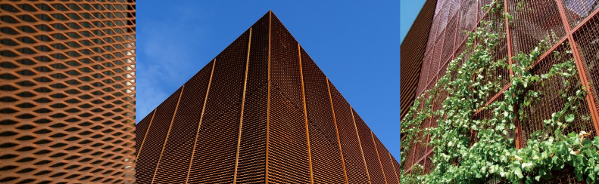

Figure 8 - Corten Mesh forms Topiary Structure

## CONSTRUCTED WETLAND

Below the topiary structure raised wetland beds mirror the ANTHROPOCENE text. These wetland beds are an intensive bioremediation system[3] tied to the biogas plant system described in the following section.

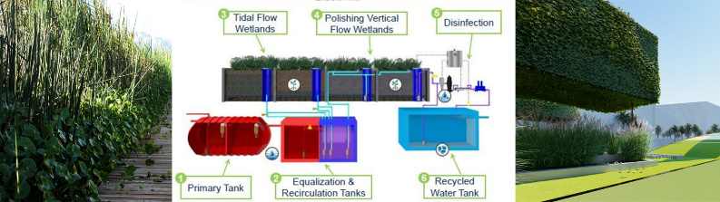

Figure 9 - Biological Wastewater Treatment

Primary, equalization and recirculation wastewater tanks are all part of the biogas system located in the basement plant room below the SENTINEL. Wastewater from the recirculation tanks is pumped out to the wetlands steadily dosing them throughout the day. Two types of wetland system are utilised:

Tidal Flow Wetlands: These are designed to mimic natural tidal wetlands, wastewater is pumped from the recirculation tank to the tidal flow wetlands filling the planters from the bottom and then draining by gravity back to the recirculation tank. The planter boxes are filled with gravel media, which provides a surface for healthy biofilm to attach to. While submerged in wastewater, a diverse population of microorganisms thriving in the biofilm feed on the nutrient-rich wastewater. When the planter box is drained, air is pulled into the planter box to oxygenate the microorganisms and facilitate aerobic metabolic processes. This filling and draining cycle repeats 12 times a day, accelerating the treatment processes that occur in a natural tidal wetland by approximately 3 times.

Polishing Vertical Flow Wetlands: After the 12 cycles through the tidal flow wetland the effluent is pumped from the recirculation tank and distributed to the vertical flow wetlands via perforated pipes near the surface, allowing the water to percolate down through the gravel media. The vertical flow wetlands remove remaining organic material, and nitrogenous compounds.

Disinfection occurs back at the biogas plant room and consists of a 50 micron filter, 5 micron filter, ultraviolet unit and chlorination tablet feeder. The filters remove remaining suspended solids and reduces turbidity below 2 NTU. The ultraviolet unit deactivates bacteria and viruses by destroying their genetic material. The chlorination tablet feeder adds a small amount of chlorine residual to the water to keep growth from occurring in the building’s recycled water pipes.

Recycled Water Tank: After wastewater is thoroughly treated through the system the water is stored in the recycled water tank until needed for irrigation or toilet flushing.

Further to providing wastewater treatment services the wetlands also produce beneficial by-products, such as reuse-quality water, ornamental plants and plant products—for building material, energy biomass for the biogas plant, and animal feed.

Aquatic and wetland plants, bacteria, algae, protozoa, plankton, snails and other organisms are used in the system to provide specific cleansing or trophic functions. It is proposed that the protected Al Wathba Wetland Reserve[4] be studied as a reference model for the wetland landscape strategy. Species diversity is a design goal that promotes complexity and resiliency in the ecosystem.

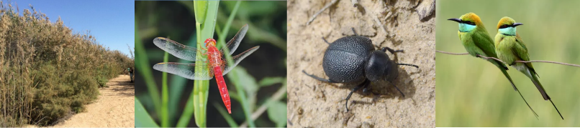

Figure 10 - Al Wathba Wetland Reserve - Reference

# The SENTINEL

The SENTINEL is a monument to the importance of the work being done at MASDAR. It is a daily reminder to all who live, work and play in the City, of the urgency of the anthropogenic climate crisis we now face and that our very survival depends on sustained, multi-generational action.

The cue for the monument is taken from the history of using sentinel species to bring attention to catastrophic events that are low in initial spectacle.

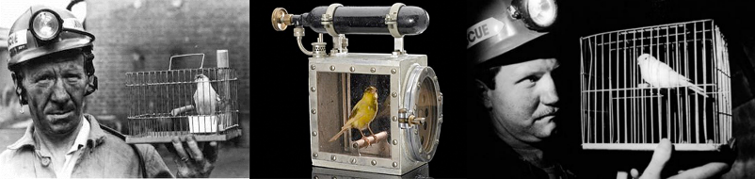

Figure 11 - The Canary in the Coalmine

The canary no longer needs to be in a coal mine to tell us the dangers of fossil fuel extraction and use, our need for a SENTINEL has never been more necessary.

The SENTINEL is a 20-metre-high fibre-glass sculpture based on the famous and beloved Eames House Bird[5] (permission will have to be sought from the Eames Estate). The SENTINEL stands atop a landscaped sustainability barometer, The Planetary Boundaries, developed by the Stockholm Resilience Centre[6].

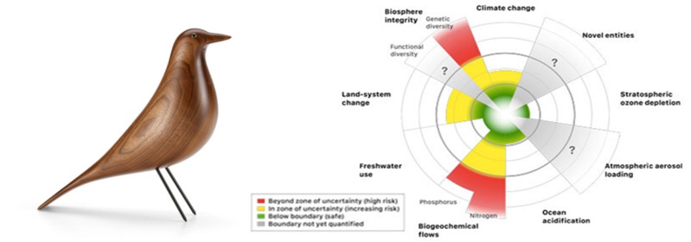

Figure 12 - The Eames House Bird and The Planetary Boundaries

In the Anthropocene, humans have become the main agents of change to the Earth system. There have been well publicised scientific warnings about risks in the areas of climate change and stratospheric ozone. However, other biophysical processes are also important. For example, since the advent of the Anthropocene, the rate at which species are being extinguished has increased over 100 times, and humans are now the driving force altering global river flows as well as water vapour flows from the land surface. Continuing pressure on the Earth's biophysical systems from human activities raises concerns that further pressure could be destabilizing, and precipitate sudden or irreversible changes to the environment.

The SENTINEL stands above this depiction of the current state of man’s impact on the planet as a clarion call for action.

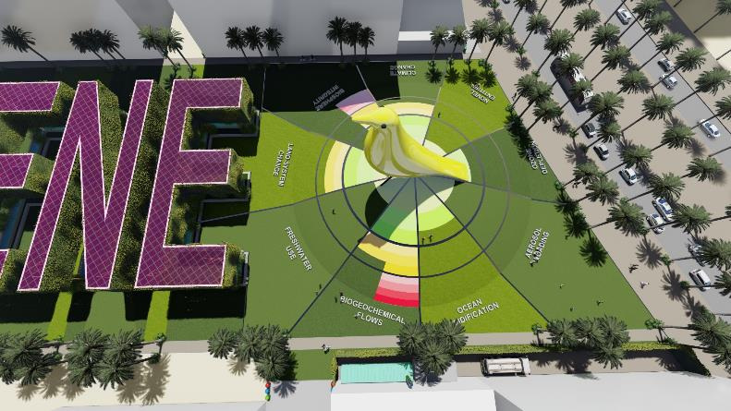

Figure 13 - The SENTINEL stands atop The Planetary Boundaries

Importantly the SENTINEL is an integral part of the overall ANTHROPOCENE installation’s energy production, it is a 180m3 biogas vessel for a proposed biogas plant.

## BIOGAS FROM FOOD AND LANDSCAPE WASTE[7]

The feedstock for the biogas plant is to be primarily food-waste based, including leftover food, vegetable refuse, stale cooked and uncooked food, meat, teabags, napkins, coffee grinds, milk products etc. By 2030 the City will be home to 50,000 residents and a base for 40,000 professionals and students, this equates to 20 tonnes of food waste per day (Food waste: 0.22kg/day/person). Landscape waste from the ANTHROPOCENE installation and across the City will also be processed through the biogas plant.

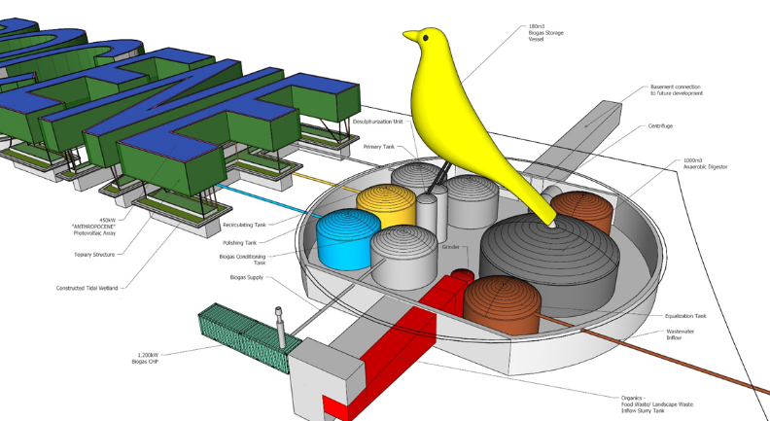

Figure 14 - ANTHROPOCENE Plant Overview Cut-away

Raw waste is shredded to reduce to its particle size to less than 12 mm, this produces a uniform feed and reduces plant “down-time” due to pipe blockages by large food particles. Shredding also improves mechanical action and digestibility and enables easy removal of any plastic bags or cling-film from waste. It is proposed that new buildings coming online incorporate “insinkerators” into kitchens and this nutrient rich waste-water stream is directed to the biogas plant.

Fresh waste and re-circulated digestate are mixed in a mixing tank. The homogenized waste stream is pumped into the feeding tank, from which the anaerobic digestion system is continuously fed. The feeding tank also acts as a pre-digester and subjected to heat at 55-60C to eliminate pathogens and to facilitate the growth of thermophilic microbes for faster degradation of waste.

From the pre-digestor tank, the slurry enters the main digester where it undergoes anaerobic degradation by a consortium of Archaebacteria belonging to Methanococcus group. The anaerobic digester is a continuous stirred tank reactor (CSTR) having an average retention time of 15 – 20 days. The digester is operated in the mesophilic temperature range (33 – 38°C), with heating carried out within the digester. The digested substrate leaving the reactor is a valuable resource rich in nutrients such as nitrogen, potassium and phosphorus, beneficial for plants and soil conditioning.

As per conservative estimates, each ton of food waste produces 150 – 200 m3 of biogas, the SENTINEL is a key component of the biogas plant, it is a 180m3 biogas storage vessel fed from the CSTR.

Biogas contains significant amount of hydrogen sulphide (H2S) gas which needs to be stripped off due to its corrosive nature. The biogas is eventually utilized in a combined heat and power (CHP)[8] unit for its conversion into thermal and electrical energy. A 700kWp tri­generation power unit[9] where some of the heat produced by the cogeneration plant is used by an absorption chiller to generate chilled water for air conditioning or refrigeration. Approximately 80% of the CHP output can be utilised as an energy source for a highly efficient, double-effect steam chiller.

The indicative energy outputs per m3 of biogas are approximately 1.7 kWh electricity and 2.5kWh heat, 3.86kWh of heat will produce 1 TR (tonne of refrigeration).

Processing 20 tonnes of the City’s waste per day is expected to yield approximately 4.6MWh of energy per year.

# EXPECTED ANNUAL kWh

The following tables outline the expected annual kWh output from both the PV array and the biogas plant. Two different photovoltaic technologies were considered, amorphous silicon (a-Si) and crystalline silicon (c-Si), the c-Si panels, with a 573kWp nameplate capacity have been used for the final output calculation.

The CHP unit proposed for the biogas plant has a 700kWp nameplate capacity.

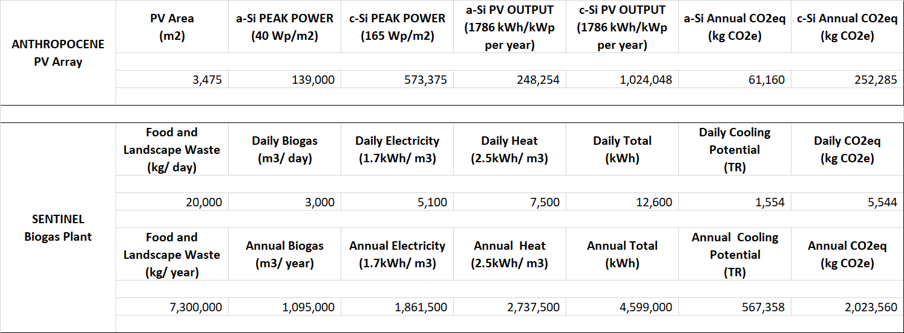

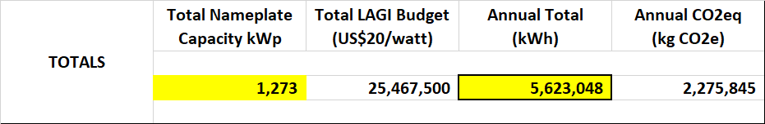

Energy equivalencies[10] shown below translate the reduced CO2 emissions due to the ANTHROPOCENE installation into more easily digested format.



Figure 15 - Energy Equivalencies

# CONCEPTUAL COST ESTIMATE



This USD18 million order of magnitude costing suggests that the ANTHROPOCENE installation will fall well below the USD20/Watt budget of USD25.5 million.

# ENVIRONMENTAL IMPACT STATEMENT

**Context** - the site, is essentially two degraded brownfield areas set aside for the next phase of development for MASDAR City. Traffic will circulate around the site and bisect it. The pedestrian experience is currently poor, and efforts should be made to ameliorate against harsh and extreme summer conditions.

**Character** - MASDAR is a development founded on innovation, education and a commitment to a sustainable future.

**Significance** – ANTHROPOCENE will provide a daily reminder to all those who live, work and visit MASDAR City of the importance of what this development stands for.

**Sensitivity** - the development respects and builds upon MASDAR’s mission. It is in this spirit that the ANTHROPOCENE attempts to bring a new destination to the region which is grounded in contemporary sensibilities and concerns.

The existing environment and the impacts of the development are explained by reference to its possible impact on the following series of environmental topics:

**Humans**

* **Economic Activity** - this new eco-attraction is designed to enhance MASDAR’s tourism draw and so should prove to be a significant boost to economic activity.
* **Social Patterns** - the new development is likely to bring a broader demographic to the area and will provide new social amenities for residents.
* **Land-use** - the change of land-use from a dilapidated brownfield site to a techno-botanic garden will enhance the social and economic value of the land considerably.
* **Employment** - the ANTHROPOCENE installation will create jobs directly and indirectly. These will include tour guides, botanists and gardeners, systems maintenance and operations staff and retail and hospitality roles.
* **Health and Safety** - issues relating to water treatment should be addressed and monitored closely. The access of the general public to the base of the SENTINEL needs to be considered and sensitively controlled as this is part of a biogas plant. Risks of Hydrogen Sulphide and Methane leakage need to be addressed and monitored. The ANTHROPOCENE PV topiary structures span across the road bisecting the site and so traffic calming measures and pedestrian crossings need to be introduced.

**Fauna and Flora**

The development is intended to inject dense bio-diversity onto a site that is currently degraded. The expected results from this will be improved habitats; enhanced breeding/ feeding/ roosting areas; and increased mammal/ bird/ fish/ insect/ reptile populations. The biomass produced from the topiary, wetlands and associated landscaping areas is an essential feedstock for the biogas plant.

As an educational and innovation facility ANTHROPOCENE will provide opportunities for critical and protected species to be encouraged and managed.

**Water**

The ANTHROPOCENE constructed wetland beneath the PV array is an ecological waste-water treatment system based on fixed-film ecology and the ecological processes of a natural tidal wetland, one of nature’s most productive ecosystems. This offers up an ecological alternative to conventional waste-water treatment for MASDAR and will act to reduce environmental damaging aspects associated with traditional sewage treatment, such as toxic sludge production and intensive chemical use.

The proposal aims to work with, enhance and manage the watercyle within the City and to that end chemical and biotic environmental issues must be monitored.

**Air**

The installation is intended to have a dramatic impact on air quality, both pollutants and suspended particles including those due to vehicle emissions and dust. In effect the topiary structures and the wetlands below are acting like a giant air filter drawing polluted air through them, this will be monitored and made available to the public.

The topiary, corresponding wetlands and peripheral landscaping will also have a noise dampening effect. The biogas CHP unit is configured to limit NOx emission levels to less than 200ppm and the unit is acoustically insulated to ensure noise emission levels of 35 dB (A) at a distance of 10 m.

**Climatic Factors**

The removal of the degraded brownfield sites and the corresponding installation of intense vegetation will positively impact on the heat island effect. The introduction of approximately 3,500m2 of topiary structures and affiliated landscaping will provide shade to pedestrians throughout the year.

The combined output of the installation’s energy systems will offset 2,275 tonnes CO2eq per annum.

ANTHROPOCENE attempts to build upon interrelationships between these factors and provide MASDAR City with a unique world class eco-installation that inspires those that visit, work and live there, and acts to educate the next generations.

1. Sir David Attenborough “*The Garden of Eden is No More*”, World Economic Forum, Davos, 2018
2. <https://www.onyxsolar.com/documents/ColoredPVGlass-EU.pdf>
3. https://www3.epa.gov/npdes/pubs/living_machine.pdf
4. https://www.ead.ae/Pages/al-wathba-wetland-2.aspx
5. https://www.vitra.com/en-us/living/product/details/eames-house-bird-walnut
6. https://www.stockholmresilience.org
7. <https://sswm.info/> - Design of Biogas Plant
8. http://www.2g-energy.com/products/biogas-product-line/
9. There is potential to expand this by putting further CHP units in the basements of new buildings as they come on-line.
10. https://www.epa.gov/energy/greenhouse-gas-equivalencies-calculator