(Re)storing Balance
Theme and Inspiration
Restoring balance
The heart of this installation is a 43m balance scale, with two beams holding up a number of spheres. One of the beams is off balance. This tipped beam represents the imbalance of the supply and demand of our natural resources and energy. The other beam, holding up two large spheres on either ends, is perfectly balanced, representing the state we aim to be, achieving balance of supply and demand of natural resources and energy.
The focal point of this art piece is the balanced beam with spheres filled with sand for thermal energy storage. The balance of the thermal energy storage system illustrates the role of an energy storage in balancing the supply and demand of energy between day and night.
Return to the source
This installation aims to highlight the natural environment and natural resources that played a key role in shaping Abu Dhabi’s culture and identity: sun and sand. “Restoring Balance” draws on the two iconic sources to highlight Masdar City’s unique natural environment and to create a platform for residents and visitors to connect with the natural roots of this city and its surrounding environment.
Rising from the source
While sun and sand are historically associated with agriculture, advances in renewable energy and Masdar City’s involvement in renewable energy technology research have changed the significance and association of the two resources. By harnessing the energy from the sun to generate electricity and using sand as a medium for thermal energy storage, “(Re)storing Balance” draws from the local sources with significant historical importance to create new possibilities for the future.
Renewable Energy Technologies:
Main Components:
“(Re)storing Balance”, displayed in the shape of a balance scale, is primarily composed of a Concentrated Solar Plant (CSP) and Thermal Energy Storage (TES), and a smaller component of sun tracking solar PV panels.
The CSP consists of a field of reflective heliostats, a solar receiver, a heat exchanger/ steam generator, steam turbine, condenser, and water storage. The TES consists of two large storage tanks, one for heated sand, and one for cooled sand. The two components of the system are connected by a heat transfer medium loop.
How it works:
The CSP uses a field of reflective heliostats to direct the sunlight to the solar receiver at the top of the sculpture. The solar energy is concentrated at the receiver to heat up the heat transfer and heat storage medium- sand, an abundant, economical and local resource. The sand is heated up to around 800°C in the solar receiver, and is then transported by a conveyer belt system to be stored in the insulated hot storage tank in the form of thermal storage until it is needed. Once needed, the hot sand is transported through a heat exchanger where water is injected, and heated up to create the high pressure steam that runs the steam turbine to generate electricity. Once the sand has passed through the heat exchanger, it is cooled and transported to the cooled sand storage tank, ready to be sent up to the solar receiver to begin the cycle again. The steam that passes through the turbine condenses in the top stacked sphere and is collected and stored in the lower sphere until needed.
With TES, this design is capable of generating electricity day and night. Energy in the form of heat is stored in the sand during the day, and at night when there is no sun, the stored hot sand can maintain a high enough temperature to generate steam for the turbine.
Advantages of CSP – solar tower
Although CSP is not a due its higher capital cost relative to solar PV, there are some advantages to CSP, especially solar tower, that support its rise in popularity to become the preferred technology in the future Some advantages of CSP include (IRENA, 2012):
- Opportunity to use thermal energy storage
- Concentrated heat energy can achieve higher temperatures that allow:
  - Opportunity to use thermal energy storage
  - Greater efficiency of the steam cycle
  - Greater temperature differentials in storage for more cost effective storage option
Using sand as energy transfer and storage medium
The unique feature of this design is the use of sand as the heat collector, transfer and storage medium. According to early research, using sand instead of conventional molten salt presents the following advantages (Iniesta A. C., et al., 2015):
- Sand is locally abundant in Abu Dhabi
- Sand is thermally stable at a higher temperature than molten salt, allowing higher operational temperatures, which results in higher efficiencies for the system.
The use of sand in TES is a research project by the local Masdar Institute. The incorporation of the new research in this design show cases the locally developed innovation to improve the performance of TES while reducing cost and environmental impact.
Capacity:
Capacity (Refer to Appendix for calculation breakdown):
 | Name Plate Capacity | Estimated output based on site condition
CSP + TES | 10,000,000 W | 5.2 MWh
Solar PV | 288,000 W | 493,560 kWh
Total | 10,288,000 W | 5.7 MWh

Estimated Project capital cost (Refer to Appendix for calculation breakdown):
 | $/ W | Estimated cost | Max budget ($20USD/W)
CSP+ TES | $6.4 / W | $64,000,000
Solar PV | $ 3/ W | $ 9,000,000
Materials |  | $450,000
Total |  | $73,450,000 | $205,760,000

Materials and Dimensions
Materials:
- Sand
- Water
- Concrete
- Structural steel
- Steel sheets
Dimensions:
- Max height at top of solar receiver:
  - 43m
- Area cover by array of heliostats and PV panel cylinders:
  - 250m x 65m (including area allowance for future road)
Environmental Assessment
“(Re)storing balance” primarily a CSP and TES, therefore, for environmental impacts for this installation will be based on impacts for the construction and operations of a CSP and TES.
As a CSP with a steam turbine, “Restoring Balance” does not require a fuel for the operations of the plant and can be considered as a carbon neutral power plant.
Typically, the largest environmental impact for all types of concentrated solar power plant is land use. Concentrated solar plants require a lot of land, and has significant environmental impact on habitat destruction if developed on ecologically sensitive areas (Ehtiwesh, 2016). However, as the area allowed for this design is an existing parking lot, and the master plan does not indicate that the area is ecologically significant, we can assume that construction a CSP in the designated space will have minimal environmental impact on the existing parking lot land.
Another component of the CSP and TES system with the negative environmental impact is the heat collector, transfer and storage medium (Nathanael Ko et al.,). Typically, conventional TES uses either molten salt or synthetic oil as the heat transfer medium. Environmental impact of using molten salt or synthetic oil includes the carbon emitted to import a large quantity of the material, as well as the disposal of the material during deconstruction. However, “(Re)storing Balance” uses sand as a heat transfer fluid instead. Compared to the conventional materials used as heat collector, heat transfer and thermal energy storage such as molten salts or synthetic oils, sand is a non-toxic, local and readily available material with comparably less environmental impacts (Iniesta, A.C., et al, 2015).
Word count: 1197
References
IRENA. (2012), Concentrating Solar Power, Renewable Energy Technologies: Cost Analysis Series, volume 1, Issue 2/5.
Iniesta, A. C., et al., (2015), Gravity-fed combined solar receiver/storage system using sand particles as heat collector, heat transfer and thermal energy storage media. Energy Procedia 69, 802-811.
Ehtiwesh I.A.S., (2016), Exergetic and environmental life cycle assessment analysis of concentrated solar power plants. Renewable and Sustainable Energy Review, 56, 145-155.

Appendix

Estimated cost of Solar PV= $3/W
Estimated cost of CSP + TES plant with approximately 6 hours of storage= $6400/ kW; $6.4/W
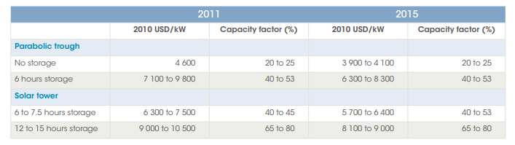
CSP capacity:
Estimated nameplate capacity: 10 MW (IRENA, 2012); used lowest capacity as reference
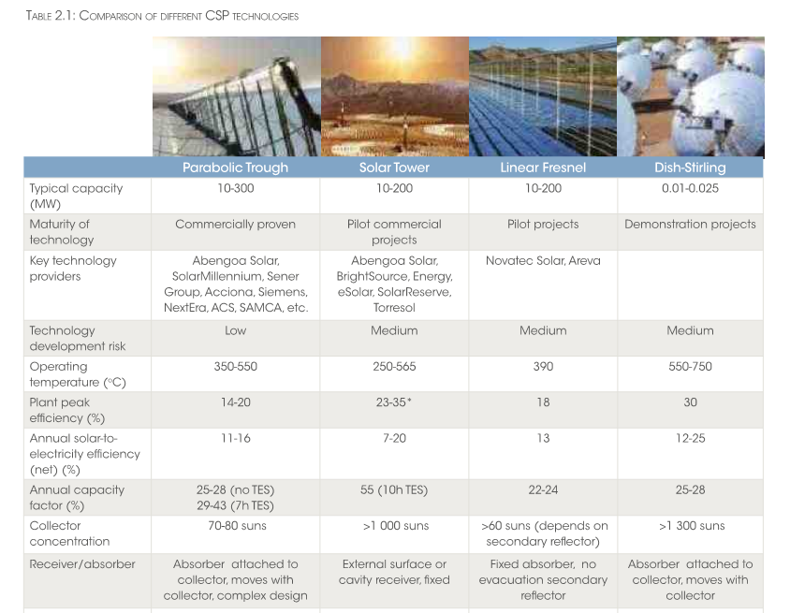

Cost of steel:
- Steel- avg $1500/ metric ton (https://www.costowl.com/home-improvement/other-metal-fabrication-cost.html)
  - Approximate 300 ton required = 600 x 300 =$180,000
CSP output calculation
Annual electricity output
E= nameplate capacity x annual average solar radiation x performance ratio
- Name plate capacity= 10,000,000 W (based on lowest of the average installed CSP capacity range) (IRENA, 2012)
- Annual average solar radiation in Abu Dhabi= 2285 kWh/m2/y (https://www.hindawi.com/journals/isrn/2012/328237/)
- Performance ratio= 0.23 (based on lowest of average efficiency range)

Energy= 10,000,000 W x 2285 kWh/m² /yr x 0.23 = 5,255,500,000 Wh = 5.2 MWh

Solar PV Panel
Solar panel area= 80m x 30m x ~0.8 =1920m2
- 150W/m2 , 150x 1920m2 = 288,000 W (https://www.theecoexperts.co.uk/solar-panels/how-much-electricity;)
- 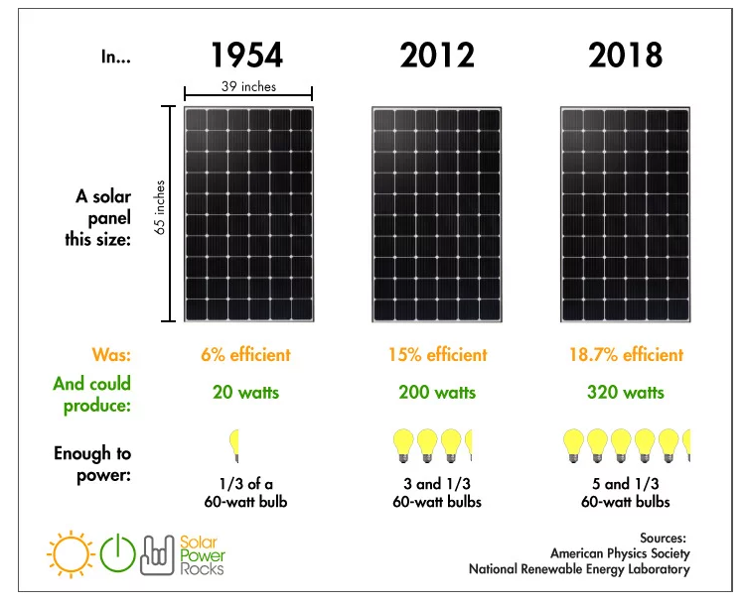

Annual electricity output
E= total panel area x solar panel yield x annual average solar radiation x performance ratio
Total panel area= (80m x 30m) x 80% = 1920m²
- Field area is 80m x 30, estimate only 80% is covered with panels on cylinders
- Solar panel yield efficiency= 150 Wp/m² (https://www.theecoexperts.co.uk/solar-panels/how-much-electricity;)
- Annual average solar radiation in Abu Dhabi= 2285 kWh/m2/y (https://www.hindawi.com/journals/isrn/2012/328237/)
- Performance ratio= 0.75 (default)
Energy= 1920m² x 150 Wp/m² x 2285 kWh/m² /yr x 0.75 = 493,560,000 Wh = 493,560 kWh

