Eco-dunes

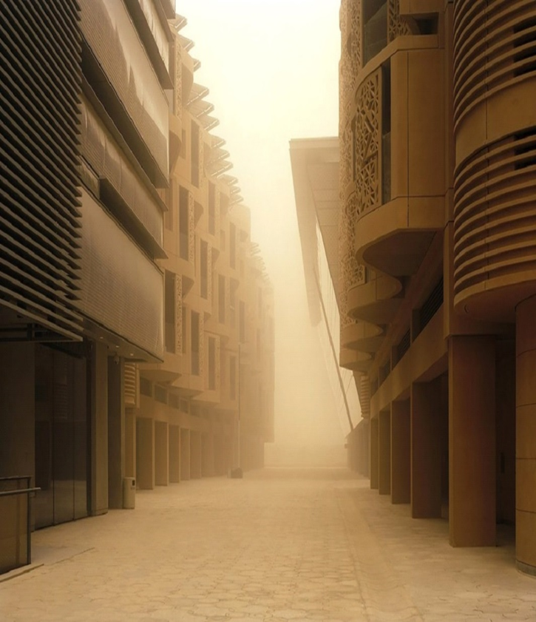
Figure 1. MASDAR: A Green City in the Middle East plagued by Dust Storms

“Nothing is built on stone, everything is built of sand, but we must build as if the sand were stone.”
-Jorge Luis Borges-

Introduction:
- Large sand and dust storms, which result from a combination of strong winds and loose dry soil surfaces in arid and semiarid areas, are detrimental to human health, agricultural land, infrastructure, and transport. Every year, an estimated 2,000 million tons of dust is emitted into the atmosphere. While much of this is a natural part of the biogeochemical cycles of the Earth, a significant amount is generated by human-induced factors, especially unsustainable land and water management.
The Middle East is known as an arid and semi-arid region with frequent and severe dust storms. In the United Arab Emirates, the Rub’ al Khali sandy desert, residing in the Sabkha Matti, which extends from the Emirates into Saudi Arabia, has sand dunes that provide a source of sand that sandblasts the surface to generate dust storms. Sand storms are reportedly becoming an environmental problem in the area. Therefore, one of the concerns in Masdar as a green city in Middle East is sand storms and the resulting dust that can trigger asthma, respiratory diseases and other infectious diseases. Sand storms can also regularly cause road accidents and flight delays. On the other hand, the resulting dust of sandstorms would accumulate on the solar panels built in Masdar thus hampering output. For example, in August 2009, when the amount of suspended dust in the air was between 1,500 and 2,000 parts per million (more than 10 times higher than normal), the Masdar solar plant was functioning at 40% below its capacity.

- In the design process of Ecodunes a new method is used to fight sand storms and desertification. In the proposed method, a specific bacteria, called Bacillus Pasteurii, is poured onto a pile of sand and starts filling up the void between the grains. A chemical process produces calcite, which is a kind of natural cement that binds the grains together. The whole cementation process takes about 24 hours.
In our designed architectural element, we made a sand dune and used Bacillus Pasteurii bacteria to solidify the necessary parts. We then excavated the sand to ultimately produce our architecture. This method of solidifying the sand provides a physical support structure for our designed public space inside the sand dune.
We found microalgae to be a promising source of renewable energy in our design. The shade inside the sand dune protects microalgae from the high solar radiation in Abu Dhabi, and creates a perfect place for harvesting microalgae.

Technology:
- In this project two technologies are used to help us achieve our project goals. One is used as a solution to fight an environmental problem in the area, and other is used as a source of renewable energy in our design. Both are explained precisely in the following paragraphs:

- Bacillus Pasteurii:
There are various ways to control wind erosion and thus reduce dust. In recent years, green and environmentally-friendly biological technology called microbial deposition (MICP calcium carbonate) has been developed as a soil improvement method. In MICP, urea hydrolysis produces carbonate ions, and ammonium by bacterial cells or pure urease enzymes as catalysts. In the following, the produced carbonate ions easily Causes deposition of calcium carbonate in the presence of a calcium source.

CO(NH₂)₂ + 2H₂O 2NH₄+ + CO₃²⁻
Ca²⁺ + CO₃ ²⁻ CaCO₃

The MICP has a relative biological superiority from two aspects. On the one hand, its environmental effects are relatively low due to the use of native bacteria in the soil. On the other hand, because the composition used in MICP is aqueous solution (Bacteria and cement solution) and its subsequent treatment occurs after dye injection, it is easier to apply in field-scale and large scale conditions. The formation of soil-resistant structures through the MICP process can significantly reduce soil erosion, stabilize sand dunes to control dust and restore vegetation. In MICP technology, the Bacillus Pasteurii bacteria is used as an Urease producing bacteria. Reasons for choosing Bacillus Pasteurii or Bacillus Cereus are that it naturally occurs in the subsurface and is a common bacterium. It is an aerobic microbe especially good for making the soil water more alkaline by improving the pH value. It is efficient at CO₂ production along with pH rise in its neighboring environment which stimulates precipitation of CaCO₃. This compels Ca and CaCO₃ present within water to conglomerate, forming microscopic CaCO₃ Crystals– calcite. It consumes urea as the energy source and so offers dual CO₂ sources – urea decomposition by urease and cellular respiration.

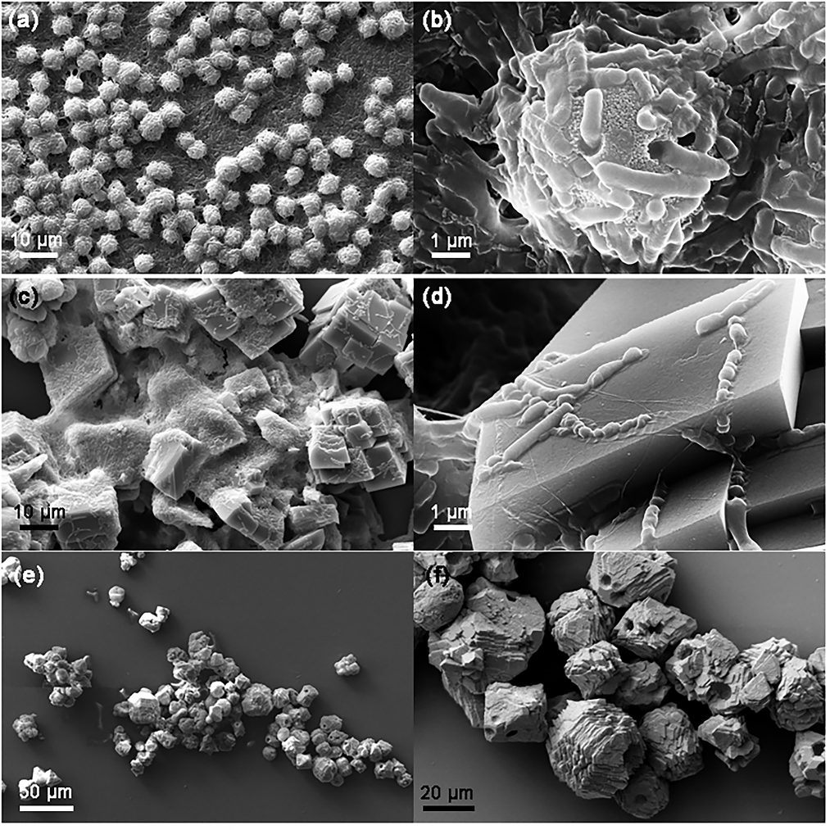
Figure 2. Bacillus Pasteurii in different scales
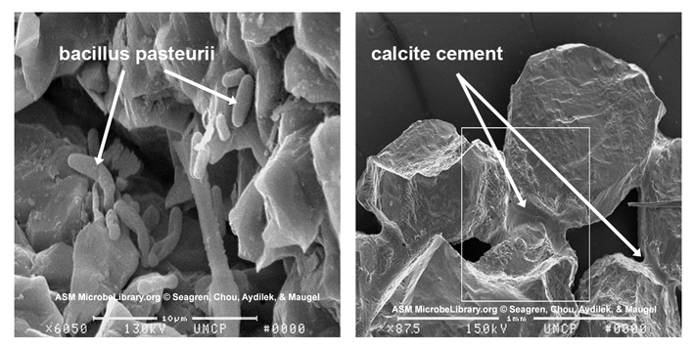
Figure 3. Cementation Process

- Microalgae:
With rising energy consumption in the world and the depletion of fossil fuels in the near future, we have to make sure that energy security is guaranteed when conventional energy sources are depleted. Nowadays, the energy we use is from fossil fuel sources. The generation of energy releases the greenhouse gas (CO₂). Since energy is transported over large distances, it needs to be generated locally and from a sustainable source to have energy security. Currently popular sustainable energy harvesters are wind turbines and photovoltaic panels. These systems can sustainably generate electricity, but they cannot take up CO₂ to support the goal of meeting the value of 20% below the 1990 level by 2020. Microalgae can mitigate the CO₂ and produce energy at the same time. Algae, microalgae in particular, is capable of producing energy from the sunlight through photosynthesis, just like plants. And, in this process, they consume CO₂ from the atmosphere and release oxygen, making it ideal for clearing up the mess created from our fossil fuels. In addition, they can also use carbon dioxide produced by Bacillus Pasteurii. But what is even more interesting with microalgae is its ability to produce fuel. Some of these microorganisms produce oils in order to store the energy and it is possible to use these oil as fuel for our cars and even as an alternative protein source for us. Also, considering the potential of the site, we can use seawater which is suitable for algae growth. So, due to its proximity to the sea, will save on shipping costs. Algae can effectively sequester carbon dioxide and treat wastewater while increasing its growth efficiency. These properties give it great potential for integration with other infrastructural systems. Synergies can be developed into closed-loop systems within the built environment, resulting in lower CO₂ emissions, O₂ production, nutrient reuse and efficient energy generation.
These multi-layered benefits of algae cultivation have strong potential for sustainability methods to utilize algae-integrated systems. Algae’s high ecological performance generates a multi-fold contribution towards improving the health of the environment. With its combination of carbon neutral energy production and recycling of environmental pollutants, the integration of algae cultivation into the built environment opens a new dimension in sustainability design.
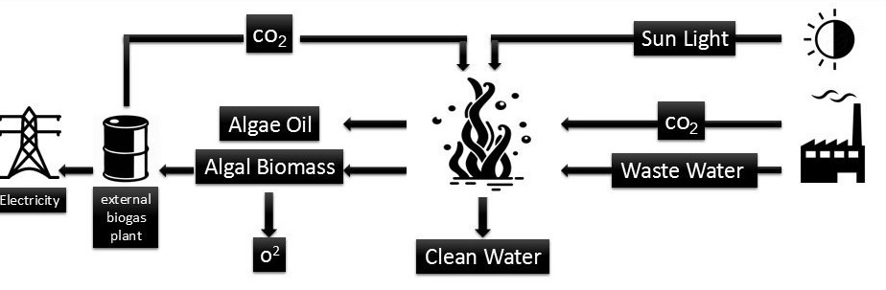
Figure 4. Applications of Algae as a renewable source of energy

Cost Estimate:
- Microalgae are commonly known to double their weight with respect to biomass within 24 h. Some species have doubling times as short as 3.5 h i.e. multiple biomass divisions per day. This high productivity imparts the potential for the modern high theoretical yield production of the yield of 47000–308000 L / ha ammun. The heat of combustion of the algae is 10000 BTUs per lb.

- The production cost of algal biomass in an idealized raceway pond system (The base case production cost) is 1.6 pound / kg to 1.8 pound / kg and the projected case cost is 0.3 pound / kg to 0.4 pound / kg.

- One cubic meter of bacterial sand would be about 11 dollars with an initial cost of 60 dollars to buy the bacteria.
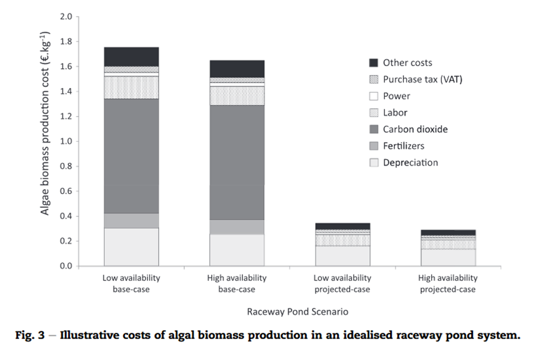

Figure 5. Illustrative cost of algal biomass production in an idealized raceway pond system.
Environmental impact:
- One of our goals in this project was to take an environmental problem in the area as an opportunity to present a solution that would allow us to design a sculpture made from natural materials (bacteria and solidified sand) so that it would have no destructive environmental impact and would be aligned with goals of Masdar as a green city.

- Injecting Bacillus Pasteurii bacteria to the sand dunes has three benefits for us:

- It binds the grains and adds roughness to the sand dunes.
- It provides a physical support structure and creates relatively cool public spaces inside the sand dunes when compared to the high temperature in Abu Dhabi.
- It creates spaces with shade inside the sand dunes that are suitable for placing algae ponds to keep them safe from high solar radiation in Abu Dhabi.

- Using algae as a source of renewable energy in our design is widely regarded, based on their high growth rates, as having high oil content and the ability to grow in waste water. Algae, microalgae in particular, consume CO₂ from the atmosphere and release oxygen, making it ideal for clearing up the mess created from the use of fossil fuels. Additionally, they can use carbon dioxide produced by Bacillus Pasteurii. Some of these microorganisms produce oils in order to store energy that can be used as fuel for our cars and even as an alternative protein source for us. Also, considering the site’s proximity to the sea, we can use seawater, which is suitable for algae growth, and also save on shipping costs at the same time.

- References:

[1] UNEP, WMO, UNCCD (2016). Global Assessment of Sand and Dust Storms. United Nations Environment Programme, Nairobi.
[2] Magnus Larsson. (2009, July). Turning dunes into architecture [Video file]. Retrieved from https://www.ted.com/talks/magnus_larsson_turning_dunes_into_architecture#t-674683
[3] M. Movahedan, N. Abbasi, M. Keramati, (2012), “Wind erosion control of soils using polymeric”
[4] M. Maleki, S. Ebrahimi, F. Asadzadeh, M. Emami Tabrizi, (2016), “Performance of microbial-induced carbonate precipitation on wind erosion control of sandy soil”, International journal of Environmental Science and Technology
[5] A. Rajan, A. Al Rawahi, A. Sen, F. Al Abri, Sh. Benny Thekkedath, (2017), “Study of Anti-desertification Techniques involving Microbes in Oman”, International Journal of Applied Sciences and Management
[6] Rawat, R. Ranjith Kumar, T. Mutanda, F. Bux (2012).Biodiesel from microalgae: A critical evaluation from laboratory to large scale production
[7] Raphael Slade*, Ausilio Bauen(2012). Micro-algae cultivation for biofuels: Cost, energy balance, environmental impacts and future prospects.
[8] John R. Benemann, Joseph C. Weissman, Ben L. Koopman & William J. Oswald. Energy production by microbial photosynthesis
[9] https://www.greentechmedia.com/articles/read/masdar-update#gs.bdsgrg

