Masdar Calligraphy

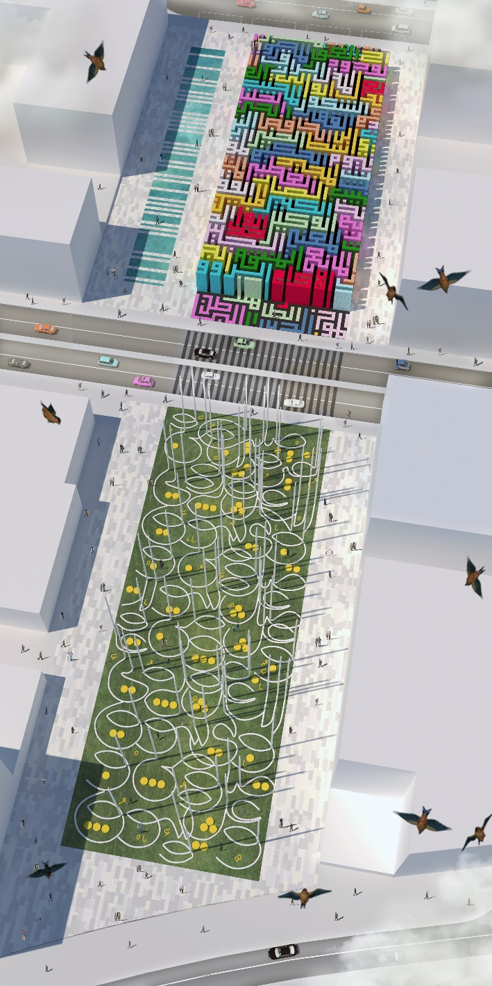 | Intro  Calligraphy is considered the quintessential art form of the Islamic world and its prevalence is not simply related to its non-figural tradition; it rather reflects the centrality of writing and written text, as according the tradition “the first thing God created was the pen”. Real “source” of the Islamic culture, calligraphy is revered as a medium of infinite duration and visual expression of faith and knowledge. It is noteworthy that the United Arabic Emirates host every other year the Dubai International Calligraphy Exhibition as the climax of the cultural scene of the year, as well as the outcome of the region’s social identity. With our proposal, then, we envision a fertile dialogue between Dubai and Abu Dhabi under the aegis of the Arabic script that we use as a “source” inspiration for our land-art work. As the Islamic calligraphy has developed a vast range of styles, we decided to assign a representative style to each of the two areas of the site. The Square Kufic (kufi mrabba’) to the north west area as a link to the past and a more curvilinear contemporary Naskh-like style to the south-east as a link to the future. The whole forms a unique rectangular layout: the Masdar Calligraphy.

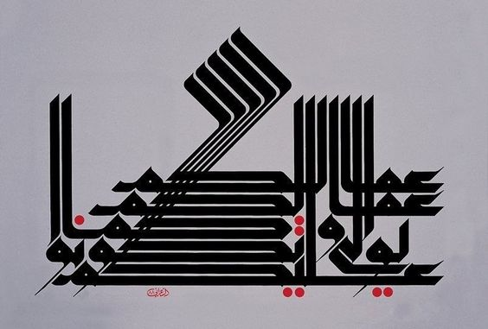

The Kufilab: let’s rewrite our own energy

The North-West area of the site hosts the Kufilab an installation of roughly 2318 m² originated by the vertical extrusion of an urban-scale Kufic text creating a sort of outdoor labyrinth with chambers. The hemstitch roof and the elevations are cladded with modular colored solar panels produced by the Dutch company Kamaleon Solar. The result is a monumental and extremely modular complex taking advantage from the geometric regularity of the Kufic style. The interiors are characterized by a series of “open chambers” carved in the mass of the volume. Each chamber presents one of the historical developments of the art of script both in the past as in the future. The quite infinite range of paths allows a non-conventional discovery of the Islamic calligraphy that can be adjusted year after year.

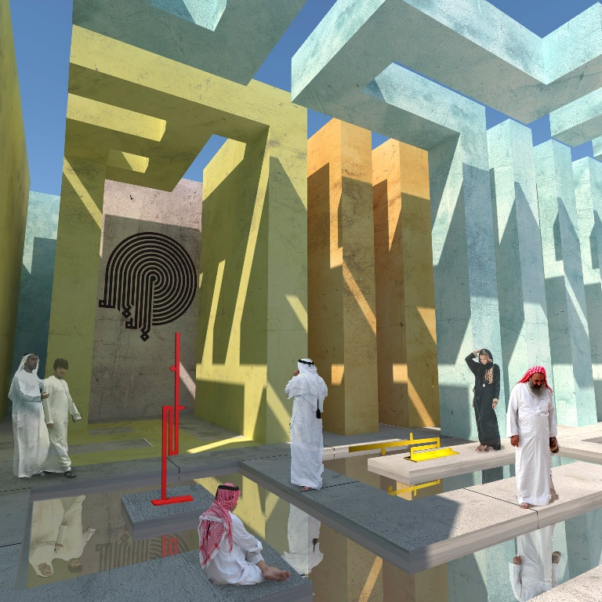

The Wind Words: producing and saving energy

The South-East area accommodates a lawn punctuated by 85 curvilinear characters and a series of orange dot-like elements for power storage. Each of the character is composed by a vertical pipe and a curvilinear base. On top of each of the 25 m high pipes there is a 2.40 m high VAWT produced by the company WINDSIDE. While creating a playful urban space composed by circular spaces, the aim of each of this element is twofold:
- Produce energy with the VAWTs;
- 2) Create a passive system of Canadian wells;
The Eolic system has a nameplate power of 259 Wp and a production of more or less 21 250 kWh per year (see more details in the next paragraphs).
The Canadian well system works as follows: below the VAWT an air intake lets air into the hollow pipe. A series of small fans draw the air to the ground while gradually cooling it. After the circular base the pipes go 3m below ground following a path of at least 30 m in order to reach the dew point at the stable temperature of 15° C. The humidity contained into the air is condensed and stocked into several tanks below ground to be used for irrigation purposes, while the cooled air is injected to the close-by buildings.

Budget, energy production and costs

The Kufilab

The Kufilab has been conceived with a 1mx1m modular grid and it will be realized with the following main materials:

- Prefabricated concrete walls (1.00mx8.00 mx0.16m) tinted in the mass
- Photovoltaic Solar Panels Kamaleon Solar Color Blast.
- Deactivated concrete slabs at the floor

The exterior surfaces are cladded with modular panels (1mx1m) with an overall surface of 3892 m². The panels used are ColorBlast of Kamaleon Solar (www.kamaleonsolar.com) We involved the company from the early stage of conception and we can declare the following data:

Nameplate Power: 100 Wp per 1mx1m panel

Kufilab Nameplate Power: 389kWp

Budget: 3892(m²) x 100(Wp) x20 ($)= 7.784.000$

Year Production: 498.218kWh/yr (conservative estimate)

Divided according the following table provided by the experts of Kamaleon Solar.

COLOR | ROOF |  | SE ELEVATION |  | SW ELEVATION |  | NW ELEVATION |  | NE ELEVATION |  | KUFILAB
 | AZIMUTH (128°) |  | AZIMUTH (128°) |  | AZIMUTH (218°) |  | AZIMUTH (308°) |  | AZIMUTH (38°) |  | AZIMUTH (38°)
 | INCLINATION (0°) |  | INCLINATION (90°) |  | INCLINATION (90°) |  | INCLINATION (90°) |  | INCLINATION (90°) |  | INCLINATION (-°)
 | M² (1X1M) | kWh/yr | M² (1X1M) | kWh/yr | M² (1X1M) | kWh/yr | M² (1X1M) | kWh/yr | M² (1X1M) | kWh/yr | M² (1X1M) | kWh/yr
PINK | 142 | 25503 |  |  | 121 | 11015 |  |  | 96 | 5978 | 359 | 42495
FUCSIA | 249 | 41525 |  |  | 42 | 3824 | 16 | 996 | 87 | 5418 | 394 | 51763
BLUE | 260 | 43360 |  |  |  |  |  |  | 31 | 1930 | 291 | 45290
LIGHT BLUE | 180 | 30019 | 79 | 7193 | 47 | 4279 |  |  | 23 | 1433 | 329 | 42923
DARK GREEN | 224 | 35633 |  |  | 55 | 4776 | 15 | 934 | 39 | 2316 | 333 | 43659
ORANGE | 208 | 34688 |  |  | 39 | 3550 |  |  | 32 | 1993 | 279 | 40230
RED | 141 | 23515 | 111 | 10105 |  |  |  |  | 40 | 2491 | 292 | 36111
CORAL | 153 | 25516 |  |  | 71 | 6464 | 71 | 4421 | 104 | 6476 | 399 | 42878
LIGHT GREEN | 159 | 26516 | 47 | 4279 |  |  | 142 | 8843 | 8 | 499 | 356 | 40136
LIGHT PINK | 147 | 24515 |  |  | 111 | 10105 | 23 | 1433 | 8 | 499 | 289 | 36551
CYAN | 183 | 30519 | 39 | 3550 | 48 | 4370 |  |  | 40 | 2491 | 310 | 40930
YELLOW | 173 | 28851 |  |  | 32 | 2914 |  |  | 56 | 3488 | 261 | 35253
TOTAL | 2219 | 370159 | 276 | 25126 | 566 | 51296 | 267 | 16626 | 564 | 35010 | 3892 | 498218

CONCEPTUAL COST ESTIMATE for the KUFILAB
Typology | quantity | unit | cost ($) | Total
Wall Concrete | 4121 | m3 | 108 | 445.068,00 USD
Wall Steel | 166,4 | t | 936 | 155.750,40 USD
Formworks | 50 | unit | 300 | 15.000,00 USD
Deactivated Concrete Slabs Finishing | 2318 | m² | 150 | 347.700,00 USD
Foundations Concrete | 1391 | m3 | 108 | 150.228,00 USD
Foundations Steel | 209 | t | 936 | 195.624,00 USD
Excavation Works+Transportation | 2318 | m3 | 50 | 115.900,00 USD
Pv panel | 3892 | m² | 700 | 2.724.400,00 USD
Power storage+management | 498218 | kWh/yr | 1 | 498.218,00 USD
Interior decoration | gross estimation |  |  | 500.000,00 USD
Installation+Labor cost | gross estimation |  |  | 540.000,00 USD
TOTAL |  |  |  | 5.687.888,40 USD

The Wind Words site

The Wind Words park is composed by 85 letter-like elements. Following the list of the main materials:

- 25 m high hollow steel pipes
- VAWT WS-60 produced by the company WINDSIDE (www.windside.com)
- Subterranean PVC pipes
- Concrete Tanks for water storage

The energy production is estimated as follows:

Nameplate Power of each Windside module: 259 Wp (according the WS-60 technical sheet)

Nameplate Power of The Park: 259 x 85 = 22 kWp

Budget: 85(units) x 259(Wp) x20 ($)= 440.300,00 $

Year Production: according the experts of WINDSIDE each element can produce 250 kWh/ year with an overall production for the Park of 21.250 kWh/yr

CONCEPTUAL COST ESTIMATE for the WIND WORDS Site
Typology | quantity | unit | cost ($) | Total
25 Steel pipes | 85 | unit | 16500 | 1.402.500,00 USD
WINDSIDE WS-60 VAWT | 85 | unit | 700 | 59.500,00 USD
Power Storage | 21250 | kwh/yr | 1 | 21.250,00 USD
Subterranean PVC Pipes | gross estimation |  |  | 15.000,00 USD
Excavation Works+Transportation | 11000 | m3 | 50 | 550.000,00 USD
Tanks for wateer storage | gross estimation |  |  | 25.000,00 USD
Installation + Labour Cost | gross estimation |  |  | 200.000,00 USD
TOTAL |  |  |  | 2.273.250,00 USD

Conclusions

Total Nameplate Power of the Site : 411 kWp
Total year production: 519.648 kWh/yr

The Budget Max for the site is 7.784.000,00 + 440 300,00= 8.220.300,00 $
The overall Cost estimate for the site is 5.687.888,40+ 2.273.250,00 = 7.961.138,40 $

Environmental Impact Summary

A summary of the key environmental outcomes arising from the Masdar Calligraphy project are listed below:

- Cultural Benefits: Spread of the knowledge of the Islamic Calligraphy as milestone of the Islamic heritage.
- Tourism Benefits: the site can become one of the touristic attractions of the new Masdar City
- Economic Benefits and Investment Return: the Kufilab is supposed to have a paid access. As a conservative figure we imagine that the structure could have 30 000 visitors per year with a paying ticket of 7 $. This means that the complex could have, the capability of producing more or less 200 000 $ per year. The number of visitors could rise with the organization of special events and most of all during the Dubai International Calligraphy Exhibition.
- Regional benefits: as a cultural landmark the Masdar Calligraphy Project set a dialogue with the other cultural institutions of the region like the Louvre Abu Dhabi and the Dubai International Calligraphy Exhibition.
- Urban and local benefits: the project can become of the poles of the neighbourhood. While the Wind Words Park creates an array of small circular green spaces suitable for relaxation and leisure in small groups, the Kufilab site becomes one of the major public squares of the area.
Environmental benefits: the Canadian well system adopted in the Wind Words Park have two major environmental benefits:
  - It recuperates water from air’s humidity to use it in the public irrigation system.
  - It provides cooled air to the close-by buildings with a possible gain in between 30% and 60% of the power consumption of the HVAC system.

