Introduction

“In time and with water, everything changes”
· Leonardo da Vinci ·

Abu Dhabi is blessed with an abundance of energy. Energy is not a problem. A flourishing contemporary society has a need for another vital resource; Water is the real challenge for the Emirates and indeed the entire Arabian peninsula.

The sun is ultimately responsible for the Emirati's wealth and prosperity for two reasons: 1·Fossil fuels originate in photosynthesis. 2·Harvesting the sun’s energy with photovoltaics has become a competitive source of energy to meet an ever-increasing demand for electricity.

Nature has its own ways of processing the sun’s energy. Ecosystems depend on two processes to support life and prevent the planet from overheating: Photosynthesis and evaporation are key to understanding one of the most urgent issues of our time; Discussions of global warming tend to focus on carbon dioxide emissions. This narrow view obscures our understanding of what is really causing severe changes in weather patterns and the increasing temperature of our fragile atmosphere.

To understand this project it is important to have a brief introduction on hydrodynamical systems and the role of photosynthesis and evaporation; It is these two processes that keep our planet at the perfect temperature and - it is perhaps no incident that - these two processes are also the basis for a healthy ecosystem. The planetary eco-and-water system is subdivided into watersheds. A watershed is a defined geographical unit with a full watercycle; water evaporates from a sea - makes landfall as precipitation or mist - seeps into the ground - and is eventually transported back into the sea.

This highly simplified version of what a watershed is fails to capture the role of topsoil, plants, organisms and their function in supporting human life. Rub’ al-Khali, the world’s largest sand desert was once a functional watershed that produced an abundance of potable water. Restarting this ancient flow is the key to creating a truly sustainable and prosperous society in Abu Dhabi and its neighbour-states.

This might seem like an improbable proposition for the scope of this project but there are ample examples to show how just this can be achieved . Besides many examples involving people like Bill Mollison, Geoff Lawton, John Liu, and the Chinese government, there are advanced plans for re-greening the Sinaï . These and other examples show that creating a steady flow of potable water is not an impossible proposition but a proposition that requires investment, commitment, political alliances, education, and experimentation. Masdar city with its education and research facilities could become the source of knowledge, wisdom, and inspiration for this project.

Great challenges can only be met with the ability to dream, to think, to imagine, to wonder and change perspective. Besides inspiration, it requires debate, action and a certain amount of optimism and naivety. The First Butterfly is not just about the idea of optimism and naivety but it’s representation in time and space.

Inspiration
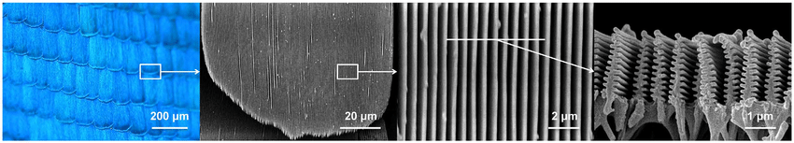
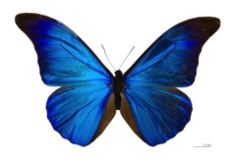
Such an ambitious project needs a place, a patron and a symbol. The Morpho is a beautiful and inspiring species of butterfly that symbolizes the greenest of watersheds. Within this little creature we have found the key to creating a beautiful, inspiring and functional artwork capable of producing energy in a highly efficient manner.
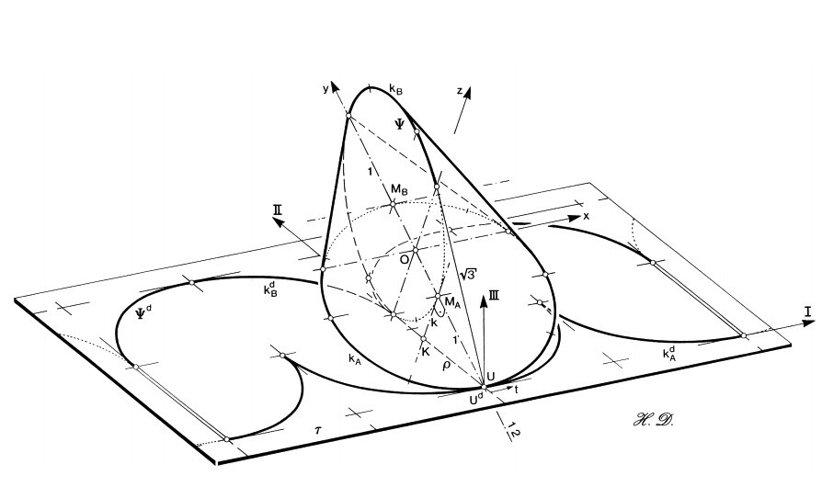
The Morpho’s beauty is produced by an arrangement of carbon in its wings. This arrangement allows the majority of light to pass through but part of the spectrum of lightwaves resonates within it. This produces a colour that reacts to its environment and varies with the angle of view. This principle has been reproduced and integrated into a glass panel. Photovoltaic cells, laminated into the glass at an interval, create a stunning visual effect and allows 15% of light to pass through.

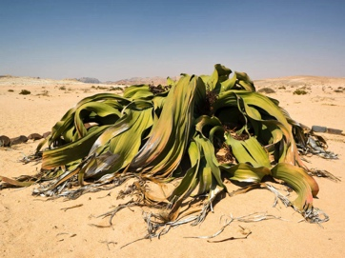
This filtered light creates the perfect cover for plants and prevents seedlings from being cooked by the desert sun. More importantly, this mimics a strategy deployed by a rather odd desert plant.
The Welwitschia Mirabilis is found in the driest of places but evergreen and huge. A single pair of broad flat leaves can grow up to six meters long with a surface area of up to 175m2 shading the ground around its stem. This allows the plant time to take up the very limited amount of water through its root system before it evaporates.

Shape
Inspired by this strategy of the Welwitschia Mirabilis we have looked for a shape that is capable of covering a patch of land during the day and revealing its purpose - fostering plant life and water retention - during the night. The oloid is an intriguing three-dimensional form that is capable of moving in a straight line as a ball would roll in any direction. It’s constructed by placing two equal circles in perpendicular planes with the center points of each circle placed on the edge of the other circle. Placing a surface between these rings in a loop that turns back on itself creates a Möbius-like shape that can only be understood in three dimensions and when unrolled is a simple flat plane. For this reason, the shape lends itself perfectly to the placement of photovoltaic cells. While regular solar arrays in the desert need to be cleaned of sand every week, this one simply sheds the sand by rolling over at night.

Time
In time a multitude of these oloids, aided by their ability to roll in a straight line, is capable of transforming a landscape on a large scale. The response of the desert to rain is extraordinary. Ephemeral plants carpet the ground and flowers produce seeds in abundance. The effect we are after is less ephemeral and explained below:

A multi-annual rhythm governs the transformation of vegetation: The first row of three oloids moves back and forth in one place for three years before moving on. Underneath it, organic waste from the surrounding area is turned into compost.
The second row of three oloids shelters a nursery for crops, perennials and trees. After three years the trees are big enough to provide shade for themselves the crops and the perennials.
During these first three years, the surrounding area will be covered with pebbles and rocks to stabilise the sand. These rocks will help establish a vegetative cover later on.

After three years the oloids move on and the crops, perennials, and trees are transplanted into the surrounding area. The trees now provide themselves and the other crops with shade. The rocks help as water is impeded and largely absorbed below stone piles and dew forms in aerated heaps. The night air condenses on the sea-facing side of the stones and soon the trees crops and perennials do the same, aided by the compost formed underneath the first row of oloids.

The rolling movement is also designed to allow for a transformation of space and activity between day and night. During the day each oloid covers a patch of ground where soil and plant life evolves. At dusk, the oloid rolls over and reveals it’s function. As outdoors life starts when the sun sets, the oloid, in its new position, creates a beacon. A place for people to gather and interact with each other and various methods for producing fertile soil, water, and electricity.

If enough energy, soil, and water producing oloids make their way through a desert through this three-year cycle they will produce a compounding effect on the entire weather system because vegetation plays an important role in weather patterns. Clouds form above forests as plants transpire. Such clouds contain more organic nuclei and plant nutrients than oceanic water. Eventually, this will dampen the heating of the area and prevent water-filled clouds from being blown away quickly, giving them time to be saturated until a point where they produce rain, in Abu Dhabi and in abundance.

Energy generation
Millions of people now purchase water at prices equivalent to or greater than refined petroleum. It is very likely that the value of land will soon be assessed by its yield of potable water. Although the ultimate outcome of this project is indeed an abundance of potable water, the short-term yield will be electricity.

One Oloid - with a diameter of ten meters for its rings - will produce an average of 380 kilowatt-hours (kWh) daily and 138,851 kWh annually. As an Emirati household uses a staggering 71,000 kWh per year, this means, on average, one Oloid can supply two households. In the US however, this number would be 14 households. On the upside, every Emirati could own his personal Oloid with a seven-meter diameter for the rings.

The primary building block of the oloid is the coloured photovoltaic module – bifacial solar cells are laminated on both sides by Kromatix coloured glass sheets that span from one metal circle to the other. Transmission of sunlight can be tuned by the filling fraction of solar cells inside the laminate, depending on the irradiation that is required for the growth of the vegetation while the optical appearance remains the same. Both bifacial solar cells and Kromatix coloured glass are mature technologies, ready for upscaling. A network of micro-electronics is used to turn on and off individual solar cells that are illuminated by solar light at any time.
Every Oloid comes with its own storage. One of the rings contains a flywheel capable of storing 60kWh for use during the night. This is far less than the 380kWh produced daily because a flywheel of that capacity would require superconducting bearings to keep the losses low enough over a 12-hour timespan.

The most important yield, however, is the production of knowledge. Visitors will be introduced to all facets of the construct and its surroundings will increase their knowledge. The oloid teaches about the transformation of vegetation, electricity generation, design, varying perspectives, resonant colour waves, and natural rhythms.

Electricity production and storage
Number of bifacial solar cells in 3D construct | 27586
Sunpreme bifacial silicon solar cell | 156x156 | mm²
kWp of 2D view of closed construct | 79,3 | kWp
Solar cell efficiency | 19,5 | %
Solar cell efficiency incl. 10% bifacial boost | 21,5 | %
Kromatix glass: transmission of sunlight | 90 | %
Annual energy generation | 138851 | kWh
Average daily energy generation | 380 | kWh
Flywheel daily storage capacity (incl. losses) | 60 | kWh
Flywheel round-trip efficiency | 93 | %
Flywheel self-discharge per hour | 1 | %
Flywheel material: Carbon Fiber Composite | 1 | %
Flywheel bearings: Hybrid Mechanical-Electromagnetic bearings

Construction & Fundability
Artistic intent and social meaning is our main focus for this ideas competition. Nonetheless, feasibility has been a key driver for the design process. We see this competition as a step in the production of a marketable product; Electricity.
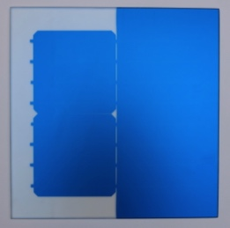
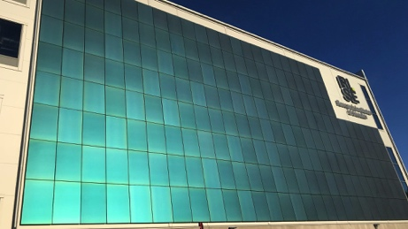
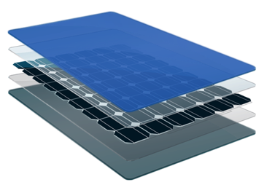
We believe a solar array can become a place of beauty and a place where nature thrives. We have made sure our design is scaleable and ready for the next step: To make it fundable. The structure is - despite its appearance - quite simple, straightforward and designable. We believe and intend to prove that it’s also buildable and even easier to maintain than current solar arrays.
Sample Principle Existing facade
Photovoltaic cells laminated into Kromatix glass: Stunning effect while retaining 90% efficiency
For the concept to be scalable it must meet two other criteria. It must come with warranties to make it eligible for insurance. These are criteria we can start to consider after the first prototypes have been built. We believe LAGI and Masdar will provide this opportunity and we made sure the entire structure is comprised of products that are already available on the market.

We see the design as the first step towards funding a prototype. The technology can become competitive when scaled. The projections for the prototype itself are as follows:

Costs | $ | $/Wp
Design | 200000
27586 solar cells (incl. micro-electronics) | 189757 | 2,39
Double-sided Kromatix coloured glass | 149297 | 1,88
Electricity inverter system 166kW | 12000 | 0,15
Electric motor for circadian turning 150kW | 10000 | 0,13
Carbon fiber composite flywheel | 38309 | 0,48
Flywheel energy storage system | 30149 | 0,38
Unforeseen 15% | 94426,8
Total | 723938,8 | 5,42

Butterfly effect
As the shape turns back on itself, so does the story:
In 1963 Edward N. Lorenz published an article on the feasibility of very-long-range weather predictions. In the introduction to his paper, Lorenz wrote:
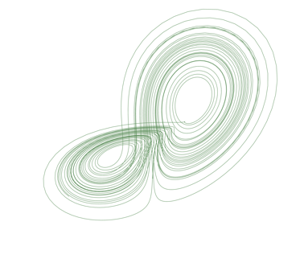
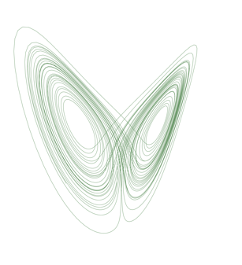
“ A closed hydrodynamical set of finite mass may ostensibly be treated mathematically as a finite collection of molecules - usually a very large collection - in which case the governing laws are expressible as a finite set of ordinary differential equations. ”
The solutions of his equations, plotted in three-dimensional space, result in a shape that is equal to the shape before you and they represent the flow of water within earths atmosphere.
Nine years later, in 1972, Lorenz gave a conference entitled “predictability: Does the flap of a butterfly’s wings in Brazil set off a tornado in Texas?” His work became popularised as: the butterfly effect.

We hope that the realisation of this project - The First Butterfly - will have have a profound and positive effect on the life of Emirati’s and people in general.

“If the flap of a butterfly’s wings can be instrumental in generating a tornado, it can equally well be instrumental in preventing a tornado”
· Edward Lorenz ·

Middle Palaeolithic and Neolithic Occupations around Mundafan Palaeolake, Saudi Arabia: Implications for Climate Change and Human Dispersals · Rémy Crassard , Michael D. Petraglia, Nick A. Drake, Paul Breeze, Bernard Gratuze, Abdullah Alsharekh, Mounir Arbach, Huw S. Groucutt, Lamya Khalidi, Nils Michelsen, Christian J. Robin, Jérémie Schiettecatte · Published: July 24, 2013 https://doi.org/10.1371/journal.pone.0069665
Green Gold - Documentary by John D. Liu https://www.youtube.com/watch?time_continue=93&v=YBLZmwlPa8A
http://theweathermakers.nl/
Sunpreme Maxima 400W Bifacial Solar Panel - http://sunpreme.com/
Annual solar energy harvesting in Abu Dhabi: annual 1,75 kWh per Wp installed capacity: Solar resource map © 2019 Solargis - https://solargis.com
Boeing Carbon Fiber based Flywheel energy storage at 500$/kWh - UNIVERSITY OF ALASKA FAIRBANKS, https://www.uaf.edu
Kromatix by SwissINSO, elegant coloured solar power - https://www.swissinso.com/
Yaskawa-Solectria Utility Scale Inverter - https://www.civicsolar.com
AC Electric Motors, UK - https://www.acelectricmotor.co.uk
Deterministic Nonperiodic Flow · Edward N. Lorenz · March 1963 · Journal of atmospheric sciences volume 20

