DOUL DYNAMO
LAGI 2019
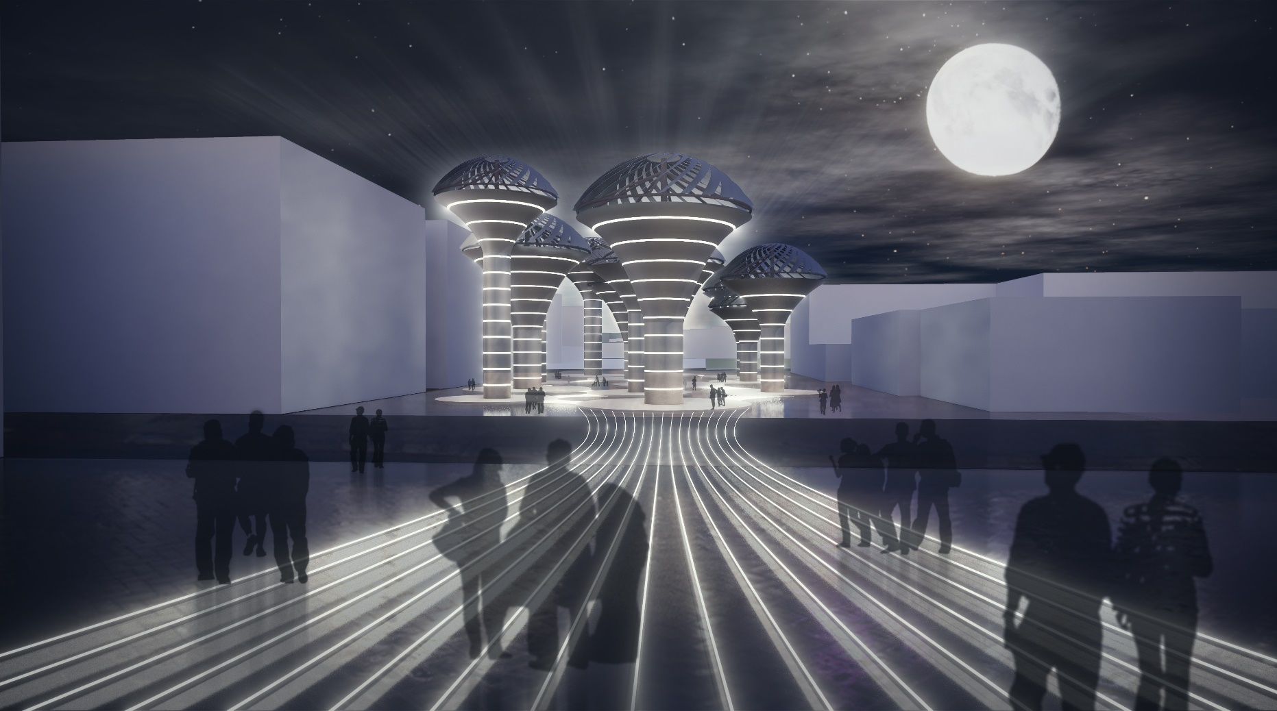

DUAL DYNAMO
PROPOSAL
The project consists of a number of energy-generating plates, which, due to the stretch and enclosed site, are subjected to be exposed to sunlight in most hours of the day. The angle of these plates is changeable by its leverage and light sensor, so all day will be exposed to the highest sunlight exposure. On the other hand, after the end of the day and the impossibility of taking advantage of sunlight, the productive plates will turn to the opening and revolving mode in order to continue to be influenced by wind to save energy at night. Actually, converting solar panel to wind turbine with vertical axial.
These plates are placed vertically on a holding structure at the right height, which is embedded around the vertical element of the energy storage. The level of energy storage on the external body is marked by luminous lines from top to bottom.
Since the site is divided by the street, we decided that the project will be included two parts. In the first part, the energy is received and stored and in the second part, with the symbolic narrative, the energy is consumed. As a result, the entire project is an iconic symbol for Masdar City.
On the other, the solar panels were inspired by Masdar’s logo.
To occur in the symbolic event, the following process will be made:
- At first, the energy will be generated of the sun and wind power and will be stored in the battery.
- Secondly, after the battery will be filled, the extra energy will be transferred through the transmission lines on the floor to the symbolic volume of Masdar City in the adjacent site
- this energy transition causes light dance to be used in the symbolic volume part of the project in the adjacent site.

Energy output
- Solar panels
Type 1
Each blade: 7.608 kwh/day
25(number of blades, each unit) x 7.608 = 190.2 kwh/day
190.2 x 365 = 69432 kwh/ year
69432 x 6 (larger units) = 416592 kwh/year
Type 2
Each blade: 4.272 kwh/day
25(number of blades, each unit) x 4.272 x 365 x 6 (larger units) = 233892 kwh/year
Total solar panel output = 650.5 mwh/year

- Wind turbines
Each unit output: 60 kw per round
Maximum unit output for type of Endurance E-3120: 60 kw
Type 1
Each unit: 60 kwh per round x 10 round per day x 365 = 219000 kwh/year
Type 2
Each unit: 30 kwh per round x 15 round per day x 365 = 164250 kwh/year
Total wind turbines output = 383250 kwh/year

Total energy out put each year = 1033.75 mwh

Project costs
- Solar panels
Type 1
6 (larger units): 8 kw (each blade) = $ 17080
25(number of blades, each unit) x 6(larger units) = 2562000 $
Type 2
6 (smaller units): 5 kw (each blade) = $ 10675
25(number of blades, each unit) *6 = 1601250 $
Total solar panels price: $ 4163250

- Wind turbines
Typical turbine type: Endurance E-3120
Price of wind turbines= $ 360000 per unit
Total wind turbines price= $ 4320000

Total price = $ 8483250

Environmental effects
Due to the limitations of fossil fuel resources and the consequences of environmental pollution, in recent years, the power generation process has been emphasized using the sun and wind energy. Therefore, we decided that the energy generators get both the energy of the sun and wind. As a result, even during the hours that do not take advantage of the sun, we have the great absorption of clean energy by the wind.

Energy technologies :

Technologies :

Energy production :

