THE WINGS OF THE FUTURE

LAGI 2019
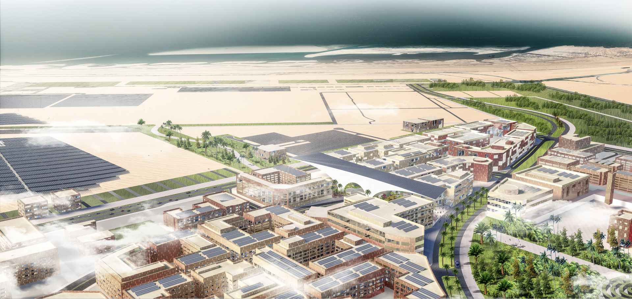

THE WINGS OF THE FUTURE
PROPOSAL
One of the most sustainable cities in the world, masdar is a future city that integrates technology, energy and development. It will become the focus of the world, which will be a great challenge for this design.How we put up a permanent sculpture in a city with advanced technology, it will be remembered by the people.The previous technology will always be replaced by more advanced technology, so when we use the most advanced technology to produce the alien sculpture, it will be replaced by more advanced sculpture one day.So what is eternity?What is eternal is only the spiritual faith solidified in the ABU dhabi nation.

ABU dhabi's most precious animal, the king of the sky, the falcon, spread its wings and soar in the sky through time and space, witnessing ABU dhabi's past and future.When the falcon flies over the dome of the mosque, we will all become its devout messenger, delivering to the future the spirit and faith solidified in the nation.

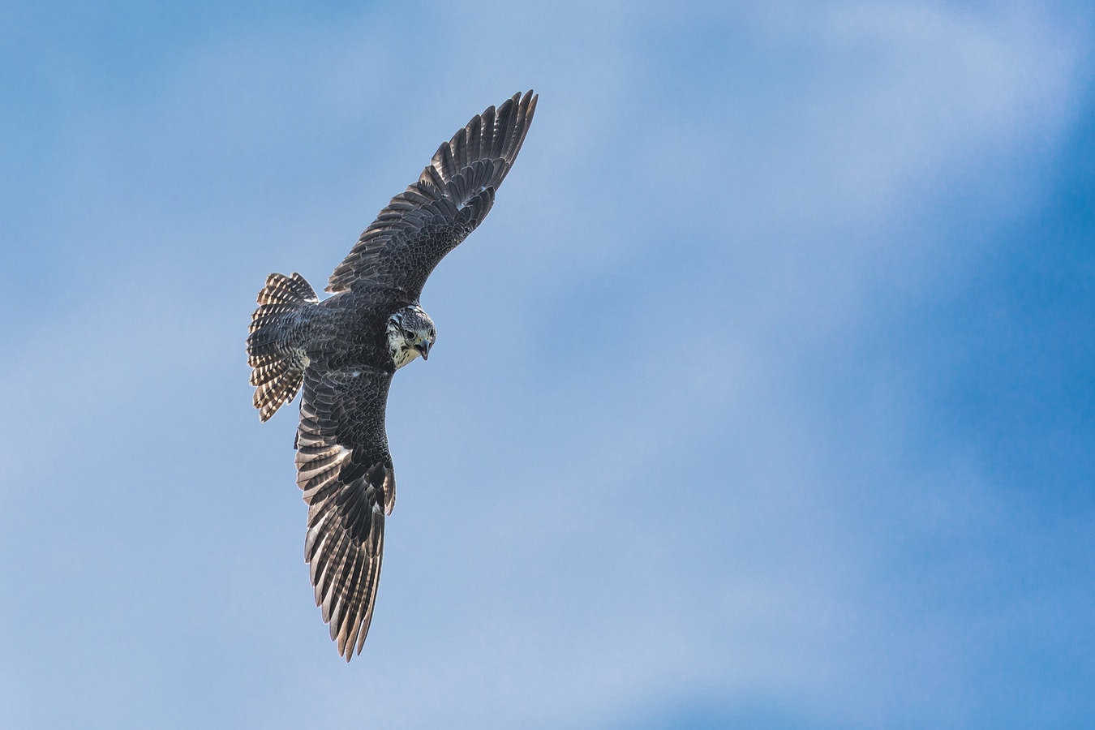

At both ends of the sculpture is a 100-meter-long cantilever structure, like a falcon with outstretched wings, which will also be the largest cantilever structure in the world.The oval space in the atrium symbolizes the dome of the mosque, and the round mirror water at the bottom is like the pearl of ABU dhabi, reflecting the whole dome."Pearl" at the very center, planted a jacaranda tree, its blue flowers, symbolized ABU dhabi's holiest and cleanest soul, it is Masdar city, the cleanest and lowest carbon city.

The design of the entire sculpture, space feeling is the core content, when people meet with it, will be one hundred, without any support of cantilever space, when people walking into cantilever space also reduce gradually, people's spatial awareness is also becoming increasingly depressed, until the bottom in the depressed, is arrived at cantilever space of the lowest place, will be through an arch, instant reached a high of 33 m public space, through the mirror surface waters, arrived in a central location, under the jacaranda tree, meditation.

Eventually, after passing through the ancient and ritualistic space, we will all become eagle messengers to the future tech city, Masdar

Outdoor natural light by light shade efficient and import the redistribution system, and specially made of light pipe transmission and enhanced by the system at the bottom of the diffuse natural light evenly efficient exposure to any need to light, from dawn to dusk, and even the rainy day cloudy, optical lighting system import indoor light is still enough.The device is mainly composed of three parts: lighting device, light guide device, diffuse device.

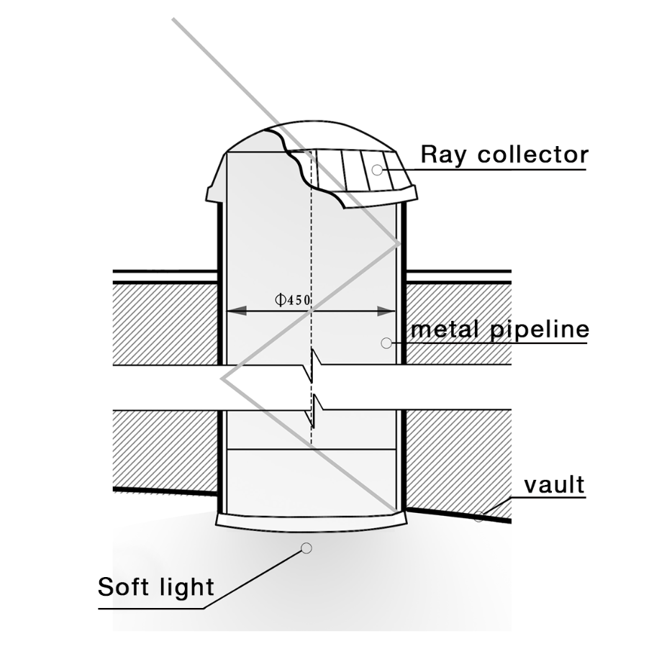

The project aims to create a new landmark for ABU dhabi, to power masdar city through solar panels on the art installation, and to show the world ABU dhabi's impressive cultural heritage.

On the long and narrow site, a huge sculpture will be raised. The two wings are 35 meters high and the cantilever length is 100m, which is the largest cantilever space in the world.The dome in the middle creates a sacred resting place. The roof collects sunlight through a pipe-lighting system, refracts soft light to illuminate the interior space, and also USES the energy stored during the day for lighting at night.Inside, an elevator leads to a 17m-high observation deck, giving visitors a panoramic view of masdar city.A 13,000-square-meter photovoltaic module made up of 15,116 solar panels is laid on top, providing the city of masdar with 542,900 MWh per year.The entire art installation on top of the 7m on the road improves the existing traffic condition and is an important channel between masdar city and the outside world.

Renewable energy components | Materials | dimensions
Main architecture | glassreinforced concrete (GRC) screens | 449,2m²
Cordage | UHMWPE cordage | 12000m
Solar Panel | Polycrystalline | 13000m²

