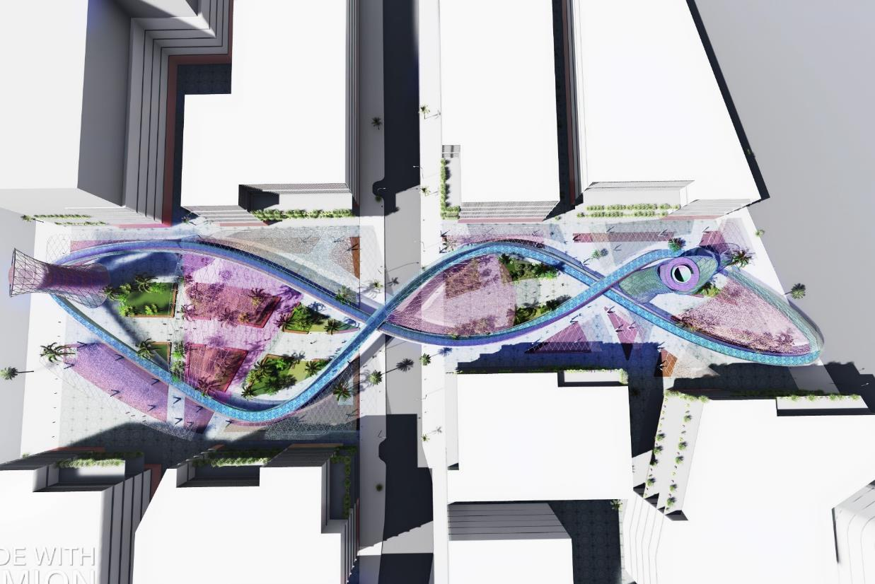

RENEWABLE URBAN RIBBON

LAGI 2019 - Abu Dhabi

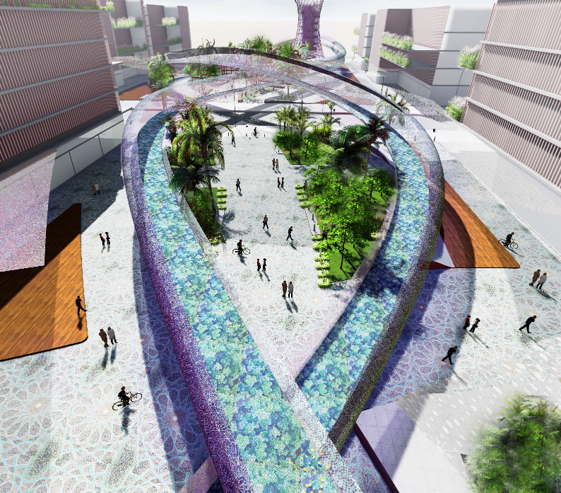

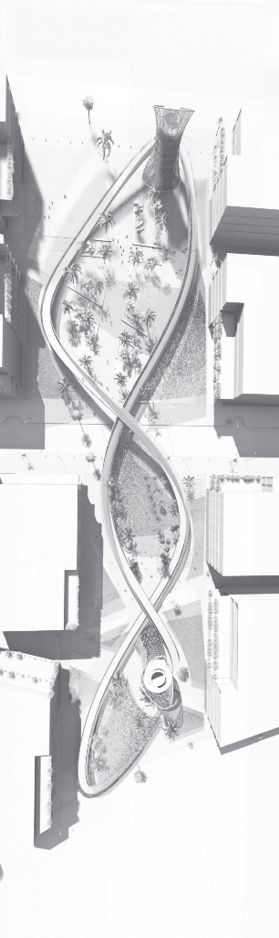

01.
LAGI 2019

Urban Vision

The proposal aims to support the vision for the Emirate of Abu Dhabi Plan 2030 to position Masdar city among the most innovative and sustainable cities in the world. Therefore, our proposal seeks to strengthen the Innovation Priority Sectors: Renewable and Clean Energy, transportation, technology, education, health, water sensitive urban design, as well as the definition of urban character.

As part of Masdar City masterplan, this proposal would be frame into a sustainable concept that would face the challenge of middle east cities to maximise weather conditions and to take advantage of it by implementing and developing new technologies. These new technologies are the opportunity that major cities across the globe are willing to develop in order to minimise the production of non – renewable energy.

02.

Masterplan

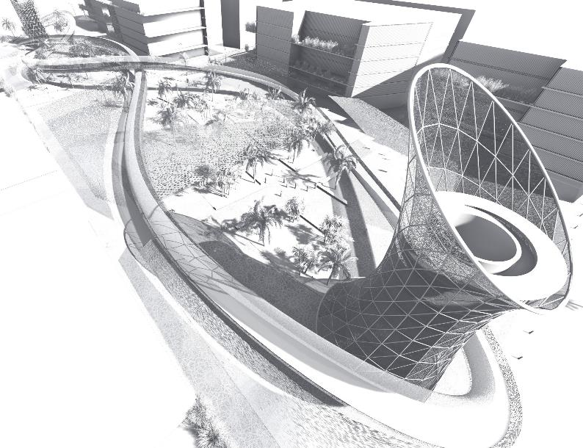
The urban design framework of this proposal is based on the idea to establish a continuity between Masdar City master plan and to define a new urban element that is able to understand and to adapt the future context by promoting urban activation and sustainable technologies.

Part of the inspiration is based on the continuity of the narrow pedestrian streets (sikkas) that characterised middle – east cities and creating a new element that established a transition of traditional into a smart city concept. This element
appears as an elevated pedestrian structure that embraces the existing context organised by a central green axis that establishes a green relationship for the green corridor that runs along Masdar City.

This urban element establishes a hierarchy of multiple components that enhances pedestrian activity but at the same time adopt renewable energy technologies to envision Masdar’s City idea of new sustainable urban centres that are able to produce instead of consumed.

03.

Renewable Energy Technologies

Solar energy
Our schemes take into consideration the new trends of solar panels focused on the efficiency, flexibility and visual design aesthetics.
Therefore combines new solar PV modules technologies with printing visuals as a cladding material. This would be a new trend in the future, where the facade of the buildings will not only collect energy but also will redefine the urban landscape with infinite possibilities.
The solar energy is collected with Lightweight flexible solar photovoltaic modules (multi- crystalline and thin-film modules). The solar panels provide as well shade and receive the breeze coming from the wind towers.
Companies: Sun-tech, Canadian Solar + Dutch Company Solar Visuals.

The Solar Road
This technology will use prefabricated panels made from recycled materials. The solar photovoltaic cells will be installed under a transparent high resistant recycled tempered glass with a special non-slip surface.
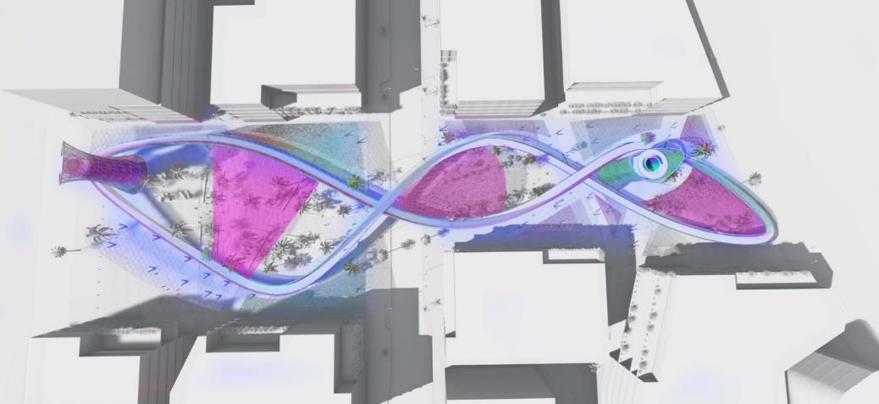
Technologies and studies: France, the Netherlands, China

Wind energy
This energy aims to bring a new system to urban parks, which takes advantage of the wind to generate energy, but also offers the pleasure and contemplation of the surroundings.
The tower aims to collect the wind coming from different directions, then, by means of a funnel, capture the wind and redirect it through a narrowing conduit (increasing wind speed) to generate the movement of the turbine (vertical axis) inside the tower. It is a motor turbo machine that exchanges momentum with the wind, spinning a rotor. Once the wind has gone
through turbo machine, the remaining air will be
used to generate an evaporative cooling effect.

04.

Energy Capacity

The region has a very large potential in its renewable energy source and has the
opportunity to provide an urban environment where renewable energy technologies and sustainable green spaces are combined into an inclusive environment.

Solar energy
- Energy (kWh) = A * r * H * PR
- A = Total solar panel Area (m2), r = efficiency(%), H
= Annual average solar radiation PR = Performance ratio (default value = 0.75)

Lightweight flexible Solar photovoltaic
modules
- A = 10.600 m2 * 0.18 * 2.600 *0.75
- A = 3.720.600 kWh
- Solar Annual Power Production = 3.721 MWh/year

Solar Road
- A = 2.400 m2 * 0.10 * 2.600 *0.75
- A = 468.000 kWh
- Solar Annual Power Production = 468 MWh/ year

Wind energy
Vertical Axis Wind Turbines (VAWTs)
- Turbine height 12 mts
- Turbine Diameter 4 mts
- Sound = 5 dB
- Wind speed Masdar = 13.4 (Km/hour)
- Annual Power Production / Tower = 100 MWh/year
- Wind annual Power Production = 200 MWh/ year
- Total Annual Power Production = 4.389 MWh/year

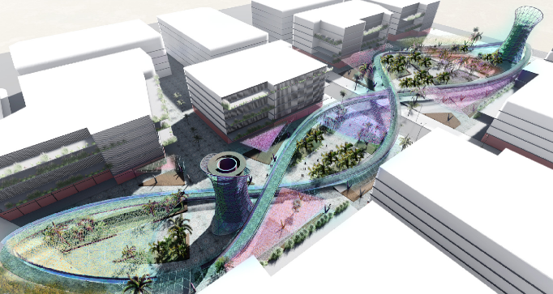

05.

Materials & Cost Estimate

Materials
The project follows PBRS principles encouraging the reduction of water and energy reduction, use of local materials and the promotion of natural, recycled, renewable and carbon neutral materials. In this order of ideas, the first source of material extraction will be recycling.
Therefore, all the materials will be extracted from related construction sites and non- Polluting Materials will be used (Zero ODP, low

GWP Insulation, chlorine free, low Toxicity) high-albedo materials, minimal embedded energy, low emission adhesives, and low emission Paints and Coatings.
Only pre-fab construction techniques, easy replacement, and low maintenance will take place.
Materials: Reinforce recycled concrete, Recycled Aluminium, Recycled Steel, glass, Low-carbon cement GRC, Adobe, Wood.

Costs
Taking into consideration that the estimated cost per watt installed must not exceed $20 USD and the cost margin can be used for the artistic landmark. In the following table is shown the average price per watt.
It is important to highlight that new technologies open the breach to implement

design features and to make more liveable spaces rather than functional itself. This will allow public spaces to enhance sustainability via Urban Design.

 | Annual Energy (MWh) | Relative Contribution | $/Watt | Watts | Total Price ($)
PV Module | 3.721 | 85% | 2,5 | 3,721E+09 | 9,303E+09
PV Solar road | 468 | 11% | 10 | 4,680E+08 | 4,680E+09
Wind Tower | 200 | 5% | 5 | 2,000E+08 | 1,000E+09
Total | 4.389 | 100% | 17,5 | 4,389E+09 | 14.982.500.000

3,41

$/Watt

Annual Energy (MWh)

Relative Contribution
$/Watt Proposal

2.5
5
10
200
450
3700
5%
11%
85%

PV Module PV Solar road Wind Tower
PV Module PV Solar road Wind Tower
PV Module PV Solar road Wind Tower

06.

Environmental Impact

Executive Summary

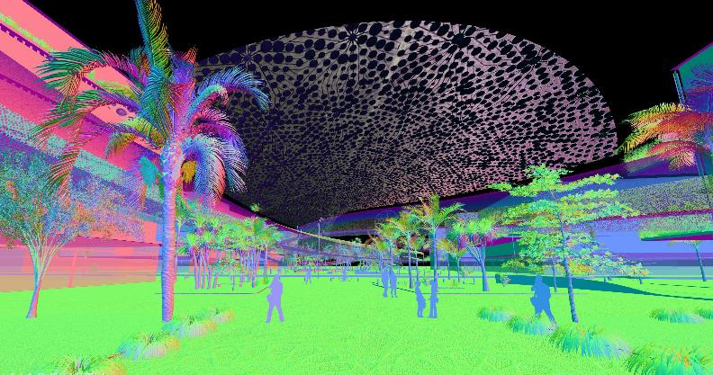
The proposal aims to encourage active urban environments that offer outdoor spaces for cultural activities, sports, and recreation with optimal thermal comfort during transition months, taking into consideration sustainable principles like wind and solar orientation, and seating as the main priority the protection of species, habitats, and ecosystems.

The main principle seeks to fulfil the public realm shade requirements, proposing more than 60% shading spaces in the competition area by combining both natural (Natives trees) and flexible solar photovoltaic membranes (Solar Reflectance Index > 29).

The materials were also chosen following a minimum energy performance requirement and their disassembly advantage, in order to reduce the long-term environmental impacts
associated with construction waste collection, transport, and disposal. The site location also follows vital urban principles like the distances to public transport and community facilities (350m), connection to bicycle lanes, urban facilities and offering a variety of pedestrian paths.

The project enhances the ecological value of the site by proposing more than 70% native species like for example Prosopis cineraria (Ghaf), Salvadora persica, Date Palm Tree. In this order, there are effective plant selection and irrigation strategies that help to minimize water demands by using recycled water, filtration systems, and sustainable urban drainage systems

\

