SAND STORM
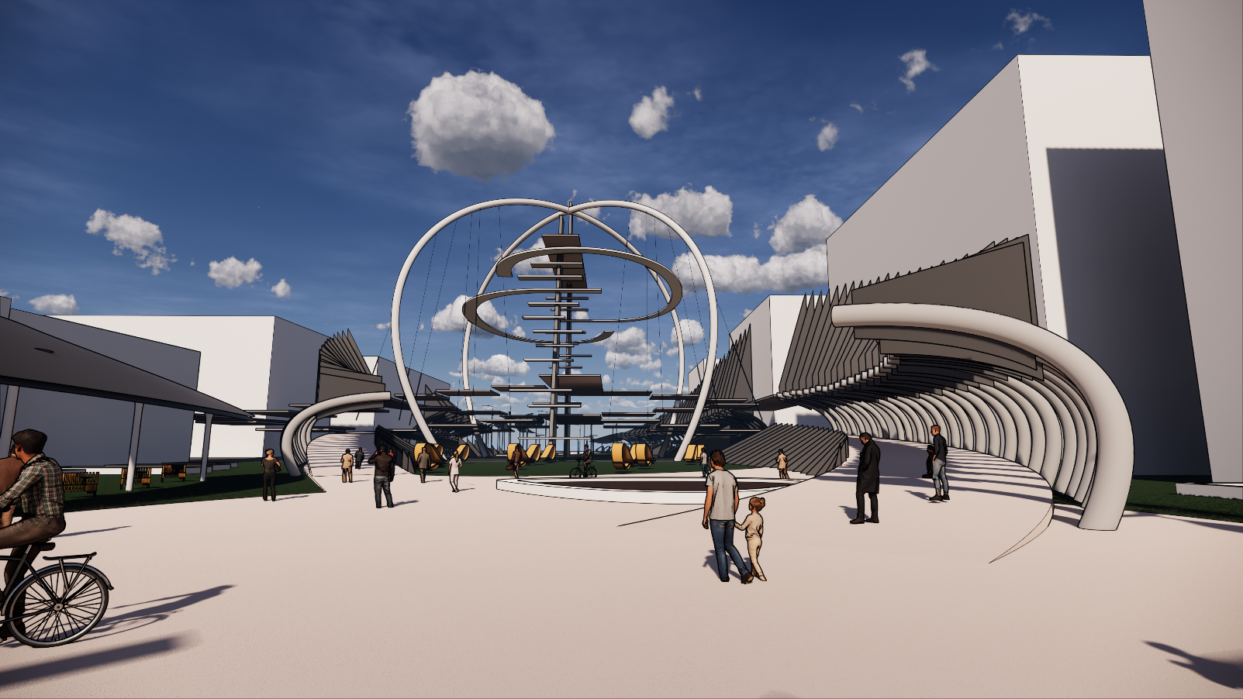
Renewable Energy: A Global Challenge
Renewable energy has become one of the largest sources of energy in the world, and pollution and the risk of fossil fuels have put the world in a huge challenge: The creation of new sources of energy from nothing, how to do that while integrating into architecture, in the immediate environment. Abu Dhabi is one of the Emirates that has not stopped developing in the last twenty years thanks to the policy followed by those trying to occupy a desert environment and by launching urban projects aimed at to accompany the development in the field of construction in the whole world with a touch that assembles the peculiarity of its architecture and its culture, the layout of the public spaces of an intelligent way which gives a glimpse on a contemporary city, tourist, intelligent.
The concept of care
The design concept of this public space in the new city "Masdar city" is inspired by the desert context of Abu Dhabi and the natural phenomena from which emerges an untapped natural energy, called "Sand Storm". The purpose of the arrangement is to create an element that symbolizes this phenomenon, which is considered in the daily life of the inhabitants as a constraint that it becomes in the site an artistic work that constitutes a new positive image of the latter.
The site is a space considered as the purpose of a line of public spaces in an axis that runs through the city. The space to be developed is composed of 2 parcels that will be linked by a multitude of continuous passages that crosses the street transforming it from a constraint to a strong point where passers-by and visitors can enjoy the view of the sea. public space and the city from a height that varies between 4 and 6 m platforms above the street and this is where lovers of adventures can climb to the highest point of the central element that symbolizes the project (30m high) and which is also equipped with several devices allowing the exploitation of wind energy (wind turbines), solar energy (photovoltaic panels), sand energy (Bloom energy)
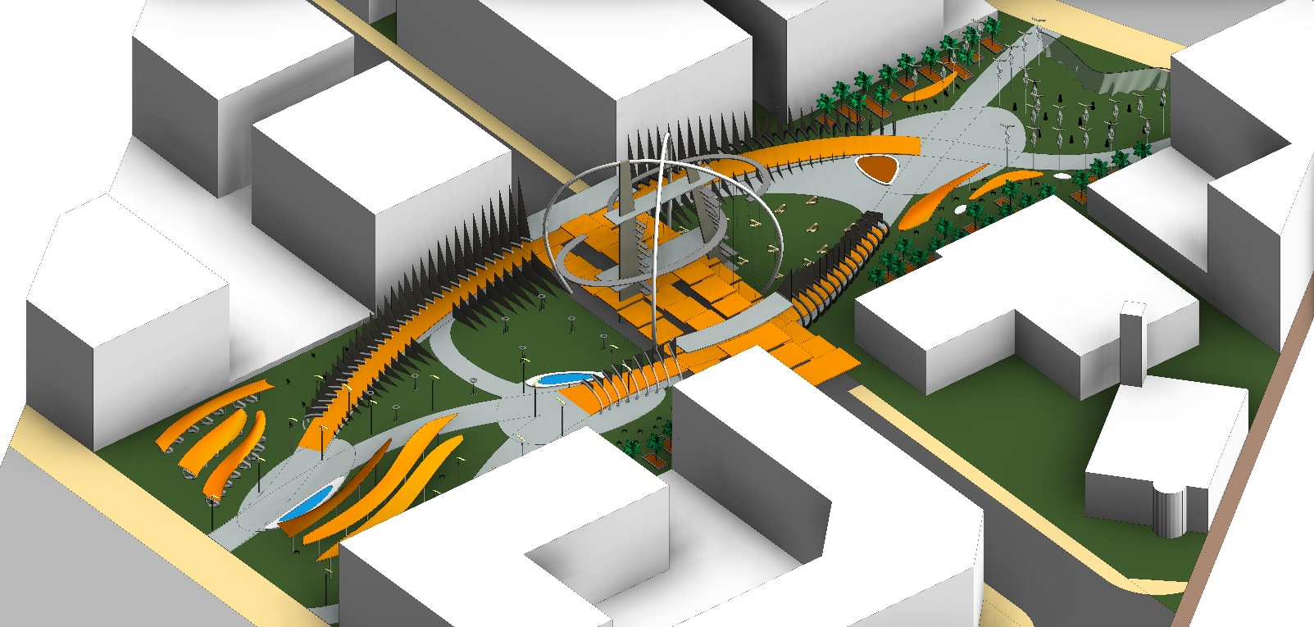
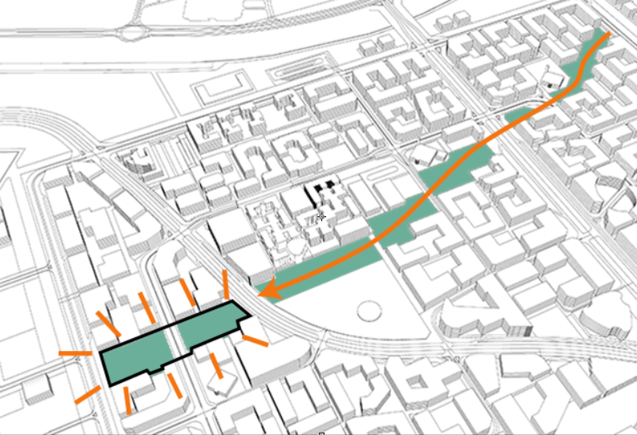
The landscaped space consists of several parts containing several activities: The relaxation, practice of the sport, consumption, ensured Thanks to the diversity of the furniture which combines between the exploitation of the solar energy and the simple use. The furniture that ensures the practice of sport also makes it possible to produce energy from human use. Fountains and pools of water and the layout of the vegetation will create a special atmosphere and moments of freshness on both sides.
Several parts of the landscaped space will be covered by roofs inspired in their shape of the flexibility of the sand dunes and which are the object of solar energy sensors at the same time thanks to the presence of a layer of photovoltaic cells. on the upper part.
Environmental impact
The use of photovoltaic panels is considered a very profitable investment in Abu Dhabi in an environment characterized mainly by the sun which will make the public space self-sufficient energy and fuel the surrounding area.
The use of sand energy has an aesthetic and energetic dimension: the units producing energy from hot air regenerate, they represent the thin elements that disperse in the air and accentuate the effect Sand Storm.
The use of wind energy allows built-in fixtures to have a durable light source as well as the aesthetic effect of these elements.
Visitors to the site can practice sport and produce energy through the walk-up machine.
Installation features and primary materials
- Central element (Sand Storm)
- Photovoltaic panels LG 365Wc Neon R Monocrystalline and fixing components: 1152 m² flat surface
- Steel slabs: 7,65x7,65 m (12 slabs) / 7,65x8,00 m (4 slabs) / 4,55x7,65 m (4 slabs)
- Concrete slabs: 7,90x30,6 m (4 slabs) / 8,00x30,60 m (3 slabs) / 6,56x30,60 m (2 slabs)
- Inclined concrete vertical elements: Element 1: Height = 35.9 m Element 2: Height = 45 m
- Concrete posts: 6 posts, section: 1m, height: 4 - 6 m
- Concrete horizontal anchors: 22 elements
- Steel prefabricated arch: 4 Arcs small radius: 16.5 m, large radius: 44 m Diameter / Thickness: 1m
- Steel tension cables: average length: / Thickness: 5 cm
- Concrete inclined inclined slabs (suspended passage): surface01: 554,5 m² / Surface02: 282,7 m² / Surface03: 226 m² / Surface04: 652 m².
- Curved elements made of steel: 147 elements
- Solar roofs
- Photovoltaic panels LG 365Wc Neon R Monocrystalline and fastening components: 1535.8 m² surface area
- Mushroom posts: 39 posts, Height: 3 - 7 m
Energy production
Photovoltaic panels LG 365Wc Neon R Monocrystalline
Total area: 2687 m² Max power: 212.58 W / m² Production Max: Per hour: 571202,46 W
Price: 280,25 € / m² Total price: 753031,75 € Annually: 5003,73 MW
Average annual production: 5003.73 x 60% = 3002.24 KW
-Micro wind turbines (integrated with air lampas / Big arcs): rotor diameter of 0.5 m,
Number: 150, Average yield per hour: 100W
Price: 200 € x 150 = 30000 € Production per hour: 876 KW Annually: 131.4 MW
- Bloom energy
Bloom energy Stack: Unit dimensions: 0,1x0,1x0,2 m3 Production: 25 W, Price: 6 €
Number: 3000 units, Average annual production: 657 MW, Total price: 18000 €
-Walk up machine
Number: 9, Production energy: Variable Price: $ 3699.00 x 9 = $ 33291

