Lungs of Masdar

Introduction

Under the pillar of Cohesive Society and Preserved Identity of National Agenda, the UAE Government aims to make the country amongst the top five happiest countries in the world by 2021. The contemporary happiness quotient looks beyond traditional economic metrics to include environmental benchmarks, and ambient environmental quality is a key variable in the equation. Air Quality Index (AQI) gauges the impact of pollutants such as Nitrous and Nitric Oxide, Sulphur dioxide, Particulate Matter on people’s happiness; higher AQI indicates higher health risk and correspondingly lower happiness.

It was observed that for both Particulate Matter and Ozone, the project site exceed the threshold limits set by UAE’s Environmental Agency (Figure 1). Particulate matter pollution is caused by regional dust clouds, industrial processes, traffic pollution and construction activities.

“Lungs of Masdar” is an attempt to improve the awareness among residents on the role played by environment quality on health and happiness. The structures are designed considering the air quality and thermal comfort required for optimum health. The design is an affirmation to the world that a sustainable future can be achieved through a combination of bioclimatic design, scientific analysis, and urban planning. The project embodies the vision of Her Excellency Ohood bint Khalfan Al Roumi to achieve a happier, healthier UAE.
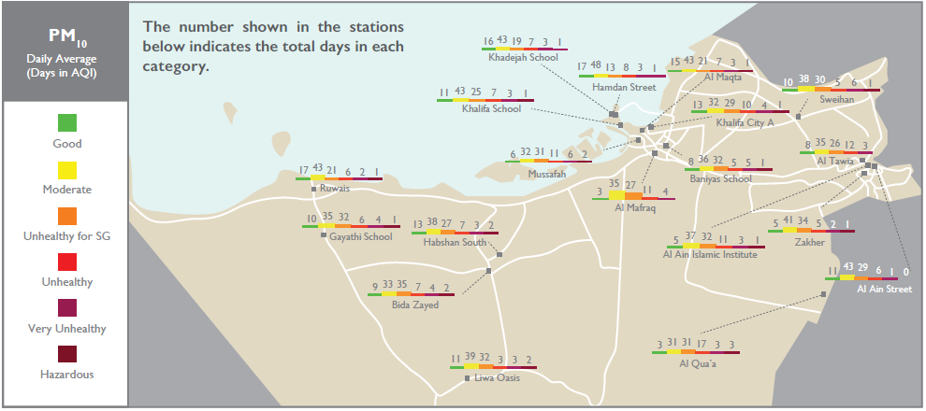
Project site
Figure 1: Site location and air quality condition for PM10 Source: Air Quality Report Annual report 2017, Environment Agency

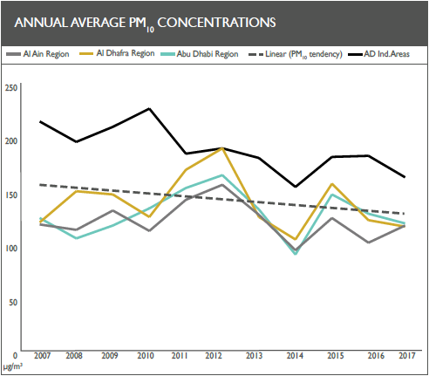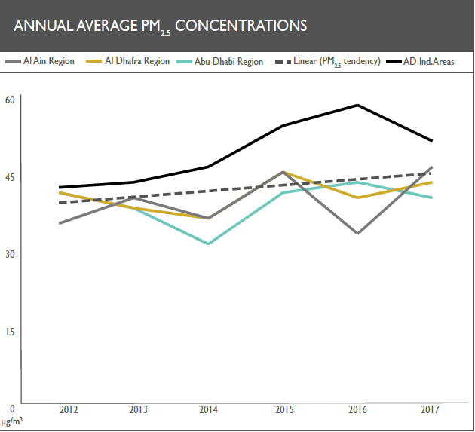
Figure 2: PM limits for each year Source: Air Quality Report Annual report 2017, Environment Agency

Particulate Matter Removal

PM particles accumulate in human bronchi and lungs and long-term exposure can result in lung and cardiovascular diseases. Various PM removal technologies exist in the market, but we have selected the following three technologies to remove PM from air to be circulated within the structure:

- Wind-powered rotating triboelectric nanogenerators (R-TENG) for precipitation of PM
- Metal-organic frameworks (MOFs) filters
- Planting species known for air purification and dust removal capacity such as Epirpremmum aureum (Scindapsus), sansevieria hyacinthaoides, ficus banghalensis (rubber tree), hedera helix (ivy) and viburnum odoratissimum (coral tree)

Electrostatic precipitator is a type of air filter technique that uses static electricity to remove particulate matter from air inlet. In contrast to traditional electricity charged precipitators, the structure uses wind energy to charge the rotating triboelectric nanogenerators (R-TENG) that are connected to charging precipitation plates. R-TENGs can recover mechanical energy from rotation and are easy to fabricate, low cost and high efficiency. R-TENG output is only 300V and not high enough to generate pollutant byproducts such as ozone and NOx. The output of R-TENG is connected to a copper mesh and 1g of copper mesh can absorb around 0.327g of PM from the air flow. The key components of R-TENG mainly stator and rotator are top grating and bottom grating electrodes can be fabricated by the print circuit board (PCB) technology.

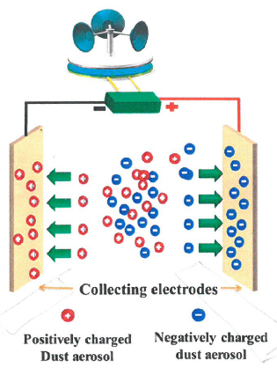

Figure 4: Dust removal by R-TENG
We also incorporated Metal-Organic Frameworks (MOFs) filters that removes PM from air inflow given their property to polarise PM particles and increase their electrostatic interaction with MOF. The unbalanced surface of MOFs can polarize the surface of PM to improve electrostatic interaction between PM and MOFs. Hot pressed Metal-organic frameworks (MOFs) filters (Zeolite Imidazolate Framework) can be used for PM filtration; they have a removal efficiency greater than 90% for both PM10 and PM2.5.

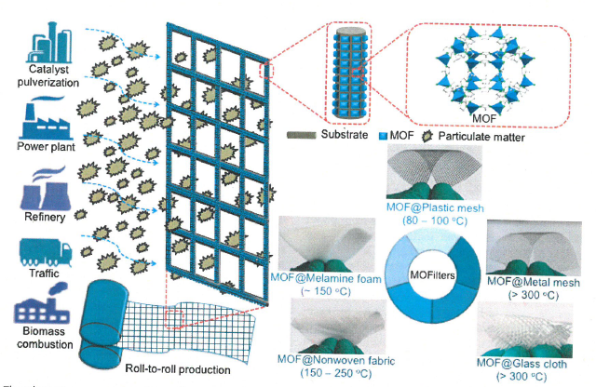
Figure 5: Dust removal by MOF

In addition, evapotranspiration technique exhibited by certain plant species to remove PM will be included in the building. The selected plant species has a PM removal efficiency of 60-90% depending on plant type.

The below graph highlights the efficiency of removal of both PM10 and PM2.5 by each plant species for a given duration of time of exposure.

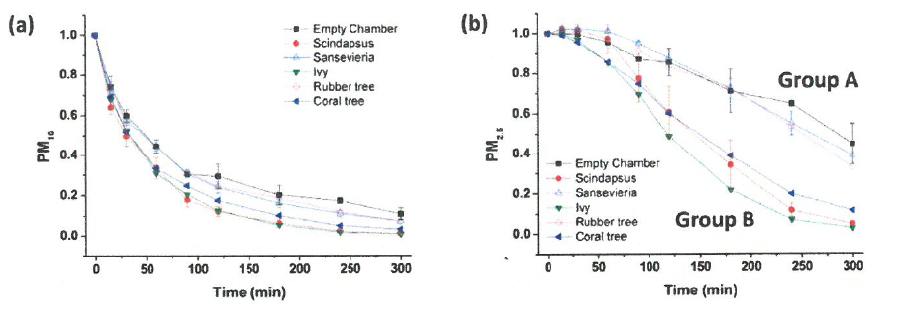

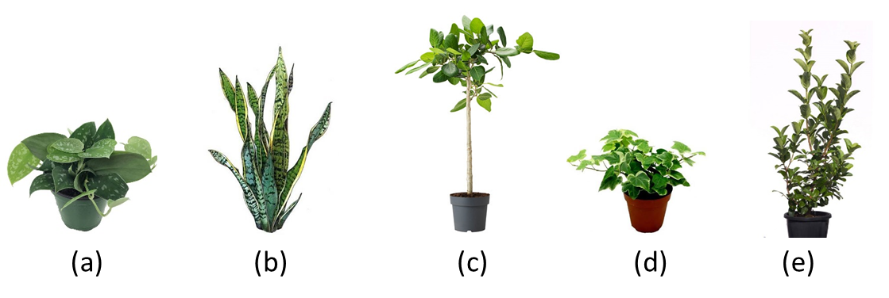
Figure 3: (a) Scindapsus, (b) sansevieria hyacinthaoides, (c) rubber tree, (d) hedera helix (ivy) and (e) coral tree

Thermal Comfort

Humans have been creating spaces to provide thermal comfort for eons. Psychrometrics is used to help select the proper air conditioning equipment and help understand a building’s regional climatic context and better address, human occupancy and use, and structural considerations. The results of study done is shown in Figure 6 indicates we need to incorporate our techniques in our design such as sun shadowing, thermal mass heat flush, two stage evaporative cooling, internal heat gain and fan forced ventilation.

Earth Wall:
The interior volumes are thermally insulated by thick mud walls often with air cavities which increase the structural stability as well as thermal performance. Research indicate that large thermal capacity of earth walls improves their thermal properties and indoor air quality and lowers embodied energy (Minke, 2000). In contrast to concrete, rammed earth walls have a thermal time lag of eight hours that can help maintain lower internal temperature during day time and release the stored heat at a slow rate during night time (Figure 7).

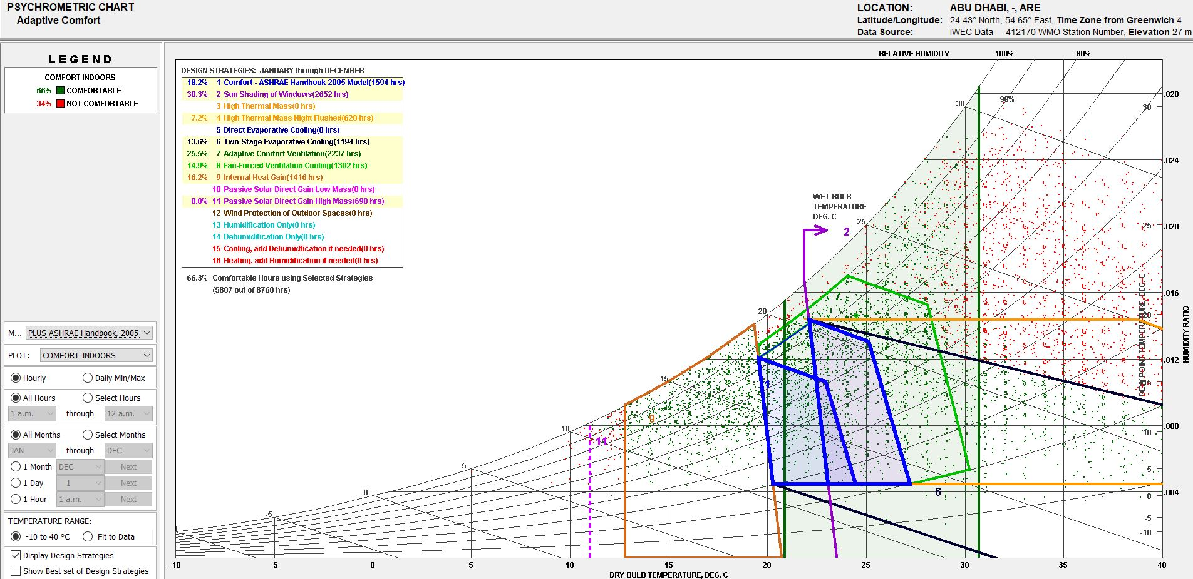
Figure 6: Psychrometric chart for Abu Dhabi

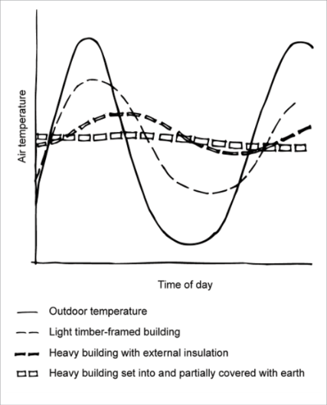
Figure 7: thermal lag of earth walls

Wind Tower
The tall rising circular towers act as the wind catch. The circular cross section helps to catch air from all directions and are brought to liveable zones through various ribs running along the building skin. The circular cross sections are also installed with water sprinklers for cooling purpose as well as improving the efficiency of dust removal. The evaporative coolers currently used in structure can easily bring signiﬁcant saving in the electrical energy during the warm months

Energy Generation

Abu Dhabi is blessed with abundant sunshine year around and with an average 6.3 kWh/m² annual solar radiation, building surfaces are perfect places to capture cheap and clean energy. Solar panel technology has made significant strides in recent years and thin film flexible PV are commercially available; they are attached to building surfaces, acting as a shield against heat and generate electricity.

The sweeping contours of this structure has a net 50% of its total 16,500 sq.m surface area facing the sky. The skin of the building is separated from the structure by a 2-inch air gap which acts as a natural heat filter. Solar skins in elegant patterns combined with conventional, flexible solar panels shall be installed to add to the aesthetics of the building as well as generate up to 700,000 kWh per annum.

Environmental Impact Assessment
We have incorporated various design parameters to lower the air pollution within the acceptable limits through use of techniques such as electrostatic precipitators, Metal Organic Framework (MOF) filters and evapotranspiration technique exhibited by certain plant species. These pollution control systems are powered by wind energy as well as energy derived from photovoltaic systems.
In addition, rammed earth walls incorporated in the design results in lower carbon footprint for the building as these building materials uses locally available materials, uses much lower cement mix and have high latent heat that help maintain lower internal temperature during day time resulting in lower air conditioning requirements. Lowering air conditioning demand results in significant carbon savings as more than 50% of energy demand if for air conditioning.
The PV installations can result in power production of upto 700,000 kWh per annum as well as a CO2 saving of 13,200 tons of CO2 equivalent per annum.

