SOLARSABKHA
“RETURN TO THE SOURCE”
(MASDAR LAGI COMPETITION 2019)

DESIGN PHILOSOPHY

“The environment is a precious part of our heritage, culture, and future.
Our forefathers recognized the need to conserve it, to take from it
only what they needed to live, and to preserve it for succeeding generations.”
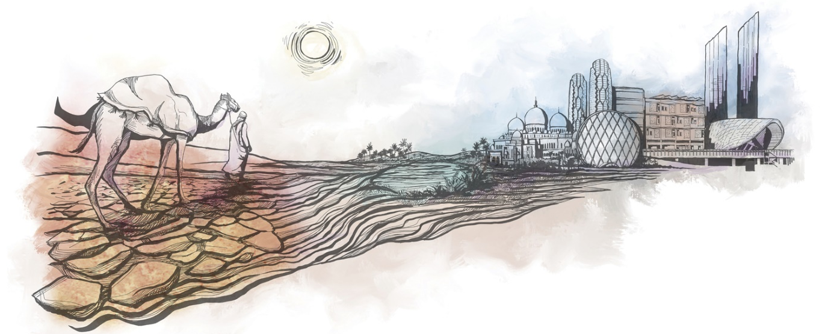
- H.H. Sheikh Zayed

The environment of UAE has always played a crucial role in shaping the country’s cultural and economic development. It is to this reason that the design philosophy that lies behind #SOLARSABKHA Park takes root from the concept of environment - from its historical and natural form and its transition to built modern and sustainable structures.

The transition from the natural to the built environment of UAE is depicted in the architectural structures and landscape design of #SOLARSABKHA Park. The natural environment of UAE, which is comprised of sabkha, arid desert, and oasis, is reinterpreted thru the forms and design of paving slabs and landscape elements (sabkha), introduction of xeriscape planting (desert), and proposal of kinetic energy-induced water features (oasis). The built environment embodied by the country’s sustainable skyscrapers, towers, and modern buildings is represented by the contemporary #SOLARSABKHA shade structures depicting Arabic patterns.
DESIGN INSPIRATION

The geological history of UAE has evidences that the coastal areas of the country are predominantly characterized by the presence of “sabkha”.

Sabkha is an Arabic word for flat, salt crusted desert. They typically lie between a desert and an ocean, whose concave surface is characterized by efflorescence of salt and gypsum, as well as windblown sediments and often tidal deposits.

The shape of sabkha has taken its influence in the overall design of the #SOLARSABKHA Park.

THE LAND ART: #SOLARSABKHA PAVING & SHADE STRUCTURE

The #SOLARSABKHA serves as a double-edge solution that not only addresses the problem of extreme heat in the desert UAE, but also leverages on heat to produce energy to sustain Masdar Community.

Starting off as a paving element in the landscape, the #SOLARSABKHA is portrayed as part of a distinct landscape experience on ground level, where park visitors have a look and feel of the LED-lighted solar panels as they walk over them. As the #SOLARSABKHA paving approaches the street, it slowly becomes an overhead shade structure. While providing shade, promoting thermal comfort to park visitors, and housing interesting activities in the park, the #SOLARSABKHA shade structure also provides a venue for solar panels for energy production and conveys the Arabic culture by the display of mashrabiya patterns.

Materials:
Paver: Glass Top Sheet PV Pavers with LED lighting
Shade Structure:
- Structural Columns: Galvanized Mild Steel with powder-coated finish. These will also accommodate the curved LED screens that display the kinetic energy produced in the different park activities.
- Shade Fabric: PVC-coated polyester with stick-on flexible solar panels on top
- Mashrabiya Panels: Hollow Cast Aluminium patterns in powder-coated finish

OTHER PARK FEATURES AND ACTIVITIES

Main Footpath
- Made of permeable paving slabs that are sabkha-shaped
- Lined with inclined seat slabs that create an impression of cracked sabkha
Amphitheatre with Lawn
- Irregular forms mimic the desert sand dunes that flows naturally into the landscape
- Combined with seats to encourage passive recreation
- Flexible lawn provides venue for outdoor exhibitions and encourages picnic and kick-ball area for families
Xeriscape Planting
- Features desert and native planting that are drought tolerant and uses minimal grey water for irrigation
Interactive Water Feature
- Powered by springers that children can rock to initiate water bubblers
- Uses grey water
Main Power Room
- Accommodates the storage for solar and kinetic energies harvested within the park
Kinetic-Energy Harvesting Activities
- Encourage park visitors to engage in physical activities like cycling, trampoline, and dance stomping while educating them about how much energy they have produced.

WHY PUT # IN FRONT OF SOLAR SABKHA

At this day and age, a large percentage of disseminating information is achieved through social media. Through the use of hashtag, a specific topic draws attention and is promoted, especially to the youth and younger adults, the age bracket of which has the most number of influencers in social media. By encouraging park visitors to promote #SOLARSABKHA, people are educated by the importance of renewable energy and how to apply and take advantage of it in our current environment to help alleviate climate change.

ENERGY PRODUCTION:

#SOLARSABKHA Park leverages on two important assets that form UAE’s physical and cultural development: its ENVIRONMENT and its PEOPLE - the solar energy from the sun and the kinetic energy from people.

SOLAR ENERGY SOURCES
- High Efficient Monocrystalline Flexible Solar Panels
- Power: 100W
- Dimensions: 1050x540x3mm
- Computation:
Ave. no. of Solar Panels per sabkha shade = 200 pcs.
Total no. of sabkha shade panels = 46 pcs
Total no. of Solar Panels = 200 x 46 = 9,200
Capacity = 9,200 x 100w = 920,000 watts = 920 kw
- Annual Capacity = 920 kW x 3,650 hours per year (Ave. 10 sun hours per day) x 18% capacity factor = 604,440 kWh
Annual Capacity = 604 MWh

- Glass Top Sheet Walkable Photovoltaic Pavers
- Dimensions: 500x500mm
- Power: 35W per tile
- Computation:
Total Area of PV Pavers = 365 sqm.
Total No. of Tiles = 1,460
- Capacity = 1,460 x 35w = 51,100 watts / 51 kw
- Annual Capacity = 51 kw x 3,650 hours per year (Ave. 10 sun hours per day) x 18% capacity factor = 33,507 kwh
Annual Capacity = 33 MWh

TOTAL ANNUAL CAPACITY (A+B) = 604 + 33 = 637 MWh
The annual capacity produced by solar energies from solar panels and walkable solar pavers will be used to power an equivalent of 200 houses in Masdar City or 637,000 Nos. of 1 kW-streetlight.

KINETIC ENERGY SOURCES
- Kinetic Energy-Harvesting Pavers
- Computation:
Kinetic Energy (KE) = ½ mv²
Average weight per person = 75kg
Velocity of person walking = 1.4m/s
- KE = 73.5 joules
Assuming in 1 second, 30 people step on the pavers all at the same time:
Capacity = 73.5 x 30 = 2,205 J
Power = Joules/second = 2,205 J/s
- W = 2,205 = 2.2kw
- Annual Capacity = 2.2kw x 4,380 hours per year (Ave. 12 hours per day) = 9,636 kwh
Annual Capacity = 9 MWh

- Kinetic Energy-Harvesting Cycling
- Computation:
Kinetic Energy (KE) = ½ mv²
Average weight per person = 75kg
Velocity of person walking = 5.5m/s
- KE = 1,134 joules
Assuming in 1 second, 5 people cycle all at the same time:
Capacity = 1,134 x 5 = 5,670 J
Power = Joules/second = 5,670 J/s
- W = 5,670 = 5.67kw
- Annual Capacity = 5.67kw x 4,380 hours per year (Ave. 12 hours per day) = 24,834 kwh
Annual Capacity = 24 MWh

TOTAL ANNUAL CAPACITY (A+B) = 33 MWh
The annual capacity produced by kinetic energies from walking and cycling will be used to help power the lighting for the shade structure and the landscape.

COST ESTIMATE:

TOTAL PROJECT COST = 9,200 solar panels x 100W x $20 = $18,400,000
ENVIRONMENTAL IMPACT ASSESSMENT

The #SOLARSABKHA Park is designed to consider the adjacent land uses and surrounding buildings in the site, while offering visitors a safe refuge with active and passive recreation. The park will also be accessed by people from all sides, and so important consideration is taken to make sure that the park will not emit harmful greenhouse gasses, airborne, or noise pollution of any sort.

The main feature of the park, the #SOLARSABKHA shade structures are made of recycled hollow structural supports that will store the electrical connections from the PV panels and the interactive LED screens from kinetic-energy powered activities. The planting proposed in the park are predominantly native trees and shrubs that are drought tolerant and do not require much irrigation water to survive. The materials used for paving are proposed to be permeable surfaces that allow percolation of water into the ground water and reduce runoff volume. Irrigation water and water features are treated grey water reducing the amount of wastewater entering sewers or on-site treatment systems.

