MAGNETIC renewable energy can be beautiful

Design is processed as an Art Installation taking as a basis the production of renewable energy. It’s considered as a center of entertainment and a walking space at the same time.
Land Art Object is a structure of different metallic circles forming a public environment to meet the interests of different age group people.
Land Art Generator is a set of magnetic circular generators where electroenergy is generated. Dimensional form came from the bunch of circles that start from one point of magnetic field and return to the same point, that way creating an unending circular movement.
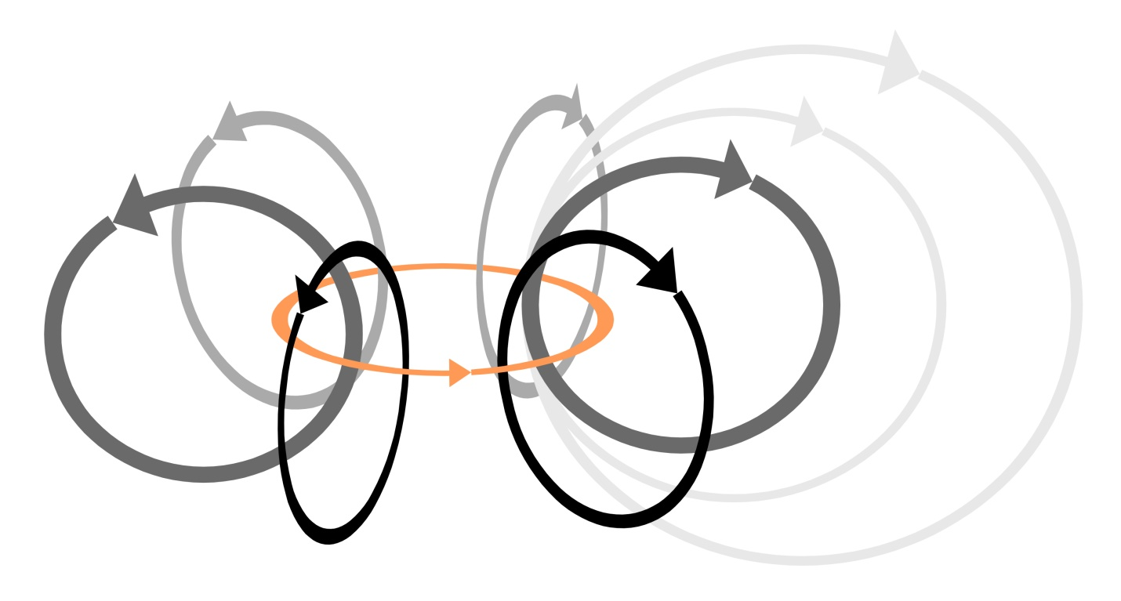
In the master plan the fragments that were divided into 2 parts were connected by a pedestrian bridge.
The north-western part was designed as an active recreational area. At this part the magnetic circular forms make a space structure and between those forms yard areas are created. Those areas may be used to create different types of entertainment zones. In one zone a skateboarding platform will be built, in the second a cycling area, in the third one will be a climbing wall, the next one can become a climbing net if used a metallic circular construction and the other one can be furnished as an open amphitheatre, etc..
The south-eastern part was designed as a passive recreational area. Keeping the principle of the production of renewable energy, Ferris wheel was built which has both a gigantic circular structure and circular constructions of wagons where magnetic generators are installed and that way electroenergy is produced which makes it function.
Technology used in design
Magnetic field is a source of renewable energy. That technology is in a processing stage, there are plenty of laboratory researches, but it has no wide usage. There are many experiments that were made in laboratory and home conditions. The essence of that technology is to create a power generator without fuel while using the magnetic field which is generated between two opposite poles and convert that power into electroenergy. The advantage of this technology is that it does not depend on any external factor,as the solar module depends on the sun or the wind turbine depends on the wind. It functions unceasingly, both day and night, and, actually, it is an everlasting engine having a 100% capacity factor.
There are two magnets set one against another by two opposite poles that are located in double circular metallic constructions with 9-24 m diameters and between them there is an enameled round winding wire.
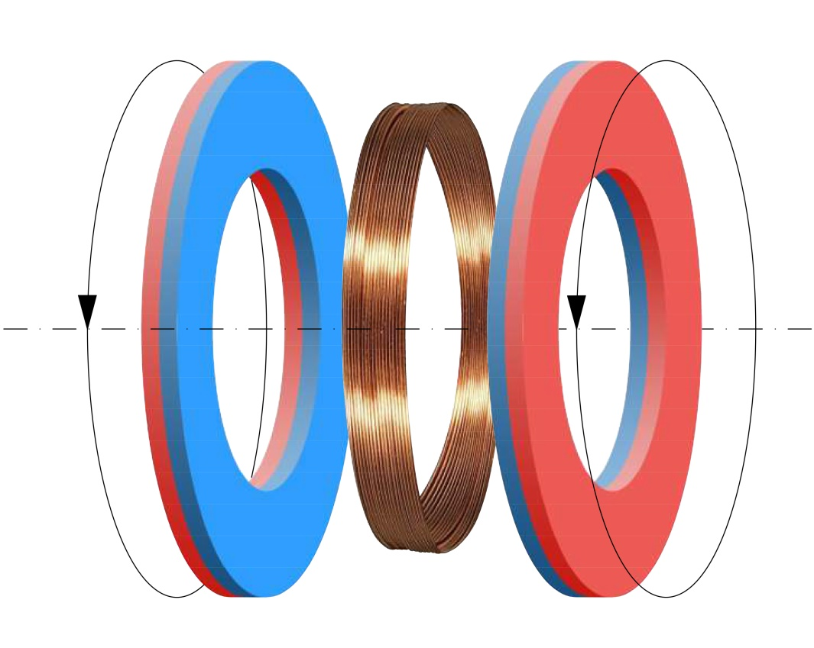

Capacity in kW (peak output measured in kilowatts of power)
. Total length of magnetic circuit - 1290 m
. Total peak capacity - 1 935 000 watt (1 935 kW)
Annual kW of energy
. 1 935 x 8 760 hours per year x 100% capacity factor = 16 950 600 kWh
Dimensions
. north-west part – 109x68x26(h) m. overall dimension
. south-east part – 68x37x55(h) m. overall dimension
Materials used and conceptual cost estimate
The main materials planned to be used in the construction: concrete, steel and aluminum frame, magnet.

. Footprint - 9950 m²
. Total structural volume - 47000 m³
. Cost estimate per 1 m³ structural volume - about 500 $
. Total cost estimate - about 23 500 000 $ (12.15 $ per watt)

Environmental impact
This technology is ecologically clean, safe for human health. It has no negative impact on the environment and meets sustainable developmental goals and standards.
- No air pollution
- No toxic emissions
- No global warming emissions
- Noiseless and the environment is safe from noise pollution
- No use of any fossil fuel: gas, oil, etc..
- No atmospheric emissions
- No hazardous materials used for making a production
- No impact on soil and its chemical consistence, no connection with underground water
- No use of natural resources like water, oxygen, etc..
- No production wastes
- Electromagnetic field is on a low frequency oscillation and is safe for human health
- Land use is associated with public space
- The applied materials can be recycled and reused

