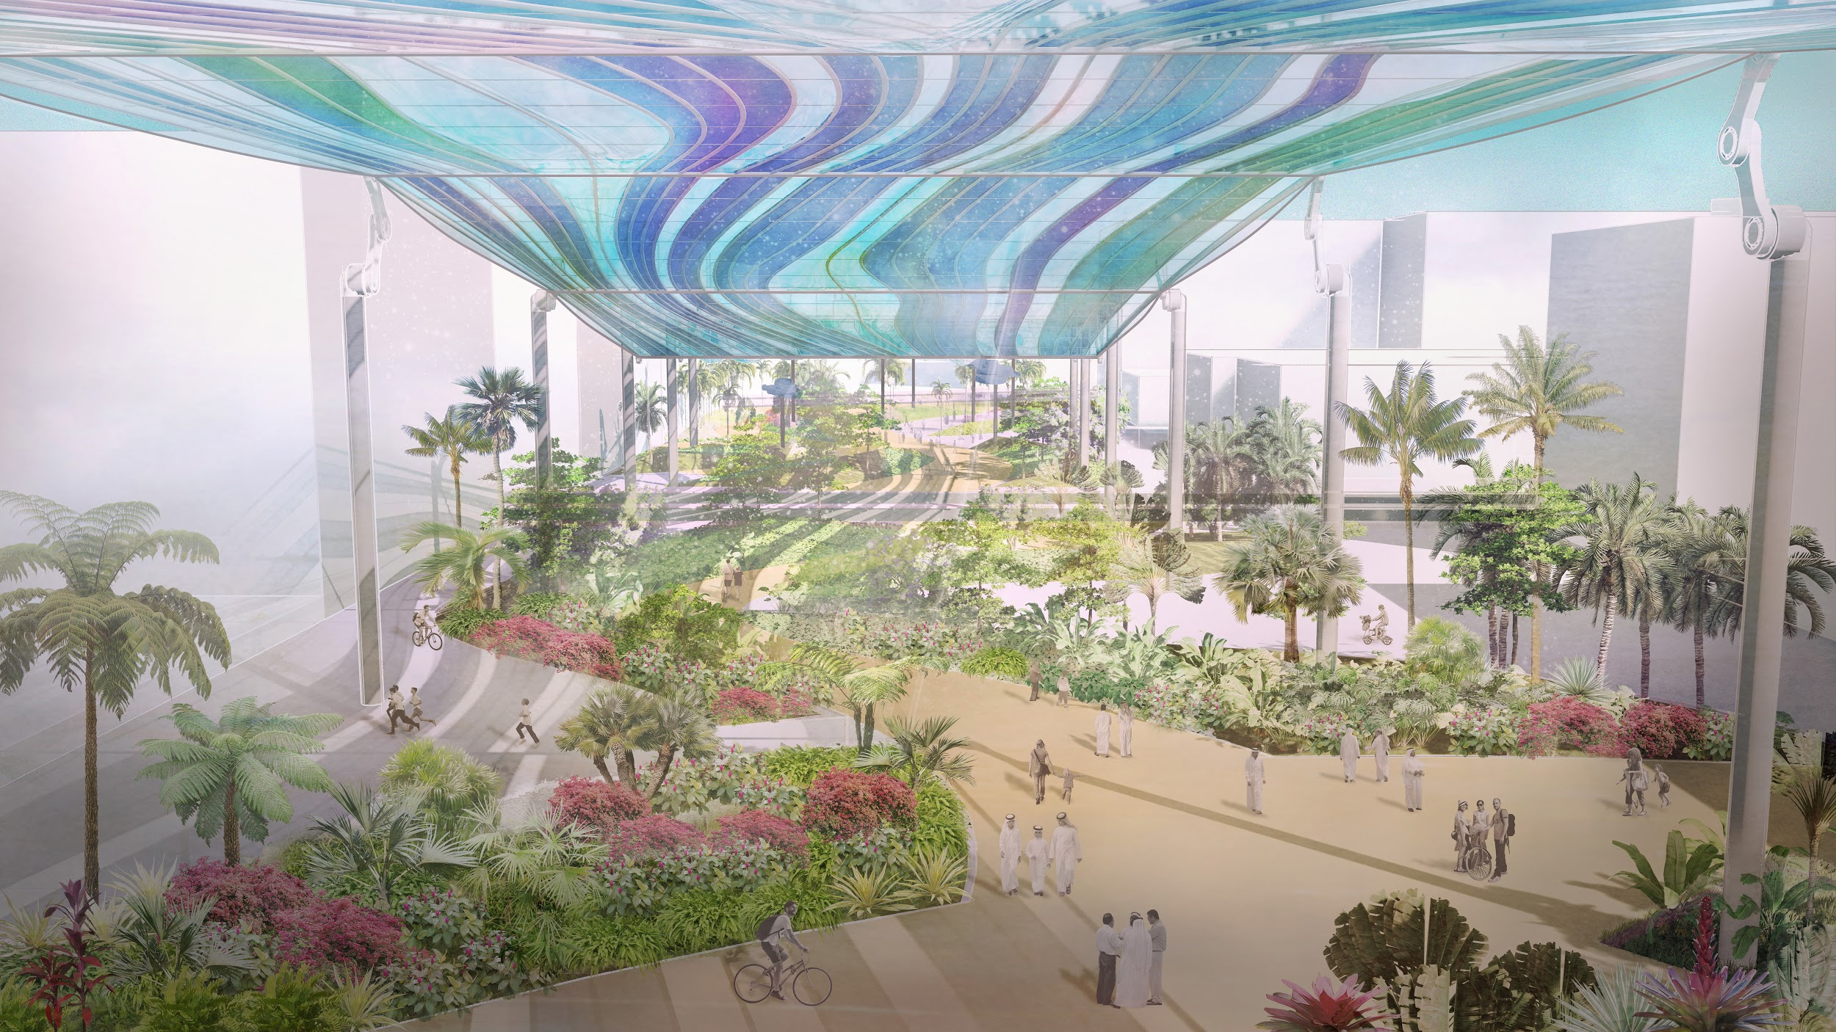
SECOND SKY
LAGI 2019 ABU DHABI

SECOND SKY
RENEWABLE WIND GENERATOR

A piece of seemingly infinite, cobalt sky is pulled down to hover at twenty meters above the ground as a new “Second Sky”. Gently levitating above the ground, this canopy converts solar energy into kinetic motion. The colossal, floating form flexes and oscillates in a smooth undulating motion, pushing pulses of air underneath to generate wind. Oriented in alignment with the prevailing wind directions, “Second Sky” also amplifies the natural wind when it flows through the site. This artificial and enhanced natural wind is pushed throughout the lush, green oases underneath the “Second Sky”, which flourish under the protection of the undulating canopy from intense solar radiation and desiccation. During stagnant, sweltering hot spells, “Second Sky” generates vital, relieving winds within the site and diffuses them throughout Masdar City.

Underneath the shade of Second Sky, a unique microclimate exists within the network of oases, paths, and plazas. Visitors are drawn in to meander through the site and take respite from the outdoor heat. The design seeks to reconnect the individual to the fleeting atmospheric phenomenon of wind cycles by creating a zone that enhances and dramatizes the climatic effects of wind (using Bernoulli’s principle). As the “Second Sky” breathes, it offers a phenomenological, technological, and ecological experience for visitors to the site.

Situated in the southeast corner of the site are a field of wind roses. Their form derives from lenticular clouds, a distinctive natural cloud formation that arises when moist air flows into eddies generated by turbulent wind. These wind roses are designed as vertical clusters of wind turbines that recapture wind energy from the combination of generated and natural wind to supplement the power needed to activate Second Sky while depositing excess energy back into the grid.

This climatic gateway into Masdar City sits at a significant crossroads between the R&D sector, residential complexes, and community facilities. The visual aspect and outdoor comfort this space provides can cater to a diverse and large crowd of users to allow this verdant node to become the apex for the public green spines that extend throughout the city.

Energy System

The UAE is aiming to be at the forefront of the energy transition to low-carbon societies (e.g. one of the first major oil-producing countries to ratify the Kyoto Protocol and UNFCCC Paris Climate Agreement). As the 2019 site of the 24th World Energy congress, Abu Dhabi is dedicated to managing greenhouse gas emissions and seeks to increase overall climate resiliency while diversifying its economy away from heavy dependency on oil through renewable energy innovations. Through the UAE Vision 2021, the UAE is aiming to reach 50% renewable energy usage by 2050 to become the global hub for clean energy and sustainability. A key aspect of transitioning into renewable energy (which is inconsistent by nature) remains in the reliability of its supply using storage, while economically competing with traditional fossil-fuel based technologies. We incorporate flexible methods of energy storage in Second Sky, making it an art space that can captivate the public by making visibly palpable the often invisible works of renewable energy systems.

The photovoltaics used on the canopy of “Second Sky” are the predominant source of low-carbon and clean energy generation. Vertical axis wind turbines (wind roses) capture energy from both the natural wind and artificial wind generated by the “Second Sky”. The Energy Management System (EMS) is based on the real-time data of energy supply and demand of Masdar City, thus enabling us to maximize the use of renewable energy by:
- Sending excess energy to the smart-grid of the larger urban network
- Storing excess energy (lithium-ion batteries, hydrogen chain)

The site has a nameplate capacity of 607 kW, and annual energy generation of 1.03 GWh (PV: 97%, Wind; 3%), which covers the annual domestic energy consumption of around 170 households.
With a global cost of $1.23 million (around 2.03 USD/W), the return on investment (ROI) of the global system (production, storage & conversion) will be made in less than 15 years.

The system can also produce up to 47 tons of hydrogen gas annually to be used in the following ways:
- Power hydrogen vehicles (enabling a fleet of 150 hydrogen buses/trucks to drive 100km daily)
- Insert electricity back into the grid during demand peaks (maximizing ROI during times of high electricity prices)
- Inter-seasonal energy storage (less solar in the winter time)
- Produce natural gas through methanation (using CO2 captured from oil power plants)

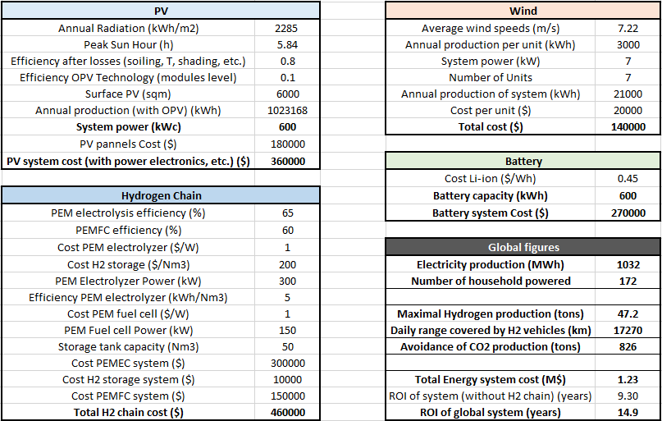

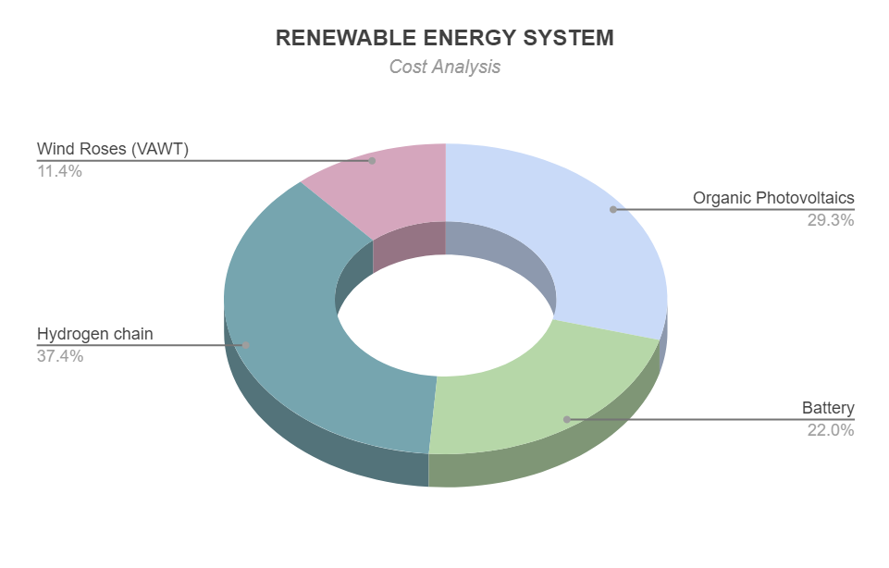

Primary materials and dimensions

- Second Sky (unit count: 1)
  - Total dimensions (L 180.0 m x W 62.5 m x H 26.5 m)
  - Assembled panels (unit count: 6):
    - ETFE double membranes (+/- 1500.0 sqm)
    - Extruded aluminum frame 140 Lm
    - OPV modules (average per panel) +/- 1000.0 sqm
  - Stainless steel support columns (unit count: 14) (H: 17.0 - 22.0 m, 1.0m dia.)
  - Stainless steel cover encased motor and robotic arm assembly (unit count: 14)
- Wind Roses (unit count: 7)
  - Total dimensions (L 9.5 m x W 9.5 m x H 8.5-15.0 m)
  - Rotary Blades (unit count: 6-8 per Wind Rose)
    - Curved extruded aluminum frame (+/- 18.0 m)
  - Rotor and generator assembly
  - Support column (height varies: 4.5-8.0 m)
- Storage
  - Li-ion Battery (600kWh) stored below ground - access via surface hatch embedded in landscape berm
  - Hydrogen chain
    - Electrolyzer (300kW)
    - Storage tank & fuel cell hidden from public view in landscape berms
- Landscape
  - Planted softscape (berms) (unit count: 13)
    - Total berm coverage varies (5415 sqm)
  - Hardscape
    - Concrete unit pavers (8605 sqm)
    - Cast in place concrete (6435 sqm)

Future Prospects : Plug + Play Adaptability

Our design enables the local R&D ecosystem (adjacent research organizations) to test and benchmark the latest renewable technologies in order to support their activities. We have made a conscious choice to use OPV modules as our main source of solar energy generation due to their transparency, flexibility, lightness, relative technological maturity and overall cost effectiveness. However, depending on the different roadmaps, future solar energy solutions (thin SHJ, perovskite, tandems, etc.) can replace our current current OPV cells within the next 10-15 years as they come into maturity. In the same vein, as vertical axis wind turbine technologies evolve in regard to energy conversion efficiency and high strength lightweight fin materials, the components of the wind roses are also able to be updated.

Lithium-ion batteries are our main Energy Storage System (ESS) because of its immediate applicability and future relevance in the next 10 years. This storage unit can easily be replaced by other technologies in the future (redox-flow, etc.). In addition, the plug-and-play structure of our ESS will re-appropriate already used batteries from electric vehicles (EVs) in order to give them a second life as a stationary application. This concept of a multiple life-cycle circular economy around batteries will become a global standard, as it enables a substantial minimization of the ecological footprint. Additionally, the electrolysis technology (PEMEC) can be replaced by others (ex. SOEC) in the next 15 years when the cost of contending future technologies will have dropped.

Environmental Impact Assessment

The carbon footprint of the Second Sky and wind rose structures is quite low as it is uses lightweight materials with polymer and thin, high strength steel and aluminum beams. This comprehensive energy system, composed of photovoltaic solar flexible cells, wind turbines, batteries and hydrogen system, enables the site to produce 1.04 GWh of decarbonized energy. Compared to traditional fossil fuel based energy generation, the site will have no air pollution and avoid the production of 825 tons of CO2 by year, contributing significantly to a low-carbon society.
Thanks to storage technologies in both the short-term (batteries) and long term (hydrogen), the site maximizes the utilization of the produced renewable energy, enhancing the global efficiency and ecological footprint of the system. The conversion of renewable energy into gas and fuel through hydrogen enables its use not only for domestic, but also for industrial and mobility applications, enabling the building of a sustainable, low-carbon system that covers the different energy needs of society. Hydrogen, associated with CO2 capture, is also important for closing the CO2 cycle.
For enhanced energy and material efficiency, we use a “plug-and-play” approach enabling technological upgrades over the years as they become more affordable and efficient. Our system also re-uses technologies from one usage to another, giving them a second life (e.g. EV batteries are given a second life as stationary batteries). We chose mature technologies for immediate use as they use less critical materials and have industry recycling capabilities built-in, enabling us to create a circular economy.

