FINGER PRINT
LAGI 2019
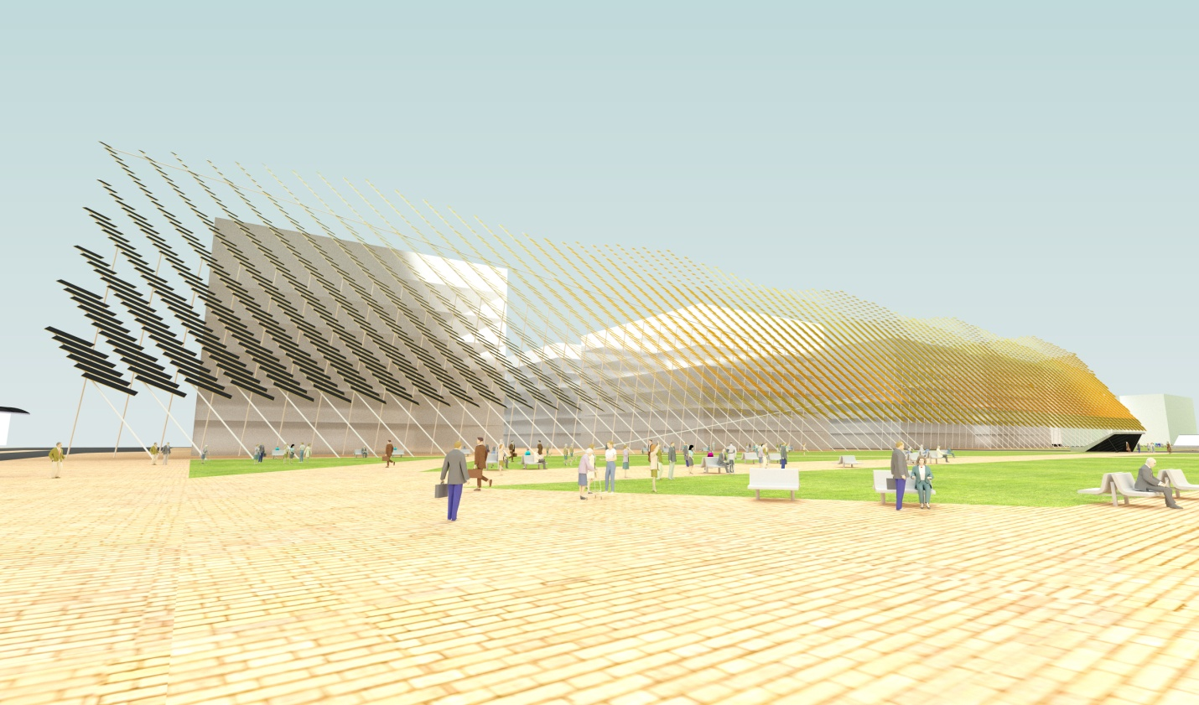
FINGER PRINT
PROPOSAL

Along the north-east boundary of the site Finger print is the Identity of green finger linear park that generate electricity over 1500 homes. This scheme integrates solar and wind energy and battery storage seamlessly within the landscape of green finger linear park.
A Lightweight tensile structure made from thin film high efficiency solar photovoltaic modules generates 2,330 MWh annually. The modules allow the shade for the existing proposed building providing 11,915 solar components. It provides improved sun protection on pathway and makes use of the accessible area as an energy harvesting opportunity.
84% of the energy is generated by solar photovoltaic cells.

The secret to making large-scale creative renewable concepts realisable is the extensive use of a mass-produced modular elements that benefit from economies of scale at their production stage.
Each renewable energy element of this scheme meets this fundamental objective.

A 40 meter high and 5 meter above from the road level Lightweight tensile steel structure made from a group of steel poles anchored with tensile steel cables on the area of 300x20 meter.

REALISING THE LAGI DREAM FUNDABILITY & BUILDABILITY

For a large-scale concept to be fundable it must
- Designable
- Buildable
- Maintainable
- Warrantable
- Insurable
Achieving the above criteria, in conjunction with acceptable return-on-investment will help make LAGI projects fundable and therefore realisable.
We believe the secret to making large-scale creative renewable concepts realisable is the extensive use of a mass-produced modular elements benefit from economies of scale at their production stage.
Each renewable energy element of our scheme meets this fundamental objective. This one can be realised..!

Modular component products utilised:
thin film solar photovoltaic (PV) modules:
- Recently-commercialised high-efficiency modules supported and warranted by permanent presence in Abu Dhabi, produced by a reputable international manufacturer with good industry-credibility.
- Product details:
  - First Solar Series 4™ PV Module (122.5 WATT MODULE EFFICIENCY OF 17.0%)-1200x600
Wind-motion regenerative dampers
Dampers attached with the steel structure convert wind motion into wind energy via the tensioned cables anchored with every steel pole. Solar modules are attached with the independent steel poles in the wind, across the green finger linear park from north-west to south-east.
Energy storage – kinetic energy storage
Kinetic energy storage cabin of the standard shipping container size arranged under the ground that store electricity from on-site energy production. A complete system of 50 cabins are away from the public and visitors.
The kinetic energy storage system makes the sustainable energy more sustainable.
Product details:
STORNETIC Flywheel Machines
EnWheel®60
Peak Power 80 kVA
Useable Capacity 3.6 kWh
Charging time 260 sec
Discharging time 260 sec

A complete system of 50 cabins are contain 1,400 STORNETIC Flywheel Machines with a storage capacity of 5MWh.

Rough estimated cost

The rough estimated installation cost of this proposal is 18,000,000$ according to International construction market survey 2017.

Limited cost:

25,000,000$(1,510,044watt modules x 17$ per watt cost of a standard small-scale solar installation)
Bodied ecological impacts of proposed materials
The renewable technologies used have been selected to have less than a quarter of the embodied environmental impact of their conventional alternative forms, using mass as a proxy. Embodied impacts of products include their embodied energy, water, waste and toxicities associated with their manufacture.

