Source Re:Source

“The wind blows wherever it wants. Just as you can hear the wind but can't tell where it comes from or where it is going....” John 3:8 NIV.

In this case, the wind is blowing from the open surrounding, and gushing towards the city of Masdar via designed open space corridors. The green energy is all around, but it is inactive until we design a way to capture it and make it visible. We started by cutting the rectangular boxed competition site into thin slices of planes. The planes themselves generate solar energy generating by using thin film solar technology and Dye Sensitized panels. We imagined if the wind blows over these planes, it would push on a this deck of solar planes on its way and cause a domino effect, which inspired the form of the project.

These planes are designed as sails supported by ultra-light structures that arc along pivots on the ground. They move with the wind much like the leafed branches of a large palm tree. To keep the structure light yet strong, cable reinforcements acts as tension members to reinforce the rod and structural sails, much like those utilized in sailing boat. When the sails move with the wind, the base pushes on a set of embedded gears that operates in two directions. This is connected to the freewheel assembly below.

Using the idea of a bicycle drivetrain where a minimum ratchet movement of the crankarm can cause the back wheel and free hub to spin, there is a series of small and large gear exchange following angular velocity principle to convert minimum movement from the sail to the freewheel hub. Energy in the form of electricity is produced via the freewheel and can be stored in underground battery.

The sails themselves are made of colorful thin dye sensitized solar films woven to clear curtains. They generate energy for the project in addition to the wind. Their height gradually increase toward the middle of the project to allow for better wind movement toward the center. The color corresponds to previous published study by Maulana Azad Nation Institute of Technology in India (2013 International Conference on Power, Energy, and Control ICPEC) on how color wave length affects solar panel performance. The flatter panels will receive better efficiency where color of panels have minimal affects. Blue and violet are identified as the least efficient light spectrum to hit a photovoltaic panel while red, yellow, and green are the most efficient color wave length for solar absorption. The project applies these colors based on the angle of the sail in order to better respond to the available lights. The lower and flatter panels receive the less efficient color dye such as blue and violet as they are at a more ideal angle to receive the solar ray. The more vertical sails are less efficient in receiving solar ray and are assigned more efficient colors such as yellow and green, with the most vertical ones receiving the highest efficiency color dye red. Beyond the technicality aspect, the colorful shadows are simply a way for us to paint the desertscape. As the sun and shadow move throughout the day and the seasons, the painting is an ever-evolving art work.

From a scale perspective, as the sails approach the city center, they reduce in height and size to create a better scale and to capture the turbulence that is created at the back end of a ridge. The color also changes back to a less intense spectrum. The total expected annual energy produced is 14 MwH [Refer to calculation provided in separate document]

The solar sails are set in a reflecting pool. As a result of this aesthetic, a waterfront plaza is created as a public space feature. In hot arid climate, the waterfront provide a more comfortable humidity level for the surrounding. As the wind circulates through the project, the evaporating water contributes to the cooling of air before they blow toward the city center of Masdar. The waterfront also changes the characteristic of the surrounding properties, making them a welcoming park feature for the adjacent buildings.

The vision of the competition referred to the importance of back to the source. This has two interpretations in the project. Green energy is passive and often invisible. We utilize various strategies to re:veal them. Theoretically, back to the source is about the basic elements that make up the energy and how we can bring attention back to them. Solar is about the seven colors spectrum that brings delight to the eyes. Colors are assigned based on their corresponding wave length efficiency and the rotation angle of the solar panels. Wind is about the movement of objects that brings attention to their existence. As objects move with the wind, the movement re:veals wind’s existence. By discovering and revealing the invisible and latent energy around us, we can bring awareness to their existence and transform these sources into re:source.

In practicality, the energy captured from the sun and wind becomes a source of energy recharge for the public visiting the site. Touchless charging are embedded on the road that intersect the site. Charging is available for anyone parking their electric vehicle or E-bicycle along the sidewalk. This can also become a stop for the autonomous vehicles in the city of Masdar. As one exits their mode of transportation, circular shape wireless phone charging hubs are embedded through out the plaza and available for charging anyone’s personal hand held devices. On site generated energy is immediately harvested back as the source of power available to the public.

The proposed project is a source of energy as much as it is a public amenity. How will one use the waterfront plaza? Is it a picnic spot on the weekend where little kids splash their feet in the water? With the colorful shades overhead, does the plaza become a waterfront street market place? With the stair bleachers and refreshing pond, does the plaza become a gathering space to host a performance or a lecture? Would a recreational cyclist take a detour to the space to charge his or her e-bike? The possibilities are endless and open to the imagination. As much as it is about making art out of energy, the project is also about making a public space that adds to the value of the surrounding and makes Masdar a day-time destination to visit.

Annual kWh calculation

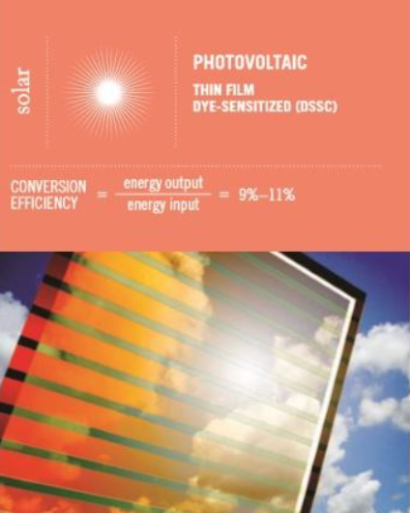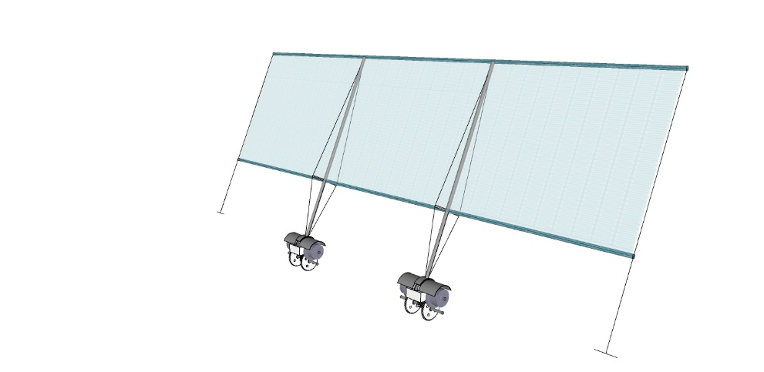

1 2 3 4 5 6 7 8 9 10 11 12 13 14 15 16 17 18 19A 19B

Fact :

Dye sensitize (DSSC) at 9-11% efficiency.

Assumption :
- Typical solar panel at 20W per sqft. Assume 10 hours of daylight, each sqft of panel will generate 200 Wh per day. This equates to 200 Wh/day x 357 days (8 rain days, https://weather-and-climate.com/average-monthly-Rainy-days,abu-dhabi-ae,United-Arab-Emirates) = 71,400 Wh per sqft per year, or 71.4 kWh per year.
- 20 solar sails, last sail reduce in size toward Masdar and integrated into adjacent sails to arrive at 19 sails total. [Refer diagram above, last two panels on the right highlighted in yellow]

Solar sail measurement: 40 ft x 150 ft = 6,000 sqft
6,000 sqft x 19 solar sails = 114,000 sqft.
114,000 sqft x 71.4 kWh = 8.1396 MWh per year.
8.1396 MWh per year x 10% efficiency = 814 kWh per year.

*********************************************************************************************
Solar Sail freewheel generator

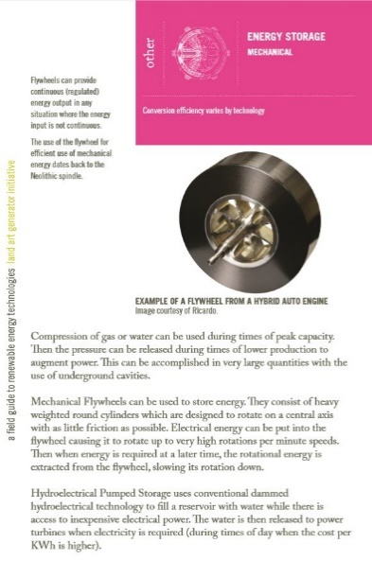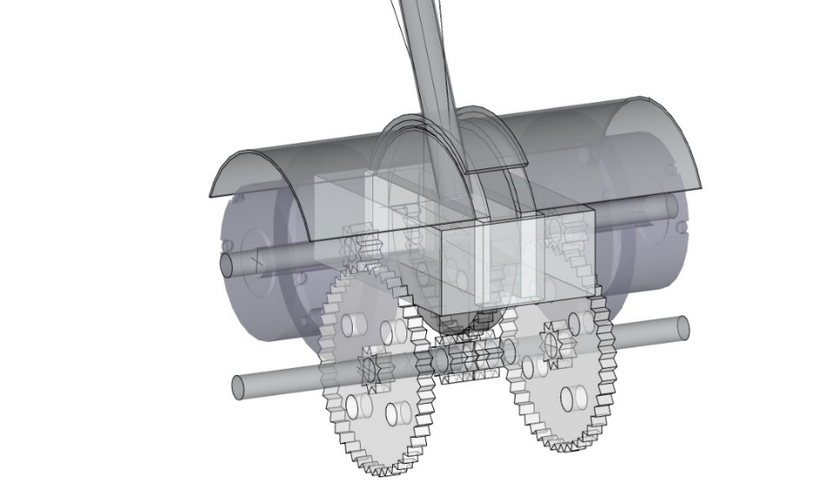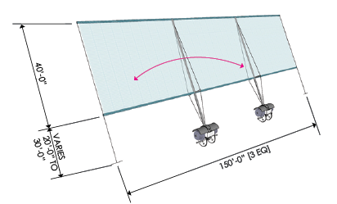

Basis of calculation:
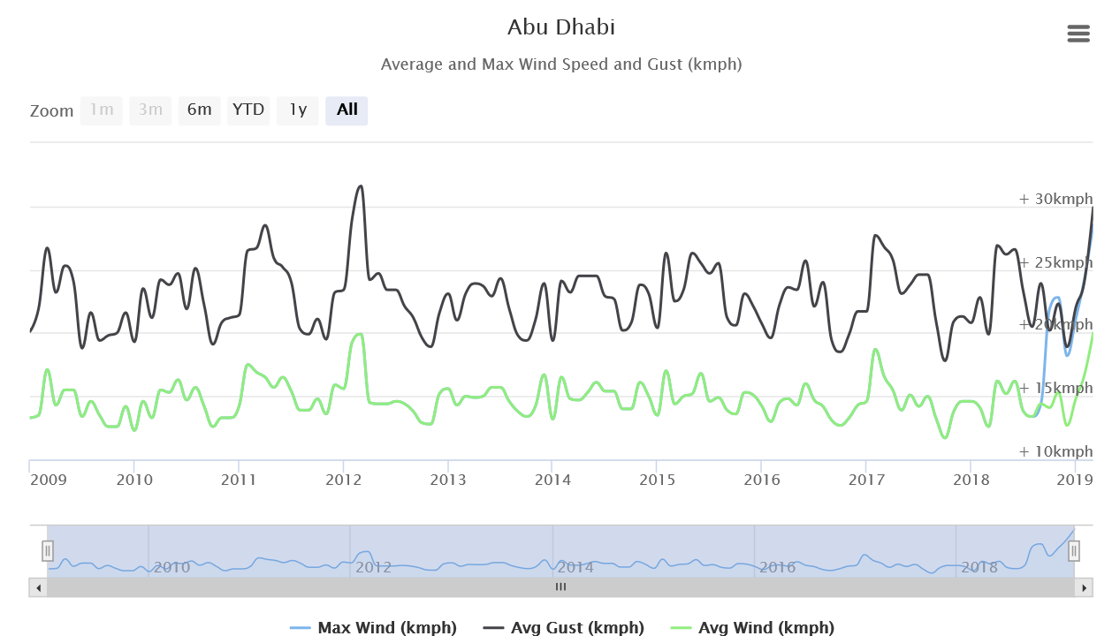

Annual wind speed for Abu Dahbi is used as data for annual
https://www.worldweatheronline.com/abu-dhabi-weather-averages/abu-dhabi/ae.aspx

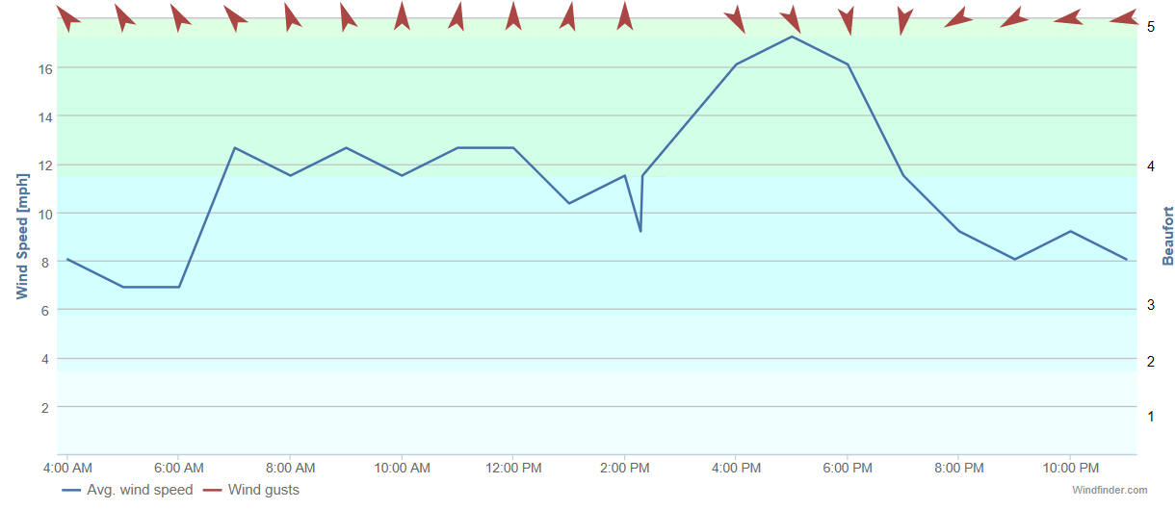
Daily Wind speed for Abu Dahbi Airport
https://www.windfinder.com/report/abu_dhabi/2019-04-20

The proposed solar sail doesn’t spin 360 degree. It is the crank-arm that rachets back and forth partially when the wind moves it, thereby initiating movement of the freewheel to generate energy. In theory, the freewheel’s diameter is consider the turbine that generates energy and will be used as “D” in the following calculation.

Energy Calculation Equation source:
https://windexchange.energy.gov/small-wind-guidebook#generate
- AEO = 0.01328 D² V³
Where:
- AEO = Annual energy output, kWh/year
- D = Rotor diameter, feet = 6 feet
- V = Annual average wind speed, mph = 10 mph (Average)

- AEO = 0.01328 D² V³
= 0.01328 (6²) (10³)
= 478.08 kWh/year per freewheel.
There are two freewheels per sail arm, and 2 sail arms per solar sail assembly.
= 478.08 kWh/year x (2 x 2) = 1,912.32 kWh per solar sail.
There are 19 solar sails per diagram above.
= 1,912.32 x 19 = 36,334.08 kWh per year from wind.

ENERGY NAME PLATE | kWp in kilowatts of power
Thin Film Dye-Sensitized (DSSC) | E = 814 kWh [P = 814kWh/ 365days(24hrs) = 93Watts, or 0.093kW]
Flywheel / Freewheel | E = 36,334 kWh [P = 36,334kWh /365days(24hrs) = 4kW]

TOTAL PROJECT kWh = 814 kWh + 36,334 kWh = 37,148 kWh per year, or 37 MWh per year.

Environmental Impact Statement

The proposed project is located along the green corridor as designed by Foster and Partners in the original Masdar urban master plan. Currently, part of the site is a paved surface parking lot with shaded structure for Seimens Building. The adjacent areas are mainly undeveloped with the exception of Masdar playground and the solar farm to the northwest. The proposed project will be a mixture of green space, paved plaza space, wooden planks boardwalk, and water feature.

As part of the open space corridor, the waterfront plaza is in line with the public space usage. It is a continuation of the Masdar playground and creates a public space that continue toward Masdar city center. The solar sails are expect to catch the northwestern wind. Due to the undeveloped surrounding, it is not expected to create any barrier to the wind. Once the surround is developed as shown with building, it is expected that the green corridor will have a wind tunnel affect that further enhances the movement of the solar sails.

The sails are colorful and translucent. They will cast multitude of colors on to the ground and adjacent buildings once they are developed.

The solar sail’s embedded gearings and freewheel will require partial excavation that is similar to the depth of regular building foundations. The water feature is above grade and excavation is minimal. When future buildings abutting the water feature are developed, consideration should be taken on how this relationship will occur. Developer of adjacent project can either stop their project at the water edge, or they can react to it with architectural feature such as boardwalk or docks to take advantage of the waterfront. The water feature is expected to aid in humidity level of the surrounding plaza.

Project Cost

It is estimated that each solar sail will cost $500,000 USD to construct and install. This include the fabrication of structural support and the dye-sensitized thin film solar. We estimate the site work involved will cost $5,000,000 USD.

$1,000,000 x 20 solar sails = $20,000,000 USD

Rough order of magnitude conceptual cost estimate is in the $25,000,000 USD range, or roughly 91,830,000 UAE dirham.

At $25,000,000 with energy at 14,000,000 watt. = $1.78 per watt.

