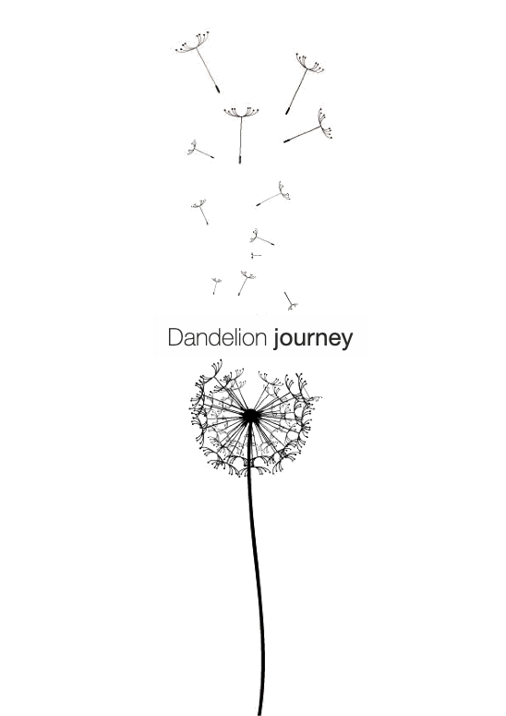

Report

Concept

The sun laid eyes on you in spring
Washed you with its colour to shine bright
The wind then whispers in your ear
And prepared you for a magical flight
That’s why you glow and shine
And are first but never late
As you swiftly ﬂy in the wind
Searching for your future and fate

Marinela Reka

As the poem states, the force of the wind allows the Dandelion to magically fly in the air, spreading life and looking for a new future. Attracted and inspired by this, the aim of the proposal is to represent the steps of this journey. Metaphorically there is a strong correlation with Masdar city: the Dandelion flower became a tool that with its travelling, drives people into the city to understand the power of the nature. Moreover, it is able to transform the present situation in Abu Dhabi — where fossils are still the main resources used today — to a new future made only by clean energy. Masdar, in this narration, become a city born from the wind.

Located on the edge, as one of the gates for Masdar, the park is covered by 20 giant Dandelion flowers. Rising from the ground, the semi-transparent elements starts the visitor journey, who is inspired to contemplate and to think. Then as the wind blows, these structures seem to break up in 80 flying components: the Achenes, swinging playfully in the breeze, they are searching for their future and fate. The journey ends with 40 other planted Achenes which now have found their place on the ground. They have brought new life to Masdar, ready to start over this circle and to spread awareness about the force of nature in other places both in the UAE and in entire world.

Experience and Interaction

As visitors walk amongst the park, the installation narrates how the natural energy can be captured and used. People guided like the Achenes by the wind towards Masdar, experience different effects. The semi-transparent Dandelions, in fact, form shading on the park, protecting from the sun but guaranteeing in any case the sunlight transition. In the air the Achenes are swinging in a higher position, they as the planted Achenes are not transparent. This allows to develop a new layer of shading. The resulted effect of these overlapping masses creates a gradual fade-away panorama for the visitors.

In particular the opaque ground elements can protect from the sun and hosts people activities: the presence of swinging seats and hammocks can make people feel as they are flying with the Dandelions.

At night happens the real interaction with the installation. The normal appearance of the Dandelion is complete turn on by the LED lights, but visitors can actually change it with the blow-activated light switch at the base of each flower. In fact, blowing inside it turns off part of the Dandelion making them disappear in the darkness, while the flying Achenes, once hidden in the dark sky, are lighted up. People can in this way actually blow the Dandelion in a childlike act, strengthening their awareness on the importance of the environment.

Designed for Energy, by Energy

The 3 elements that compose the installation (the Dandelion, the flying Achene and the planted Achene) have been designed simultaneously with the technology analysis. The resulted shape, in fact, guarantee the implementation of the wind and solar systems merging them with the artistic and concept aim. For reaching this outcome, the shape of the flower has been first simplified then abstracted.

Masdar location is dominated by north-west winds. The city is designed with different NW-directed wind-corridors and the project site is at the initial part of one of them. For this reason, the design has been influenced in particular by the wind analysis. The location of the elements inside the park has been a fundamental issue to fully exploit the wind power. In the analysis has been underlined the more suitable area and for each component its most excellent height. Reaching 10-30 meters for the Dandelions and 35-45 meters for the flying Achenes.

Each Dandelion is assembled by 31 different Achenes with a total area of 200m², formed by hexagons and pentagons shapes. The single component is the actual energy collector: their structure is made by PTFE pipes which sustain three layers of semitransparent and flexible materials: the solar panels, the structural panels and the piezoelectric material. The solar panels consist of OPV (organic solar cells): the choice of this typology is due not only for their transparency and flexibility but also because 2018 has been a great year for OPV panels, reaching for the first time a 15% photoelectric conversion efficiency; in the next 10 years is expected to rise up to 25%. The OPV is attached on the PTFE structure panel, meanwhile below is contained the piezoelectric material: the MoS2 developed by the Columbia University. Once the wind shakes the panels, the MoS2 made up by electrodes, produces energy compressing them, even with low wind velocity (from 5m/s).

The Dandelion inner core is opaque. It contains a LED lights system with lithium batteries to store surplus energy, using it when needed to power the park area.
In contrast, for the city energy demand are used the charges connected to the underground storage and power grid by the cables contained in the structural steel steam of the flower.

The flying Achenes with wan area of 6m² dd is nothing else than a single component of the Dandelion. The structure remains similar: OPV panels on the top layer and PTFE panels and pipe structure. The difference consists on the presence of the helium chamber which allows this element to float on the sky. The system is inspired by NASA scientific balloons. The pipe attaches the flying Achenes on the ground or directly on the flowers. Inside two cables are used: one for the electrical energy and the second for topping up the helium air chamber.
At the base of the pipe it is present the recirculating ball system that transforms the mechanical energy made by the wind into electric energy. When the wind is too strong or in case of maintenance a re-wrap system can recall the elements on the ground.

The planted Achenes, with which our journey end, uses only OPV panels on their top.

Energy outcome estimation

Solar energy:

- OPV solar panels
Considering the efficiency reached last year by OPV of 15%, a total area of 4 692m² and an average of 8 hours per day in which this efficiency is totally reached by the site devices, the total energy output per year is 2 055 MWh / year.

Since in 10 years the efficiency is expected to reach 25%, with this future forecast it is possible to reach 3 425 MWh / year only from solar energy.

Wind energy:

- MoS2 Piezoelectric material solar panels
With a total of 2 000m² of panels in the park with a production of 5 W / m² the total output of all the 20 Dandelions is 60 MWh / year.

- Recirculating balls system devices
The electrical power output for each of the 180 devices (2 for each flying Achene) present in the site is 55 W / m² . Reaching in total 152 MWh / year.

TOAL ENERGY OUTCOME: 2267 MWh / year

Costs:
Material | Unit | Unit price/$ | Price/$
PTFE panels | 4 692 m² | 64 | 300 288
PTFE pipes | 27 200 m | 37 | 1 006 400
OPV | 4 318 m² | 320 | 1 501 440
Piezoelectric | 4 692 m² | 265 | 1 243 380
Recirculating Balls system | 80*2 units | 420 | 67 200
Steel steams | 85 tons | 1 890 | 160 650
Pipes | 4 200 m | 10 | 42 000
Cables | 8 700 m | 3 | 26 100
Lights | 5 000 units | 55 | 275 000
Other fee (labor, excavating, transport…) |  |  | 3 200 000
TOTAL PRICE: |  |  | 7 822 458

According to these estimates, the installation cost (included technology, design and materials) is about 10 $/W.

Environmental impact

The materials and technologies used in the installation have an initial cost that is offset by manufacturing, installation and maintenance processes.
The organic photovoltaic solar cell is 100% recyclable, heat and rain resistant, and has an expected life span of 20-30 years. The piezoelectric material has also environmental adaptability and have excellent mechanical properties. The piezoelectric effect is known to generate voltage when the material is distorted or compacted: compared to other windmill, this kind of wind generator is less noisy. Main structural materials (PTFE) have long service life and good fireproof performance, it can be mainly recycled for reducing its production impact.

Overall, dandelions enable the contemplation of nature as a source of beauty. Although wind and solar do not have a shape or a colour, it can come alive and express its powerful elegance through the use of technology.

