INARA – Bubble Dunes
Description
This energy park is located in the desert type climate of Abu Dhabi
The harsh sun has traditionally kept the public spaces off limits to the citizens during the day time. By using an array of solar spheres, we are able to convert this solar energy to electricity.
This array of energy generating spheres creates a cooler shaded space, that links up 3 arterial roads This space is converted to a public park where people can assemble for cultural exchanges contemplate, and relax.

This sensor actuated spheres are cheap, but energy efficient and controlled by individual motors that can lift or push them down based maximum energy output. The spheres are 2 m in diameter and can generate energy out 2KW/ day. These spheres are self-illuminating at night, rendering the sky with a thousand full moons hence the name INARA. These spheres are placed on a space frame of 3.5 x 3.5 sqm which is also used as the dimension for the landscape grid. A significant number of these spatial grids are converted into landscape planters for native plant species. A few more of those pixels are combine to create a vast water body that lends a poetic definition to this surreal space.

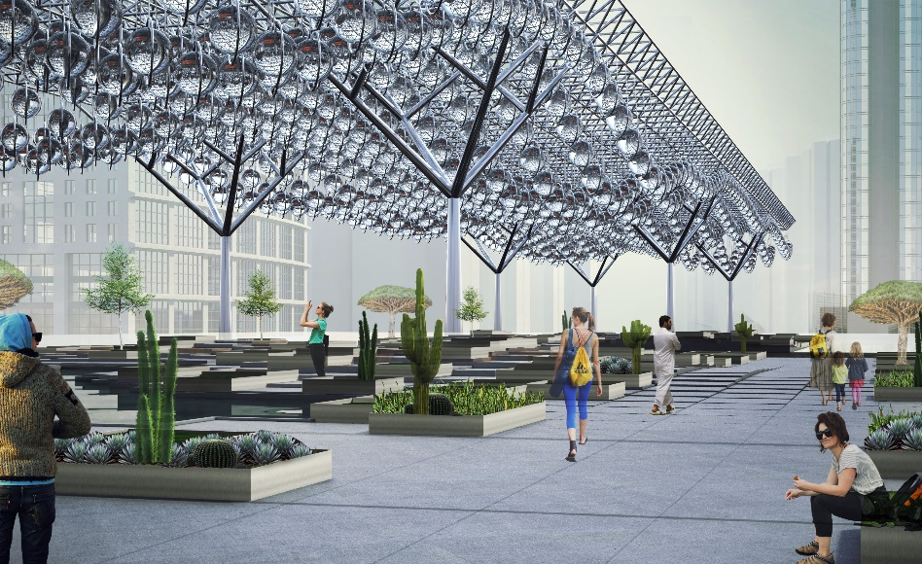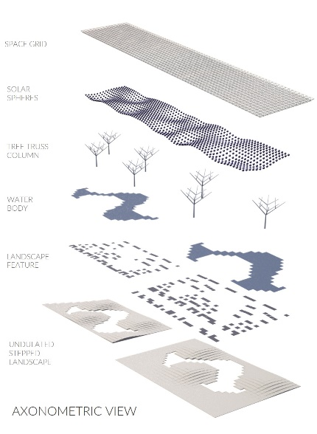

This in turn creates an inverted and animated sand dune, that mimics the ever-changing patterns of Rub’al-Khali desert. Our design is a radiating energy park that keeps pace with the time and space, bridging the divide between technology, culture and landscape.

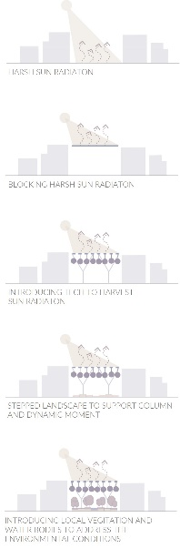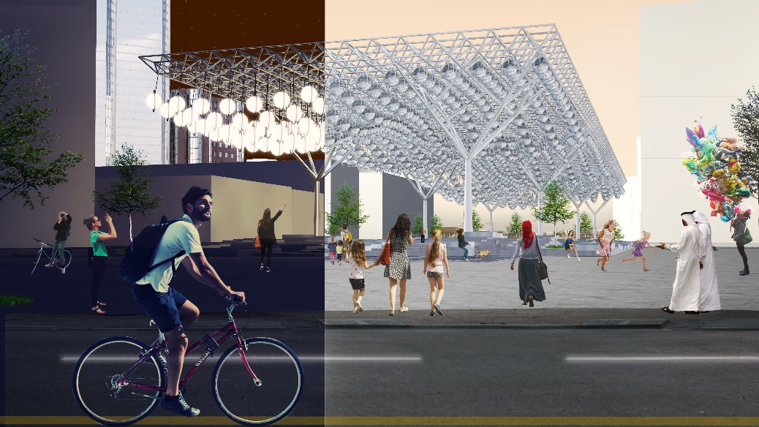

Technology
The design of Solar Spheres utilizes spherical solar concentrators to focus sunlight onto a photovoltaic thermal (PV+T) solar cell. By concentrating the sunlight through a sphere, the solar radiation per square meter is increased, allowing the solar orbs to generate the same amount of power using a smaller photovoltaic cell as compared to a larger solar panel. These panels are 25% the size of conventional commercial solar panels but have the same efficiency. ²
Solar Sphere can absorb diffused rays of solar energy to harness solar energy during low light conditions such as early morning hours, overcast days, late evenings, and even moonlight.1, 2 Using principles of spherical geometry Solar Sphere enhance efficiency, decrease solar cell surface, absorb diffused sun rays, and contribute to an aesthetic suitable to an urban environment. Unlike conventional solar panels that are fixed in place and only able to harvest energy for part of the day, Solar Spheres can track the sun as it moves across the sky each day.2 Each solar panel is mounted on a dual access tracking system, maximizing the potential power generated.1, 2 By utilizing PV+T solar panels Solar Spheres can not only generate electricity but also capture heat and use it on site in heating buildings or water.2, 3 Collecting heat from the panels performs another benefit in that it keeps the panels from overheating, thus optimizing production. This optimization of both solar efficiency and heat collection allows Solar Spheres to be four times more productive than conventional systems.4, 5

Energy Production
To calculate the power generated, we used the following equation:
P = [nameplate capacity] x [time] x [capacity factor]
Electrical generation nameplate capacity: 220W/m2 (5)
Heat generation nameplate capacity: is 350 W/m2 (5)
Capacity factor: .25
Because the sunlight is focused through the orbs onto the photovoltaic cells, the area of light being collected is a circle within the diameter of the orb. The equation for the area of a circle is as follows: A = πr2
In this intervention there is Solar sphere is 2 m in diameter. The effective area for each 2 m orb is 2.83 m2.

Electrical power generation for the 1095 solar spheres per year:
P_{e} = 1095 x (220 W/m2 x 2.83 m2 x 8,760 h/yr x .25)
P_{e} = 1,49,30,259.30 kWh/yr

Thermal power generation for the 1095 solar spheres per year:
P_{h} = 1095 x (350 W/m2 x 2.83 m2 x 8,760 h/yr x .25)
P_{h} = 1,49,30,259.30 kWh/yr

*Energy storage proposed to exist within proposed Cultural Center

Materiality + Dimensions
Each sphere is made of a clear acrylic sphere, filled with water. The orbs are supported by stainless steel space frame components. The height of the spaceframe from ground is 25m and the grid is of 3.5sqm respectively each module contains sphere of 2m diameter having total 1095 modules. Each sphere has an 18” PV+T panel and a motor for vertical moment of the sphere the vertical moment is controlled by the amount of solar energy the sphere receives and thus creates and kinetic installation. These spheres and space frame are supported by steel tree truss column system and further supported by the stepped foundation and landscape. Planter boxes of polished metal of dimensions 3.5mx3.5mx0.45cm having locally available planter species of agave and cacti.

Environmental Impact Summary
Today we are challenged with the issue of global warming – the 2020 Vision for Melbourne begins to confront this issue head on. Our proposal will contribute to the Net Zero 2020 Initiative, giving users a chance to interact with green energy, seeing how it can be beautiful and artful, yet functional. Our design stems from the formal relationship of the natural and built environments – proposing a union between the two to creating a powerful impact on how people perceive our environment and how the built and natural environments can function simultaneously as one.
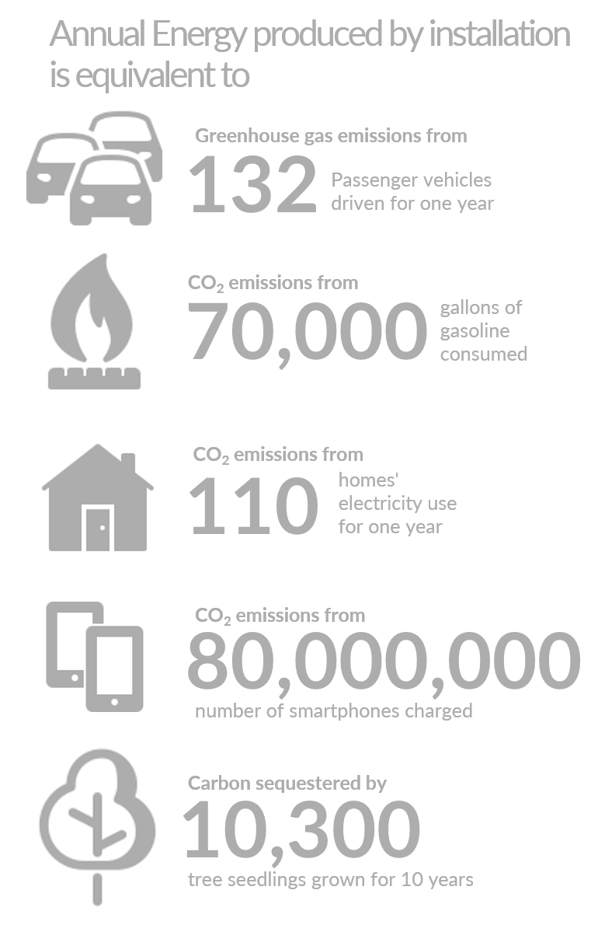
The Solar Spheres while positively contributing to the Net Zero 2020 Initiative, will also contribute to Abu Dhabi’s light pollution. The proposed lights are white LED that illuminate the transparent sphere, using less energy and having a longer life span. The Solar Sphere structure is also filled with water, but they only need to be filled once.
The solar panel on the dual axis tracking arm is ¼ the size of an average solar panel, but has the same efficiency – utilizing less material, and being easier to replace in the future.

References
- Nitin, G. "Spherical Sun Power Generator Market | Global Report, Application & Research 2025." MilTech. Accessed April, 2018. https://www.military-technologies.net/2018/04/25/spherical-sun-power-generator-market- global-report-application-research-2025/.
- Luleva, Mila. "Beta.ray - Spherical Collector That Combines Photovoltaic and Thermal Power." The Green Optimistic. June 11, 2015. Accessed April, 2018. https://www.greenoptimistic.com/beta-ray-pv- thermal/#.WujmK9TwaUn.
- Morris, Bob. "Solar Panels That Generate Usable Heat and Electricity." Politics in the Zero. June 04, 2009. Accessed April, 2018.
https://polizeros.com/2009/06/04/solar-panels-that-generate-usable-heat-and-electricity/

- "Hybrid Solar Thermal Panels Produce Electricity & Heat, for Quadruple the Energy Production." Cost of Solar. February 10, 2015. Accessed April, 2018.
http://www.costofsolar.com/hybrid-solar-thermal-panels-produce-electricity-heat-quadruple-energy-production/.

- "Rawlemon. The First Company in History to Concentrate Diffuse Light." Shopify. Accessed April, 2018. https://cdn.shopify.com/s/files/1/0478/6453/files/2013_rawlemon_flyer_NYC.pdf

- University of Exeter. "Coastal light pollution disturbs marine animals, new study shows." ScienceDaily. Accessed April, 2018. www.sciencedaily.com/releases/2015/04/150429090144.htm.

