**Statement of Intent:**

Tracing old references we see that natural forces, the so-called renewable energies, were known to human beings from the very early times and a key element in establishing civilization in the small communities of the antiquity.

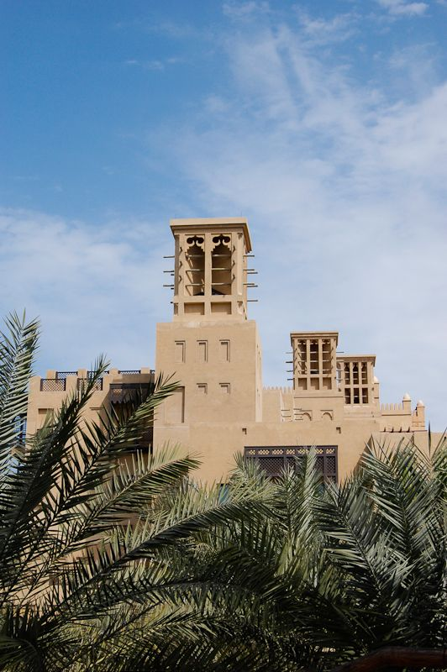

Considering how the dynamics of the demand are changing and using the technology we have a new approach in transforming the way resources are consumed. Our approach is based on deploying renewable energy technologies while being committed to ‘nature’s technology’ perfected over hundreds of millions of years in delivering key services to sustain life on Earth.

To some extent, a society‘s identity is based on its traditional heritage so our design idea was based on the actual arrangement of spaces and buildings of Abu Dhabi.

We turned to vernacular to reestablish contact with the fundamental nature of arrangements of spaces and buildings. A return to the roots. We believe in this simple approach, sustainable design looks to the future by looking at the past.

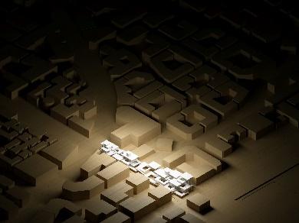

**Design Overview:**

Vernacular combines the best of both worlds: it is both conservative and radical, pragmatically based in experience. This was the initial source for designing the Suspended Gardens.

Traditional architecture in the UAE was based on modifying ambient environment to protect the occupants. Protection was needed from dense solar radiation, extreme temperatures, high humidity and dusty winds and courtyard housing typologies were generally utilized.

With all these in mind, following the traditional architecture of the city we have created a design that works with its natural surroundings, rather than against them. It is a fact that proper building placement is vital in minimizing its energy consumption and having the least amount of negative impact on the environment.

Constructed with low-carbon cement and consisting of three layers artfully interconnected; with each layer serving a purpose. We eliminated negative environmental impact through skillful, sensitive design.

Our main approach to the design is translated through mixing the indigenous solutions and modern technology which manifests to a sustainable design that requires renewable resources, impact the environment minimally, and connect people with the natural environment. Some of the traditional climate responsible solutions in architecture are used throughout the design which makes Suspended Gardens a vernacular based work of art. The considered solutions are:

Natural way of creating shading throughout using the layered design concept Use of Hanging Fabrics to create cooling air ventilation system in the interiors. Some of these installations are acting as Fog Catchers. (The new technology that is going to contribute to water generation) Use of Wind Catchers to create air Ventilation and direct cool breeze to the lower level

**Layer 1:**

On the street level and featuring interconnected courtyards with a free flowing concept for the walking traffic makes the first layer. We believe tradition is that part of culture that is transmitted from one generation to the next one. In the Arab world, tradition is not a single layer of past cultural manifestation; rather, it is multilayered complex. Suspended Gardens not only recognized but also creatively transformed those values that have accumulated over centuries, and through this process incorporated contemporary values.

Following the traditional courtyard design typology, this layer is formed. People can easily access this area from any side and emerge themselves in an oasis of landscape and gardens. Courtyards are artfully connected while the above layers are working as means to provide shade and protection from sun. The skillful placement of four wind catcher creates natural ventilation in the site. The towers catch cooler breeze that prevail at a higher level above the ground and direct it into this layer. To further provide the comfort and enjoyment of the visitors, some fabric elements are installed as interior arches which catch the cool breeze and letting the air through acting like air conditioners. They also provide an aesthetic factor and works with the environment to promote the comfort of the visitors.

**Layer 2:**

The design of a space plays an important role in building culture and preserving the traditions. It helps all citizens appreciate the richness of their heritage developed over centuries; it reflects political and cultural forces in tangible form. Layer 2 of Suspended Gardens has been designed with the mission of providing as much elements as possible in recognizing the importance of cultural values and principals. Void spaces create natural light and circulation encouraging visitors to stay outside and enjoy social gatherings and events. The interconnected ramps facilitates the flow of walking traffic and makes it a great outdoor experience while being part of a close and diverse society.

The use of fabric elements for air cooling and beautiful landscape design are continued from Layer1 making Suspended Gardens a harmonious space with many cultural attributes.Fog Catcher system are present on this level and making

**Layer 3:**

Generating energy from natural resources in an area of about 5,336 square meter is what this layer is all about. Installation of Monocrystalline Silicone Photovoltaic panels to generate electricity from solar energy along with devices that uses the newly discovered Metal Organic Frameworks to harvest water from thin air makes the top layer.This layer is all about technology that is integrated in the design to make Suspended Gardens a sustainable work of art.

Also, some of the water generated at this layer is used in misting nozzles installed at the corners to quickly absorb the energy (heat) present in the environment and evaporate, becoming water vapor (gas). The energy (heat) used to change the water to gas is eliminated from the environment, hence cooling the air. The water droplets contribute to irrigation of the greenery around.

**Technologies Used:**

**Photovoltaic Solar Panels (4002 square meter)**

**Monocrystalline Silicone Photovoltaic**

**LG400N2W-V5**

The LG NeOn 2 is LG’s best selling solar module, and is one of the most powerful and versatile modules on the market today. Featuring LG’s Cello Technology the LG NeON® 2 increases power output.

400w x 2001(4002/2) = 800,400w

800,400w x 6(hr) = 4,802,400w (4,802.4kw)

4,802.4kw x365 = 1,752,876 kw/h (1,752.876 mw)

1,752,876 kw/h (1,752.876 mw/h) Annual

**MOF based water harvesters (1334 square meter)**

**Devices that uses an Aluminum based Metal Organic Framework (MOF-303)**

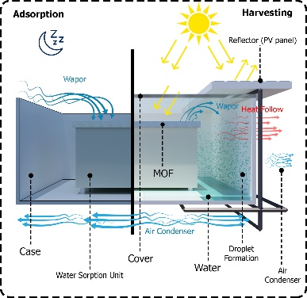Water harvesting cycle that produces water from air. About 13 sextillion (10 21) liters of water exist in the atmosphere at any given time. Our considerations in the design of the water production system took into account the energy, materials, and air requirements for the Water Harvesting Cycle. The capture cycle starts with saturation of unsaturated MOF upon exposure to the air at nighttime. This is followed by the release of captured water from the saturated MOF upon exposure to sunlight during daytime. The collecting cycle takes place during daytime when the released water vapor humidifies the air in the vicinity of the MOF. The hot humid air is subsequently cooled down, in our case by ambient cooling, to its dew point, resulting in liquefied water at the condenser. The collecting cycle (release-condensation) continues until the end of the daytime when the liquid water is collected and the next WHC starts.

0.450 kg of MOF-303 = up to 105 g of water (105ml)

2kg of MOF-303 (for each square meter) = 105x 4= 420ml

1334 x 420ml = 560,280ml (560L)

560x365=204,400 L Annual

**Fog Catcher mesh technology (500 square meter)**

**Functional Nano Composite Materials to Harvest Fresh Water from Humid Atmosphere**

On an average, there are 20 occurrences of dense fog each year in the UAE, mainly during the December-January period.

12 L/Square Meter of Mesh

12x500 =6000L

6000L Daily

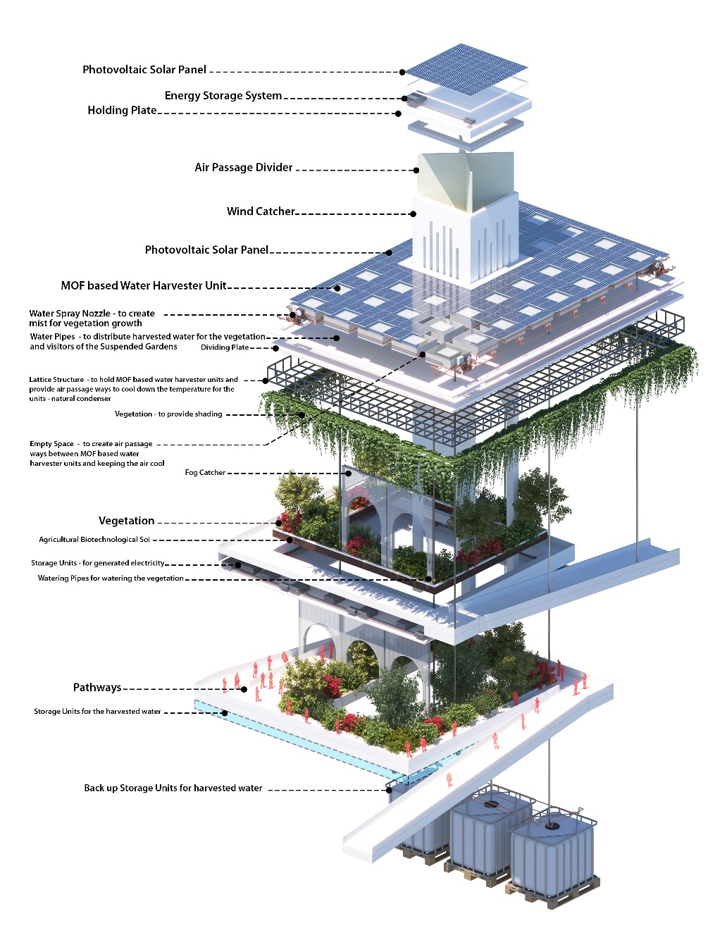

**Environment Impact statement**

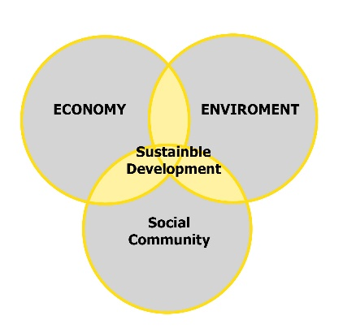The goal of sustainable development is to meet the needs of today, without compromising the needs of tomorrow. We have made this the blueprint to achieve a better and more sustainable future for the people living in the region. As stabilizing and reducing carbon emissions is key to living within environmental limits, all of our design elements are in harmony with the surroundings and have the least amount of interruption and negative impact on the environment. Our design concept is based on the three pillars of sustainability: economic, environmental and social sustainability. The main characteristics of our design are:

**• it respects and cares for all kinds of life forms**

**• it improves the quality of the human life**

**• it minimizes the depletion of natural resources**

The natural elements used for the energy generation are solar, air and fog which are better for the environment than burning fossil fuels. They produce less pollution which will help protect the environment and provide us with cleaner air and water. These resources are regenerated in the design through smart, innovative ideas.

Considering the scarcity of water in the region, new technologies for harvesting water from just the thin air are a breakthrough which is deployed in the design resulting in a building that is sustainable and energy efficient. Solar power is in abundance in the region and implementing this renewable energy in the design will result in avoidance of fossil- fuel consumption to a great degree. Designing in an environmentally sensitive manner requires detailed planning. It needs knowledge of materials and their interactions; knowledge of construction, craft techniques, skilled technicians, and available resources; and an ongoing commitment to the region identity through a sustainable approach. In Suspended Gardens all these are taken into considerations and the final result is a building that is based on traditional architecture and sustainable.

Sustainable buildings can not only reduce or eliminate negative impacts on the environment, by using less water, energy or natural resources, but they can - in many cases - have a positive impact on the environment (at the building or city scales) by generating their own energy or increasing biodiversity.

Sustainability is not all about energy conservation, renewable resources, or building materials. Sustainability is a life style, a way of living, and society’s cultural identity. Suspended Gardens goes beyond the general belief of environmentally friendly building by promoting the essence of sustainably in people’s everyday activities, the way they live, act, work, produce, plant, and build.