THE BIOSOLAR ESPLANADE

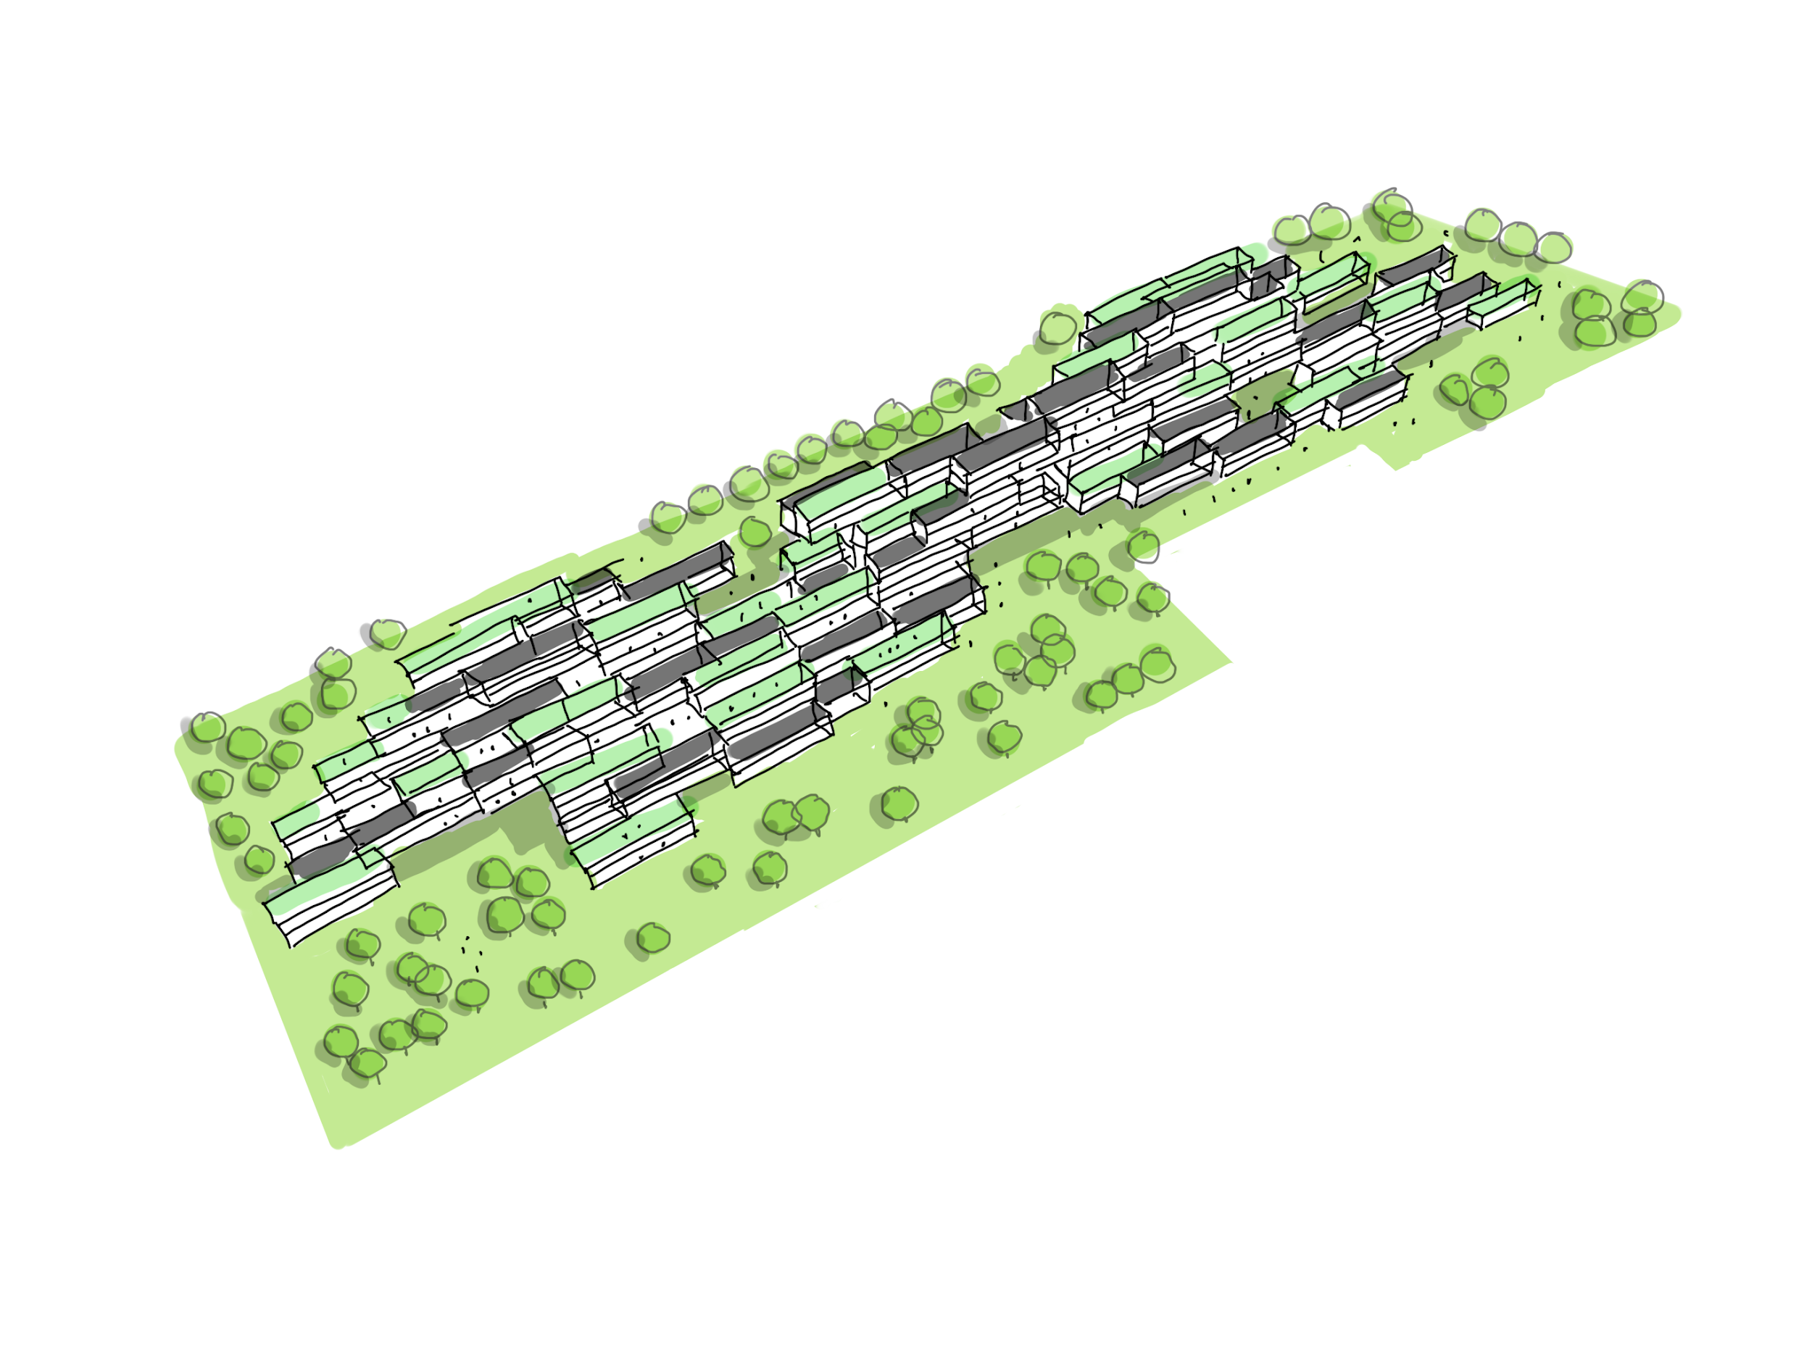

Biosolar Esplanade Concept

The Biosolar Esplanade is an infrastructural piece of art and elevated urban park. It aims to create a unique human experience in relation to sustainable technology by being a place that visitors can experience inside and out.

Our main design approach is an urban one that attempts to meld the built urban environment at Masdar with the existing park and solar farms to create a more cohesive urban fabric.

The technology used is made up of biosolar terraced roofs with integrated thin form battery storage in the structure. Intentionally integrating the technology and making it visibly part of the structure engages visitors in the story of Masdar, the most sustainable city in the world, and the story of humanity’s transition to a 100% renewable future.

The Esplanade provides shade from the hot sun while creating various pockets of public space that can be used for different types of pop-up or seasonal activities. The spaces are integrated with the biosolar terraced roofs in such a way that blurs the line between the renewable energy technology used in the project and the public spaces. The hope is that this approach will help in educating and engaging the public on sustainability and a carbon-free energy future. The structure ends with viewing platforms that provide a sense of orientation and show off the sweeping views of Masdar City and the landscape while acting as a point of contemplation and reflection; seeing both the old primitive desert while literally standing on the most cutting edge of and technologically advanced city.

The structure is made up of modular recycled structural steel frames with timber floors and ramps. The roof that can be adapted to fit either a green roof or solar panels. Since each module is identical in size there is an opportunity for scalability and obtaining a cost-effective system, making it a feasible concept in terms of constructability.

Energy Calculations

Electricity generated through pv solar cells
2,094 m² of pv cells x 200 W/m² = 418.9 KW/h

Estimated savings of green roof compared to regular roof
5,324 m² of green roof x 2.56 (W/m²/Day) = 13.6 KW

Increase in green space of approx. 130% in relation to existing lot condition

Environmental Impact Statement

It is estimated that the urbanization and infrastructure development could account for an additional 226 GtCO2 globally by 2050 according to the UN International Panel on Climate Change. The Esplanade modules are intended to be fabricated off-site in a controlled factory setting and later assembled on-site. This controlled method of construction allows for efficient use of resources, reduced construction related greenhouse gas production, and reduced construction waste.

In addition to the environmental cost of construction, building operations account for 32% of global energy consumption. The Esplanade is projected to produce far more energy than it will consume over its lifetime.

Lastly, the reduction in the urban heat island & an increase in biodiversity through green roofs and green urban infrastructure increases local resilience in a warming climate while providing the social good of public green space. Various cooling levels of urban vegetation have been recorded in studies of surface air temperature measurements and have shown that the cooling effect in micro-climates of parks ranges from 1 to 7 °C.

Primary Materials List

Materials required per module:

100 linear meters of recycled steel for the structure
87 m² of photovoltaic cells or 87 m² of vegetative green roof
115 m² of timber for floors and ramps

