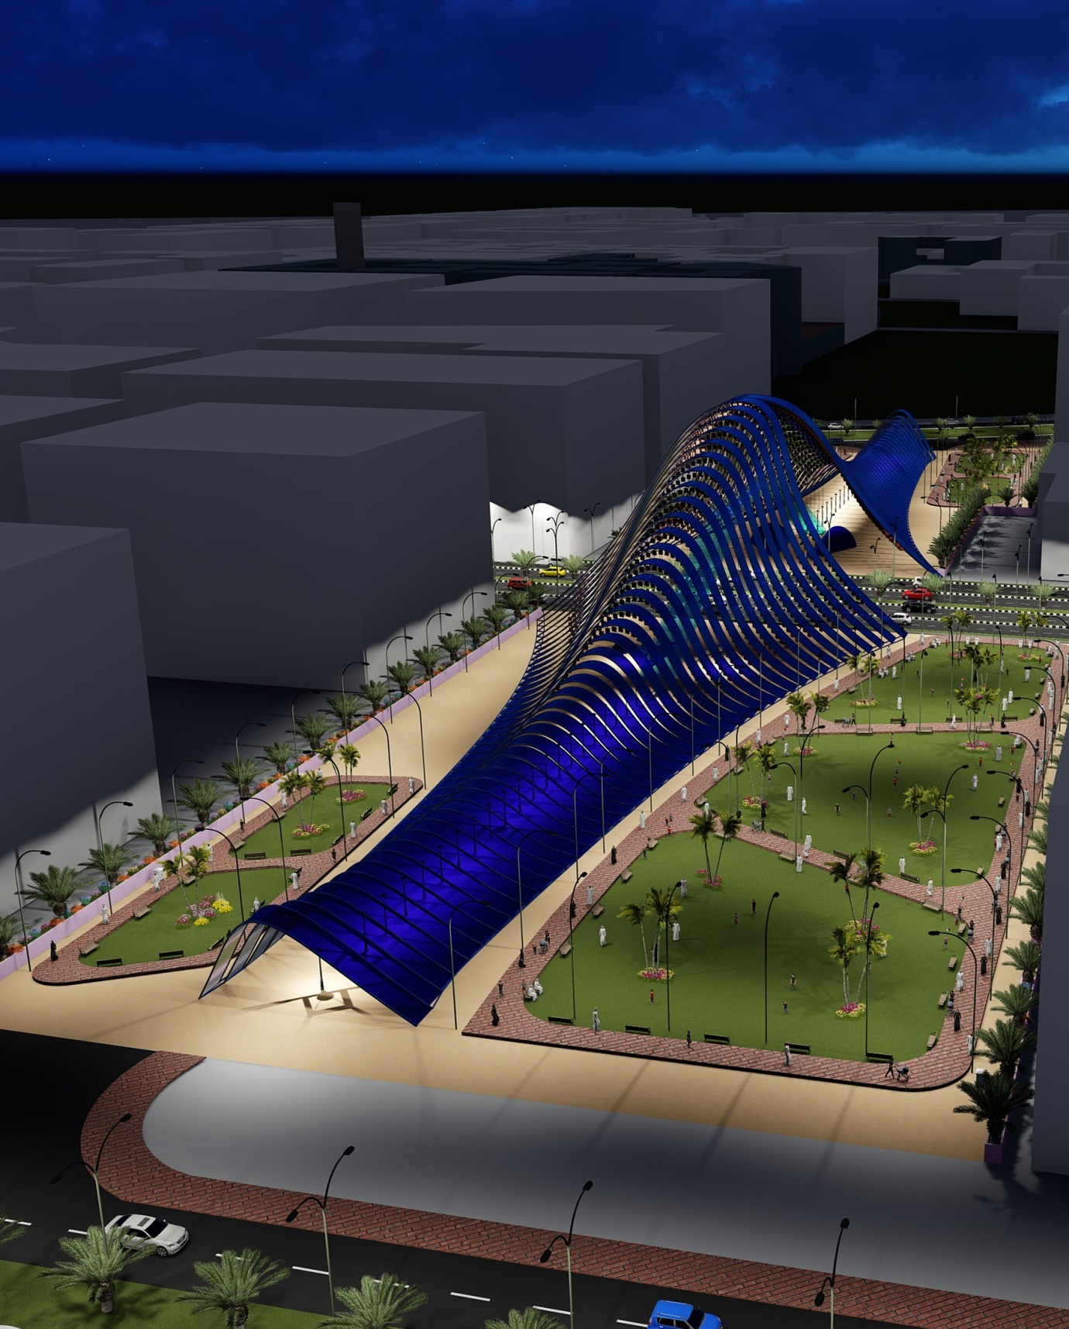**AHANA**

**LAGI 2019**

* **PROPOSAL**

AHANA is an Arabic name which means “Ray of Light”.

In this proposal, the energy generated from the sun light and wind, can provide electricity in 2100+ households in masdar city.

The scheme integrates solar (Ultra-light Next Generation PV Modules , 1950x320 mm each) & Vertical Wind Turbine for energy harvesting and Tesla Power Pack battery storage seamlessly within the landscape of the given site.

A Lightweight tensile structure made from flexible ultra-high efficiency solar photovoltaic modules generates 1940 MWh annually. The modules create a light filtered surface over the given site providing 8890 solar components. It provides improved sun protection on the given site and makes site area as an energy harvesting opportunity.

71% of the energy is generated by solar photovoltaic cells.

We believe that, the secret to making large-scale creative renewable concepts realizable is the extensive use of mass-produced modular elements that benefit from economies of scale at their production stage.

Each renewable energy element of our scheme meets this fundamental objective.

The structure is made from a light weight tensile trusses spanning between ends of the site width. The undulated surface is achieved by a series of built-up trusses connecting and cross tension cables.

* **MASTERPLAN**

It is a dynamic long term planning to guide future growth and development. It is about making the connection between buildings, social settings and their surrounding environment without affecting the future resources.

The site is divided into two(OS-01 & OS-02) by a thoroughfare so, for connecting these spaces a glass foot over bridge and a passage through underground exhibition area are proposed. Whereas for landscaping, low maintenance evergreen plants are recommended.

We truly tries to make it, energy efficient as well as an enjoyable place because the site comes under park and open spaces zone(according to the master plan) and the structure is so design to gain more solar power and wind power.

The advanced regenerative features and the amalgamation between rejoicing structure, surrounding buildings, the proposed pedestrian network and interacting park spaces are assimilated.

* 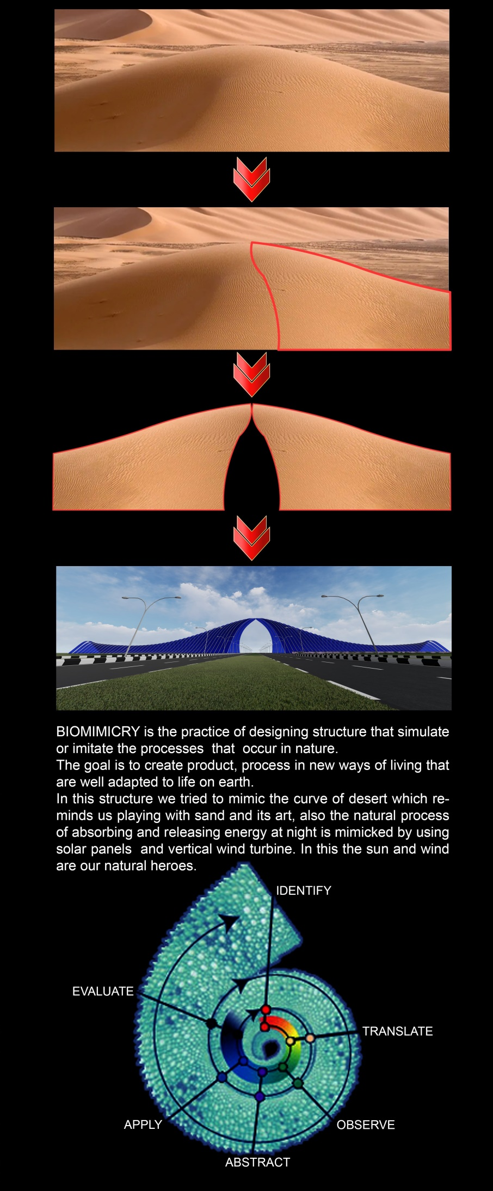**CONCEPT**

**Desert**

* **FUNDABILITY**

For a large-scale concept to be fundable it must be:

* Designable
* Buildable
* Maintainable
* Warranteeable
* Insurable

Achieving the above criteria, in conjunction with acceptable return-on-investment will help make LAGI projects fundable and therefore realisable.

* **BUILDABILITY**

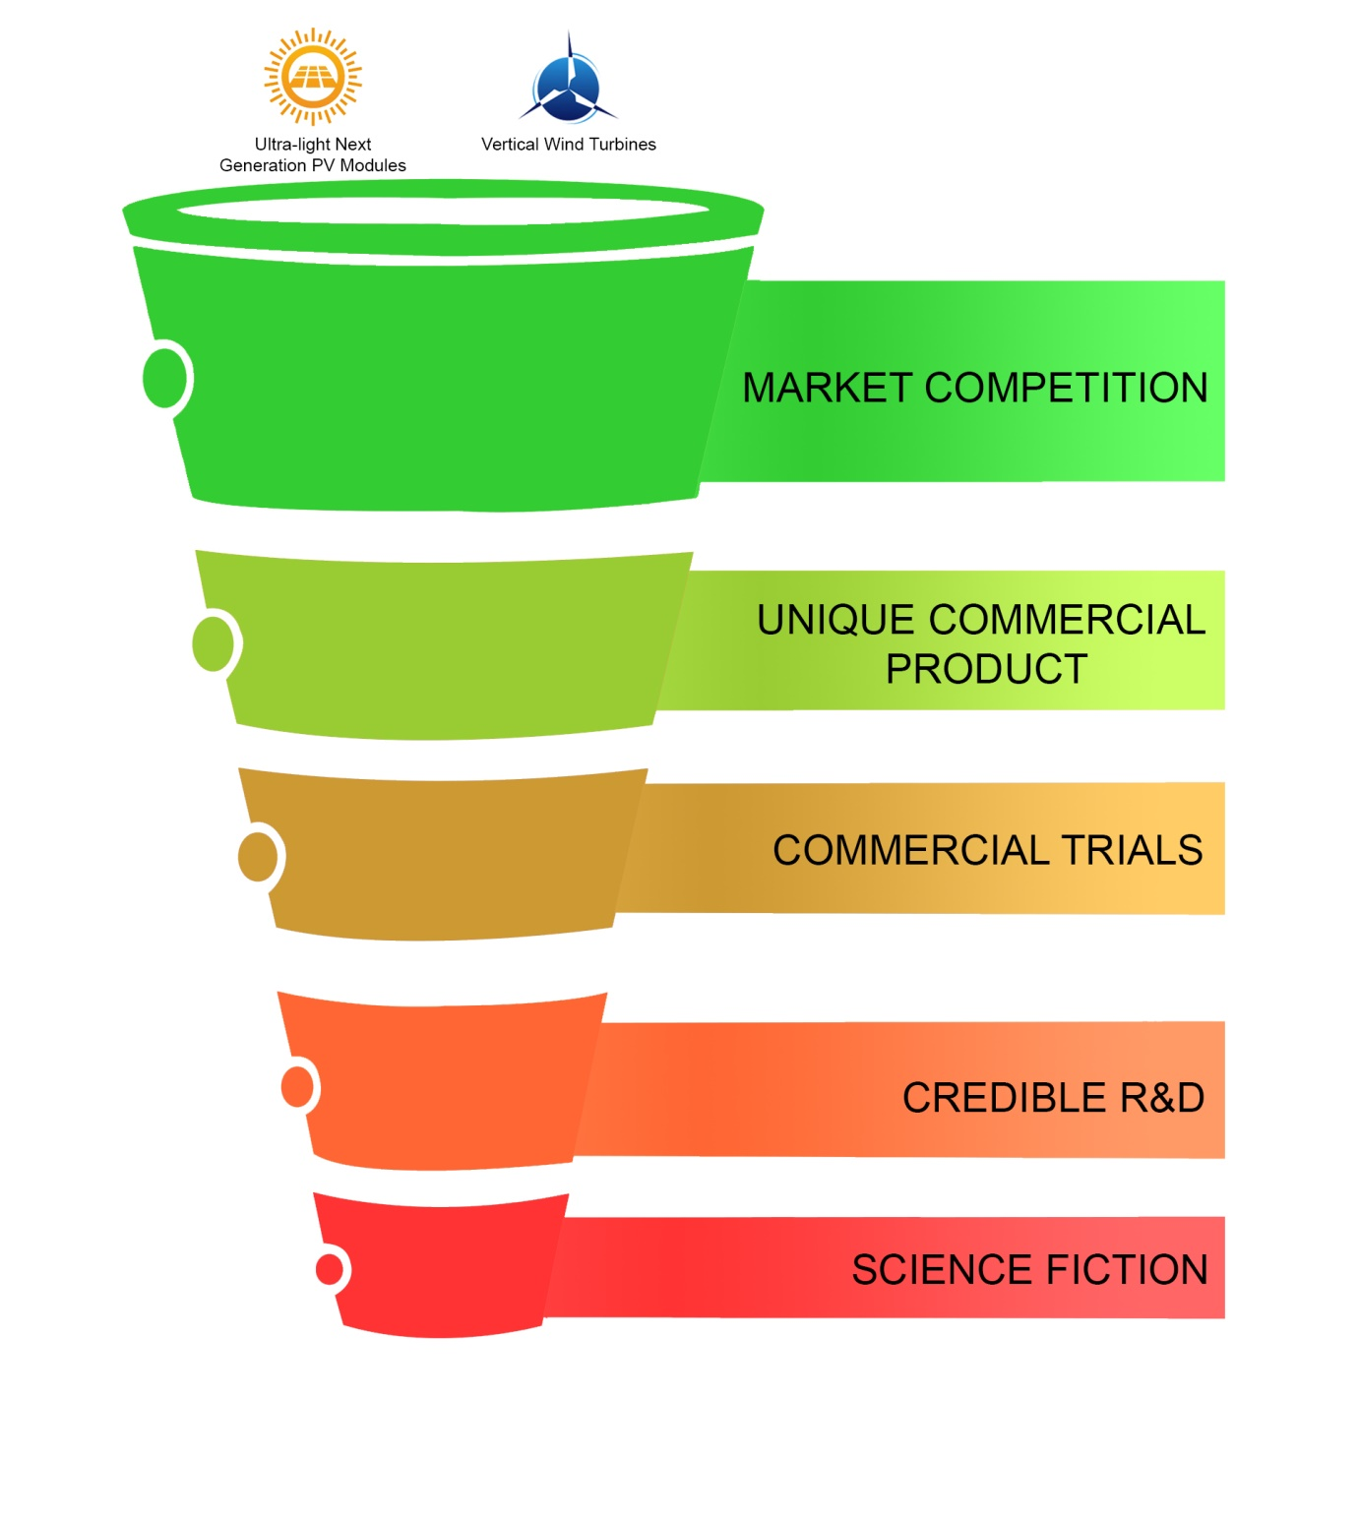

* **MODULER COMPONENT PRODUCTS UTILISED**

**Ultra-light Next Generation PV Modules :-**

### Flisom’s products are based on an innovative thin film solar technology developed in Switzerland. High efficiency, flexible solar panels, ultra-light weight and unique product features open a completely new dimension in solar energy. Smart technology. For smart applications.

### High Efficiency Thin Film CIGS Technology - Laser interconnected cells, which are produced on industry leading substrate widths in multi-kilometre long rolls will change solar manufacturing in the future. The roll-to-roll manufacturing process and tools developed by Flisom pioneers mass production of next generation solar foils

### Ultra efficient Solar Power

This technology reached 20.4 % cell efficiency on laboratory scale. This is the highest cell efficiency achieved on plastic substrate and will increase in the future.

##### **Low material and energy consumption**

### Sustainable solar electricity

Only a few micrometre thickness of material is needed to turn sunlight into electricity. This solar foils use very little material and energy during production. That makes it very resource efficient and enables CO2 footprint reduction for solar electricity.

### Lightweight & flexible

This means less mounting substructure, less installation time and less wiring. It also opens many possibilities for structure integration and reduces the overall ``Balance of System`` (BoS) cost and increases the value of your structure.

### Customized service

This technology offers you a variety of sizes, shapes and electrical outputs, customized to the specific needs of your application.

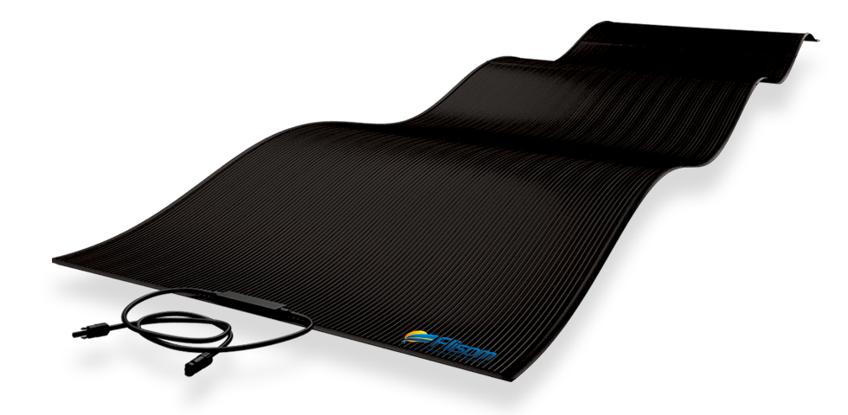

**Vertical Wind Turbine :-**

The performance of the turbine rotation was strongly influenced by the swept area. Drag and lift force was influenced by the swept area. Both of the forces had its own advantages and disadvantages. Because of that, the dimensional engineering was implemented to obtain the optimal performance of the turbine. Experimental dimensions were tested with the variation of height size (H = 40 cm and 60 cm) and diameter size (D = 40 cm and 60 cm). The distance between the blades known as the overlap ratio was related to the dimensions. Overlap ratio has a role to the upwind and downwind wind flow because the overlap ratio changes affect the swept area. The experimental variation of the overlap ratio was at the distance of 0 cm and 10 cm. The experimental results concluded that the best turbine performance was obtained during wind turbine testing with H = 40 cm and D = 60 cm on primary overlap value minus 10 cm and secondary overlap 0 cm.





**Energy storage – “Powerpacks” :-**

“Powerpacks” house the world’s most sophisticated batteries. Each Powerpack is a DC energy storage device containing 16 individual battery pods, a thermal control system and hundreds of sensors that monitor and report on cell level performance.

The Powerpack system scales to the space, power and energy requirements of any site, from small commercial businesses to regional utilities. It can be configured in various arrangements, offering far more modularity than competing models.

**Renewable Integration** - Smooth and firm the output of a renewable power generation source such as wind or solar.

**Capacity Reserve -** Provide power and energy capacity to the grid as a standalone asset.

**Ancillary Services -** Charge or discharge instantly to provide frequency regulation, voltage control, and spinning reserve services to the grid.

**Transmission & Distribution Support -** Supply power and energy capacity at a distributed location to defer or eliminate the need to upgrade aging grid infrastructure.

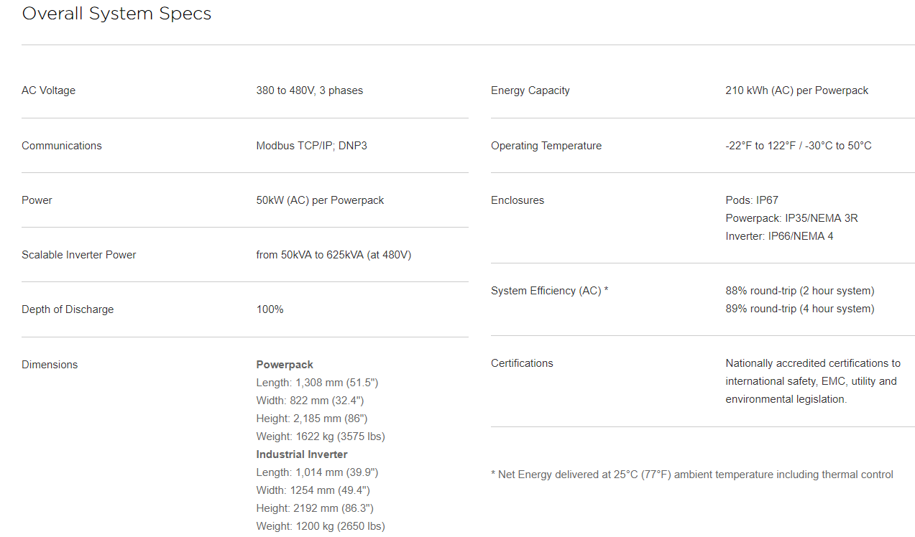

**Scalable Design -** The Powerpack system scales to the space, power and energy requirements of any site, from small commercial businesses to regional utilities. It can be configured in various arrangements, offering far more modularity than competing models.

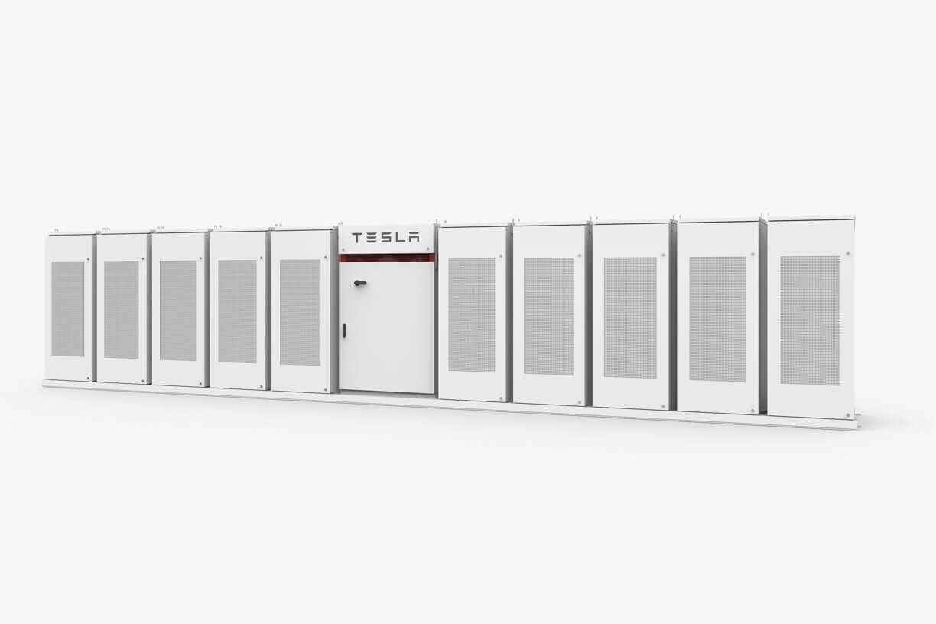

* **RETURN ON INVESTMENT ANALYSIS**

|  |  |  |  |  |  |  |
| --- | --- | --- | --- | --- | --- | --- |
| **Renewable energy technology** | **Annual energy yield (MWh)** | **Relative contribution (%)** | **Capital cost**  **(USD)** | **return over life span based on household energy value (USD)** | **Total Value Over life span (USD)** | **Return On investment** |
| Ultra-light Next Generation PV Modules | 1940 | 71 | 969010 | 12849546 | 12849546 | 13.3 |
| Vertical Wind Turbine | 790 | 29 | 306000 | 2601720 | 2601720 | 8.5 |
| **Total Renewable energy Generation Per annum** | **2730** | **100** | **1167010** | **15451266** | **15451266** | **13.2** |

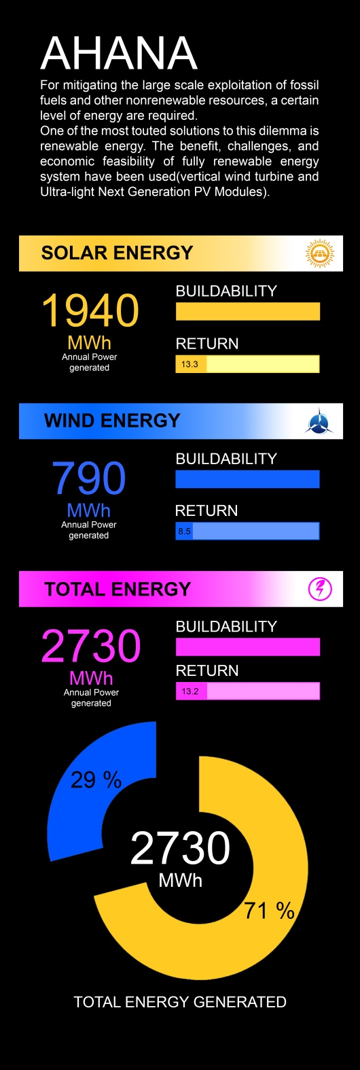

**Embodied ecological impacts of proposed materials**

The renewable technologies used have been selected to have less than a quarter of the embodied environmental impact of their conventional alternative forms, using mass as a proxy. Embodied impacts of products include their embodied energy, water, waste and toxicities associated with their manufacture.

