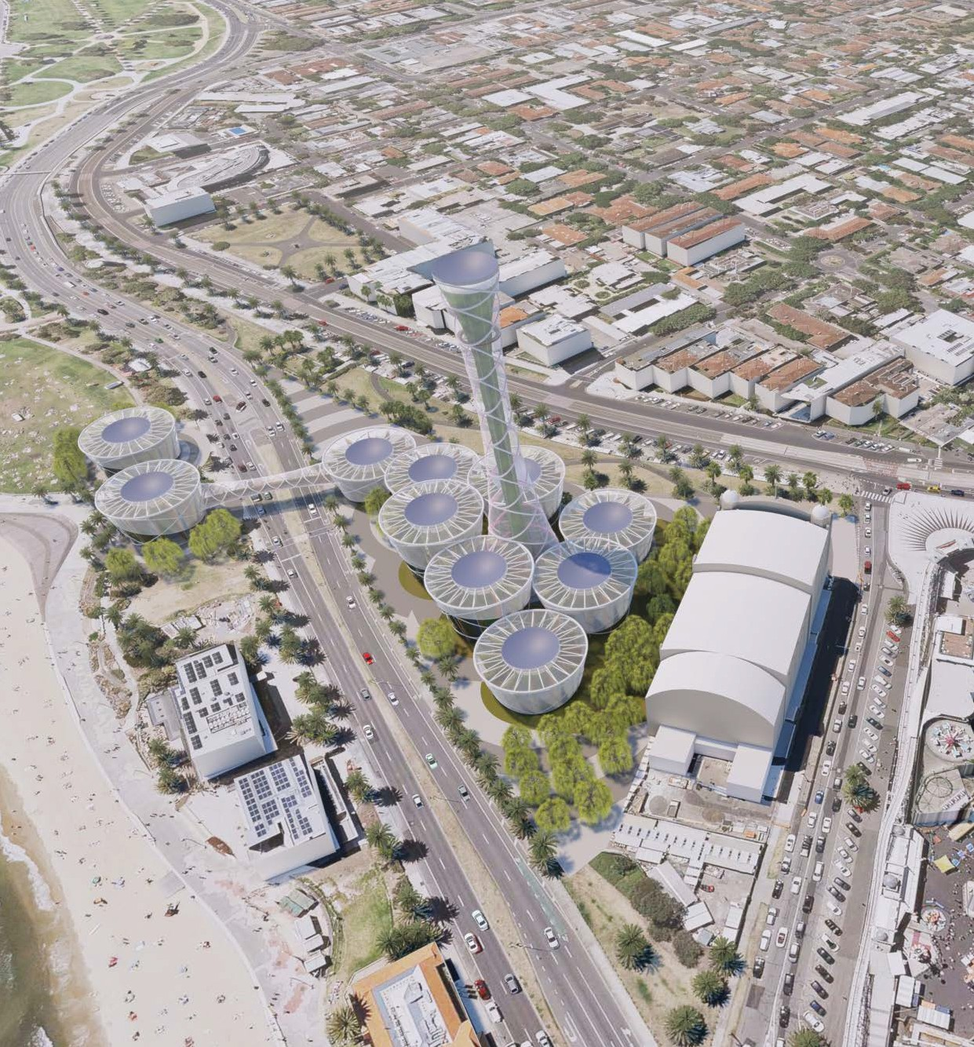

Transpiration Tower
LAGI 2018
St Kilda Triangle Victoria Australia

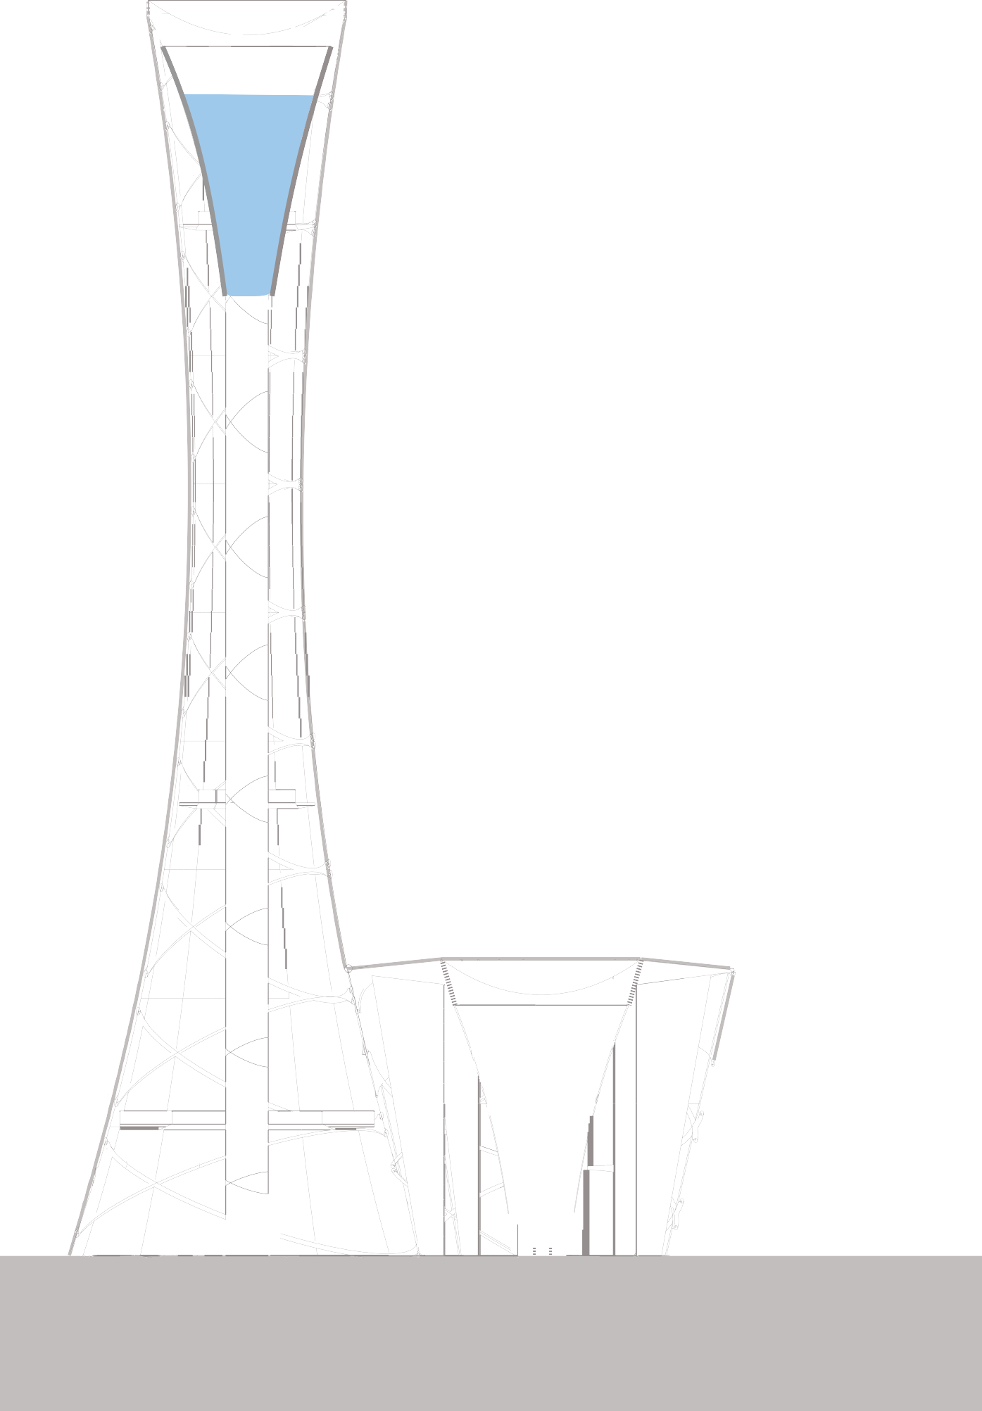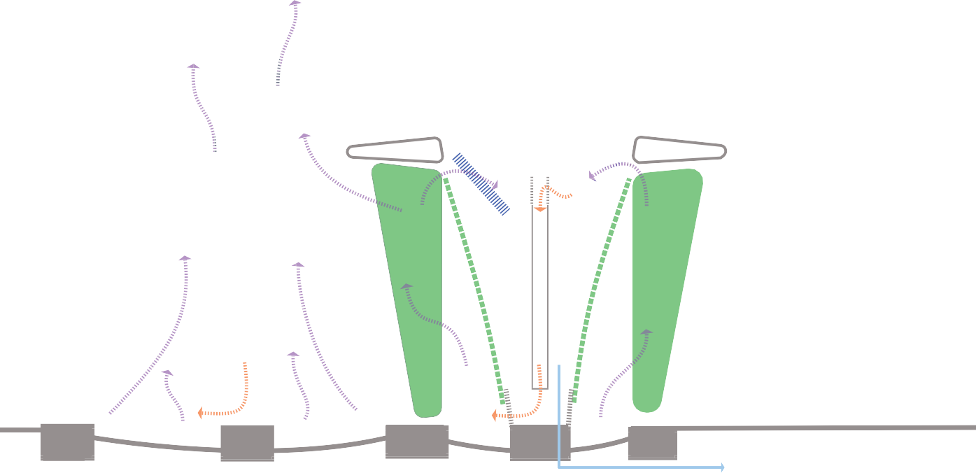35kW PV array

condensing plates

water tank

access/air shaft

vegetated walls

ETFE enclosure

condensate water
100 metres

grey/saline water

vegetative walls warm/humid air cool/dry air

ETFE drum

vegetated walls

evaporation basin

Transpiration Tower
An experiment in using the power of natural plant evapo-transpiration to desalinate and lift water. It is an attempt to wrap intensivley cultivated vegetated walls in sculptural greenhouse structures.

The central 100m high (9m dia) Transpiration Tower forms the focal point of the installation and generates a stack effect that drives the system. At the base of the tower are clustered eleven tapering drum structures (15m dia) of varying heights up to 20m,

The components of the proposal are as follows:
- The primary structures for both the tower and drums are based on standard steel elevated water tanks with steel pedestals.
- Hooped steel CHS's with an ETFE skin form the enclosure structures.
- Parabolic Photovoltaic arrays form the roofs of the water tanks.
- Humidity condensing plates and associated refrigeration within the tanks are powered by the PV array
- Vertical vegetated panels radiate out from the drums. These panels are intended to be can- vases for local artists to create works using living walls as their pallette.
- At the base of each structure evaporation basins generate a humid atmosphere and supply irrigation water to the vertical vegetated walls.
- Ultraviolet LED grow lights wrap aroun the inside of the hooped structures.
- Elevated walkways allow access through the different drums and connect across Jacka
Boulevard within an enclosed footbridge.

The intention is for the evaporation basins to become progressively less saline as they get further away from the beach and closer to the main tower. This progressive desalination starts at the first pod which starts with sea water.
The different salinity of the evaporation basins will influence the vegetation used in that specific
drum.

The evapotranspiration system that shrouds the water towers replaces the energy intensive pumping of traditional water towers with living art.

Openings at the top of each tower allow the hot humid air to be drawn into the water tanks. It is here that condensation plates, dehumidify the air and collect the water at height, thereby generat- ing a head. The relatively cooler, drier air falls to the base of the tower.

The water in the tower has been desalinated and lifted to significant height in an environmentally
benign manner.

Parabolic PV Arrays

Parabolic photovoltaic arrays form the eleven roofs of both the tower and the drums. These are thin film arrays, 215m2 each. This combined 2365m2 has a DC system rating of 385kW, with an annual output of 382,447kWh/year.

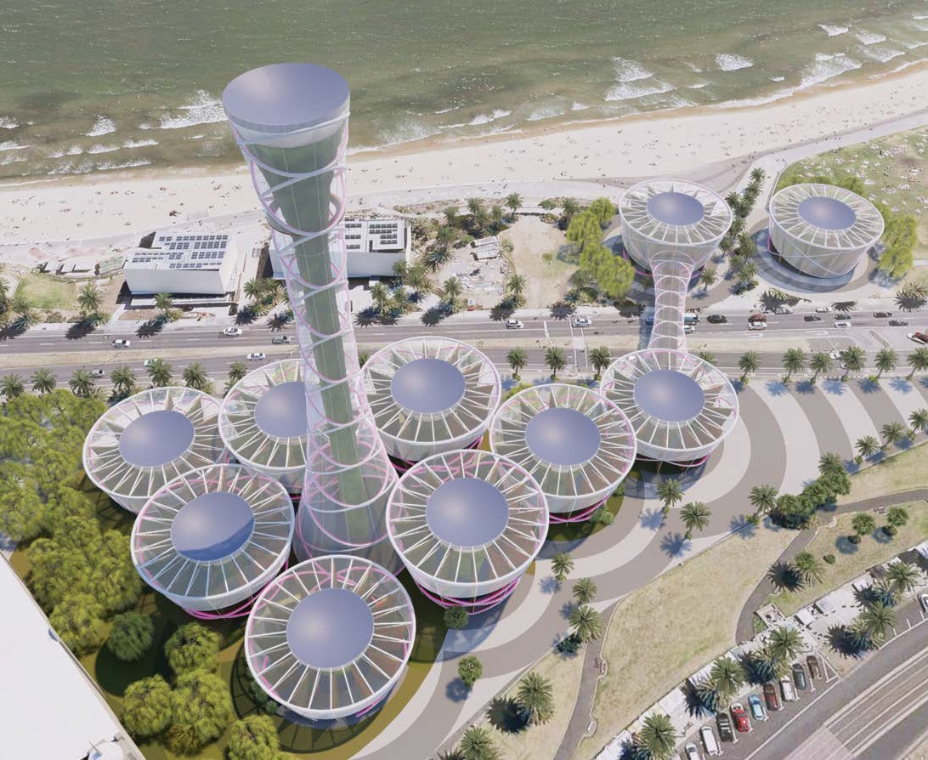
35kW PV array

The following figures illustrate the sunpath movement across the site, this analysis was used to
determine forms and layout to maximise system yield.

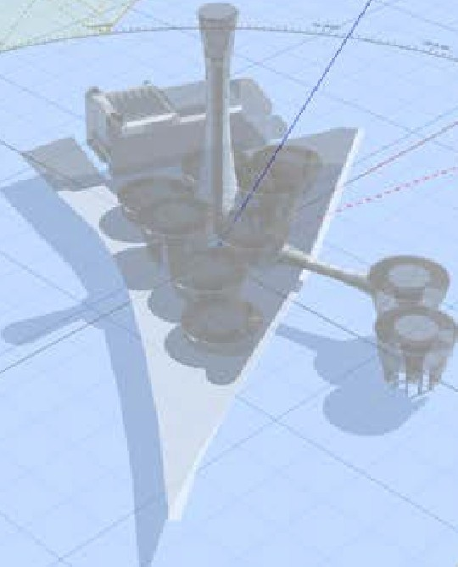
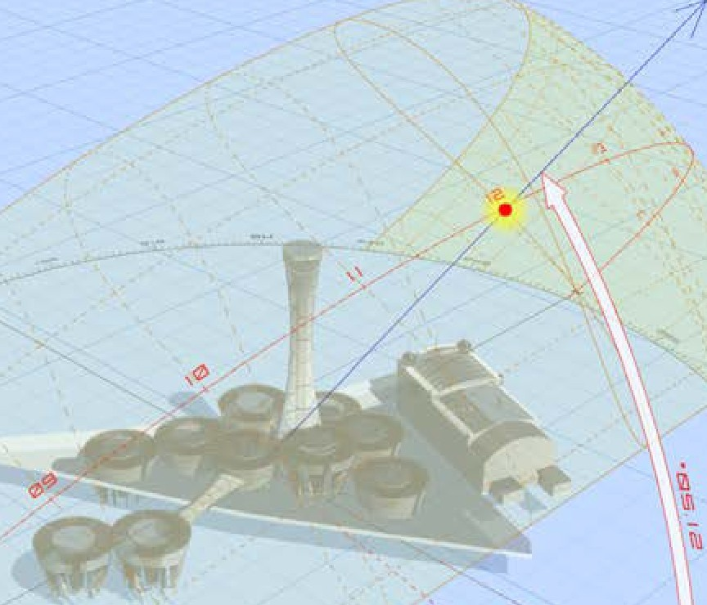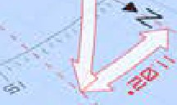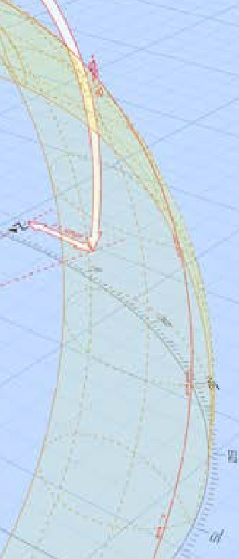
...-,
'>'
,f
..,.
I!
,.,,.
, -.,?,
Iii
04:57 / 19.58
AsUOilOl11,
05:28 / 19:27
NauUcal:
lWILIGHT TIMES v
CIVIi ' 05:58118:57
lt.02 /51.20
0625118:30

12:06 Hrs
Az1 I AIL
Rise/Set,

Oay!ghl.
)
- ? 00

SOLAR INFORMATION
2 Mar 2018
Dale:
Time:
v
GMT+10·00

DATE ANO TIME
-3 867211685
I 44.97 256902
LaUlude: Loogltude:
Timezone·
GEOGRAPHIC LOCATION

 |  |  |  |  |  | GEOGRAPHIC LOCATION
 |  |  |  |  |  | Latitude: -J7 t,1,72106/IS
 |  |  |  |  |  | Long,1ude 144 975256902
 |  |  |  |  |  | llme.zone: GMT+•0·OO
 |  |  |  |  |  | DATE ANO TIME V
 |  |  |  |  |  | D a te 21 Mar2018
 |  |  |  |  | • | Time: 12.00  SOLAR INFORMATION >
 |  |  |  |  |  | Azj I All. )t 02 51.20
 |  |  |  |  |  | Rise /Set 06·25 I 18:30
 |  |  |  |  |  | Day1rghL 1 2:06 Hrs
 |  |  |  |  |  | TWILIGHT TIMES V
 |  |  |  |  |  | CIVIi 05:58 I 18:Sl
 |  |  |  |  |  | Nau cal 05:28/ 1927
 |  | ., |  |  |  | Astronom. 04:57 / 19:58
 | ,#
N
ra
 | 'I.
 |  |  | -$'_.;,,

The table below gives a predicted system output:

RESULTS

382,447 kWh/Year*

Month | Solar Radiation | AC Energy | Value
( kWh / m2 / day ) ( kWh ) |  |  | ( $ )
January | 6.12 | 58,157 | 12,213
February | 5.26 | 44,745 | 9,396
March | 3.76 | 34,975 | 7,345
April | 2.21 | 19,487 | 4,092
May | 1.39 | 12,615 | 2,649
June | 1.12 | 10,051 | 2,111
July | 1.30 | 11,887 | 2,496
August | 1.79 | 16,770 | 3,522
September | 2.92 | 26,736 | 5,615
October | 3.96 | 38,077 | 7,996
November | 5.44 | 50,711 | 10,649
December | 6.09 | 58,237 | 12,230
Annual | 3.45 | 382,448 | $ 80,314

Location and Station Identification

Requested Location st kilda

Weather Data Source (INTL) MOORABBIN AIRPORT, AUSTRALIA 10 mi

Latitude 37.98° S

Longitude 145.1° E
PV System Specifications (Commercial)

DC System Size 385 kW

Module Type Thin Film

Array Type Fixed (roof mount)

Array Tilt 20°

Array Azimuth 180°

System Losses 14.08%

Inverter Efficiency 96%
DC to AC Size Ratio 1.2
Economics

Average Retail Electricity Rate 0.210 $/kWh
Performance Metrics

Capacity Factor 11.3%

Carbon offset = 413tCO²eq

This clean electricity is to be used to run the following active systems: condensing plates; UV grow
lighting; filter and misting pumps/ systems.

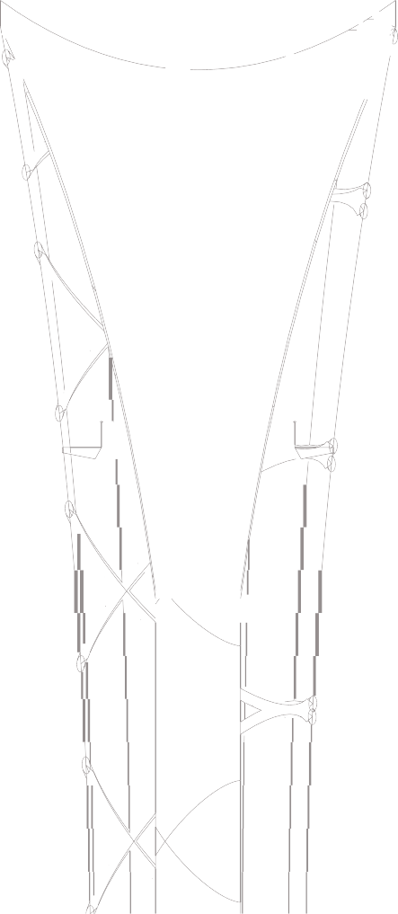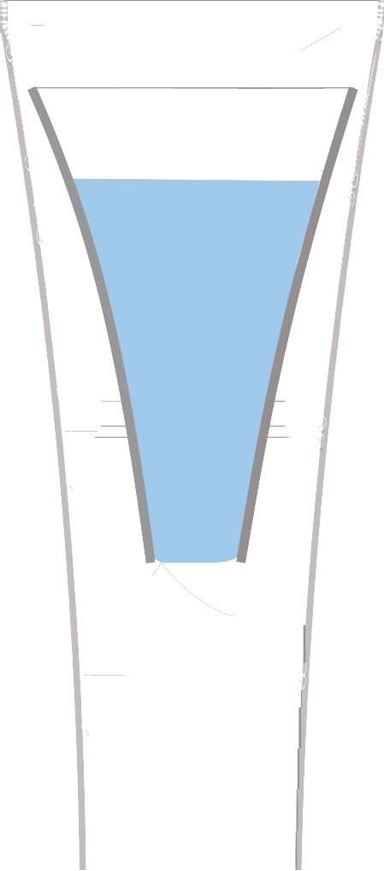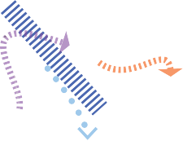Condensing Plates

The humidity condensing plates (food safe stainless steel) are the key elements in the water making system in each drum and at the head of the transpiration tower. To harvest water from the warm humid air entering the top of the tank chamber, the plates are actively chilled. This is done with a refrigeration system comprised of cooling compressor units (2*15kW SCROLL) using CFC free and low ODP refrigerant (R410A) and correspond- ing anti-corrosion treated aluminium and copper heat exchangers.

35kW Water making systems at 30 degrees C and 70% humidity can reliably produce 500 litres of potable water per day. From this conservative assumption, the annual, carbon neutral, water production from the 11 water mak- ing systems is estimated to be over 2,007,500 litres/ year.

To this the following should also be factored:

  - The Parabolic PV roofs are designed to capture rainfall. Melborne's annual rainfall is approximately 650mm and so for this project that would account for a further 1,537,250 litres/year harvested.

  - The lighting scheme for the project is a functional part of the overall project comprised of UV LED "Grow Lights" which are designed to extend plant transpiration time (and therefore growth) into the evening.
condensing plates
condensate water
vegetated walls
warm/humid air cool/dry air

Water Tanks

The primary structure for both the drums and the tower are derived from fairly standard, 900,000 litre, steel, elevated water storage tanks.

This project aims to use such structures which are very often seen as visual blights, in a way that the community embraces and significantly benefits from .

Vegetated Walls

Green wall systems are installed on the outside of the water tank structures and also are used to form the panels that radiate out from the centre of the drums.
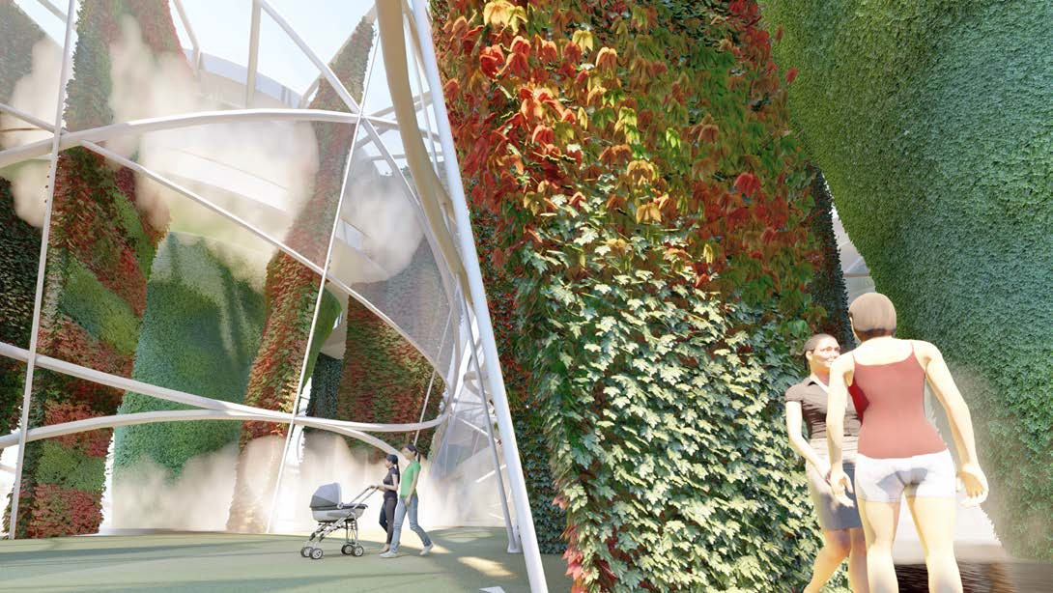
These vertical vegetative walls are the engine of the overall system.

In total there are over 27,000m² of green walls within the drums and the tower. The transpiration
rate calculated for this installation is conservatively over 100,000 litres per day.
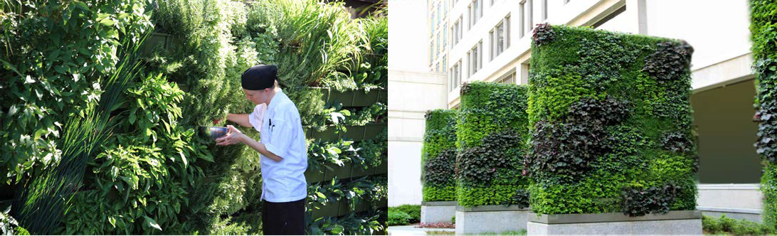

The intent is to harness and capture this natural phenomenon, to use the vegetation as mecha-
nism to passively filter and lift water.

The quality of the water being drawn from the evaporation basins will determine the type of plant- ing to be used in the different drums. It is envisaged that as the further the drums get from the beach water quality will be improved and less brackish. This will necessitate a diversity of planting that will enhance the variety of species used and thereby increase the interest; the potential for urban farming initiatives; business and employment opportunities; and the educational value within the spaces.

As well as acting as an intense water lifting and filtering mechanism, the walls are to be canvases
for local artists to create works using vegetation as their pallette.

Within the current model, the patterns of Boonwurrung possum cloaks have been used as an ex-
ample of art that could influence these living tapestries.

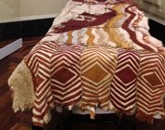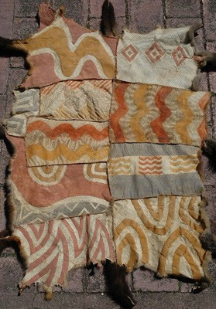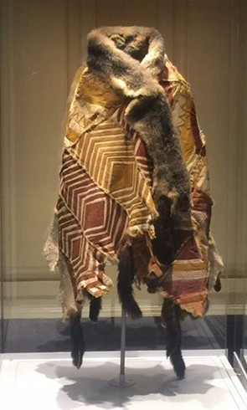

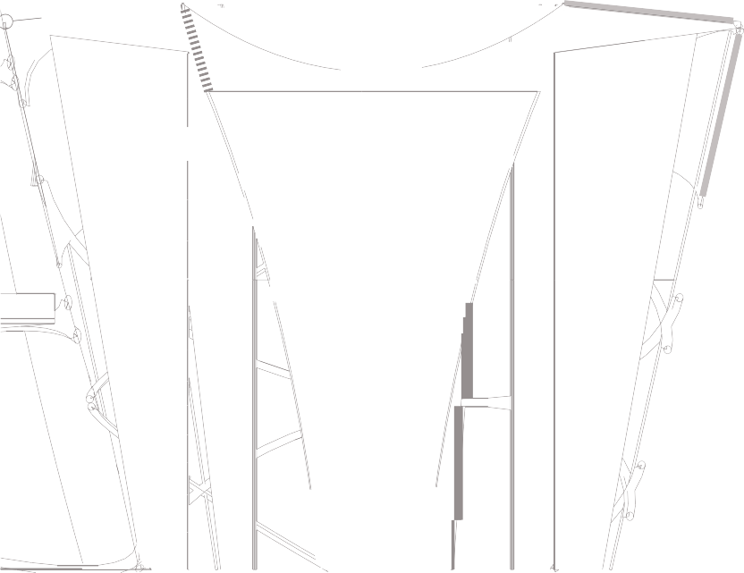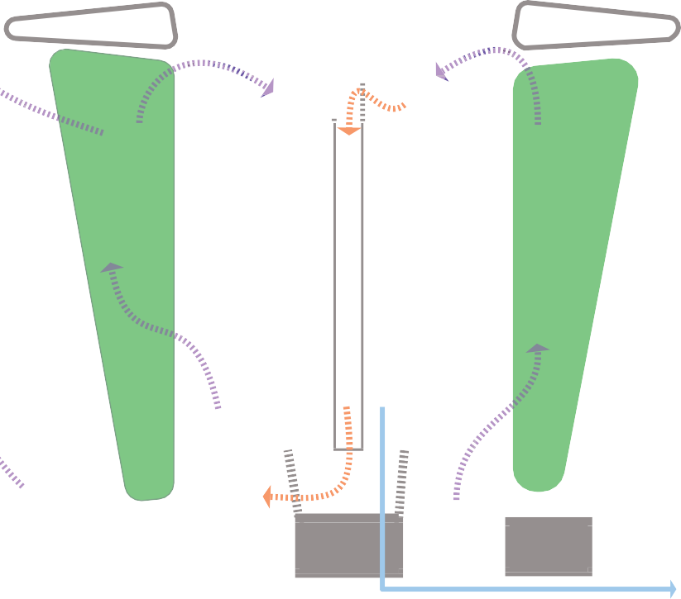
ETFE drum
Boonwurrung
living tapestries
condensate water
grey/saline water

vegetative walls
warm/humid air cool/dry air

UV LED Grow Lighting

To enhance growing times a lighting scheme for the project is proposed that is based on UV LED grow lighting as used in commercial greenhouses. The power for these LEDs will come from the battery provision which will be part of the PV system. Lighting times will be determined by battery- capacity and/or light curfews imposed by the local authorities.

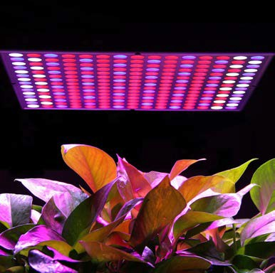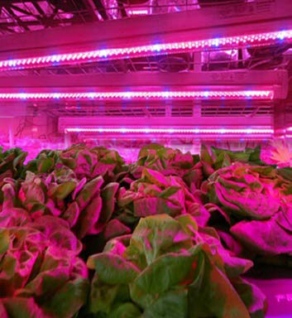

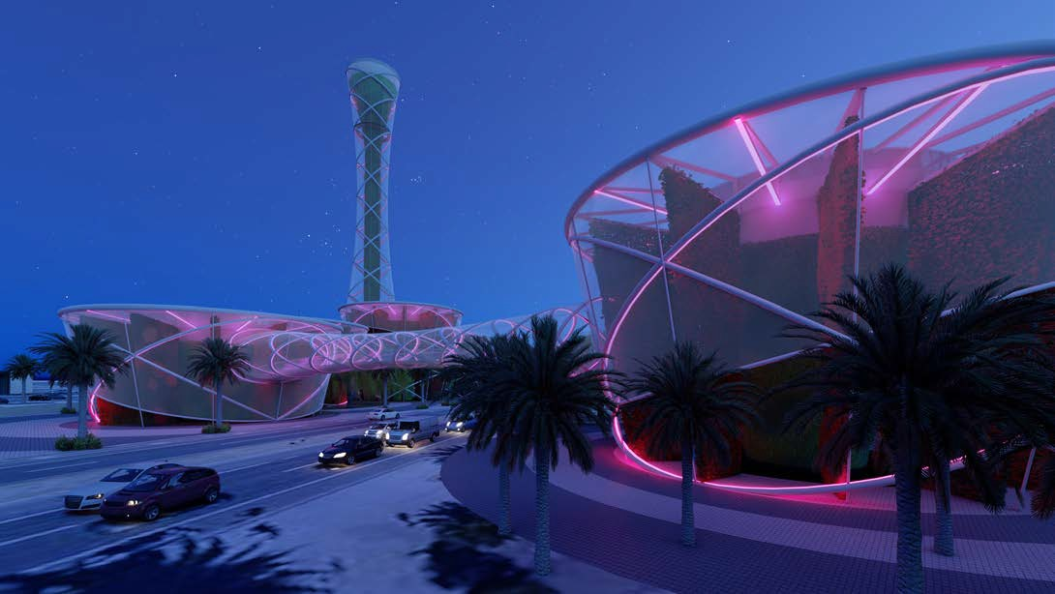

Filter and Misting Systems

To allow easy access, water treatment filter systems, including carbon block and UV treatment, are located within the pedestal of the water tank structures. The balance of the PV system, including battery banks,controllers and inverters are also stored at this level.

Irrigation water for the vegetated panels is pumped from the evaporation basins when needed, the power for the pumps and misting systems is also derived from the PV system.

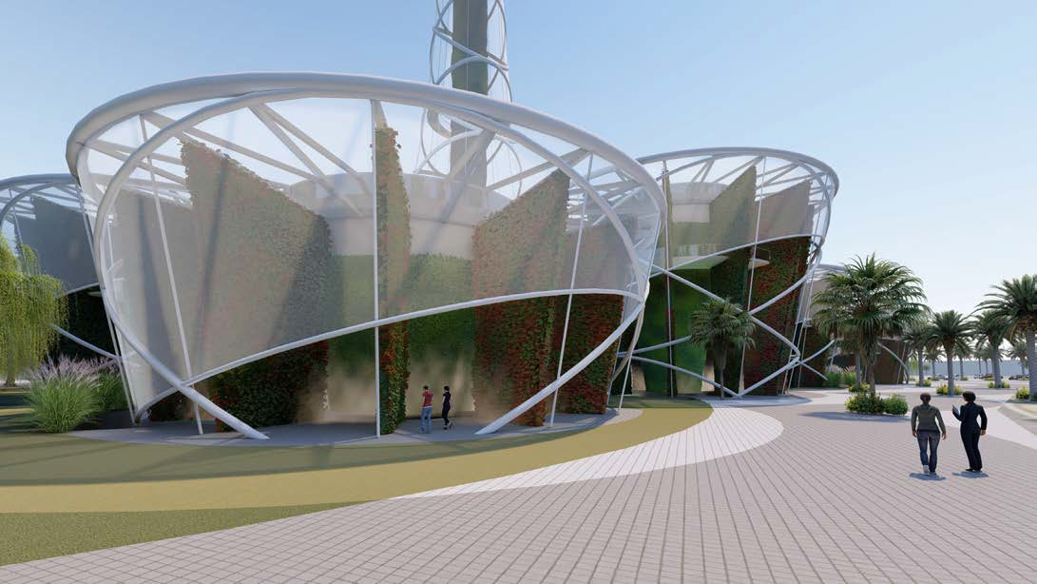
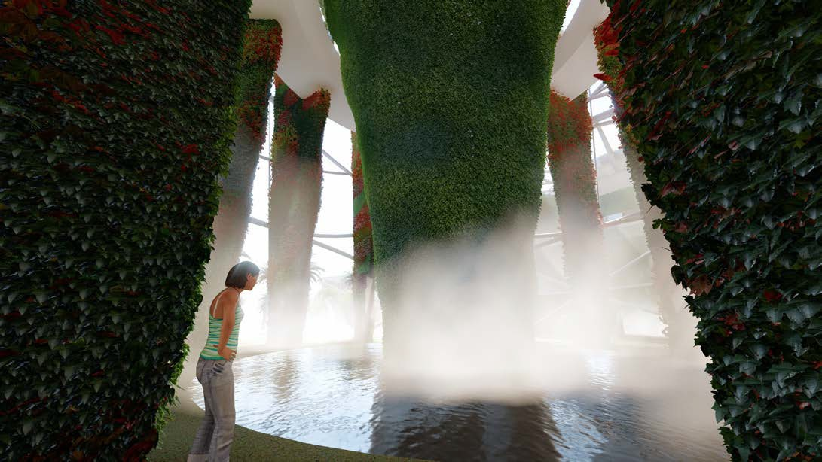

Environmental Impact Summary

Context - the primary site, the St Kilda Triangle, is essentially an old degraded non-permeable car- park area. Traffic circulation around the site is poor and makes for a low quality pedestrian experi- ence for those accessing the beach on the other side of Jacka Boulevard.

Character - this is a seaside, beach destination that has drawn visitors for generations.

Significance - the historic neighbouring Palais Theatre and Lunar Park developments have defined
the nature and character of the district as a fun, leisure destination since 1912.

Sensitivity - due to the proximity of these iconic neighbours, the development should respect and build upon what they stand for. It is in this spirit that the Transpiration Tower attempts to bring a new destination to the region which is grounded in contemporary sensibilities and concerns.
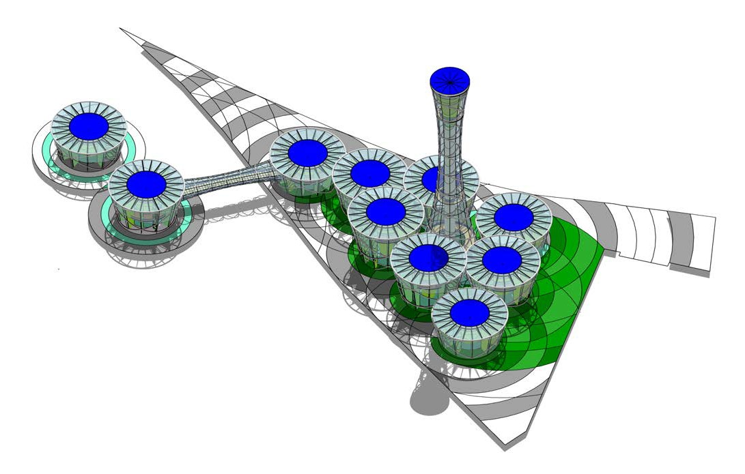
Sea side drums
Jacka Footbridge

The existing environment and the impacts of the development are explained by reference to its possible impact on the following series of environmental topics:

Humans
  - Economic Activity - this new eco-attraction is designed to reinvigorate St Kilda's tourism draw
and so should prove to be a significant boost to economic activity.
  - Social Patterns - the new development is likely to bring a broader demographic to the area than the legacy attractions and will provide new social amenities for residents.
  - Land-use - the change of land-use from a delapidated carpark to a techno-botanic garden will enhance the social and economic value of the land considerably.
  - Employment - the Transpiration Tower will create jobs directly and indirectly. These will in- clude tour guides, botanists and gardeners, systems maintenance and operations staff and retail and hospitality roles.

  - Health and Safety - issues relating to water treatment should be addressed and monitored closely. The access of the general public to the walkways at height need to be considered and possibly controlled. The footpridge over Jacka Boulevard will enhance pedestrian safety by reducing the potential for traffic accidents. The opportunities for adventure activities such as abseiling and zip lining will be supervised.

Fauna and Flora
The development is intended to inject dense bio-diversity onto a site that is currently degraded. The expected results from this will be improved habitats; enhanced breeding/ feeding/ roosting areas; and increased mammal/ bird/ fish/ insect/ reptile populations.
As a botanic institution the facility will provide opportunities for critical and protected species to be encouraged and managed.

Water
The removal of the existing non-permeable carpark will improve ground water recharge and sur-
face water management will be significantly improved.
Seawater will be drawn into the evaporation basins of the drums on the sea side of Jacka Boule- vard but there will be no discharge to the marine environment.
The very essence of the proposal is to work with, enhance and manage the watercyle within the installation and to that end chemical and biotic environmental issues must be monitored.

Air
The installation is intended to have a dramatic impact on air quality, both pollutants and suspended particles including those due to vehicle emissions. In effect the tower and the drums are acting like a giant air filter drawing polluted air through the vegetated panels, this will be monitored and made available to the public.
The vegetated panels will also have a noise dampening effect and all the energy produced on site
will be from silent photovoltaics.

Climatic Factors
All refrigerants used by the water making condensing plates will be CFC free and have low/zero Ozone Depleting Potential (ODP).
The removal of the carpark and the corresponding installation of intense vegetation will positively
impact on the heat island effect.

The Transpiration Tower attempts to build upon interelationships between these factors and pro-
vide St Kilda with a unique world class eco-tourism installation.

