The Corral
Materials:
- Concrete
- Steel
- PVC tube
- Flex piping
- Glass
- Fiberglass
Dimensions:
- Sea Anemone PBR: 55m diameter, 10m H at highest point
  - 1000 tentacles (photobioreactors); 40cm diameter and 2 to 3.5m high
- Coral Pavilion: 50m W x 20m H
Renewable Energy Technologies
“The Corral” is an integrated art installation consisting of two main components with two distinct technologies that to form a complete energy production hub. The first component is the sea anemone installation microalgae photobioreactor, and the second is the coral pavilion lined with solar PV Glass. The two
Microalgae Photobioreactors (PBR):
Microalgae is a single-cell organism that converts sunlight and CO2 and other nutrients such as phosphorous into biomass. Because they are single cell organisms, they are more efficient at performing photosynthesis and therefore reproduces at a much higher rate than other multi-cell plants.
Microalgae is becoming a more economically feasible and reliable source of renewable energy. Compared to other biomass, such as land crops, growing microalgae as a consistent source or renewable energy has various advantages such as high growth rate, all-year production, and high efficiency in CO₂ capture (Kosowska-Golachowska, et al., 2016).
Furthermore, microalgae, as biomass can serve various functions. Through different processes microalgae can be converted into three main types of renewable energy medium: raw biomass in the form of powder and pellets, biofuel, biogas (Appendix Figure. 1).
A photobioreactor (PBR) is a mechanism to grow microalgae as biomass. The main attraction of “The Corral” is the bed of sea anemone. Each sea anemone is a single PBR based on the bioreactor façade developed and constructed by IBA Hamburg GmbH. The PBR is made of a large clear flexible PVC tube filled with microalgae growing medium. The tube of microalgae medium, with added nutrients is introduced into the PBR from the bottom of the tube. CO₂ and compressed air are injected from the bottom of the tube to create constant turbulence to ensure adequate mixing of the algae medium for highest biomass production. The microalgae medium leaves the PBR through a bottom outlet periodically, then filtered and processed into usable biomass. The residual liquid is recycled back into the PBR for further biomass production.
After the microalgae medium is filtered, the microalgae is then dried and turned into microalgae pellets as a combustible biomass. The microalgae pellets are then fed into a micro combined heat and power (CHP) plant based on the “Entrade Energiesystems E3” CHP plant that converts the pellets into heat and electricity.
The benefit of this system is that it is a closed loop system, where the flue gas from the micro CHP plant is injected into the PBRs as nutrient, and the post-filtered algae medium is also recycled back into the PBR system.
End product alternatives; Installation Phases:
An alternative to installing an onsite CHP plant is to transport the dried algae to an offsite processing plant that converts the biomass into either biogas or biofuel. Both biogas and biofuel can be either sold as a renewable energy source on their own, or can be converted to electricity and be fed back to the grid.
This installation can be executed in phases, to keep the project economically feasible. Phase 1 of this installation can be implemented as a biomass production plant to gain back the capital cost for the installation. Then the Municipality can decide when to continue to implement Phase 2 of this installation to install the onsite micro CHP plant for local electricity and heat production.
Solar PV Glass
The second component of the installation is the solar PV glass-filled coral pavilion.
The pavilion is made up of 350m2 of Onyx solar PV glass. The solar PV glass is composed of a layer of PV glass, a layer of a-Si thin film solar cells, a layer of PBV solar foil and a layer of tempered glass. At peak power, the solar PV glass at 20% transparent, can produce 34 W/m² .

Energy Production Summary:
Refer to Appendix for calculations:
Anemone PBR
 | Phase 1 (w/o onsite CHP plant) |  | Phase 2 (w/ onsite CHP plant)
 | Annual energy production in biomass | Annual net heat output | Annual electricity production | Annual heat production
Sea Anemone PBR | 132,011 kWh | 113,200 kWh | 109,500 kWh | 262,800 kWh
Note: solar panels on the tip of the anemone PBR is not considered in this table. All electricity produced by those PV panels will be used to operate installation equipment and light

Coral Pavilion
 | Estimated annual electricity production
Coral Pavilion glass | 89,476 kWh

Environmental Assessment
As the main component of “The Corral”, the PBR has minimal environmental impacts and performs well to produce high density production of biomass (Silva et al., 2015). According to research, biomass production in microalgae compact PBR is considered environmentally favourable as it sequesters carbon, produces close to no solid waste, and in generally, the value of the system output greatly outweighs the non-environmental impactful input (i.e.: Sunlight, nutrients, CO2) (Silva et al., 2015). The main environmental impact associated with this installation is the energy use and packaging waste of building materials. In order to minimalize the construction related impacts, this installation will aim to use local recycled and reclaimed materials to reduce environmental impacts associated with the material processing and packaging, and transportation.
Furthermore, as this installation functions as a closed system, CO₂ output from the micro CHP plant will be captured and used as nutrient for microalgae production, achieving net neutral gas house gas emission.
Moreover, this installation creates the basis of a district energy system for the St. Kilda Triangle area. With the construction of the network completed as part of the installation, future buildings in this area can easily hook up to the system, eliminating redundancy in construction cost and environmental impact of multiple isolated systems at various times.
Word count: 966
APPENDIX
Supporting Figure:
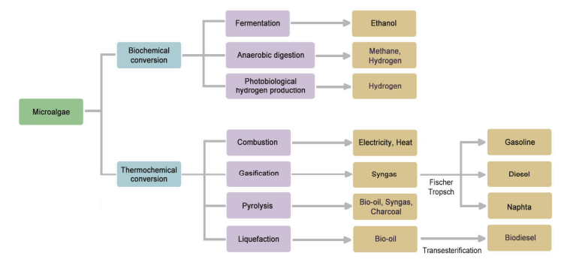
Figure 1. Microalgae uses (Kosowska-Golachowska, et al., 2016)

Calculations:
PBR
Design info:
- Single tube diameter= 0.4m
- Average height of tube= 3m (tube height ranges from 2m to 3.5m tall)
- Total number of tubes= 1000
  - Total surface area= 3774m²
- PBR annual biomass production= 345kJ/m²/day
- PBR annual net heat output= 6000 kWh/200 m²/year
Annual biomass energy production
- 345kJ/ m²/day x 0.00277778 kWh/kJ x3774 m²/ 365 days= 132,011 kWh/year
Annual heat output
- 6000kWh/200 m²x3774 m²= 113,220 kWh/year

PBR + CHP plant
CHP Plant specs based on Entrade E3 v2.0- 25kW Mobile Power Unit:
- Total installed capacity: 26kW (electricity)
- Nominal heat output: 60kW
- Biomass consumption= 23kg/hr
Annual electricity output
- 25kW x 8760 hr/year x 0.5 capacity factor*= 109,500 kWh/year
Annual heat output
- 60kW x 8760 hr/year x 0.5 capacity factor*= 262,800 kWh/year
* assume only operate for half a day. Theoretically, it can run at 100% as the PBR produces an excess of biomass (3,396,600 kg/year) compared to the biomass consumption annually (201,480 kg/year).

Solar PV Glass
Annual electricity output
E= total panel area x solar panel yield x annual average solar radiation x performance ratio
Total panel area= 350m²
Solar panel yield efficiency= 34 Wp/m²
Annual average solar radiation in Melbourne= 1503.8 kWh/m2/y
Performance ratio= 0.75 (default)
Energy= 350m² x 0.34 kWp/m² x 1503.8 kWh/m² /yr x 0.5 = 89,476 kWh

Word count= 230

References:
IBA Hamburg GmbH (2013). Smart Material House BIQ. International Building Exhibtion Hamburg.
Kosowska-Golachowska M., et al. (2017). Analysis of microalgae pellets combustion in a circulating fluidized-bed. Energy and Fuels 2016. E3S Web of Conferences 14, 02035 (2017).
Silva A.G., et al. (2015). Life cycle assessment of biomass production in microalgae compact photobioreactors. GCB Bioenergy (2015), 7, 184-194.

