Ballo - on

Semiotic archeology
The St. kilda triangle is not only a physical triangle surrounded by The Esplanade, Jacka boulevard and cavell street, but also a programatic one ¹. Composed by three strong elements, ; the Palais theater with its internal events, Port phillip bay where people joyously spend their time freely and the upoming St. Kilda triangle masterplan with its new public space experience. It's certain that the genius loci ² of St.Kilda is of leisure and recreation.
The spirit of the place is also represented outside of the polygon´s direct context ; Luna Park, Sea baths, Catani gardens, Albert park lake, Federation square, etc... thus, denoting a ludic cultural landscape and a programatic connection with the broader contexts of St.Kilda, the City of Port Phillip, Melborne and the State of Victoria.

The Design
Forms and Functions
"We are pre-programmed by our intuitions of building types to behave in ways appropriate to the form." ³
Two building types reign over St.Kilda's pre-programmed intuitions, Palais Theater and Luna park. The festive atmosphere exudated by these two landmarks impregnate the imaginary of the place. Our proposal takes a common denominator that will always be present in every festivitie ; the balloon. Ballo-on aims to make public and open the joy felt only in the depths of these two projects.

Through the eyes of art
Looking at the site through an artistic lens makes us vizualize it in another way. The Palais theater and Luna park as part of the museum-city, kitesurfing in the sea horizon and ordinary "flash mobs" as performance (art) and the new winning proposal of the land art generator as a new component inserted into the city fabric. All of these examples allows us to see the site as a symbol, as "...works of art which "represent life-situations." ⁴
Because "...the purpose of the work of art is to "keep" and transmit meanings." ⁵. The scheme proposes a collection of linked art works, thus allowing a strong integration with outdoor display and events, while at the same time offers a new perspective of the port and the city. The void between the ballo-ons and the rest of the art works is the programatic use that we like to call an "open air museum", without boarders, schedules, entrances, fees, etc... In this way, we propose that the land art generator should be thought of in terms of horizontality, openess, felxibility and public engagement. Each orientated to respect the city grid and most importantly the new St. kilda triangle masterplan. Every work of art is a celebration of life, and like in every celebration, this one celebrates the birth of the St. Kilda triangle masterplan with the ballo-ons.

Technology
A Buoyant Airborne Turbine (BAT) is a flying aerostat that has a horizontal axis wind turbine within its shell and can elevate up to 600m. Pioneered in 2010 by the Massachusetts Institute of Technology and Altaeros this technology aims to harness the abundant energy in strong, steady winds at higher altitudes.
A almost ring shaped aerostat with two wind turbine installed in its interior (as in Fig. 8c). The whole generator is lighter than the air, so the take-off and landing maneuvers are simplified, and the only remaining issue is the stabilization of the generator in the right position relative to the wind ⁶. The aerostat is aerodynamically shaped so that the absolute wind generates lift that helps keeping a high angle of altitude together with the buoyancy force.
The hybrid technology of wind-solar responds to the identification of Melbourne's optimum climatic values ( Diagram 1 ). This means that there is a high possibility of sun capturing when there is a low average wind speed and the other way around (high wind capturing when low sunny days.

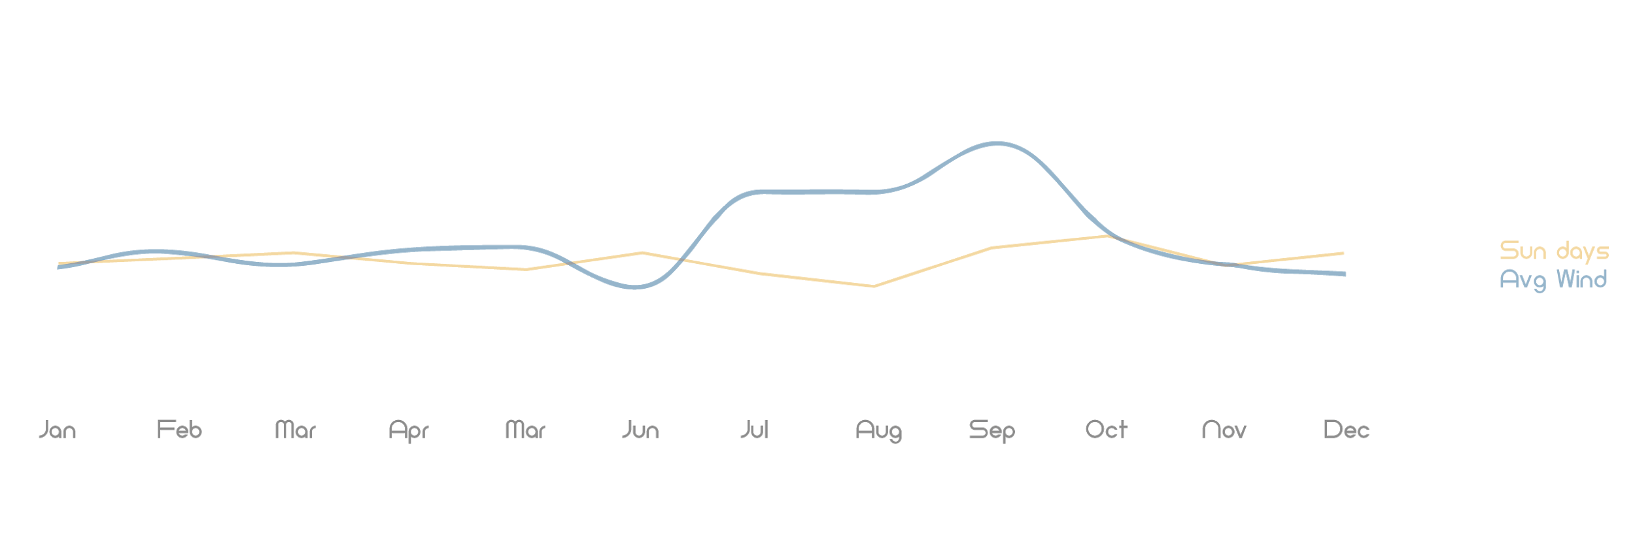

Diagram 1
(source: authors; diagram based on World weather online)

Parameters
The balloon scheme consists of 10 elements with dimensions divided into three categories in balance with the design guidelines:
Primary Boundary: One ballo-on of 4 m diameter with a flying altitude of 12m .
Primary and secondary Boundary: Two ballo-on's of 2 m diameter with a flying altitude of no more than 12m .
Secondary Boundary: Seven ballo-on's of 1 m diameter with a flying altitude of no more than 12m .

Materials

1. Envelope Fabric: Translucent polyvinyl fluoride (PVF) bonded with copolyester thermoplastic elastomer.
1.1. Sales fabric: Lacquered gold finnish polyvinyl fluoride (PVF) bonded with copolyester thermoplastic elastomer.
2. Solar cell Fabric : organic photovoltaic cell (OPVC).
2.1. Solar cell Fabric protection: PVF based backsheets films
3. Bladder: thin leak-resistant polyurethane plastic film
4. Axle: Horizontal-axis wind turbine with asynchronous generators
5. Cable: Conductive wire tether
6. Winch: mechanical device that is used to pull in (wind up) or let out (wind out) or otherwise adjust the "tension" of a rope or wire rope (also called "cable" or "wire cable")

Energy Estimation

Wind energy
Calculating on line concepts ⁷ of Wind data (wind speed, height above ground) Parameter (Roughness length, shape parameter) and Rotor area exposed to the wind, we obtained the following results depending on the type of balloon (diagram 2):
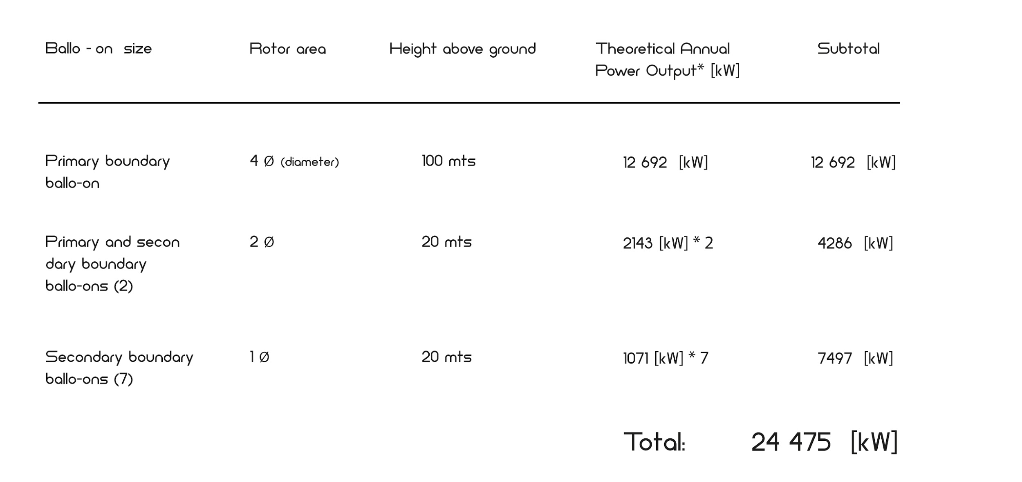

Diagram 2
(source: authors; diagram based on renewable-energy-concepts.com)

Solar energy
Based on traditional solar energy calculation ⁸ to get a rough estimate. Power is proportional to the area of the scales multiplied by reference parameter [kW] and multiplied by the annual average sun hours, we obtain the following results:

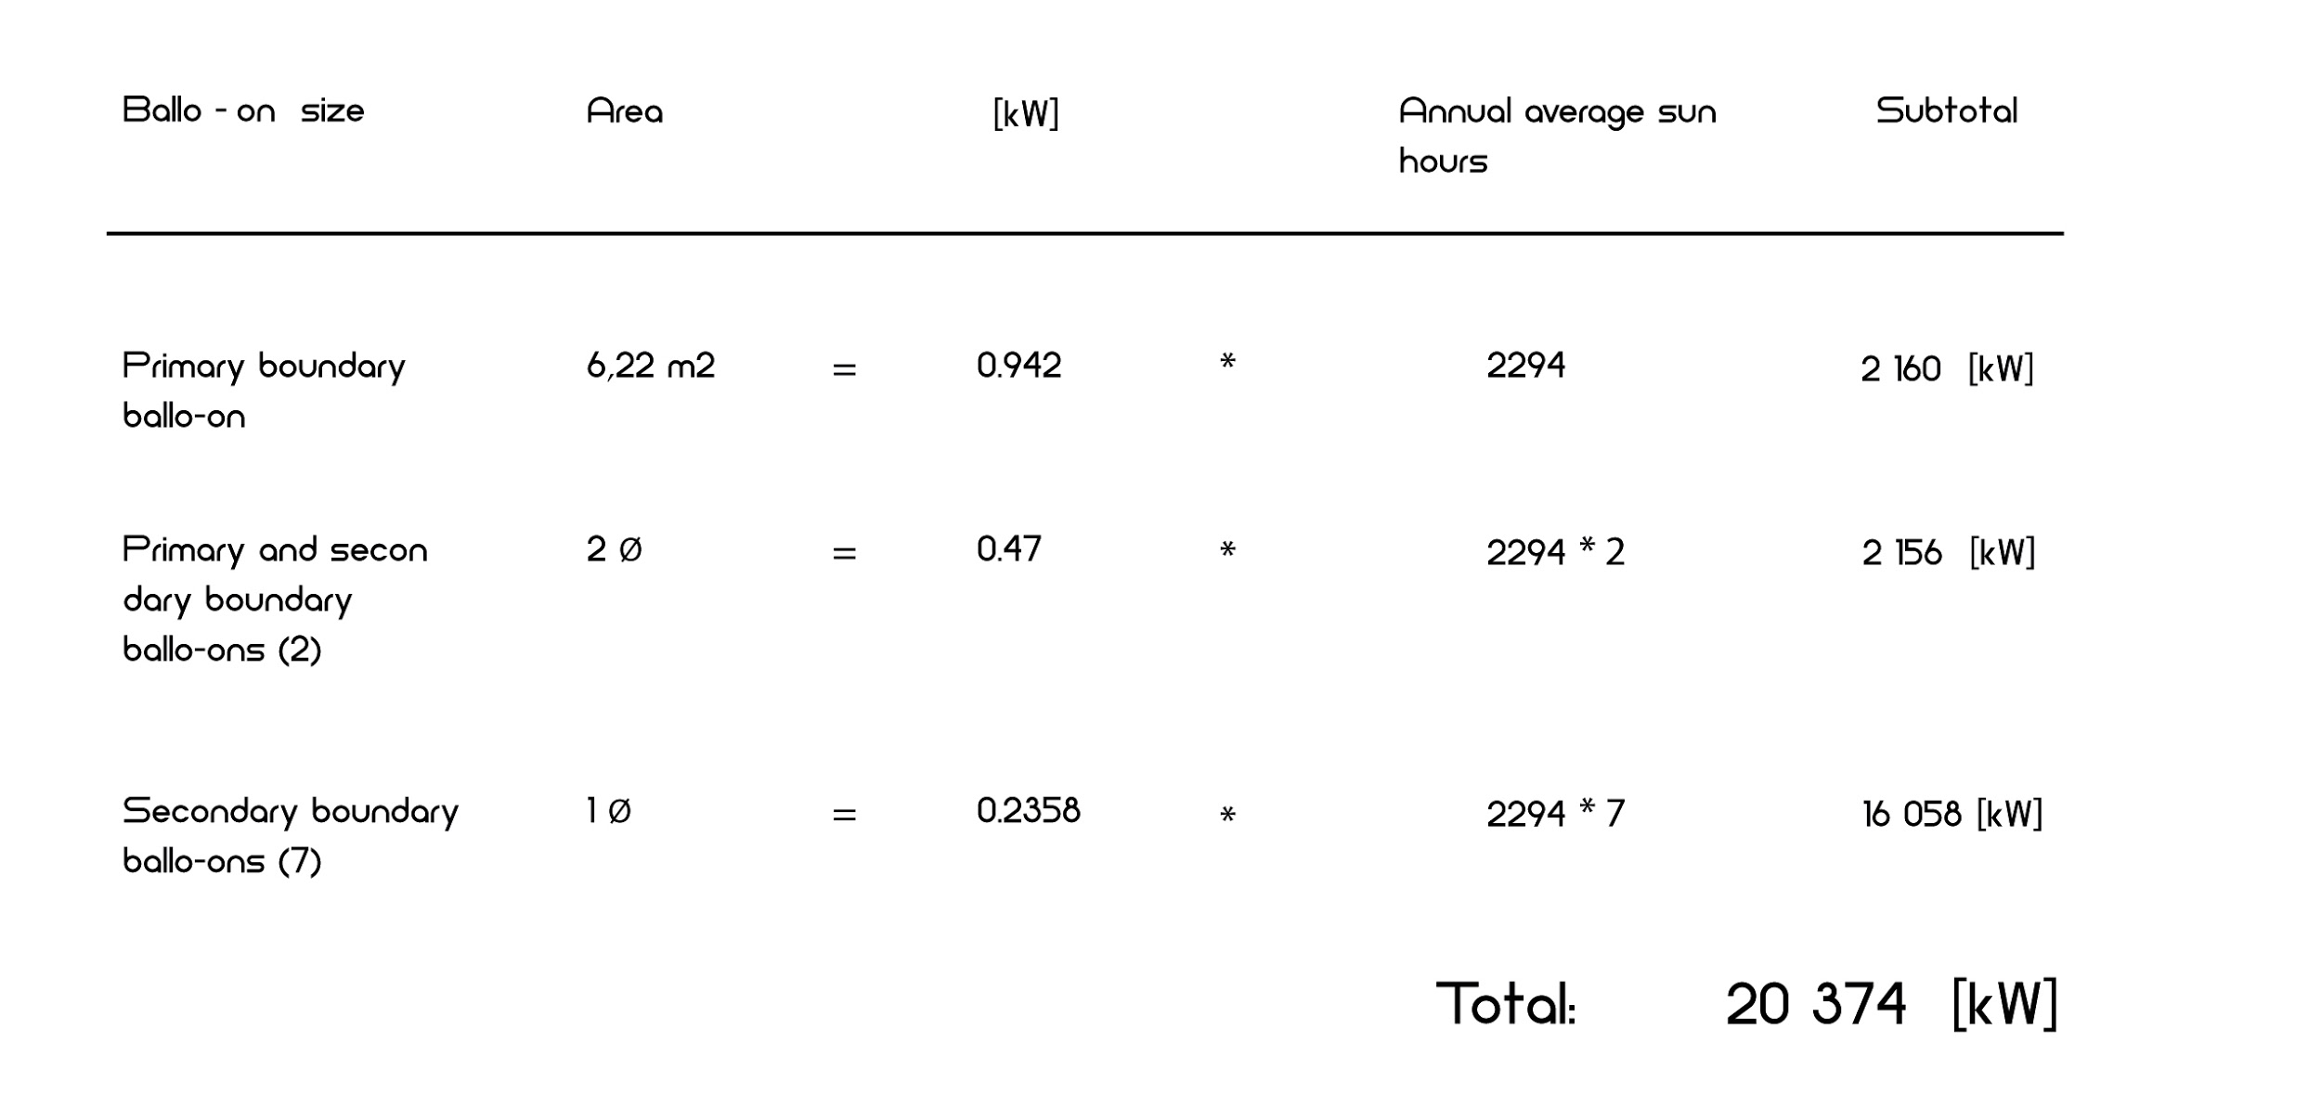

Diagram 3
(source: author; diagram based on solarpowerrocks.com )

Adding up the wind energy sub-total plus the solar energy sub-total estimation, the grand total of the whole scheme of ballo-on's results in an annual average energy production of : 44 849 [kW].

Environmental impact
Port phillip bay is not only home to is home to shorebirds such as: curlew sandpiper, sharp-tailed sandpiper but also part of a group of sites that has been identified as an Important Bird Area (IBA) by BirdLife International because it supports significant numbers of critically endangered orange-bellied parrots and vulnerable fairy terns, and over 1% of the world populations of blue-billed ducks, chestnut teals, Australian white and straw-necked ibises, red-necked stints and silver gulls. Taking this into account , the brightly and soft lacquered golden fabric (a kind of flash tape) of the ballo-on's will serve as a deterrent of the birds. ⁹
Helium
Helium is the second most abundant element in the known universe, after hydrogen. Its low molecular weight allows it to escape to space at the same rate of its formation. ⁹
Solar cell
A study ⁷ conducted by Synapse Energy Economics, Inc. shows that solar is the energy source with the lowest negative impact on the environment.

01. Bill Hillier. (2007). Space is the machine. United Kingdom : Press Syndicate of the
University of Cambridge.
02. C. Norberg Schulz. (1991). Genius Loci - Towards a phenomenology in Architecture.
p.18.
02. UNESCO. (2008). QUÉBEC DECLARATION ON THE PRESERVATION OF THE SPIRIT OF
PLACE .
03. Bill Hillier. (2007). Space is the machine. United Kingdom : Press Syndicate of the
University of Cambridge.
04. C. Norberg Schulz. (1991). Genius Loci - Towards a phenomenology in Architecture.
p.5.
05. Ibíd.
06. Vermillion C, Glass B, Goessling A. Systems and methods for attitude control of
tethered aerostats. PCT Patent Application WO2013043586; 2013.
07. Renewable energy concepts. (2018). How to calculate your wind power. 06.05.2018,
de Renewable energy concepts Sitio web: http://www.renewable-energy-
concepts.com/wind-energy/wind-basics/calculate-windpower.html
08. Ben Zientara. (2013). How much electricity does a solar panel produce. 2018, de Solar
Power Rocks.com Sitio web: https://solarpowerrocks.com/solar-basics/how-much-
electricity-does-a-solar-panel-produce/
09. J. Bishop, H. McKay, D. Parrott and J. Allan. (2003). Review of international research
literature regarding the effectiveness of auditory bird scaring techniques and
potential alternatives.. 06.05.2018, de Department for Environment Food & Rural
Affairs Sitio web: https://naturalresources.wales/media/675823/deterring-birds-fact-
sheet.pdf
10. Lenntech. (1998). Chemical properties of helium - Health effects of helium Read more:
https://www.lenntech.com/periodic/elements/he.htm#ixzz5EicgEdOe. 06.05.2018, de
Lenntech Sitio web: https://www.lenntech.com/periodic/elements/o.htm
11. Geoff Keith, Sarah Jackson, Alice Napoleon, Tyler Comings, and Jean Ann Ramey .
(2012). The Hidden Costs of Electricity: Comparing the Hidden Costs of Power
Generation Fuels. 06.05.2018, de Synapse energy economics,Inc. Sitio web:
http://www.civilsocietyinstitute.org/media/pdfs/091912%20Hidden%20Costs%20of% 20Electricity%20report%20FINAL2.pdf

