Seaweed generation operation principle:
In the process of power generation by algae, we chose to use extremely fast-growing microalgae as raw materials. We used a three-dimensional photo reactor with different sizes as shown in the figure and a water pump as the driving force at the lower end of the reactor so that the microalgae which are in the entire reactor flow and receive sufficient light. Due to the high propagation efficiency of microalgae, which can be doubled within 24 hours, we designed a collection tank for algae at the bottom of the reactor. A gate was set between the collection tank and the reactor, and the door was opened every 24 hours. Since the density of the algal fluid is uniform due to the operation of the pump, we can collect half the amount of algae in the photo reactor. The collected algal fluid is transported to the spray dryer through pipelines, and the heat is exchanged to carry away the water, then dried into algae powder, transported to the algae powder collector, and then the vast majority of algae powder is used as biofuel which is transported to alga powder combustion capacity equipment combustion power generation. A small portion of microalgae is used for other uses such as biodiesel, food or feed. Because the combustion products of algae powder are only carbon dioxide, the carbon dioxide after the completion of power generation still carries a huge amount of heat, and the carbon dioxide is transported through the pipeline to the spray dryer for waste heat recovery, assisting in the drying of the algal fluid. Carbon dioxide is also a raw material for algae propagation. Therefore, we will send the carbon dioxide that has released the residual heat to the carbon dioxide recovery device, and then pass it into the photo reactor for the cultivation of microalgae to form a cycle.
In this process, we use the characteristics of microalgae, the main use of energy from solar energy, supplemented by a small amount of electricity, carried out the carbon cycle, to produce the electrical energy we need and a small amount of algae supplies. At the same time, by utilizing the photosynthesis of microalgae, oxygen is produced to achieve the purpose of purifying the air.
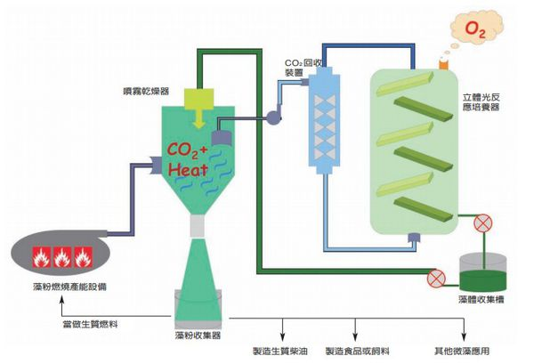
Spray dryer
CO₂ recovery device
Stereophotometric incubators
Algae powder burning capacity equipment
Algae collecting tank
Other microalgae applications
Manufacturing food and feed
Algae powder collector
Manufacturing biodiesel
Used as biofuel

Figure 1 Seaweed generation operation principle

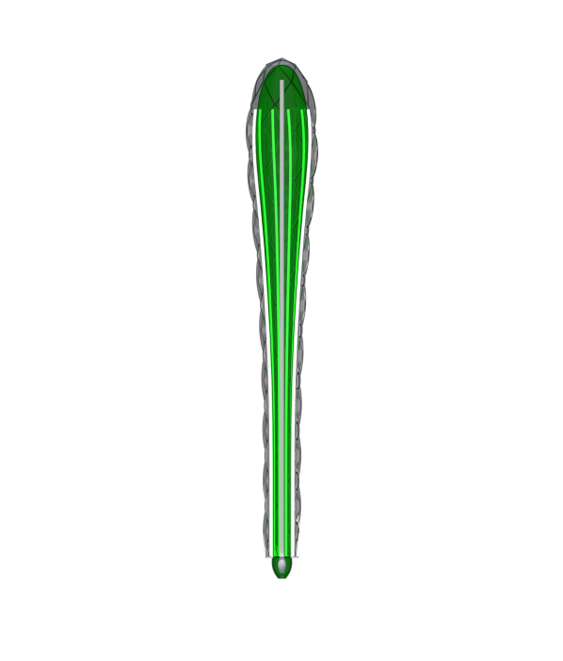
Some equipment parameters and product quantity:
Stereo photometric incubators: The aspect ratio is 1:1:16 and the shape is shown in the figure below. In the reaction chamber, there are a number of light reaction incubators with the same proportion and size, which can simultaneously culture 604m³ of algae.
Figure 2 Stereo photometric incubators

Algal fluid collector: Cylindrical, consistent with the size of the lower end of the photo reactor. The height of each collector is determined by the amount of algae produced by the different reactors.

CO2 recovery device: The shape is a rectangular parallelepiped, volume is 12m³, there are demister and scrubber.

Spray Dryer: The shape is as shown and the volume is about 50m³. At the top of the drying tower, the high-temperature CO₂ introduced by the power generation equipment is introduced. At the same time, the algae liquid to be dried is sent to the top of the tower, the algae liquid is atomized by the atomizer, and the high-temperature CO₂ is contacted to quickly dry the algae liquid in a short time and algae powder is produced.
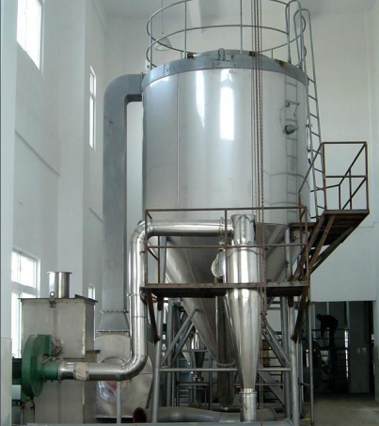

Figure 3 Spray Dryer

Product quantity:
In the 604m3 algae cultured, the algal density can reach 6 g/L. The biomass of the algae can be doubled in one day. Even if the light is insufficient, the light intensity can be artificially provided to ensure its annual growth is 1322 tons. After being calculated one ton of microalgae which is used for combustion and power generation can produce 20,000 kWh, and the total annual power generation is 26.44 million kWh. At the same time, the maximum oil content of microalgae can reach more than 80% of the biomass dry weight, and the oil level is 20% to 50%. The annual oil production capacity can reach 370 tons. The remaining dry material can be used to make about 200 tons of food or feed. The entire process carried out a cycle of carbon, produced oxygen, and achieved the effect of purifying the air. Although the amount of electricity generated is not very large, our design mainly wants to combine the city with the ecology and let people feel the concept of green health.

