Design concept:
Our design concept combines culture history and new technology together. New energy technology and Culture of Aboriginal Australians is combined in modern totem poles to represent past and future. They also are combined in campfire plaza. This combination displays St Kilda people respect history and past culture, it also displays St Kilda people’s determination of development to the future.
Modern Totem Pole:
Kulin people use totem pole to display their culture, our design is inspired by it to create a modern totem pole combine with wind energy technology together. Totem is a good carrier to display some culture elements. Such as pattern. So we also add four different patterns of culture elements on its surface. Like native language, aboriginal art and some famous culture elements of Melbourne. We combine them together to create new totem pole to display culture and provide power. It also has function of light to make sure this site can work in the evening. We leave open space around the Wind electric generator to make sure it can work no matter wind comes from any direction.
Totem pole is an individual. Our modern totem pole doesn’t has big size so it will not affect around areas too much. If some of them affect around areas, it is easily to move. We can put any numbers on the site but is low possibility lots of them broke together. If someone is broke, people can maintain it like maintain lamppost. That means manage them is not difficult. In other way, these patterns on surface of totem pole can change. That means we can change patterns to give other meaning for these totem poles. Such as we can redesign patterns for a school in St Kilda. Then combine the school’s patterns with totem pole. After this, the new totem pole can display the school’s culture. Them can put in the school and provide light and power for it. We also can do it for other site, such as market and company. If people want, they also change form of the totem pole. This means our design has expansibility and adaptability. If more people accept this way and join us. We will have more totem pole, we also will have more clean energy.
Campfire public plaza:
This area is the largest flat area of the whore site. So, we want to make this area can become a public space for peoples’ activities. Our design concept is combine old culture and new technology together. So, we try to use elements of Australians Aboriginal symbols to grade our site. In their culture, symbols of circle have special meaning for them. These symbols of circle usually mean an area can connect people together. So, we choose some of these symbols and use a new way to display them. First, we use symbol of camp to design our benches around the site. Second, the form of it looks like annulus. We use modern totem poles around benches to display symbol of campfire. Third, we add concentric circles benches and totem poles to create a campfire circle to represent symbol of meeting area. In the end, we use A 360 circle screen in the center to replace real campfire.
They can rest and meet new friends here. The campfire display old culture, it also flow our design concept: combine old culture and new energy technologies together. The center 360 circle screen can become campfire in the evening. Give people a comfortable environment to sit here. It also can show videos to display culture of St-Kilda or Melbourne. Solar eagles will put around the campfire circle. They also can for people to rest. New totem poles on the both sides of path ways that for people cross the public space. Solar Eagle and wind totem poles provide power to the whole site, at the same time, they also use another way to display culture elements. This public site means St Kilda triangle like the campfire is a comfortable area for different people to enjoy and relax. No matter where they come from, no matter who they are, in this area, they all are friends. Welcome to St Kilda!Totem poles and end of benches can become light in the night, make the site more beautiful. They also can change different colors from the center screen.
Wind technology:
We use wind technology in design of modern totem poles. The name of it is VAWT (Vertical axis wind turbine). It is new wind power technology. The material of turbine is aluminum alloy, and material of gantry is steel pipe. Material of its surface is PVC material. Every modern totem pole is 10 meters high, and turbine size is 3.5 meters high. One of VAWT benefit is its start speed is very slow. It just needs 2m/s -3m/s wind speed can start work. Average wind speed of St Kilda is very enough for make sure it can work.
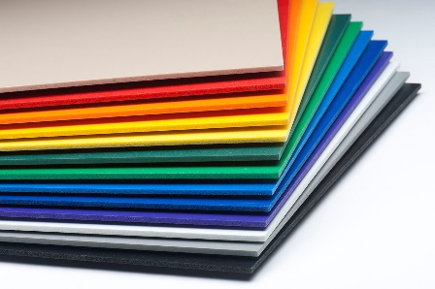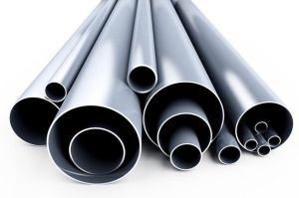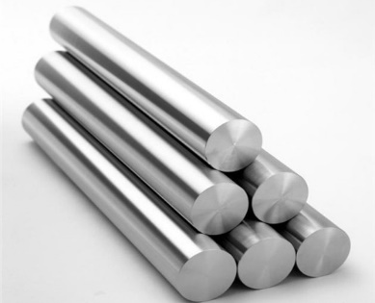
PVC material steel pipe material aluminum alloy
Every modern totem pole can provide 25kw-h /DAY. Number of modern totem pole in the site are 64. Modern totem poles can provide 48000 Kw-h/Month. They can provide total 576,000 Kw-h/Year. Every family in St Kilda usually use 5782 Kw-h/Year. So, Modern totem poles can provide power for close 100 family use every year.
Solar panel:
We also use 830 m2 size solar panel to provide power in the site. The solar panel are placed on the pavilion. Its material is Multi Junction solar cells. Its style is photovoltaic multifunction. Its efficiency is 40%. So, it can provide power 402,016 Kw-h/Year. (The data from PVWatts Documentation)

