SKYSCRAPERS AS WIND TOWERS - Horizontal axis windmills

Description

Summary
Conventional windmills present visual problems and are not feasible to be placed within populated areas.
Vertical axis windmills known to date have not brought a solution for wind energy on a significant scale
Finding a model for a vertical axis windmill resembling a tower that blends with the urban environment presents a great source of clean energy at a low cost by requiring minimal transmission costs as it is placed very close to the consumers.
The proposed model is designed and includes features that make it more effective than other models to date:
To date there are no large size vertical axis windmills noticeable in in cities or anywhere else. Nor are there many small size vertical axis windmills to provide power of any significance to a city.
This proposal argues that with specific design features it is possible to create a model of a vertical axis windmill that can make them more competitive than what we have seen to date.
In the image below is a spinning "wing" that captures the wind force with flappers that close from the wind pressure in the concave side and close from the wind pressure on the return (concave side) in order to reduce resistance on the return.
Vertical Axis Windmill with dynamic shutters that close when needed to capture wind power and open when needed to reduce resistance on the return cycle.
In the image below there are two vertical axis windmills turning in opposite directions. The lower windmill can be seen with the shutters closed indicated by yellow arrow on the right side - white rectangles - while on the left side the shutters are open to minimize wind resistance until they reach into position to capture wind power again.
The upper windmill turns in the opposite direction to the lower where the upper yellow arrow indicates the shutters closed to capture the wind power.
the red arrow indicates the placement of the generator capturing the power from both upper and lower rotors turning in opposite directions.
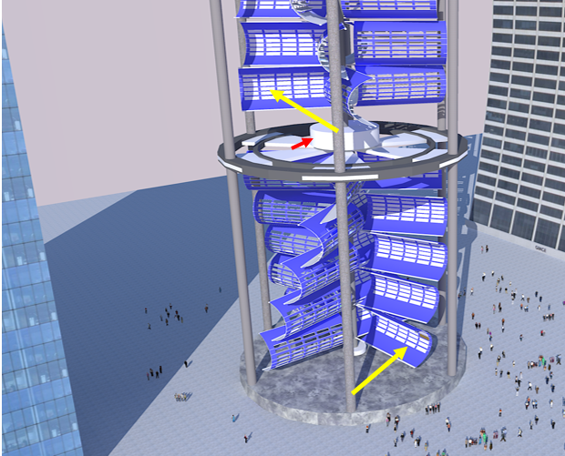
Stabilizers for the blades/wings: In the image below the orange arrows indicate small wheels built into the tips of the wings to turn within circular stabilizing structure indicated by green arrows. This helps keep a smooth and continuous movement.
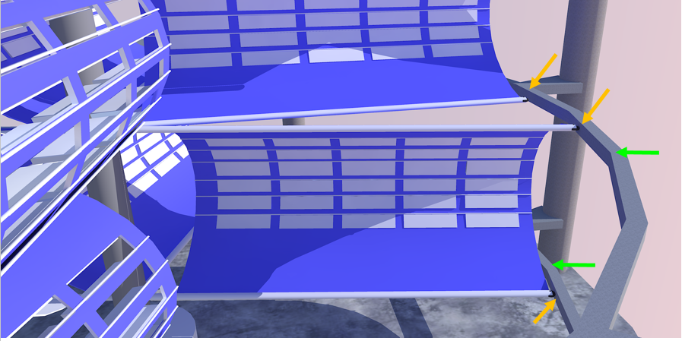
Horizontal elements (shown by arrows below) are connected to provide structural support against lateral force from the wind.
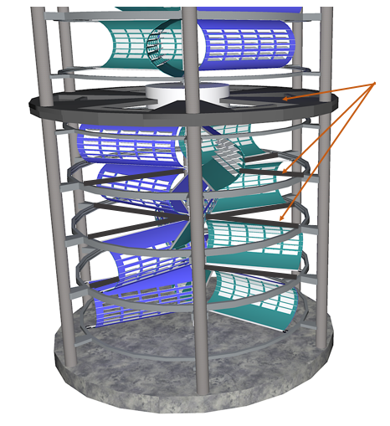
Land concessions and regulations will depend on a variety of scenarios. In commercial areas with extensive malls or factories etc. it would be simpler to implement as they would be further away from residential area and the height of the towers will not have the visual impact of “looming” when built at extensive heights of over 300 meters.
For example in the image below is an example of 300 m height in an area near highways and commercial areas.
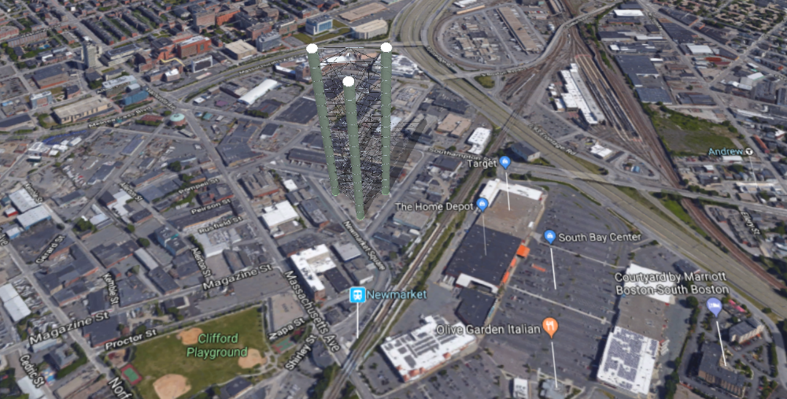
The advantage of this model is that it can be built at extreme heights without the complexities presented by horizontal axis windmills especially the transportation and the mounting of the blades such as in the image below.
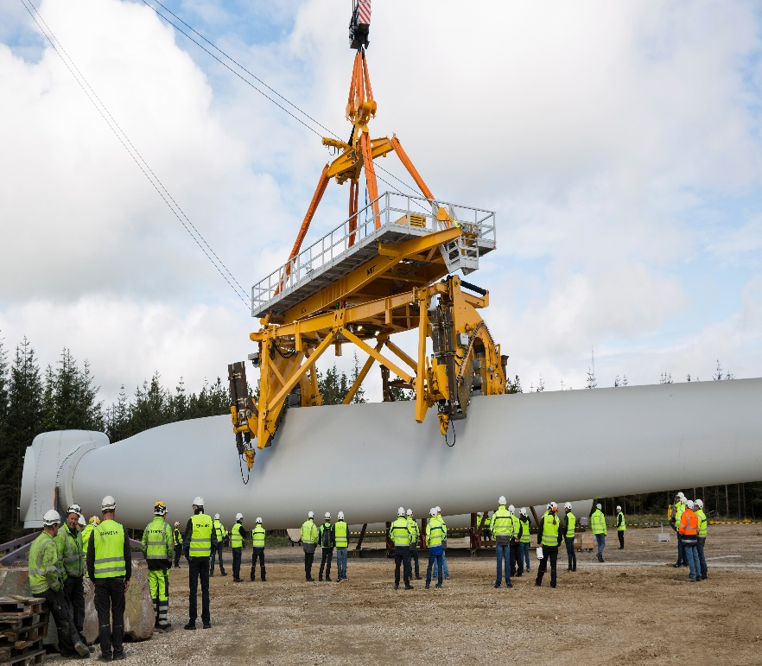
the proposed model can be built with simpler technologies and easy assembly reaching at least to heights equal to some of the tallest buildings and more. In the image below is an example of three towers connected for structural stability.
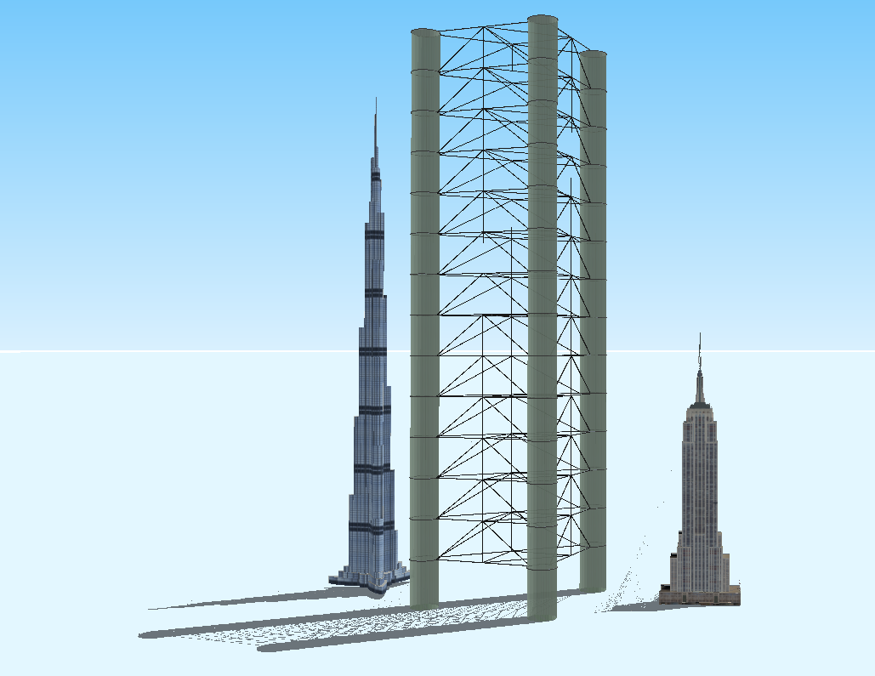

The proposed Vertical Axis Windmill at 300m height and diameter of 30m can be assumed to produce at least half the above output: 4MW per tower and power about 4000 homes -> TIMES THREE – SEE IMAGE BELOW
