PLUME

In the Dreamtime, the Great Ancestor Creator Spirit Bundjil brought the gift of Fire to Mankind. Teachings of the Creator of the Kulin have been passed down to Woman and Man, through the generations, and in this Age of Innovations we pay respect to our Aboriginal culture through the PLUME Monoliths of Wing and Fire.
Overlooking the Water, anticipating the rising Sun, are talismans of Light that capture the Fire in the sky and with it creates perpetual Energy in motion, an eternal Dance in the embrace of Wings that float our hopes and Dreams for an ever-soaring future to the heavens.
Within this transient frame we embed the eternal secrets of our Ancestors, brought forward through Augmented Realities and the Storytelling of our Elders. Through day and night our beacons stand, vanguards of the Boonwurrung and lighting the way for all those that call this land Home.
PLUME is a contemporary interpretation of Aboriginal monolithic structures, harvesting electricity from sunlight and transforming this power into both Kinetic and Light energies. These resulting energies are prioritised for own use throughout the day and night to facilitate its artistic purposes and interactive social functionalities, with offset considerations. Additionally, the contextual imagery and meaning are both twofold – PLUME from the Wings of the Bundjil and PLUME of Fire from the Sun.
PLUME is an overlay of Energy, Tradition, and Technology, all of which contribute to the Cultural Flux of Melbourne. It is aimed to be an iteration of the artistic embodiments that comprise contemporary Urban Infrastructure Identity, providing both Form and Function to its surrounding.
PLUME is also designed with the Internet of Things [IoT] in mind and envisioned to be always online and interactive through the latest consumer immersion technologies, programmable for foreseeable software and embodying the ability for hardware upgrades that keep it future-proof.

THE OPPORTUNITY

With the re-envisioning of Melbourne’s St. Kilda Triangle, the opportunity to incorporate more contemporary, physical and interactive iterations of cultural appreciation in the Urbanscape has never been higher and their purpose is elevated with the city’s Net-Zero target. To achieve an Equilibrium of Form and Function for the site, Grassroots needs and wants were assessed through On-the-Ground Community Consultation¹ which afforded the current Masterplan.
Within these guidelines it became clear that Tradition and Technology, the Past and Future, have to be reconciled into the Cultural Flux of the Present.
This reconciliatory manifestation needed to be Energy self-sufficient and within the dimensionalities that ensured adherence to its supplementary role in the aesthetic of the natural landscape as a whole.
Unlike artistic installations of the past, Social Interaction has to play a pivotal role in maintaining Public Interest as a Key Performance Indicator and, to that end, integration with Social Network Services alongside emerging Immersion Technologies has to be foremost as its design DNA.
Value Creation is, in essence, part and parcel of all design considerations and final output.

THE INNOVATION

Positioned as an ensemble on The Lawn of the current Masterplan, the Innovative
PLUME Design is best described through an elaboration of its Overlays – Energy, Tradition and Technology.
The PLUME Energy Overlay is based on Solar Power and, as such, takes advantage of the latest innovative Solar Panel technologies. For its material composition, the PLUME incorporates Solar Panels that are custom-made, high-output Monocrystalline Cell panels with Kromatix² Coloured Glass backsheeting. Kromatix is an Architectural standard for today’s Solar Panels in their capacity as Building-integrated Photovoltaics and this technology is ideal in providing Value Creation through visual aesthetics as elements of the PLUME of Fire from the Sun. These panels are created frameless and custom-fitted to the size and shape that is required for this design.
With its high-output specifications of 160Wp per square metre in its Kromatix Coloured Glass format, this Solar Panel requires 6.25 square metres to achieve a 1kWh Energy output design. This 1kWh output, when calculated for the sunlight of the
St. Kilda Triangle area, is estimated to provide 3.68 kWh of Energy daily³, providing more than 150 Watts of electricity for a full 24 hours, enough to power the equivalent of three laptops⁴ during that time. As the PLUME utilizes two Solar Panels in its design, this 2kWh configuration is expected to provide 7.36 kWh of Energy daily, providing more than 300 Watts at the equivalence of two 61” televisions running for a full 24 hours, which is more than enough for both its Kinetic and Light functions throughout each day.
As a self-sufficient Energy generator, the PLUME is estimated to produce 2,683.41 kWh of Energy annually.

The Annual System Output for a 2kWh Solar Panel configuration in the St. Kilda Postcode Area of 3182 is shown in the Table below:
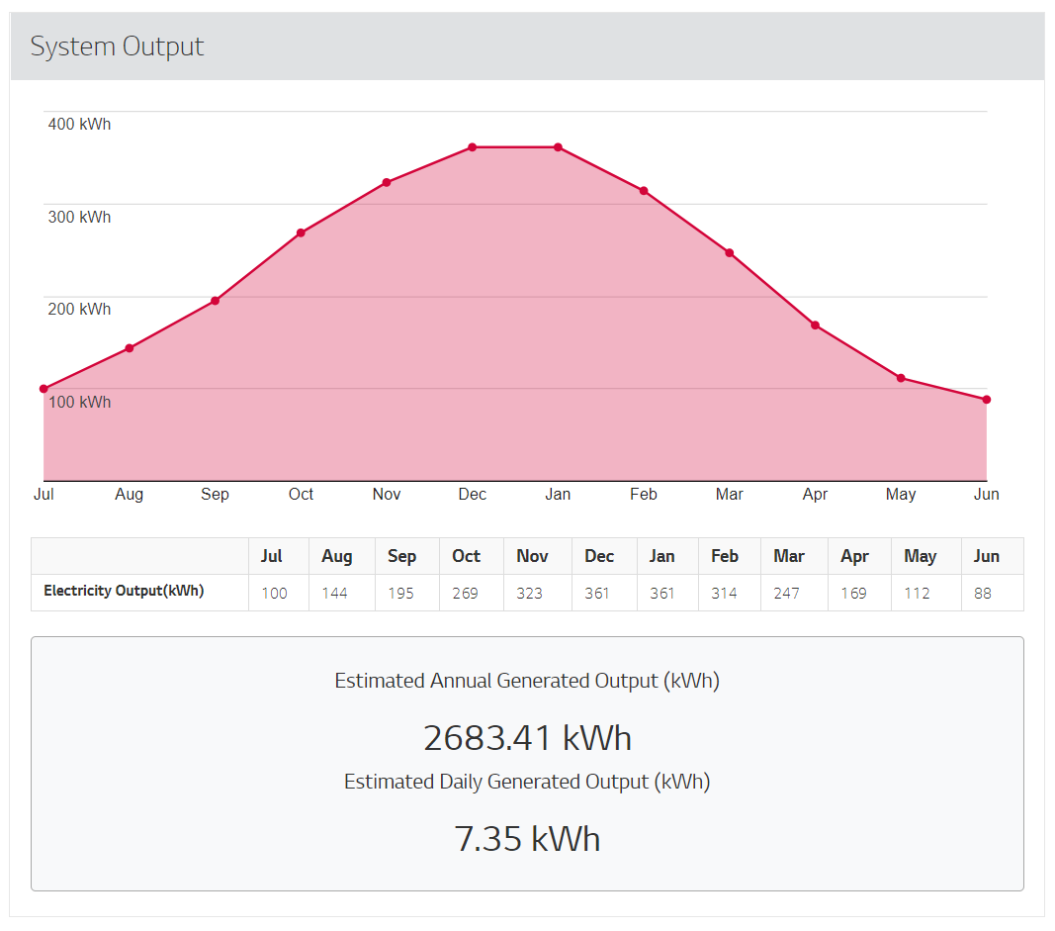
The PLUME Tradition Overlay is based on Aboriginal Boonwurrung culture, specifically a contemporary representation of the Great Ancestor Creator Spirit Bundjil with his gift of Fire for Mankind. This is mainly represented through the PLUME Monoliths of Wing and Fire, each comprised of a pair of Wing elements holding up the Fire elements between them.
The PLUME stands roughly 10 metres tall at its highest. Visually, black Wing elements encase the golden Fire elements and provide contrast that adheres to the traditional visual representations of the Bundjil. Fire elements comprise of golden-coloured
Solar Panels and a perpetual, black, red and gold Kinetic mobile that denotes the activated and harnessed power of the Sun by Mankind. Innovative Value Creation is achieved through interactive abilities embedded into the Wings element that allow for
colour-changing lights and rhythmic Kinetic motions to accompany various cultural events happening on The Lawn.

The PLUME Technology Overlay is based on innovative Augmented Reality technologies to spur cultural Value Creation for the PLUME. Through its Light functions, programmable Full-RGB OLED lighting will create patterns on its front face that, when scanned through a mobile device running a customized scanning application, will play
Augmented Reality 3D scenes that line themselves with this Monolith. These 3D scenes will be used as a multimedia medium for avant-garde Aboriginal Storytelling through
Elders engagement in its creation and a source of interactive self-education for visitors to the site, spreading the Boonwurrung culture, day and night.

ENVIROMENTAL IMPACT STATEMENT

From a Materials standpoint, the PLUME is constructed from weather-resistant, cladded metal structures that provide minimal negative impact for surrounding wildlife. Similarly, Kinetic elements are housed within tensile membranes that prevent wildlife accidents, whilst Full RGB OLED lighting are safely housed inside the Wings element and maintain the silhouette of the Monoliths by night.
As a non-invasive addition to an already outstanding Masterplan for the area, the ensemble of PLUME Monoliths augment this Vision through self-sufficient Solar Energy harvesting that have minimal negative environmental impacts on their surroundings whilst their presence as Overlays of Energy, Tradition and Technology are capable of providing a plethora of positive environmental impacts through thought-out, immersive and future-proof Value Creation, derived from the crystallization of On-the-Ground Reality.

