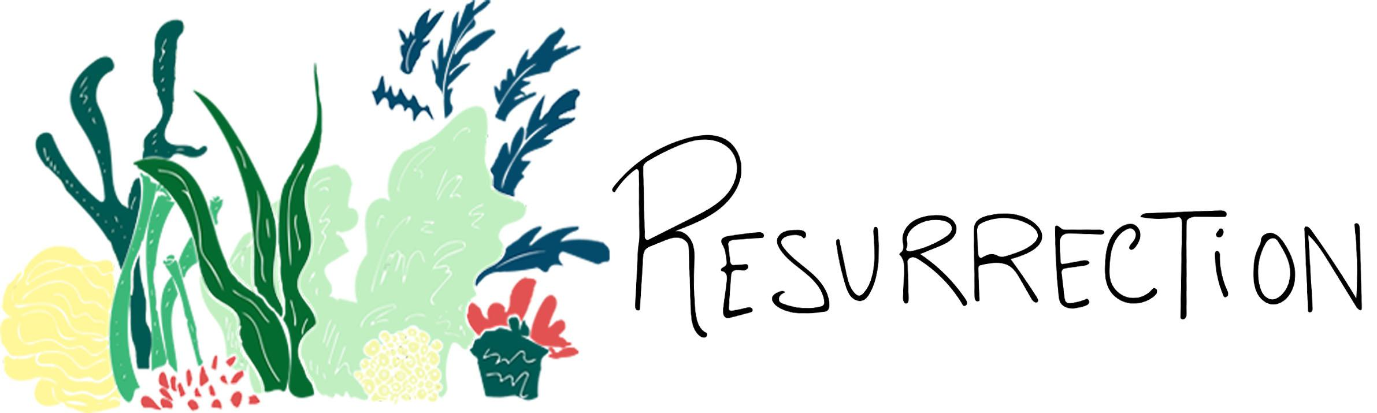
Resurrection is dedicated to the magnificent coral reef, a key component of Australian culture. Covering over 344,400 square kilometers of ocean, containing fifteen hundred species of fish, over four-hundred types of hard coral and one third of the world’s soft coral, this global entity is one of the most diverse ecosystems on the planet. Millions of people visit the Great Barrier Reef every year; intense tourism is one of the many factors harming these fragile reefs. The submission includes a variety of shapes that have been inspired by the features of aquatic organisms. The ground layout of the greenery was designed to mimic the sporadic nature of the coral reef. The general appearance of the site aims to maintain the vibrancy and the playfulness of underwater life. Resurrection’s main components include the large coral skyline, created using thin-film organic photovoltaic cells.

The tallest installation’s transition of bright pink to white represents coral bleaching, a phenomenon that occurs when coral decays due to ocean acidification. Ocean acidification occurs when carbon dioxide is absorbed by the ocean, decreasing the amount of calcium carbonate and thus preventing coral and other sea life from developing the hard exteriors they need to survive. In addition, nutrient runoff from industrial manufacturing depletes oceanic oxygen levels, creating dead zones within coral reefs.

At Resurrection, bricks are placed in concentric circles to imitate ocean currents. The fluid vertical columns imitate anemone or seaweed and are designed with piezoelectric plates placed at the bottom to collect energy as the wind pushes them. Energy is collected from the kinetic energy plates that have been placed throughout the walkways of the designed area. Although human contact has historically caused great harm to coral, visitors walking through Resurrection will generate electricity, positively impacting the environment rather than harming the reef system.

Raising awareness for the damage to the Great Barrier Reef is Resurrection’s main objective. In St. Kilda’s Triangle, the park will stand as a testament to the strength of the natural surroundings and attempt to help the suffering world around us, juxtaposing an organic and colorful structure upon an urban environment

The idea of Resurrection not only extends to the coral reef, but to all peoples of Australia. We plan for our design to serve as a place of social gathering though monthly events and gatherings, which would ensure significant annual energy production. Planning beach clean ups and light shows could improve the lives of both surrounding individuals and the ecosystem itself. Additionally, Resurrection could serve as a platform for Aboriginal peoples. Melbourne is known for its fantastic arts culture. Hence, there could be a commissioned street mural that would fill the surrounding sidewalks. Alternatively, artwork could be created and displayed in an outdoor gallery. Parking will be located underneath our structure.

Technology

We want Resurrection to provide mitigation techniques for those that visit. Pressure, heat and carbon dioxide sensors will be used in the imitation coral reef to mirror the Great Barrier Reef’s reaction to the above variables. For example, when large amounts of carbon dioxide are present, the coral will begin to lose color. These interactions will give Resurrection’s visitors real-time examples of what is happening in the nearby ocean.
Our installation will incorporate piezoelectric technology produced by a company called PaveGen that produce tiles that generate electricity from footsteps. These tiles produce up to 8 Watts of energy per footstep. The tile is self powering with 5% of energy going towards powering the tile and 95% is stored in a battery. This is equivalent to powering an LED street lamp for thirty seconds. The tiles are made to be extremely durable and currently have a lifetime of about 5 years. Pavegen manufactures these tiles using 80% recycled materials.

Our solar energy is produced through thin-film organic photovoltaic plastic sheets that can be found throughout Resurrection. This technology was chosen for it's malleable properties; the sheet is flexible, able to withstand movement from wind while resilient enough to maintain its integrity. We wanted to emulate the organic shapes coral forms in its natural habitat. This solar technology uses organic polymers to absorb sunlight and transmit electrical charges that will be collected within the installation.

The bulk of our energy comes from what we have dubbed the “piezoelectric squiggles”. The lightweight material of the squiggles allows them to move in the wind and capture its energy. There are piezoelectric discs at the base of the the structure which will harvest the energy as the squiggles sway in the wind.

Dimensions and Materials

Area of land: 11143.65 m^2
Solar panels are 0.5m wide
From small to large the coral circles have radii of (m): 6, 9, 11, 21
Radii of piezoelectric circles: 3.2 m
Pavegen Dimensions: 500mm each edge, 2x4 meter array

Primary Materials:
Wood
Thin Film Organic
Pavegen Tiles
Squiggle Material - Lightweight PVC created from recycled materials
Pavegen Tiles: Steel, Recycled Aluminium, Composite

Calculations

Piezoelectric floor:
Average time spent in park: 1 hour
Average walking time: 4828.03 m/hr

4828.03 m (91.8635 steps/70 m)= 6335.996 steps/person
6335.996 steps/person (20000000 people/year)= 1.2673*10¹⁰ steps/year
( 8 Watts/Step)(0.70 seconds/step)=5.44 Joules/step
1.2673*10¹⁰ steps/year (5.44 joules/step)= 6.8935*10¹⁰ joules/year
Annual Energy Output = 19.2 MWh

Solar:
Organic Thin Film Organic PVC produces about 100 W per unit area with a conversion efficiency of 10%
Area of the solar panels - 847.02 m^2
Capacity factor - 10% (the panels are oriented vertically)
Annual Energy Output = $100 W/m^{2} * 847.02 m^{2} * .1 * .1 * 8760 \frac{hr}{yr}$ = 7.4 MWh

Piezoelectric Squiggles:
Average wind velocity - 5.69 m/s
Area of squiggle ~ 10 m^2
Number of squiggles - 130
Density of Air = 1.23 kg/m^3ca
Efficiency ~ 30 %
Annual Energy Output = $\frac{1}{2}*(5.69 m/s)^{3}*10 m^{2}*1.23 kg/m^{3}*.3*8760 hr/year*130 squiggles$= 387.4 MWh

TOTAL ANNUAL ENERGY OUTPUT = 414 MWh

Environmental Impact

While Resurrection has the potential to become a significant source of energy for Melbourne’s Kilda Triangle, like any construction site, it poses a threat to the surrounding ecosystem. According to new studies, the construction sector contributes to 40% of drinking water pollution, 23% to air pollution and accounts for 40% of worldwide energy use. These statistics do not account for effects on biodiversity. As a result of previous deforestation and climate change, many of Australia’s beloved animals, like woylies and leadbeather’s possums, are endangered or already extinct. Unfortunately, these impact will occur regardless of the chosen design for the St. Kilda Triangle. But, our design intends to mitigate the effects of climate change by not only creating an environmentally sustainable landmark but also by educating the public as they travel through Resurrection.

The materials used in Resurrection will provide ample energy for Melbourne’s Tram System and power the structure itself, but initial economic and environmental costs will be high. The photovoltaic sheets that cascade throughout the structure will have to be replaced in approximately 20 years. As advances in sustainable energy, disposal of renewables become a growing issue. In fact, IRENA predicts that solar panel waste will equal 78 million metric tons by 2050. They are difficult to recycle due to the poor quality of recovered silicon, and “for every 1,000 kg of PV panel waste, about 20 kg of metals, including tin, aluminum, lead, and zinc, are recovered as hydroxides and landfilled” [2]. However, PaveGen plates, which we are using for piezoelectric energy production, are constructed from recycled materials and have a long expected life.
Bibliography

[1] Fujimoto, Alyssa. “Energy Harvesting Flooring.” Stanford University, 17 Nov. 2014, large.stanford.edu/courses/2014/ph240/fujimoto1/
[2] Bomgardner, Melody. Scott, Alex. “Recycling Renewables.” Chemical and Engineering News. April 9, 2018.

