PITCH!
Part 1: Project description

PITCH! is an iconic interactive sculpture, designed in a manner to respect the history and culture of the area while making notable contribution to the urban renewal and evolving character of St Kilda.

Bounded by The Esplanade and Jacka Boulevard, the site is surround by the rich history and vibrant culture of the St Kilda area. At St Kilda triangle, Palais Theatre and the now demolish The Palace anchors St Kilda as a major entertainment destination in Victoria. It is characterized by its long association to the jazz music scene in Melbourne. South to the site, St Kilda beach embodies a vibrant and playful character as the major seaside playground for Melbournians, local tourists and beyond. Future plans outlined in purple document published in 2016 strive to reinstate St Kilda as the music and art capital for Melbourne and beyond.

Our approach to the design of St Kilda Triangle land sculpture takes advantage of the unique location and is a blended response to both its past-present and future character of the area.
Jazz it up!
The sculpture draws inspiration from St Kilda’s vibrant jazz and dance scene through its visual form and composition. It reinterprets music into three dimensional forms, expressing itself in the form of soundwaves through its variation in height and orientation. The improvisation nature of jazz music informs the design as an interactive light sculpture at night, where shard of glass illuminates following the movement of visitors via motion sensors, composing an improvised light show through pedestrian movement.

A transparent sculpture
Composition of the sculpture is carefully curated to protect important vistas between The Esplanade and the beach. Glass panels are designed with varying heights and orientations to direct views to important points of interest across the area. The use of clear glass blends the sculpture seamlessly into its surroundings, scattering lights yet minimizes obstruction of views from all angles.

24hr sculpture
The design present itself as monumental art installation through its sculptural composition and it’s interplay with the sun during daylight hours. At night it transforms into an interactive light sculpture with shards of glass luminates following visitor’s movement, creating a dynamic and vivid seaside playground and providing important sense of surveillance for safety.

Community in mind
The design follows closely with endorsed masterplan in 2016. Its careful composition adopts to the proposed landscape yet augments its intended use. Its location strives to provide a strong visual presence to the proposed piazza at Palais Theater and Hotel. Composition of the sculpture allows various community events being held within the sculpture such as Sunday market and an iconic meeting place for locals and beyond.

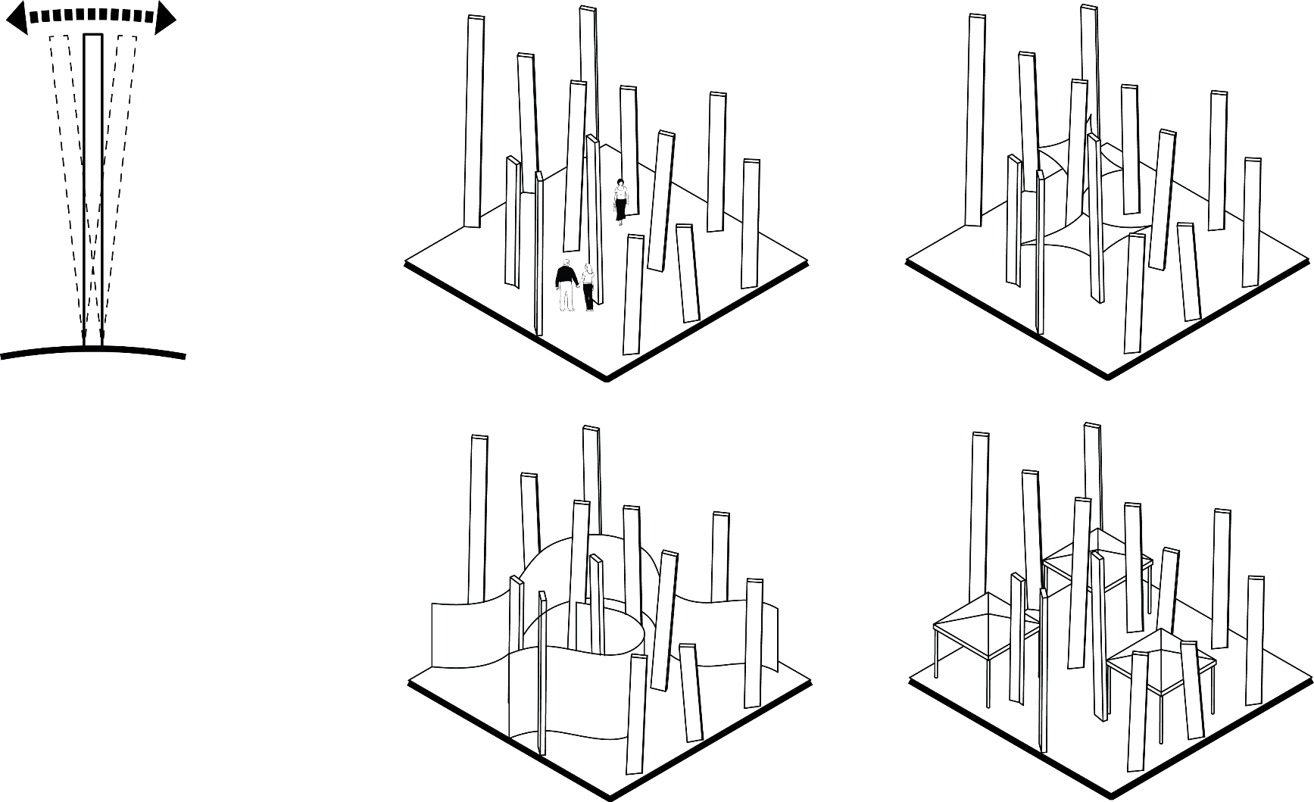

A gift to the city
The sculpture is clearly contemporary yet it speaks to the past present and future of the St Kilda area with sensible composition of material and form which will stand as a timeless and authentic contribution to St Kilda’s context.

Technology
The design employs energy harvesting clear glass technology developed by the Electron Science Research Institute at Edith Cowan University in conjunction with ClearVue Technology. The glass contains a nano-particle doped PVB interlayer sandwiched between two panel of glass that redirect ultraviolet and infrared component of natural light towards the edge of the glass. Conventional PV solar cells are installed around the edge of glass to generate electricity, resulting a true clear glass solar panel. It is a proven technology with pilot projects being carried out in Melbourne and Singapore.

The glass technology can produce up to 30W of power per square meter. Our proposal adopts this technology by sandwiching its patent special compound interlayer between 2 layers of low iron clear glass to achieve its crystalline appearance. The glass embodies self-cleaning properties which requires low maintenance. Typical glass panels of our proposal are 500mm wide with height varies between 2.4m to 12m. With a total glass surface area of 1442.5m², the estimated annual kWh generated for our design at Stage 1 is about 85453kWh.

Energy storage system such as the Tesla Powerpack has the capacity of storing 210kWh per Powerpack. It’s modular and weather prove form factor ensures future expandability of the solar system as a whole for the area.

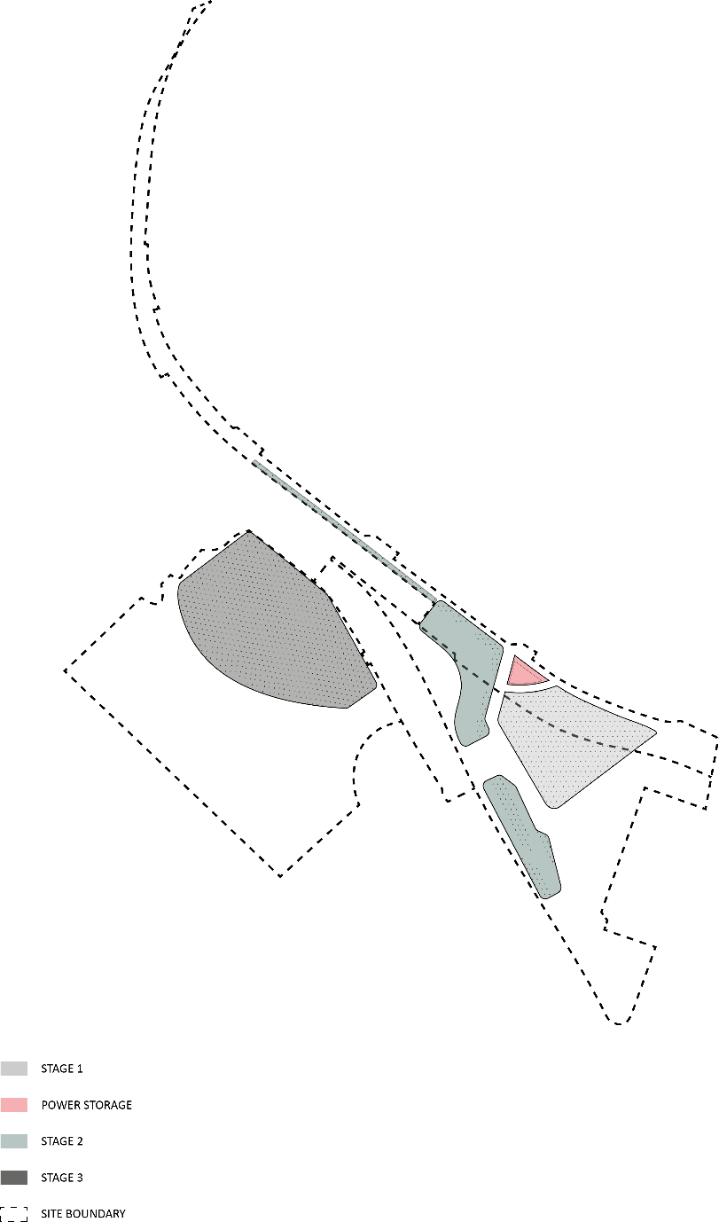
Part 2: Environmental Impact Summary

Landscape and geology
The proposed sculpture is designated to adopt and integrated into the masterplan of St Kilda triangle as outlined in the purple document. It is designed to be integrated with the current landscape proposal as shown in the masterplan. There is limit effect to surface permeability of the proposed development. However, location of power storage might imply extra excavation to accommodate the required equipment at carpark level. There are also risks of soil erosion and contamination due to oxidation of metal base and electric wires of the sculpture in the long run.

Vegetation
The proposed design does not remove any trees sited within primary and secondary boundary. With maximum 12m in height to the tallest structure and setback from the boundary of the primary site, there is little overshadowing to plant species along the esplanade. There are potential impacts on the grass surfaces due to overshadowing, causing soil erosion in the long run.

Fauna
The sculpture has a reflective and translucent surface. Strong glare might be present at a sunny day which might have an adverse impact to local bird species during day time.

Carbon Footprint
Both glass and metal component of the proposed sculpture contains high embodied energy. However, the proprietary technology employs in the design ensures the sculpture is manufactured locally in Australia and possibly within the state of Victoria. This drastically reduces the carbon footprint of design components.

