**LIGHT UP**

LAGI 2018

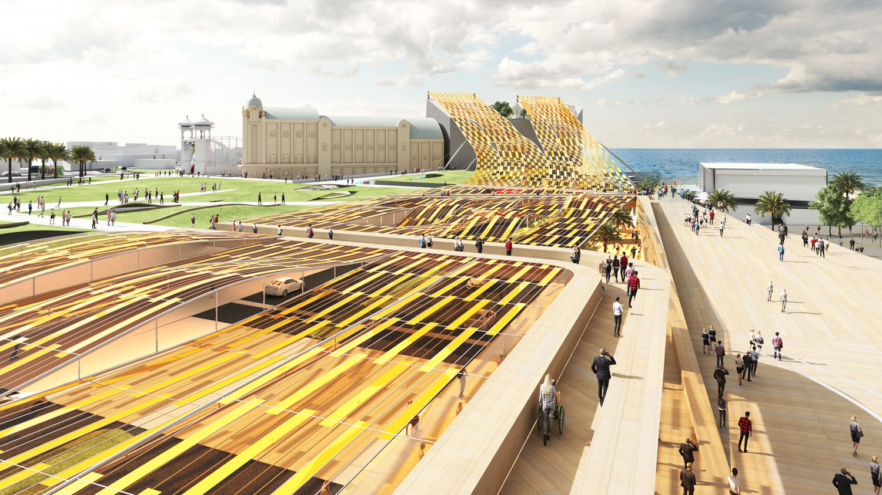

**LIGHT UP**

PROPOSAL

Light up proposes to generate lighting for over 900 homes, Luna Park, the Palais Theatre, the Esplanade, and the St Kilda Foreshore.

The scheme integrates solar, wind, plant fuel-cell energy harvesting and battery storage seamlessly within the landscape of St Kilda.

A Lightweight tensile structure made from flexible ultra high efficiency solar photovoltaic modules generates 1552 MWh annually. The modules create a light filtered surface over Jacka Boulevard providing 8,600 solar components. It provides improved sun protection on Jacka Boulevard and makes use of the street area as an energy harvesting opportunity.

70% of the energy is generated by solar photovoltaic cells.

We believe the secret to making large-scale creative renewable concepts realisable is the extensive use of a mass-produced modular elements that benefit from economies of scale at their production stage.

Each renewable energy element of our scheme meets this fundamental objective.

The structure is made from a subset of cables spanning between bridges and the hotel. The undulated surface is achieved by a series of Vierendeel trusses connecting to the bridges and cross tension cables.

**The Masterplan**

Our proposal departs from the 2016 Master plan with an allowance for approx. 300 cars, a new cultural centre, a new hotel and an uninterrupted landscape from the Esplanade and Luna Park to the beach front.

The views towards the beach and institutions like the Stoke House and Donovan have been carefully integrated and considered.

The proposed carpark and the cultural centre are submerged in the landscape and use the fall of the land towards Jacka Boulevard.

An improved integration of existing public, pedestrian and street networks and proposed new linkages provides a robust connectivity framework. All parts of the landscape are designed to be wheel chair accessible.

A new Event Plaza forms the heart of the cultural hub and interfaces strategically with the North façade of Palais Theatre and the new carpark.

The materiality and architectural language is a continuation of the St Kilda beach walk (completed in 2009) with warm timber and sandy tones.

The undulating landscape on top of the carpark allows for natural light and carpark ventilation.

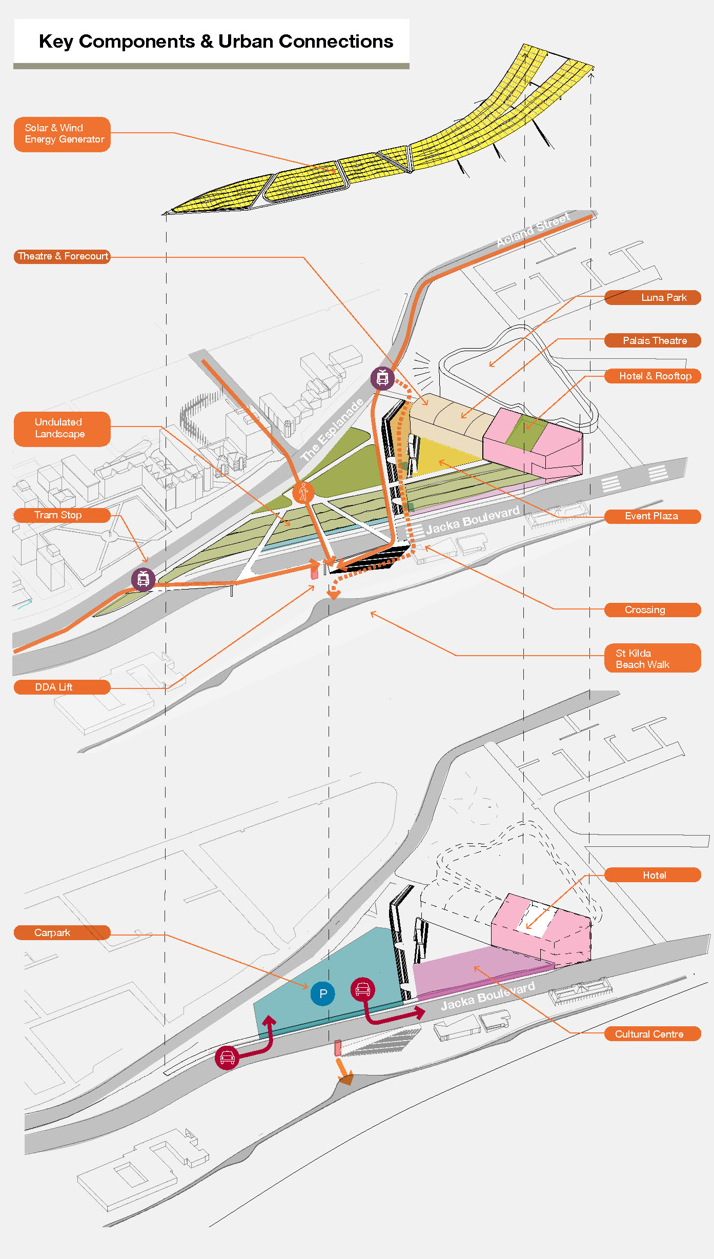**REALISING THE LAGI DREAM**

FUNDABILITY & BUILDABILITY

Regrettably, winning LAGI schemes from previous competition years have remained unfunded and unbuilt. An underlying reason is that the technologies and/or components involved reside largely to the left of the division on the chart below:

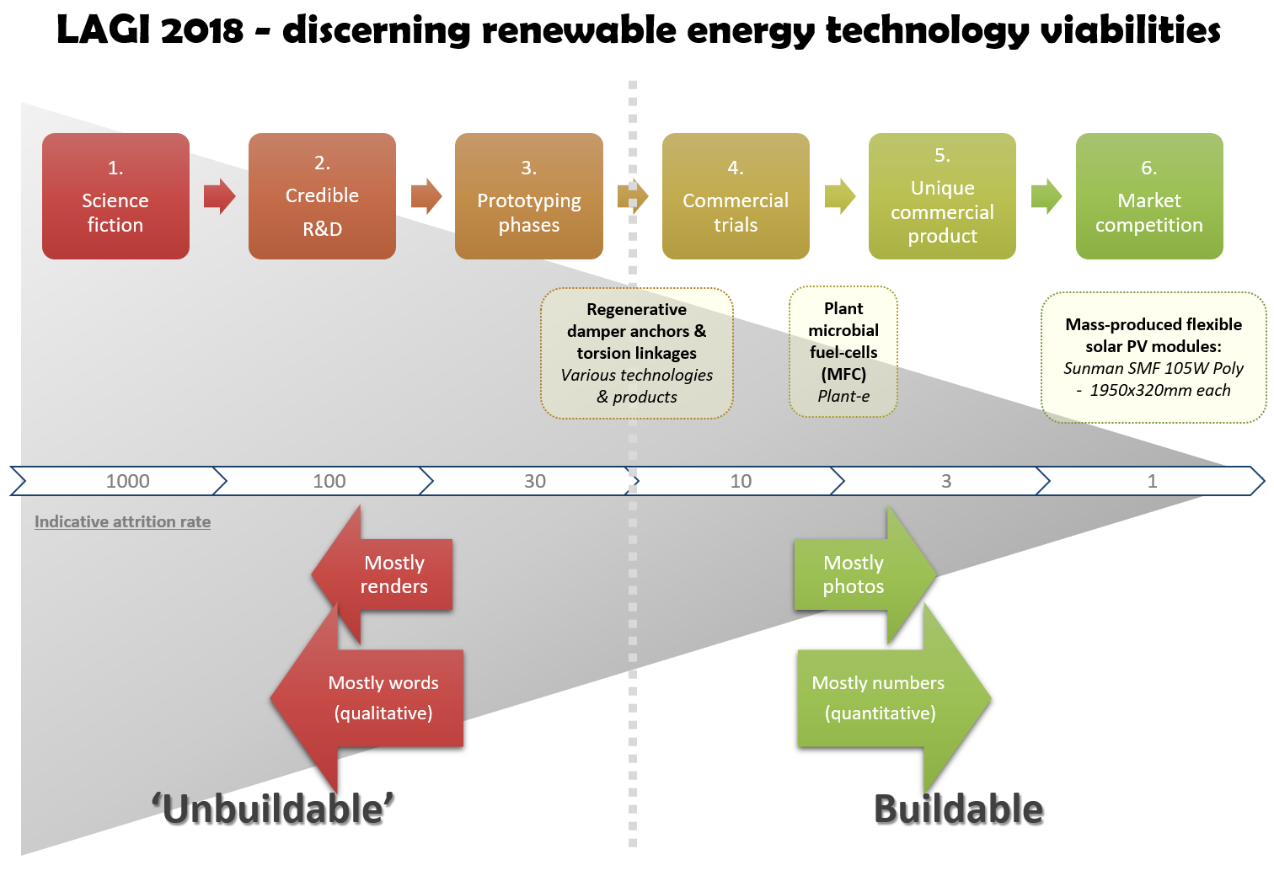

Such technologies typically require years of investment, refinement and marketing before becoming commercially available and financially attractive.

For a large-scale concept to be fundable it must be:

* Designable
* Buildable
* Maintainable
* Warranteeable
* Insurable

Achieving the above criteria, in conjunction with acceptable return-on-investment will help make LAGI projects fundable and therefore realisable.

We believe the secret to making large-scale creative renewable concepts realisable is the extensive use of a mass-produced modular elements benefit from economies of scale at their production stage.

Each renewable energy element of our scheme meets this fundamental objective. *This one can be realised..!*

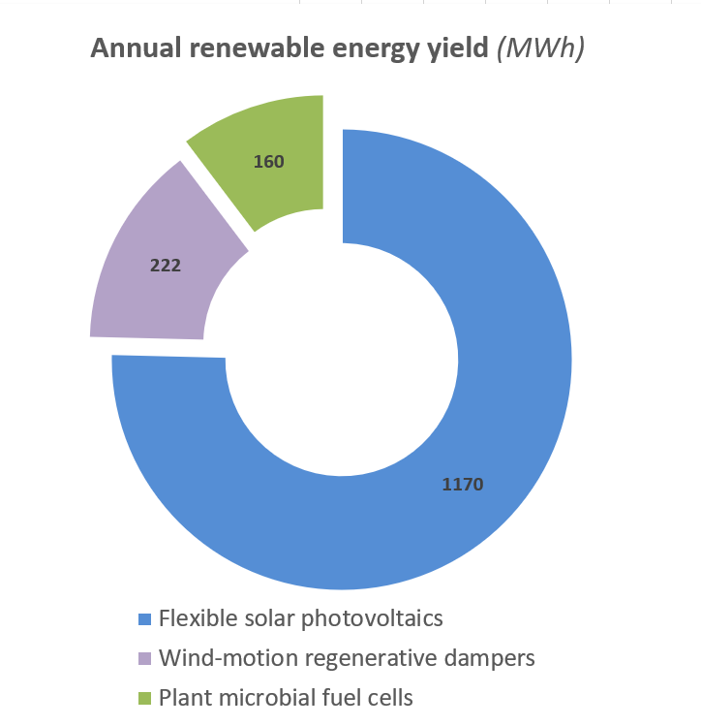

**Modular component products utilised:**

**Lightweight flexible solar photovoltaic (PV) modules:**

* Recently-commercialised ultra-high-efficiency proprietary modules supported and warranteed by permanent presence in Australia, produced by a reputable international manufacturer with good industry-credibility.
* Product details:
  + Sunman eArche SMF 105W Poly ( 2 x 12 polycrystalline PV cells)- 1950x320mm each

**Wind-motion regenerative dampers**

Each of the 8,600 flexible solar module will pivot independently in the wind, from across Port Phillip bay in winter and largely from deep inland during summer months. The modular natural of this array reveals the invisible dancing wind patterns, enhancing public awareness of this inexhaustible sitewide energy resource.

Individual micro-regenerative dampers at each module fixing point harvest this torsional energy. Additional regenerative dampers at the stainless-steel cable anchor points harvest tensional energy flexing within each tensile cable.

**Turf microbial fuel-cells:**

* Award-winning commercially available technology developed by Wageningen University in the Netherlands and commercialised under the Plant-e brand:

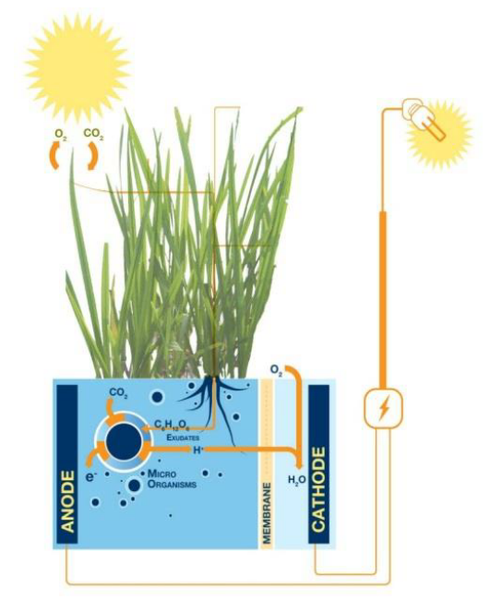

* Plants photosynthesize organic matter using solar energy. A significant part of this organic matter is released into the soil. These electrochemically active micro-organisms break down the organic matter producing electrons, which are transported to the anode of the fuel-cell. The energy rich electrons flow through a load to the cathode to generate electricity 24 hours per day.

**Return on investment analysis**



**Embodied ecological impacts of proposed materials**

The renewable technologies used have been selected to have less than a quarter of the embodied environmental impact of their conventional alternative forms, using mass as a proxy. Embodied impacts of products include their embodied energy, water, waste and toxicities associated with their manufacture.

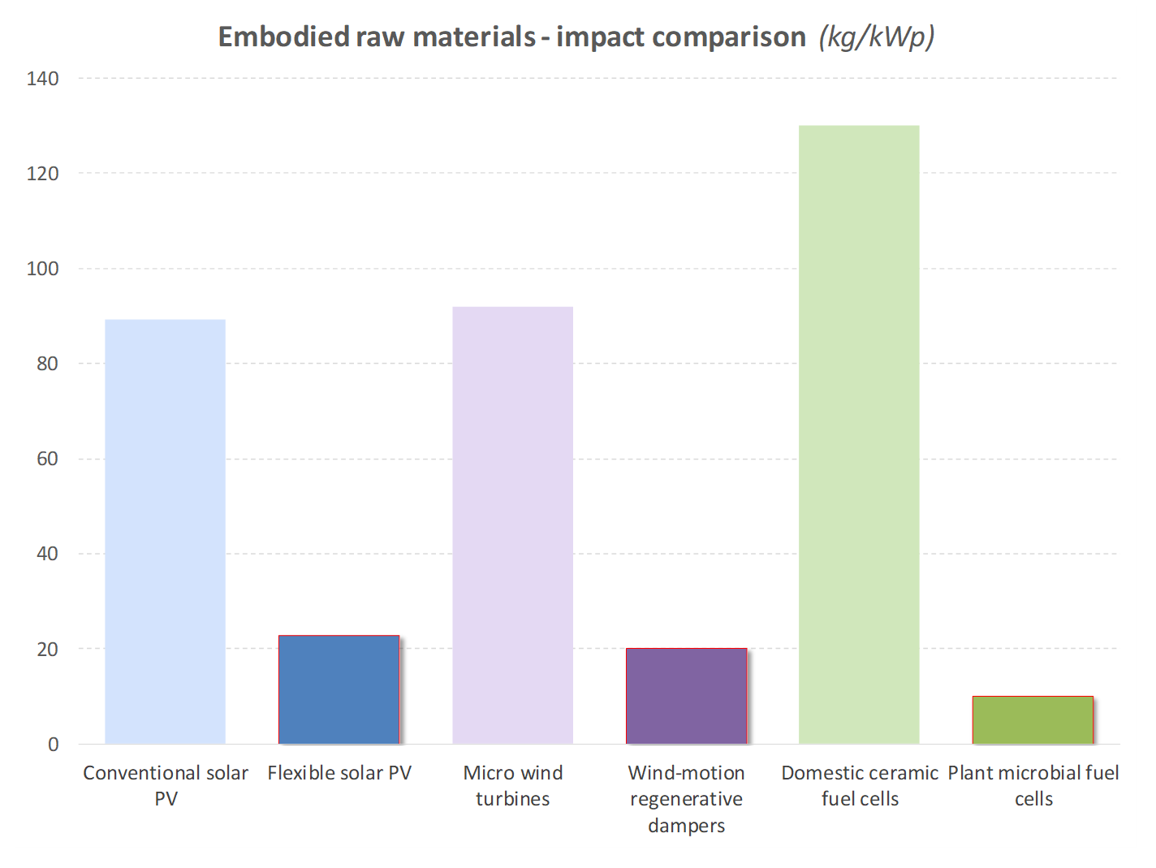

**Energy storage – battery cell array**

Intermittency of renewables, grid reliability and storage of electricity is a highly politically charged topic in Australia today. As a consequence Australia is home to the world’s largest battery

Storage will be visually integrated into the architectural language of the scheme through the use of lithium-ion cells. These will be repurposed from the growing number of retired electric vehicle batteries (averaging 60% of cell capacity when new) providing a new lease of life, and avoiding premature disposal or recycling of cells that still have potential life beyond transport.

These battery cells are slightly larger than domestic ‘AA’ type batteries i.e. 70mm long by 21mm diameter. A total storage capacity of 1.4MWh will be provided to match solar and wind-power production profiles (turf fuel-cells will generate power 24/7).

This will require 107,000 used EV battery cells, equivalent to the number of replaceable cells in 50 fully electric cars. When arranged in a line as a bandolier these cells will span a distance of over 2km. They will be embedded within the handrails of the bridge structures.

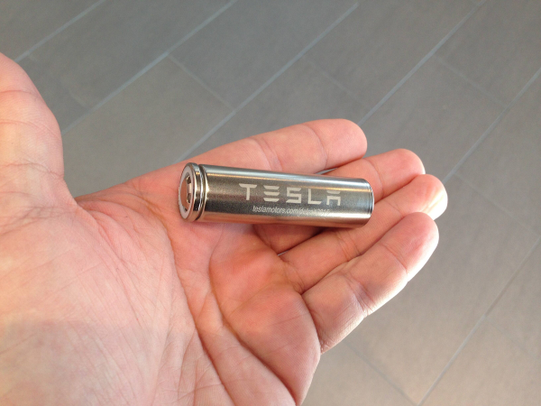

**Note the Negawatts…**

Negawatts represent megawatts saved i.e. renewable energy that doesn’t need to be generated due to consumption savings inherent in the design. Negawatts are always cheaper than renewable megawatts. The car-park element of our masterplan design integrates openings for natural lighting and natural ventilation. As well as providing a more amenable facility it provides significant savings in traditional capital and operational costs associated with mechanical ventilation and artificial lighting of the car-park.

